# ΒΑΣΕΙΣ ΔΕΔΟΜΕΝΩΝ

Εξαμηνιαίο PROJECT 2021 – 2022

***Στοιχεία Ομάδας:***

* Καζολιάς Βασίλειος 1072610 Έτος 3ο
* Ταμβάκης Θωμάς-Χρυσοβαλάντης 1072631 Έτος 3ο
* Καψιμάλης Διονύσιος-Κωνσταντίνος 1072603 Έτος 3ο

***Περιεχόμενα***

* **ΠΡΟΛΟΓΟΣ**
* **ΚΕΦΑΛΑΙΟ 1 :** Ανανεωμένη βάση δεδομένων και παραδοχές
* **ΚΕΦΑΛΑΙΟ 2 :** Δημιουργία πινάκων και εκχώρηση δεδομένων
* **ΚΕΦΑΛΑΙΟ 3 :** Stored Procedures
* **ΚΕΦΑΛΑΙΟ 4 :** Triggers
* **ΚΕΦΑΛΑΙΟ 5 :** GUI

**Πρόλογος**

Η εργασία (Project) αυτή εκπονήθηκε από τους προπτυχιακούς φοιτητές Βασίλειο Καζολιά, Διονύσιο Κωνσταντίνο Καψιμάλη και Θωμά Χρυσοβαλάντη Ταμβάκη. Στα παρακάτω κεφάλαια, δίνονται λεπτομερείς απαντήσεις στα ερωτήματα που τέθηκαν, με ανάλυση του κώδικα και πλήθος στιγμιότυπων οθόνης (screenshots). Αυτό το word αρχείο, περιέχει τις απαντήσεις για τα δύο μέρη της εργασίας (Α’ Μέρος: **SQL**, B’ Μέρος:**GUI**), με επεξηγήσεις και παραδείγματα, και στο τέλος τον πλήρη SQL κώδικα που συγγράψαμε. Ο κώδικας αυτός εκτός από όλους τους πίνακες **(tables)**, περιέχει επίσης όλες τις εισαγωγές τιμών **(inserts),** αλλά και τα **Procedures** και **Triggers** που μας ζητήθηκαν να κατασκευάσουμε. Τα ερωτήματα αυτά (Procedures και Triggers) βρίσκονται μέσα σε σχόλια, και εμφανίζονται σειριακά, όπως δηλαδή μας ζητούνται στην εκφώνηση (πρώτα το 3.1 μετά το 3.2 κλπ.). Αξίζει επίσης να σημειωθεί, ότι για ευκολία των εξεταστών, στο .zip αρχείο που υποβάλαμε, περιέχονται αρχεία .txt που περιέχουν τον κώδικα, για κάθε ένα ερώτημα ξεχωριστά (π.χ. για το procedure 3.1 ο κώδικας βρίσκεται μέσα στο .zip αρχείο με ονομασία 3.1.txt κλπ.)

**ΚΕΦΑΛΑΙΟ 1**

Στην επόμενη σελίδα παραθέτουμε το σχεσιακό διάγραμμα της αναθεωρημένης βάσης δεδομένων μας. Παρατηρούμε πως έχουμε συνολικά **23** πίνακες.

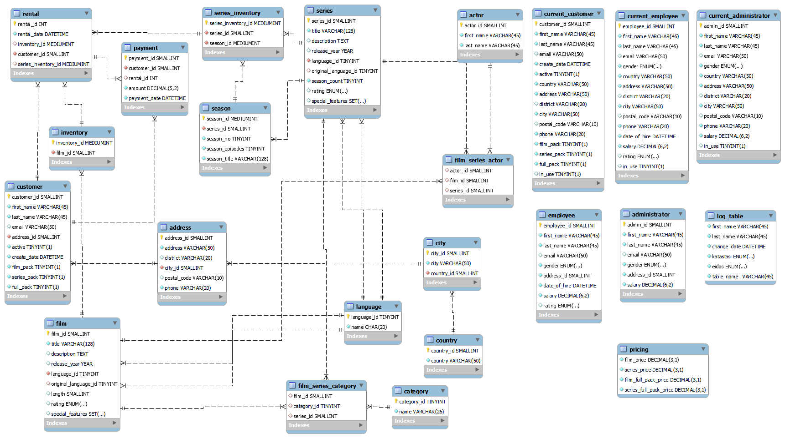

**B)**

Σε ότι αφορά τις παραδοχές και τις αλλαγές που κάναμε, στους δοθέντες πίνακες, παραθέτουμε παρακάτω την πλήρη περιγραφή τους, με σαφήνεια και ακρίβεια.

Όσον αφορά τις παραδοχές που πραγματοποιήσαμε, η πιο βασική είναι πως οι πελάτες με πρόσβαση σε σειρές (εγγεγραμμένοι σε ***series_pack*** ή ***full_pack***), κάθε ενοικίαση (κάθε **rental**) που πραγματοποιούν θα αφορά μία σεζόν, και δεν θα γίνεται ούτε ανά επεισόδιο, ούτε ανά ολόκληρη την σειρά. Γι’ αυτό ακριβώς τον λόγο, όπως θα δούμε και παρακάτω δημιουργήσαμε τον πίνακα **season**, που εκτός από το ***season_id*** (μοναδικό για κάθε κύκλο σειράς), περιέχει και τον αριθμό των επεισοδίων ανά κύκλο για κάθε σειρά ξεχωριστά (***season_episodes***). Επιπροσθέτως, για να ορίσουμε δύο πίνακες, τους **film_series_actor** και **film_series_category**, οι οποίοι θα περιέχουν ηθοποιούς και κατηγορίες αντίστοιχα, που ανήκουν τόσο σε ταινίες, όσο και σε σειρές, θα χρειαστούμε δύο εγγραφές στους πίνακες **film** και **series** (μία στον καθένα), οι οποίες αντιστοιχούν σε μια «μηδενική εγγραφή», για να ξεχωρίσουμε τις εγγραφές που συμμετέχουν μόνο σε ταινίες και μόνο σε σειρές αντίστοιχα (παρομοίως και για τις κατηγορίες). Για τον πίνακα **film**, έχουμε την εγγραφή με ***film_id*** = 1000 :



ενώ για τον πίνακα **series**, έχουμε την εγγραφή με ***series_id*** = 1020 :



Επιπλέον, αναφορικά με τις ενοικιάσεις, κάθε πελάτης μπορεί να ενοικιάζει όποια ταινία ή κύκλο σειράς, όσες φορές επιθυμεί.

Πιο συγκεκριμένα σε ότι αφορά τους πίνακες, ο σχολιασμός για το αν τους επεξεργαστήκαμε ή όχι και πόσο, γίνεται κάτωθι σειριακά (όπως βλέπουμε το πρόγραμμα) για περισσότερη ευκολία στην κατανόηση. Ο συνολικός αριθμός πινάκων που χρησιμοποιήσαμε είναι 23.

* Για τους πίνακες **actor**, **country**, **city**, **address**, **category** και **language** δεν προχωρήσαμε σε καμία αλλαγή.
* Σε ότι αφορά τον πίνακα **customer**, προχωρήσαμε σε αύξηση των στοιχείων – columns. Ειδικότερα, προσθέσαμε τρεις Boolean μεταβλητές (***film_pack, series_pack, full_pack***), για την εξυπηρέτηση του συστήματος εγγραφών της υπηρεσίας μας. Αναλυτικότερα, μόνο μία από τις προαναφερθείσες μεταβλητές μπορεί να είναι true, έτσι ώστε ο τύπος εγγραφής να αντιστοιχίζεται ως εξής :
* film_pack = **true**, series_pack = **false**, full_pack = **false** => **Πακέτο ταινιών**
* film_pack = **false**, series_pack = **true**, full_pack = **false** => **Πακέτο σειρών**
* film_pack = **false**, series_pack = **false**, full_pack = **true** => **Πακέτο ταινιών και σειρών**
* Στη συνέχεια, φτάνουμε στον πίνακα **film**. Ο συγκεκριμένος πίνακας, παρέμεινε σχεδόν αναλλοίωτος. Η μόνη αλλαγή που πραγματοποιήσαμε, ήταν να προσθέσουμε στο column ***special_features*** την τιμή ‘NOTHING’, η οποία μας εξυπηρετεί στον πίνακα **inventory,** που θα σχολιάσουμε παρακάτω.
* Εν συνεχεία, συναντάμε τον νέο πίνακα **series**. O συγκεκριμένος πίνακας, δημιουργήθηκε, με σκοπό να εντάξουμε τις σειρές στην αναθεωρημένη – αναβαθμισμένη βάση δεδομένων. Αξίζει να επισημανθεί, ότι ο πίνακας αυτός περιέχει παρόμοια στοιχεία με τον πίνακα **film**, με μερικές παραλλαγές. Ειδικότερα, σε σχέση με τον πίνακα **film**, ο πίνακας **series**, δεν περιέχει τη μεταβλητή ***length*** και αντ’ αυτής, έχει ενταχθεί το ***season_count***, το οποίο αναπαριστά τον αριθμό των κύκλων (seasons) σε κάθε σειρά. Τέλος, όπως στον πίνακα **film**, το ***film_id*** είναι το primary key, έτσι και στον πίνακα **series**, το ***series_id*** είναι το primary key του πίνακα
* Ύστερα, παρατηρούμε τον νέο πίνακα **season**. Όπως γίνεται φανερό, ο προαναφερθείς πίνακας, χρησιμοποιείται για τη διαχείριση των κύκλων (season) της εκάστοτε σειράς. Αρχικά, αυτός ο πίνακας, διαθέτει μια μεταβλητή τύπου mediumint, μη μηδενική, την οποία την ονομάσαμε ***season_id*** και αυτή αποτελεί το πρωτεύον κλειδί (primary key) του πίνακα. Επιπρόσθετα, χρησιμοποιούμε τη μεταβλητή ***series_id***, η οποία λειτουργεί ως ξένο κλειδί (foreign key), μεταξύ των πινάκων **series** και **season.** Έπειτα, ορίζουμε ακόμη τρεις μεταβλητές ***season_no*** (τύπου tinyint), ***season_episodes*** (τύπου tinyint), ***season_title*** (τύπου varchar), οι οποίες αντιστοιχούν στον αριθμό του εκάστοτε κύκλου (πχ 1ος κύκλος), στον αριθμό επεισοδίων κάθε κύκλου και στον τίτλο του κάθε κύκλου.
* Συνεχίζοντας, βλέπουμε τον πίνακα **film_series_actor,** o οποίος προήλθε από την τροποποίηση του πίνακα **film_actor**. Πιο συγκεκριμένα προσθέσαμε τα κλειδιά ***actor_id*, *film_id*,** ***series_id***, ενώ το κάθε ένα ξεχωριστά αποτελεί ξένο κλειδί για τον πίνακα. Το ***actor_id*** συσχετίζει τον πίνακα **film_series_actor** με τον πίνακα **actor.** Με τον ίδιο τρόπο, το ***film_id*** και το ***series_id*** συσχετίζουν τον πίνακα **film_series_actor** με τους πίνακες **film** και **series** αντίστοιχα.
* Σε ότι αφορά τώρα, τον πίνακα **film_series_category,** όπως και με τον πίνακα **film_series_actor** αποτελεί την τροποποιημένη έκδοση του πίνακα **film_category.** Παρόμοια με προηγουμένως, προσθέσαμε τα κλειδιά ***series_id***, ***category_id*** και ***film_id*** και το κάθε ένα ξεχωριστά αποτελεί ξένο κλειδί για τον πίνακα. Το ***category_id*** συσχετίζει τον πίνακα **film_series_category** με τον πίνακα **category.** Με τον ίδιο τρόπο, το ***film_id*** και το ***series_id*** συσχετίζουν τον πίνακα **film_series_category** με τους πίνακες **film** και **series** αντίστοιχα.
* Για τον πίνακα **inventory** δεν προχωρήσαμε σε καμία αλλαγή.
* Ακολούθως, δημιουργήσαμε τον πίνακα **series_inventory,** για την ένταξη του καταλόγου των σειρών στην υπηρεσία μας. Ομοίως με τον πίνακα **inventory**, o πίνακας αυτός αποτελείται από ένα πρωτεύον κλειδί, το οποίο είναι το ***series_inventory_id*** (τύπου mediumint), καθώς και τα ξένα κλειδιά ***series_id***, ***season_id****,*με τα οποία συνδέεται ο πίνακας **series_inventory** με τους πίνακες **series** και **season** αντίστοιχα.
* Έπειτα, φτάνουμε στον πίνακα **rental,** ο οποίος προ υπήρχε όμως εμείς τον τροποποιήσαμε. Αναλυτικότερα, αφήσαμε ως έχουν τα στοιχεία του πίνακα **rental**, και προσθέσαμε μια μεταβλητή ***series_inventory_id*** (τύπου mediumint), η οποία αποτελεί ξένο κλειδί (foreign key), συνδέοντας έτσι τον πίνακα αυτό με τον πίνακα **series­_inventory**.Ως μοναδικό κλειδί (unique key), αφήσαμε την δυάδα ***rental_date,customer_id***.
* Για τον πίνακα **payment** δεν προχωρήσαμε σε καμία αλλαγή.

Στην συνέχεια, δημιουργήσαμε έξι νέους πίνακες, εκ των οποίων οι δύο αφορούν τους υπαλλήλους (**employee**) και τους διαχειριστές (**administrator**), οι οποίοι είναι οι μόνοι που έχουν πρόσβαση και διαχείριση της βάσης, ενώ οι επόμενοι τρείς την τρέχουσα κατάσταση του εκάστοτε χρηστή (είτε αυτός είναι πελάτης → **current_customer**, είτε αυτός είναι υπάλληλος → **current_employee**, είτε αυτός είναι διαχειριστής → **current_administrator)**, και τέλος έναν ακόμη για την διαχείριση των logs (**log_table**). Πιο συγκεκριμένα:

* Σε ότι αφορά τον πίνακα **employee**, περιέχει μεταβλητές αντίστοιχες του πίνακα **customer** με ορισμένες παραλλαγές. Ειδικότερα, αντί του ***customer_id*** θα έχουμε ***employee_id*** (εφόσον αναφερόμαστε σε υπάλληλο), το οποίο αποτελεί το πρωτεύων κλειδί του πίνακα (primary key). Επιπρόσθετα, θέτουμε τις νέες μεταβλητές ***gender*** (τύπου ENUM), όπου προσδιορίζεται το φύλο, ***date_of_hire*** (τύπου DATETIME), η οποία προσδιορίζει την ημερομηνία πρόσληψης, ***salary*** (τύπου DECIMAL(6,2)), η οποία αναφέρεται στον μισθό, ***rating*** (τύπου ENUM), η οποία ορίζει την αξιολόγηση, και ***mobile*** (τύπου VARCHAR), η οποία περιέχει το κινητό του υπαλλήλου.

* Σε ότι αφορά τον πίνακα **administrator**, περιέχει μεταβλητές αντίστοιχες του πίνακα **employee** με ορισμένες παραλλαγές. Ειδικότερα, αντί του ***employee_id*** έχουμε ***admin_id*** (εφόσον αναφερόμαστε σε διαχειριστή), το οποίο αποτελεί το πρωτεύων κλειδί του πίνακα (primary key). Επιπλέον, χρησιμοποιούμε τις υπόλοιπες μεταβλητές του πίνακα **employee** πλην των ***date_of_hire***, ***rating***, ***mobile***.
* Σχετικά με την δημιουργία του πίνακα **current_customer**, θεωρήσαμε ως μεταβλητές του, τις μεταβλητές που περιέχονται στους πίνακες **customer**, **country**, **city**, **address**, δίχως τις μεταβλητές ***country_id***, ***city_id***, ***address_id***, οι οποίες αποτελούν τα στοιχεία του τρέχοντα πελάτη.
* Σε αντιστοιχία με τον πίνακα **current_customer**, δημιουργήσαμε τους πίνακες **current_employee** και **current_administrator** σύμφωνα με τον προαναφερθέντα τρόπο.
* Aναφορικά με τον πίνακα **log_table**, θέτουμε τις εξής μεταβλητές: ***first_name*** (τύπου VARCHAR), ***last_name*** (τύπου VARCHAR), ***change_date*** (τύπου DATETIME), ***katastasi*** (τύπου ENUM), ***eidos*** (τύπος ENUM), ***table_name_*** (τύπου VARCHAR).
* Τέλος, δημιουργήσαμε τον πίνακα **pricing**(τον οποίο θα αξιοποιήσουμε στο GUI), χάρη στον οποίο μπορούν οι διαχειριστές να αλλάξουν τις τιμές ενοικιάσεις ταινιών και σειρών. Αναλυτικότερα, διαθέτει το ***film_price*** (τύπου DECIMAL(3,1)), το ***series_price*** (τύπου DECIMAL(3,1)), το ***film_full_pack_price*** (τύπου DECIMAL(3,1)), και τέλος το ***series_full_pack_price*** (τύπου DECIMAL(3,1)).

Οι επτά παραπάνω πίνακες δημιουργήθηκαν με απώτερο σκοπό την αξιοποίηση τους στο GUI του προγράμματος του μέρους Β’.

**ΚΕΦΑΛΑΙΟ 2**

Όπως είδαμε στο παραπάνω κεφάλαιο, πέρα από τις τροποποιήσεις που εφαρμόσαμε στους υπάρχοντες πίνακες, δημιουργήσαμε ορισμένους εξ’ ολοκλήρου νέους πίνακες, με σκοπό την ορθή λειτουργίας της αναθεωρημένης βάσης δεδομένων, έτσι ώστε να συμπεριλαμβάνονται πλέον και σειρές στην υπηρεσία μας. Γι’ αυτό τον λόγο, παρακάτω θα αναλύσουμε ενδελεχώς το σκεπτικό μας για την δημιουργία των σχετικών πινάκων αλλά και την κατάλληλη τροποποίηση κάποιων ήδη υπαρχόντων πινάκων. Αναλυτικότερα :

* Δημιουργήσαμε τον πίνακα **series**, με σκοπό να εισάγουμε τις σειρές στην υπηρεσία μας, που θα έχουν πρόσβαση οι πελάτες μας μέσω της κατάλληλης εγγραφής. Κάθε σειρά έχει έναν μοναδικό κωδικό (***series_id***), τον τίτλο της (***title***), μία σύντομη περιγραφή (***description***), το έτος κυκλοφορίας της (***release_year***), την γλώσσα στην οποία προσφέρεται (***language_id***), την γλώσσα στην οποία εκτυλίσσεται (***original_language_id***), τον αριθμό των κύκλων της (***season_count***), η ακαταλληλότητα της (***rating***), και τέλος κάποια ιδιαίτερα χαρακτηριστικά (***special_features***).
* Ύστερα, δημιουργήσαμε τον πίνακα **season**, στον οποίο καταχωρείται στην βάση ο εκάστοτε κύκλος κάθε σειράς. Κάθε κύκλος αποτελείται από έναν μοναδικό κωδικό (***season_id***), από μία μεταβλητή (***series_id***), που συνδέει τον κύκλο με την αντίστοιχη σειρά, από τον αριθμό του (***season_no***), από τον αριθμό των επεισοδίων του (***season_episodes***), καθώς και τον τίτλο του (***season_title***).
* Έπειτα, δημιουργήσαμε τον πίνακα **series_inventory**, στον οποίο εκχωρείται ο κατάλογος των κύκλων κάθε σειράς της υπηρεσίας μας, από τον οποίο αντλείται ο κύκλος που επιθυμεί να παρακολουθήσει ο εκάστοτε πελάτης. Ο πίνακας αυτός διαθέτει έναν μοναδικό κωδικό για κάθε κύκλο κάθε σειράς (***series_inventory_id***), τον κωδικό της αναφερόμενης σειράς (***series_id***), και φυσικά τον κωδικό του αναφερόμενου κύκλου (***season_id***). Τους κωδικούς-κλειδιά ***series_id*** και ***season_id***, τους αντλούμε από τους πίνακες **series** και **season** αντίστοιχα.
* Εν συνεχεία, κατασκευάζουμε τον πίνακα **employee**, ο οποίος διαθέτει στοιχεία για τους υπαλλήλους της υπηρεσίας μας. Συγκεκριμένα, τα στοιχεία αυτά είναι το ονοματεπώνυμο του εκάστοτε υπαλλήλου (***first_name***, ***last_name***), τη διεύθυνση του ηλεκτρονικού του ταχυδρομείου (***email***), το φύλο του (***gender***), τον κωδικό της διεύθυνσης του (***address_id***), την ημερομηνία πρόσληψης του (***date_of_hire***), τον μισθό του (***salary***), και τέλος την αξιολόγηση του (***rating***).
* Παρόμοια, δημιουργήσαμε τον πίνακα **administrator**, ο οποίος διαθέτει στοιχεία για τους διαχειριστές της υπηρεσίας μας. Πιο αναλυτικά, τα στοιχεία αυτά είναι το ονοματεπώνυμο του εκάστοτε διαχειριστή (***first_name***, ***last_name***), τη διεύθυνση του ηλεκτρονικού του ταχυδρομείου (***email***), το φύλο του (***gender***), τον κωδικό της διεύθυνσης του (***address_id***), την ημερομηνία πρόσληψης του (***date_of_hire***), και τον μισθό του (***salary***).

Όπως αναφέραμε και στο κεφάλαιο 1, δημιουργήσαμε ορισμένους πίνακες για την βέλτιστη λειτουργία του GUI. Παρακάτω παραθέτουμε τους πίνακες αυτούς και την λειτουργία τους :

* Δημιουργήσαμε τον πίνακα **current_customer**, ο οποίος αποθηκεύει προσωρινά όλα τα στοιχεία του τρέχοντα πελάτη, τα οποία αντλεί από τους πίνακες **customer**, **country**, **city**, και **address** (πλην των κλειδιών ***country_id***, ***city_id***, ***address_id***).
* Δράσαμε παρόμοια με τον πίνακα **current_customer**, και στους πίνακες **current_employee** και **current_administrator**, δηλαδή αποθηκεύονται προσωρινά όλα τα στοιχεία του τρέχοντα χρήστη (πελάτη ή υπαλλήλου ή διαχειριστή αντίστοιχα) στον εκάστοτε πίνακα.
* Μετά, δημιουργήσαμε τον πίνακα **log_table**, στον οποίο αποθηκεύονται οι καταγραφές (logs) των ενεργειών INSERT, UPDATE, DELETE. Τα στοιχεία του πίνακα αυτού αποτελούνται από το ονοματεπώνυμο του χρήστη των προαναφερθεισών ενεργειών (***first_name***, ***last_name***), την ημερομηνία που πραγματοποιήθηκε κάποια ενέργεια (***change_date***), την κατάσταση της ενέργειας (***katastasi***), το είδος της ενέργειας (***eidos***), και στον πίνακα (π.χ. **rental**, **payment**) που έγινε η εν λόγω ενέργεια (***table_name_***).
* Τέλος, κατασκευάσαμε τον πίνακα **pricing**, με σκοπό την σωστή ανατίμηση για τις ενοικιάσεις ταινιών και σειρών, ανάλογα τον τύπο εγγραφής του εκάστοτε πελάτη. Ειδικότερα, ορίζουμε τέσσερις μεταβλητές, καθεμιά από τις οποίες, αφορά την τιμολόγηση ταινιών και σειρών ανάλογα το πακέτο που επιλέγει ο πελάτης [***film_price*** → film_pack : πακέτο ταινιών, ***series_price*** → series_pack : πακέτο σειρών, (***film_full_pack_price*** , ***series_full_pack_price***) → full_pack : πακέτο ταινιών και σειρών].

Όσον αφορά τώρα, τις εκχωρήσεις τιμών στους πίνακες (**insert**), δημιουργήσαμε μεγάλο πλήθος εντολών insert, με σκοπό την ορθή λειτουργία όλων των **stored procedures**, καθώς και των **triggers** που μας ζητήθηκαν και θα αναλύσουμε στο κεφάλαιο 3 και 4. Παρακάτω σας παραθέτουμε παραδείγματα των προαναφερθεισών εκχωρήσεων για κάθε πίνακα χωριστά :

*Νέοι Πίνακες*

* **Πίνακας *series***



* **Πίνακας *season***

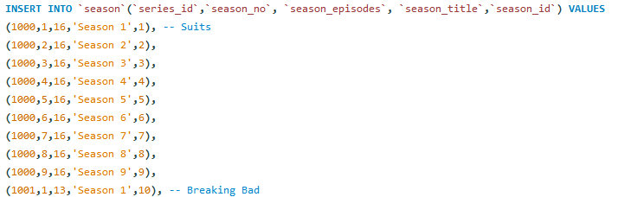

* **Πίνακας *series_inventory***

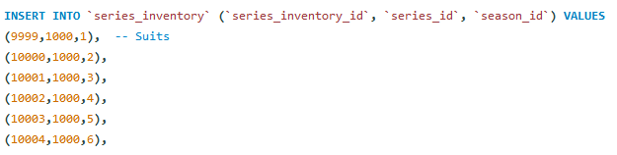

* **Πίνακας *employee***



* **Πίνακας *administrator***



* **Πίνακας *current_customer***



* **Πίνακας *current_employee***



* **Πίνακας *current_administrator***



*Αναθεωρημένοι Πίνακες*

* **Πίνακας *customer***

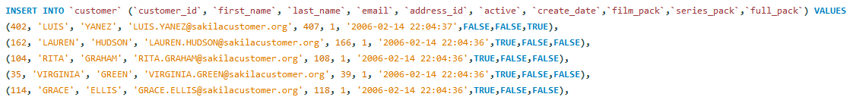

**\*Στην περίπτωση του customer με id = 402, για την ευκολία στην εξέταση της ορθότητας του πλήρους πακέτου εγγραφής θέσαμε ότι έχει εγγραφεί στο πλήρες πακέτο *full_pack*, ενώ για κάθε άλλο προ υπάρχοντά πελάτη θέσαμε ότι θα έχει εγγραφεί στο πακέτο ταινιών *film_pack*.**

* **Πίνακας *film_series_actor***

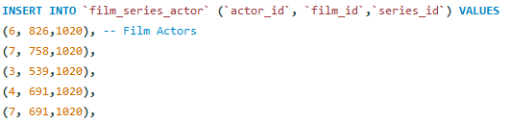

* **Πίνακας *film_series_category***

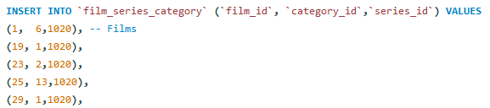

* **Πίνακας *rental***

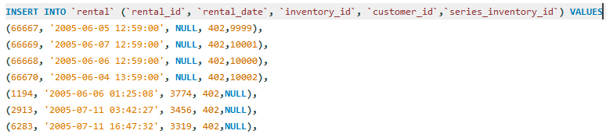

**ΚΕΦΑΛΑΙΟ 3**

Σε αυτό το κεφάλαιο, θα μιλήσουμε για τις stored procedures. Μας ανατέθηκε δημιουργία πέντε stored procedures, από τις οποίες στις δύο τελευταίες θα γίνει χρήση των ευρετηρίων. Παρακάτω, θα παραθέσουμε για κάθε ένα ερώτημα ξεχωριστά, στιγμιότυπα από τα αποτελέσματα κλήσεων των stored procedures, καθώς και στο τέλος του εκάστοτε ερωτήματος το κώδικα για το αντίστοιχο ερώτημα.

**3.1**

Στο **ερώτημα 3.1**, θα παραθέσουμε παραδείγματα κλήσης της πρώτης stored procedure.

Ειδικότερα στο πρώτο παράδειγμα ζητάμε από την procedure που δημιουργήσαμε να μας εμφανίσει τις **5 σειρές** με τα περισσότερα rentals μεταξύ ορισμένων **ημερομηνιών.**



Στην παραπάνω κλήση της συνάρτησης, οι δύο ημερομηνίες που θέσαμε είναι η **01-01-2007** και η δεύτερη είναι η **06-04-2007**. Ανάμεσα σε αυτές τις ημερομηνίες έγιναν οι ενοικιάσεις για τις σειρές που ενοικιάστηκαν περισσότερο, με φθίνουσα σειρά φαίνονται παρακάτω:

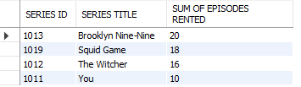

Παρατηρούμε πως παρόλο που θέσαμε να βρούμε τις 5 σειρές με τα περισσότερα rentals, ως αποτέλεσμα, ο αριθμός των σειρών που ενοικιάστηκε είναι τέσσερις στο συγκεκριμένο χρονικό διάστημα. Όπως μας ζητείται, τις ενοικιάσεις τις μετράμε σαν το άθροισμα των επεισοδίων, κάθε κύκλου, κάθε σειράς.

Σε ότι αφορά τις ταινίες και το δεύτερο παράδειγμα, ως αποτέλεσμα παίρνουμε τις **7 ταινίες με τις περισσότερες ενοικιάσεις** στο χρονικό διάστημα από **03-06-2005** έως **20-09-2005** που έχουμε ορίσει στην κλήση της :



Σαν αποτέλεσμα παίρνουμε τον παρακάτω πίνακα, κατά τον οποίο βλέπουμε τις 7 ταινίες που νοικιάστηκαν περισσότερο, αλλά και τον αριθμό των ενοικιάσεων της κάθε ταινίας :

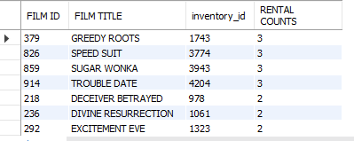

*Επομένως καλύψαμε όλα τα δυνατά σενάρια εκτέλεσης του ερωτήματος 3.1*

**Κώδικας της stored procedure 3.1**

--

-- PROCEDURE 3.1

--

DELIMITER $

CREATE PROCEDURE p(IN product ENUM('m','s'),IN count TINYINT, IN date_1 DATE, IN date_2 DATE)

BEGIN

DECLARE datetime_1 DATETIME;

DECLARE datetime_2 DATETIME;

DECLARE c_datetime DATETIME;

DECLARE date_add DATE;

SELECT CAST(date_1 AS DATETIME) AS 'START_TIME' INTO datetime_1;

SELECT CAST(date_2 AS DATETIME) AS 'TEMP' INTO c_datetime;

SELECT date_add(c_datetime, INTERVAL 1 DAY) AS 'DATE_ADD' INTO date_add; -- metatroph gia na upologizei oloklhrh thn mera tou deuterou orismatos

SELECT CAST(date_add AS DATETIME) AS 'END_TIME' INTO datetime_2;

IF(product = 'm') THEN -- if, gia tanies

SELECT film.film_id AS 'FILM ID' , film.title AS 'FILM TITLE', rental.inventory_id, count(rental.rental_id) AS 'RENTAL COUNTS'

FROM rental

INNER JOIN inventory ON rental.inventory_id = inventory.inventory_id

INNER JOIN film ON film.film_id = inventory.film_id

WHERE rental.rental_date >= datetime_1 AND rental.rental_date < datetime_2

GROUP BY rental.inventory_id

order by count(rental.rental_id) desc, film.film_id

LIMIT count;

ELSEIF(product = 's') THEN

-- if, gia seires

SELECT series.series_id AS 'SERIES ID' , series.title AS 'SERIES TITLE', sum(season.season_episodes) AS 'SUM OF EPISODES RENTED' -- season.season_episodes

FROM rental

INNER JOIN series_inventory ON rental.series_inventory_id = series_inventory.series_inventory_id

inner join season ON series_inventory.season_id = season.season_id

INNER JOIN series ON series.series_id = season.series_id

WHERE rental.rental_date >= datetime_1 AND rental.rental_date < datetime_2

GROUP BY series.series_id

ORDER BY sum(season.season_episodes) desc , series.series_id

LIMIT count;

END IF;

END$

DELIMITER ;

-- CALL p('s',5,'2007-01-01','2007-04-06');

-- CALL p('m',7,'2005-06-03','2005-09-20');

**3.2**

Για το **δεύτερο ερώτημα** θα παρουσιάσουμε τέσσερα παραδείγματα, της υλοποίησης του ζητούμενου stored procedure.

Στο πρώτο παράδειγμα εισάγουμε το email του χρήστη *LAUREN HUDSON* **(LAUREN.HUDSON@sakilacustomer.org)** και την ημερομηνία **06/06/2005** :



Το αποτέλεσμα αυτής της κλήσης είναι το ακόλουθο :



Ως αποτέλεσμα, παρατηρούμε ότι ο συγκεκριμένος χρήστης **δεν έχει κάνει κάποια ενοικίαση εκείνη την ημερομηνία** και βρίσκεται εκείνη τη στιγμή στο πακέτο **FILM PACK** .

Στο δεύτερο παράδειγμα εισάγουμε ξανά το email του χρήστη *LAUREN HUDSON* **(LAUREN.HUDSON@sakilacustomer.org)** και την ημερομηνία **31/07/2005** :



Το αποτέλεσμα αυτής της κλήσης είναι το ακόλουθο :

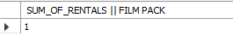

Ως αποτέλεσμα, παρατηρούμε ότι ο συγκεκριμένος χρήστης **έχει κάνει μία ενοικίαση εκείνη την ημερομηνία** και βρίσκεται εκείνη τη στιγμή στο πακέτο **FILM PACK**

Στο τρίτο παράδειγμα εισάγουμε το email του χρήστη *LUIS.YANEZ* **(LUIS.YANEZ@sakilacustomer.org)** και την ημερομηνία **06/06/2005** :



Το αποτέλεσμα αυτής της κλήσης είναι το ακόλουθο :

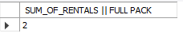

Ως αποτέλεσμα, παρατηρούμε ότι ο συγκεκριμένος χρήστης **έχει κάνει δύο ενοικιάσεις εκείνη την ημερομηνία** και βρίσκεται εκείνη τη στιγμή στο πακέτο **FULL PACK**

Στο τέταρτο παράδειγμα εισάγουμε το email του χρήστη ALEXANDROS.DIMITRIOU **(ALEXANDROS.DIMITRIOU@sakilacustomer.org)** και την ημερομηνία **01/01/2007** :



Το αποτέλεσμα αυτής της κλήσης είναι το ακόλουθο :

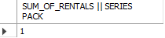

Ως αποτέλεσμα, παρατηρούμε ότι ο συγκεκριμένος χρήστης **έχει κάνει μία ενοικίαση εκείνη την ημερομηνία** και βρίσκεται εκείνη τη στιγμή στο πακέτο **SERIES PACK**

*Επομένως καλύψαμε όλα τα δυνατά σενάρια εκτέλεσης του ερωτήματος 3.2*

**Κώδικας της stored procedure 3.2**

--

-- PROCEDURE 3.2

--

DELIMITER $

CREATE PROCEDURE rental_count( IN c_email VARCHAR(50) , IN c_date DATE, OUT c_rentals TINYINT)

BEGIN

DECLARE c_film_pack BOOLEAN;

DECLARE c_series_pack BOOLEAN;

DECLARE c_full_pack BOOLEAN;

DECLARE x DATETIME;

DECLARE y DATETIME;

DECLARE DateAdd DATE;

DECLARE id smallint;

DECLARE film_rentals TINYINT;

DECLARE series_rentals TINYINT;

SELECT CAST(c_date AS DATETIME) AS 'START_TIME' INTO x;

SELECT date_add(x, INTERVAL 1 DAY) AS 'DATE_ADD' INTO DateAdd;

SELECT CAST(DateAdd AS DATETIME) AS 'END_TIME' INTO y;

SELECT customer_id INTO id FROM customer WHERE c_email = email;

SELECT film_pack INTO c_film_pack FROM customer WHERE id=customer_id;

SELECT series_pack INTO c_series_pack FROM customer WHERE id=customer_id;

SELECT full_pack INTO c_full_pack FROM customer WHERE id=customer_id;

IF(c_film_pack = TRUE) THEN -- Count rentals for Film Pack

SELECT count(rental.rental_id) INTO c_rentals

FROM rental

INNER JOIN customer ON customer.customer_id = rental.customer_id

WHERE customer.email = c_email AND rental.rental_date >= x AND rental.rental_date < y;

SELECT c_rentals AS 'SUM_OF_RENTALS || FILM PACK';

ELSEIF(c_series_pack = TRUE) THEN -- Count rentals for Series Pack

SELECT count(rental.rental_id) INTO c_rentals

FROM rental

INNER JOIN customer ON customer.customer_id = rental.customer_id

WHERE customer.email = c_email AND rental.rental_date >= x AND rental.rental_date < y;

SELECT c_rentals AS 'SUM_OF_RENTALS || SERIES PACK';

ELSEIF(c_full_pack = TRUE) THEN -- Count rentals for Full Pack

SELECT count(rental.rental_id) into series_rentals

FROM rental

INNER JOIN customer ON customer.customer_id = rental.customer_id

WHERE customer.email = c_email AND rental.rental_date >= x AND rental.rental_date < y AND rental.inventory_id IS NULL;

-- SELECT series_rentals;

SELECT count(rental.rental_id) into film_rentals

FROM rental

INNER JOIN customer ON customer.customer_id = rental.customer_id

WHERE customer.email = c_email AND rental.rental_date >= x AND rental.rental_date < y AND rental.series_inventory_id IS NULL;

-- SELECT film_rentals;

SELECT series_rentals + film_rentals INTO c_rentals;

SELECT c_rentals AS 'SUM_OF_RENTALS || FULL PACK' ;

END IF;

END$

DELIMITER ;

-- CALL rental_count('LAUREN.HUDSON@sakilacustomer.org','2005-06-06', @c_rentals);

-- CALL rental_count('LAUREN.HUDSON@sakilacustomer.org','2005-07-31', @c_rentals);

-- CALL rental_count('LUIS.YANEZ@sakilacustomer.org','2005-06-06', @c_rentals);

-- CALL rental_count('ALEXANDROS.DIMITRIOU@sakilacustomer.org','2007-01-01', @c_rentals);

**3.3**

Στο **ερώτημα 3.3** δημιουργήσαμε μια stored procedure που υπολογίζει τα έσοδα της επιχείρησης ανά μήνα. Παρακάτω παραθέτουμε κάποια από τα αποτελέσματα της κλήσης αυτής της procedure. Αξίζει να σημειωθεί ότι δεν χρειάζεται να εισάγουμε κάποια τιμή καθώς εκτυπώνεται απλώς το σύνολο των εσόδων για κάθε μήνα από την αρχή λειτουργίας της υπηρεσίας μας, μέχρι και την τελευταία ενοικίαση που πραγματοποιήθηκε.

Παρακάτω παρουσιάζουμε κάποια αποτελέσματα για το συνολικό ποσό που εισέπραξε η επιχείρηση κάποιους μήνες.

*Για σειρές :*

* **Για το μήνα Ιούλιο του 2005 έχουμε τα εξής έσοδα από σειρές :**

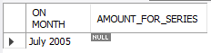

Παρατηρούμε πως δεν έχουμε κάποια έσοδα από σειρές αυτό το μήνα.

* **Για το μήνα Ιανουάριο του 2006 έχουμε τα εξής έσοδα από σειρές :**



Παρατηρούμε πως δεν έχουμε κάποια έσοδα από σειρές αυτό το μήνα

* **Για το μήνα Ιανουάριο του 2007 έχουμε τα εξής έσοδα από σειρές :**

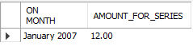

Παρατηρούμε πως υπάρχουν έσοδα από σειρές για τον μήνα Ιανουάριο του 2017 και φανερώνονται στο παραπάνω screenshot

*Για ταινίες :*

* **Για το μήνα Μάιο του 2005 έχουμε τα εξής έσοδα από ταινίες :**



Παρατηρούμε πως υπάρχουν έσοδα από ταινίες για τον μήνα Μάιο του 2005 και φανερώνονται στο παραπάνω screenshot

* **Για το μήνα Ιούλιο του 2005 έχουμε τα εξής έσοδα από ταινίες :**



Παρατηρούμε πως υπάρχουν έσοδα από ταινίες για τον μήνα Ιούλιο του 2005 και φανερώνονται στο παραπάνω screenshot

* **Για το μήνα Σεπτέμβριο του 2005 έχουμε τα εξής έσοδα από ταινίες :**



Παρατηρούμε πως δεν υπάρχουν έσοδα από ταινίες το συγκεκριμένο μήνα

*Επομένως καλύψαμε όλα τα δυνατά σενάρια εκτέλεσης του ερωτήματος 3.2*

**Κώδικας της stored procedure 3.3**

--

-- 3.3

--

DELIMITER $

CREATE PROCEDURE total_m()

BEGIN

DECLARE min_datetime datetime;

DECLARE max_datetime datetime;

DECLARE min_date date;

DECLARE max_date date;

DECLARE day_of_min TINYINT;

DECLARE day_of_max TINYINT;

DECLARE firstday_of_min_month DATE;

DECLARE firstday_of_max_month DATE;

DECLARE firstday_of_max_month_for_until DATE;

DECLARE month_repeat DATE;

DECLARE sum_amount DECIMAL(5,2);

DECLARE month_year VARCHAR(50);

DECLARE first_day_of_month DATE;

DECLARE first_day_of_next_month DATE;

SELECT min(payment_date) INTO min_datetime

FROM payment;

SELECT max(payment_date) INTO max_datetime

FROM payment;

SELECT CAST(min_datetime AS DATE) INTO min_date;

SELECT CAST(max_datetime AS DATE) INTO max_date;

SELECT DAY(min_date) INTO day_of_min;

SELECT DAY(max_date) INTO day_of_max;

SELECT DATE_ADD(min_date, INTERVAL (1-day_of_min) DAY) INTO firstday_of_min_month;

SELECT DATE_ADD(max_date, INTERVAL (1-day_of_max) DAY) INTO firstday_of_max_month;

SELECT DATE_ADD(firstday_of_max_month, INTERVAL 1 MONTH) INTO firstday_of_max_month_for_until;

SET month_repeat = firstday_of_min_month;

REPEAT -- REPEAT FOR SERIES

SET first_day_of_month = month_repeat;

SELECT DATE_ADD(first_day_of_month, INTERVAL 1 MONTH) INTO first_day_of_next_month;

SELECT DATE_FORMAT(month_repeat,'%M %Y') into month_year;

SELECT sum(payment.amount) as 'AMOUNT' into sum_amount

FROM payment

inner join rental ON rental.rental_id = payment.rental_id

where rental.inventory_id IS NULL AND first_day_of_month<=payment.payment_date AND payment.payment_date < first_day_of_next_month;

SELECT month_year AS 'ON MONTH', sum_amount AS 'AMOUNT_FOR_SERIES';

SELECT DATE_ADD(month_repeat, INTERVAL 1 MONTH) INTO month_repeat;

SET sum_amount = 0.00;

UNTIL(month_repeat=firstday_of_max_month_for_until)

END REPEAT;

SELECT DATE_ADD(min_date, INTERVAL (1-day_of_min) DAY) INTO firstday_of_min_month;

SELECT DATE_ADD(max_date, INTERVAL (1-day_of_max) DAY) INTO firstday_of_max_month;

SET month_repeat = firstday_of_min_month;

REPEAT -- REPEAT FOR FILMS

SET first_day_of_month = month_repeat;

SELECT DATE_ADD(first_day_of_month, INTERVAL 1 MONTH) INTO first_day_of_next_month;

SELECT DATE_FORMAT(month_repeat,'%M %Y') into month_year;

SELECT sum(payment.amount) as 'AMOUNT' into sum_amount

FROM payment

inner join rental ON rental.rental_id = payment.rental_id

where rental.series_inventory_id IS NULL AND first_day_of_month<=payment.payment_date AND payment.payment_date < first_day_of_next_month;

SELECT month_year AS 'ON MONTH', sum_amount AS 'AMOUNT_FOR_FILMS';

SELECT DATE_ADD(month_repeat, INTERVAL 1 MONTH) INTO month_repeat;

SET sum_amount = 0.00;

UNTIL(month_repeat=firstday_of_max_month_for_until)

END REPEAT;

END$

DELIMITER ;

CALL total_m();

**3.4**

Για το ερώτημα 3.4 και την αξιοποίηση του πίνακα **actor,** o οποίος διαθέτει δεκάδες χιλιάδες εγγραφές, γίνεται χρήση **ευρετηρίων** **(indexes)**, καθώς όταν πρόκειται για πολύ μεγάλο πλήθος εγγραφών, είναι πιο οικονομικό (σε ότι αφορά το χρόνο) και πιο εύκολο να αξιοποιηθεί το προαναφερθέν εργαλείο για να φτάσουμε σε μία εγγραφή. Για κάθε ένα ερώτημα (3.4α και 3.4β) γίνεται χρήση διαφορετικών τύπων indexes, και τον λόγο αυτό θα τον εξηγήσουμε κάτωθι σε καθένα υπό-ερώτημα.

***3.4α***

Για το **α) ερώτημα** χρησιμοποιούμε τον τύπο index με χρήση **BTREE**.

**Ειδικότερα, αξιοποιούμε τον συγκεκριμένο τύπο ευρετηρίου καθώς γίνονται συγκρίσεις με τους τελεστές *>=,>,<=,<* ή και του BETWEEN.**

Παρακάτω, θα παρουσιάσουμε δύο παραδείγματα από την κλήση της συγκεκριμένης stored procedure.

***Παράδειγμα 1 :***

Αν καλέσουμε την procedure 3_4_a με δεδομένα **‘BY’ και ‘CA’** (όπως βλέπουμε παρακάτω) :



έχουμε τα εξής αποτελέσματα :

* Αρχή πίνακα αποτελεσμάτων:

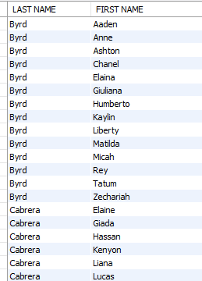

* Τέλος πίνακα αποτελεσμάτων :

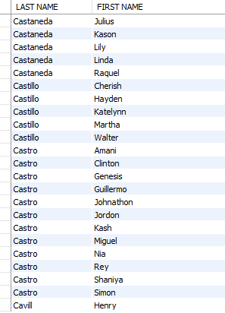

***Παράδειγμα 2 :***

Αν καλέσουμε την procedure 3_4_a με δεδομένα **‘AT’ και ‘AU’** (όπως βλέπουμε παρακάτω) :



έχουμε τα εξής αποτελέσματα :

* Αρχή πίνακα αποτελεσμάτων:

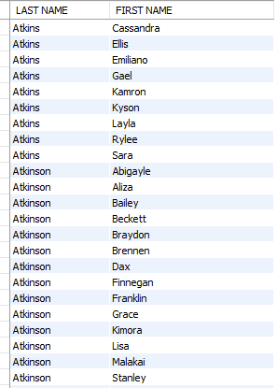

* Τέλος πίνακα αποτελεσμάτων :

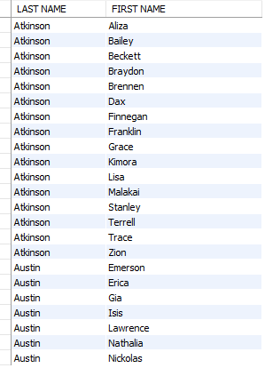

*Επομένως καλύψαμε όλα τα δυνατά σενάρια εκτέλεσης του ερωτήματος 3.4_A*

**Κώδικας της stored procedure 3.4_A**

--

-- 3.4_A

--

CREATE INDEX index_for_procedure_3_4a USING BTREE ON actor(last_name,first_name) ;

DELIMITER $

CREATE PROCEDURE pr_3_4_a(IN par_a VARCHAR(45), IN par_b VARCHAR(45))

BEGIN

DECLARE min_f_name VARCHAR(45);

DECLARE max_l_name VARCHAR(45);

-- DECLARE cnt_ int(6);

DECLARE last_name_procedure VARCHAR(45);

DECLARE actor_id_procedure SMALLINT;

SELECT last_name INTO last_name_procedure

FROM actor

WHERE actor_id_procedure = actor_id;

SELECT min(last_name) into min_f_name -- FIND MIN CHAR FROM PAR_A

from actor

WHERE last_name like Concat(par_a,'%')

order by last_name;

if(min_f_name IS NULL) THEN

SELECT LEFT(par_a, 1) into min_f_name;

SELECT CHAR(ASCII(min_f_name) + 1) into min_f_name;

END IF; -- END

SELECT max(last_name) into max_l_name -- FIND MAX CHAR FROM PAR_B

from actor

WHERE last_name like Concat(par_b,'%')

order by last_name;

SELECT min_f_name AS 'MINIMUM ALPHABETICAL NAME';

SELECT max_l_name AS 'MAXIMUM ALPHABETICAL NAME'; -- END

select count(*) AS 'NAMES FOUND'

FROM actor

WHERE last_name >= min_f_name AND last_name <= max_l_name;

SELECT last_name AS 'LAST NAME' ,first_name AS 'FIRST NAME'

FROM actor

WHERE last_name >= min_f_name AND last_name <= max_l_name

order by last_name, first_name;

END$

DELIMITER ;

-- call pr_3_4_a('BY', 'CA');

-- call pr_3_4_a('AT', 'AU');

***3.4β***

Για το **β) ερώτημα** χρησιμοποιούμε τον τύπο index με χρήση **HASH**.

**Ειδικότερα, αξιοποιούμε τον συγκεκριμένο τύπο ευρετηρίου καθώς γίνεται χρήση των τελεστών ισότητας ( = ) και ισοδυναμίας ( ⬄ )**

Για τη λύση του ερωτήματος, λόγω των ανωτέρω τελεστών που χρησιμοποιήσαμε, δημιουργήσαμε το ευρετήριο **« index_for_procedure_3_4b »**

Το ευρετήριο που κατασκευάσαμε έχει την εξής μορφή :

**CREATE INDEX index_for_procedure_3_4b USING HASH ON actor(last_name) ;**

Παρακάτω, θα παρουσιάσουμε τρία παραδείγματα από την κλήση της συγκεκριμένης stored procedure.

***Παράδειγμα 1 :***

Αν καλέσουμε την procedure 3_4_b με δεδομένα **‘Jordan’** (όπως βλέπουμε παρακάτω) :



έχουμε τα εξής αποτελέσματα :

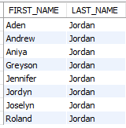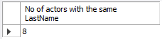

Παρατηρούμε δηλαδή, πως αν καλέσουμε την stored procedure 3_4_b με εισαχθείσα τιμή το επώνυμο **“ Jordan ”** έχουμε σαν αποτέλεσμα οκτώ (8) ονοματεπώνυμα που έχουν κοινό επώνυμο. Την συγκεκριμένη stored procedure την έχουμε δομήσει έτσι, ώστε να **εκτυπώνονται τα ονοματεπώνυμα με αύξουσα σειρά ονομάτων (order by first_name)**

***Παράδειγμα 2 :***

Αν καλέσουμε την procedure 3_4_b με δεδομένα **“ Gewrgiou ”** (όπως βλέπουμε παρακάτω) :



έχουμε τα εξής αποτελέσματα :

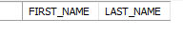

Παρατηρούμε δηλαδή, πως αν καλέσουμε την stored procedure 3_4_b με εισαχθείσα τιμή το επώνυμο **“ Gewrgiou ”** δεν θα εμφανιστούν ούτε ονόματα, ούτε και επώνυμα. Επιπρόσθετα αφού ο αριθμός των actor, που εμφανίζονται είναι μικρότερος του δύο (στην περίπτωσή μας μηδέν) δεν εξάγεται ο αριθμός (αντίθετα με το Παράδειγμα 1) των actor με το ίδιο επώνυμο.

***Παράδειγμα 3 :***

Αν καλέσουμε την procedure 3_4_b με δεδομένα **“ Gable ”** (όπως βλέπουμε παρακάτω) :



έχουμε τα εξής αποτελέσματα :

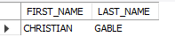

Παρατηρούμε δηλαδή, πως αν καλέσουμε την stored procedure 3_4_b με εισαχθείσα τιμή το επώνυμο **“ Gable ”** θα εμφανιστεί μία εγγραφή (ονοματεπώνυμο). Ακόμη αφού ο αριθμός των actor, που εμφανίζονται είναι μικρότερος του δύο (στην περίπτωσή μας ένας) δεν εξάγεται ο αριθμός (αντίθετα με το Παράδειγμα 1) των actor με το ίδιο επώνυμο.

*Επομένως καλύψαμε όλα τα δυνατά σενάρια εκτέλεσης του ερωτήματος 3.4_B*

**Κώδικας της stored procedure 3.4_Β**

--

-- 3.4_B

--

CREATE INDEX index_for USING HASH ON actor(last_name) ;

DELIMITER $

CREATE PROCEDURE pr_3_4_b(IN given_lst_nm VARCHAR(45))

BEGIN

DECLARE first_name_procedure VARCHAR(45);

DECLARE last_name_procedure VARCHAR(45);

declare find_count_of_first_names_char VARCHAR(45);

DECLARE actor_id_procedure SMALLINT;

DECLARE count_names TINYINT;

SELECT first_name,last_name INTO last_name_procedure, first_name_procedure

FROM actor

WHERE actor_id_procedure = actor_id;

SELECT first_name AS 'FIRST_NAME' , last_name AS 'LAST_NAME'

FROM actor

WHERE last_name = given_lst_nm

GROUP BY first_name

order by count(first_name) desc, first_name;

SELECT count(*) INTO count_names

FROM actor

WHERE last_name = given_lst_nm;

if

count_names>1

then

SELECT count_names AS 'No of actors with the same LastName';

END IF;

END$

DELIMITER ;

-- CALL pr_3_4_b('Jordan');

-- CALL pr_3_4_b('Gewrgiou');

-- CALL pr_3_4_b('Gable');

**ΚΕΦΑΛΑΙΟ 4**

Σε αυτό το κεφάλαιο, θα μιλήσουμε για τα triggers. Μας ανατέθηκε δημιουργία τριών triggers. Όπως είναι γνωστό από τη θεωρία, μπορούν να πυροδοτηθούν το πολύ έξι διαφορετικών ειδών triggers για κάθε πίνακα ***(AFTER | BEFORE INSERT/UPDATE/DELETE)***. Παρακάτω παρουσιάζουμε τις λύσεις για τα τρία ερωτήματα που μας ανατέθηκαν μέσω screenshots καθώς και τον κώδικα για κάθε ερώτημα ξεχωριστά.

**4.1**

Για το **ερώτημα 4.1** κατασκευάζουμε έναν **πίνακα καταγραφής ενεργειών (log table)**, ο οποίος, χάρη σε **triggers**, θα καταγράφει αν πραγματοποιείται **εισαγωγή (insert) , διαγραφή (delete) και ενημέρωση (update)**, την **ημερομηνία** και **ώρα** που πραγματοποιήθηκε αυτό το γεγονός, αλλά και σε ποιόν **πίνακα** έγινε η ενέργεια **(rental, payment)**. Παρακάτω, παρουσιάζουμε κάποια παραδείγματα από την χρήση των trigger που όταν πυροδοτούνται εισάγουν δεδομένα στον πίνακα ενεργειών.

*Παράδειγμα 1 :*

Αν πραγματοποιηθεί κάποια **νέα ενοικίαση, δηλαδή έχουμε ένα insert** στον πίνακα **rental** όπως παρακάτω :



**πυροδοτείται** το trigger με ονομασία **for_insert_rental** και το αποτέλεσμα στο **log table** είναι το εξής :



*Παράδειγμα 2 :*

Αν πραγματοποιηθεί κάποια **νέα πληρωμή, δηλαδή έχουμε ένα insert** στον πίνακα **payment** όπως παρακάτω :



**πυροδοτείται** το trigger με ονομασία **for_insert_payment** και το αποτέλεσμα στο **log table** είναι το εξής :

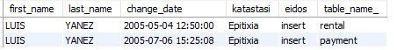

Παρατηρούμε πως ο πίνακας log_table ανανεώθηκε, και προστέθηκε μία νέα εγγραφή που παρουσιάζει ότι **πραγματοποιήθηκε κάποια πληρωμή**, την ημερομηνία που έγινε αυτή αλλά και το ονοματεπώνυμο του πελάτη.

*Παράδειγμα 3 :*

Αν πραγματοποιηθεί κάποια **αλλαγή** σε μία προ υπάρχουσα **πληρωμή, δηλαδή έχουμε ένα update** στον πίνακα **payment** όπως παρακάτω :



**πυροδοτείται** το trigger με ονομασία **for_update_payment** και το αποτέλεσμα στο **log table** είναι το εξής :

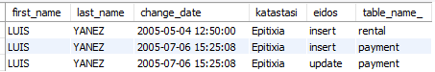

Παρατηρούμε πως ο πίνακας log_table ανανεώθηκε, και προστέθηκε μία νέα εγγραφή που παρουσιάζει ότι έγινε κάποια **αλλαγή στον πίνακα payment** και το όνομα του χρήστη που αφορά την συγκεκριμένη πληρωμή .

*Παράδειγμα 4 :*

Αν πραγματοποιηθεί κάποια **διαγραφή** σε μία προ υπάρχουσα **ενοικίαση, δηλαδή έχουμε ένα delete** στον πίνακα **rental** όπως παρακάτω :

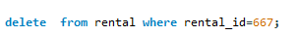

**πυροδοτείται** το trigger με ονομασία **for_delete_rental** και το αποτέλεσμα στο **log table** είναι το εξής :

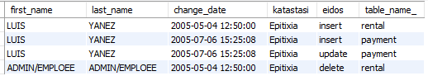

Παρατηρούμε πως ο πίνακας log_table ανανεώθηκε, και προστέθηκε μία νέα εγγραφή που παρουσιάζει ότι έγινε κάποια **διαγραφή** στον πίνακα **rental** από έναν **admin** ή έναν **employee** της πλατφόρμας .

**Κώδικας για trigger 4.1**

--

-- 4.1

--

DELIMITER $

CREATE TRIGGER for_insert_rental -- insert_rental

AFTER INSERT ON rental

FOR EACH ROW

BEGIN

declare fn VARCHAR(45);

declare ln VARCHAR(45);

select first_name into fn

from customer

inner join rental on customer.customer_id = rental.customer_id

where rental.rental_id = new.rental_id;

select last_name into ln

from customer

inner join rental on customer.customer_id = rental.customer_id

where rental.rental_id = new.rental_id;

INSERT INTO log_table(first_name,last_name,change_date,katastasi,eidos,table_name_)

values (fn,ln,NEW.rental_date,'Epitixia','insert','rental');

END$

delimiter ;

DELIMITER $

CREATE TRIGGER for_update_rental -- update_rental

AFTER UPDATE ON rental

FOR EACH ROW

BEGIN

declare fn VARCHAR(45);

declare ln VARCHAR(45);

select first_name into fn

from customer

inner join rental on customer.customer_id = rental.customer_id

where rental.rental_id = new.rental_id;

select last_name into ln

from customer

inner join rental on customer.customer_id = rental.customer_id

where rental.rental_id = new.rental_id;

INSERT INTO log_table(first_name,last_name,change_date,katastasi,eidos,table_name_)

values (fn,ln,NEW.rental_date,'Epitixia','update','rental');

END$

delimiter ;

DELIMITER $

CREATE TRIGGER for_delete_rental -- delete_rental

AFTER DELETE ON rental

FOR EACH ROW

BEGIN

declare fn VARCHAR(45);

declare ln VARCHAR(45);

select first_name into fn

from customer

inner join rental on customer.customer_id = rental.customer_id

where rental.rental_id = old.rental_id;

select last_name into ln

from customer

inner join rental on customer.customer_id = rental.customer_id

where rental.rental_id = old.rental_id;

INSERT INTO log_table(first_name,last_name,change_date,katastasi,eidos,table_name_)

values ('ADMIN/EMPLOEE','ADMIN/EMPLOEE',old.rental_date,'Epitixia','delete','rental');

END$

delimiter ;

DELIMITER $

CREATE TRIGGER for_insert_payment -- insert_payment

AFTER INSERT ON payment

FOR EACH ROW

BEGIN

declare fn VARCHAR(45);

declare ln VARCHAR(45);

select first_name into fn

from customer

inner join payment on customer.customer_id = payment.customer_id

where payment.payment_id = new.payment_id;

select last_name into ln

from customer

inner join payment on customer.customer_id = payment.customer_id

where payment.payment_id = new.payment_id;

INSERT INTO log_table(first_name,last_name,change_date,katastasi,eidos,table_name_)

values (fn,ln,NEW.payment_date,'Epitixia','insert','payment');

END$

delimiter ;

DELIMITER $

CREATE TRIGGER for_update_payment -- update_payment

AFTER UPDATE ON payment

FOR EACH ROW

BEGIN

declare fn VARCHAR(45);

declare ln VARCHAR(45);

select first_name into fn

from customer

inner join payment on customer.customer_id = payment.customer_id

where payment.payment_id = new.payment_id;

select last_name into ln

from customer

inner join payment on customer.customer_id = payment.customer_id

where payment.payment_id = new.payment_id;

INSERT INTO log_table(first_name,last_name,change_date,katastasi,eidos,table_name_)

values (fn,ln,NEW.payment_date,'Epitixia','update','payment');

END$

delimiter ;

DELIMITER $

CREATE TRIGGER for_delete_payment -- delete_payment

AFTER DELETE ON payment

FOR EACH ROW

BEGIN

declare fn VARCHAR(45);

declare ln VARCHAR(45);

select first_name into fn

from customer

inner join payment on customer.customer_id = payment.customer_id

where payment.payment_id = old.payment_id;

select last_name into ln

from customer

inner join payment on customer.customer_id = payment.customer_id

where payment.payment_id = old.payment_id;

INSERT INTO log_table(first_name,last_name,change_date,katastasi,eidos,table_name_)

values ('ADMIN/EMPLOYEE','ADMIN/EMPLOYEE',old.payment_date,'Epitixia','delete','payment');

END$

delimiter ;

-- INSERT INTO `rental` (`rental_id`, `rental_date`, `inventory_id`, `customer_id`,`series_inventory_id`)

-- VALUES(667, '2005-05-04 12:50:00', 3774, 402,null);

-- INSERT INTO `payment` (`payment_id`, `customer_id`, `rental_id`, `amount`, `payment_date`) VALUES

-- (663, 402, 667, '0.99', '2005-07-06 15:25:08');

-- INSERT INTO `rental` (`rental_id`, `rental_date`, `inventory_id`, `customer_id`,`series_inventory_id`)

-- VALUES(668, '2005-03-04 12:50:00', 3774, 162,null);

-- INSERT INTO `payment` (`payment_id`, `customer_id`, `rental_id`, `amount`, `payment_date`) VALUES

-- (664, 162, 668, '0.99', '2005-03-06 15:25:08');

-- update payment set amount = 2.0 where payment_id=663;

-- update rental set inventory_id = 187 where rental_id=668;

-- delete from rental where rental_id=667;

-- SELECT * FROM log_table;

**4.2**

Για το **ερώτημα 4.2**, υλοποιήσαμε έναν trigger, ο οποίος, θα διαβάζει τα rentals που πραγματοποιεί ένας πελάτης. Στην περίπτωση που ο πελάτης έχει προβεί σε τουλάχιστον τρεις ενοικιάσεις την ίδια μέρα, τότε χάρη στον trigger που δημιουργήσαμε, ο πελάτης δικαιούται έκπτωση 50% για τις επόμενες αγορές εντός της ημέρας. **Αξίζει να αναφερθεί, ότι για την επίλυση του ερωτήματος, αξιοποιήσαμε το ερώτημα 3.2, το οποίο το τροποποιήσαμε κατάλληλα.** Ειδικότερα, προσθέσαμε τον πίνακα **c**, που περιέχει μία μεταβλητή ***c_rentals*** (τύπου tinyint) την οποία την αξιοποιούμε για να μετράμε τις συνολικές ενοικιάσεις του πελάτη σε ένα μήνα, ενημερώνοντας τη συνεχώς με τις κατάλληλες τιμές (update).

Παρακάτω θα παραθέσουμε κάποια παραδείγματα από την πυροδότηση του trigger μας :

*Παράδειγμα 1 :*

Θεωρούμε ότι τον πελάτη “ Alexandros Dimitriou ” με customer_id = 600. Εκτελώντας τις εντολές :



και



Παρατηρούμε ότι ο χρήστης αυτός, δεν έχει κάνει μία ενοικίαση, την ημερομηνία :



Και έχουμε το εξής αποτέλεσμα :

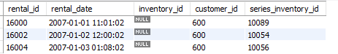

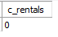

Το c_rentals = 0 φανερώνει ότι δεν έχει γίνει καμία ενοικίαση για την προαναφερθείσα ημερομηνία **(από τον νέο πίνακα c που δημιουργήσαμε για τις ανάγκες του ερωτήματος)**, ενώ ο πιο πάνω πίνακας φανερώνει τα rentals που έχει κάνει ο συγκεκριμένος πελάτης.

Όταν, ο πελάτης αυτός προχωρήσει σε μία νέα ενοικίαση **(πρώτη)** :



Το c_rentals γίνεται 1 καθώς πραγματοποιείται την ίδια ημερομηνία (2007-01-04) :

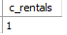

αντίστοιχα στον πίνακα που φαίνονται τα rentals του πελάτη εισάγεται μια νέα εγγραφή με **rental_id = 66671** :

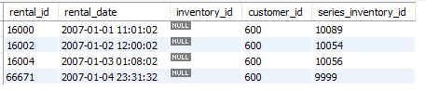

Όταν πραγματοποιηθεί και **δεύτερη ενοικίαση** την ίδια μέρα :



το c_rentals γίνεται 2 καθώς πραγματοποιείται την ίδια ημερομηνία (2007-01-04) :

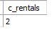

αντίστοιχα στον πίνακα που φαίνονται τα rentals του πελάτη εισάγεται μια νέα εγγραφή με **rental_id = 66672** :

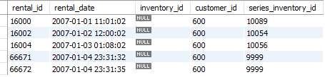

Όταν πραγματοποιηθεί και **τρίτη ενοικίαση** την ίδια μέρα :



το c_rentals γίνεται 3 καθώς πραγματοποιείται την ίδια ημερομηνία (2007-01-04) :

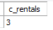

αντίστοιχα στον πίνακα που φαίνονται τα rentals του πελάτη εισάγεται μια νέα εγγραφή με **rental_id = 66673** :

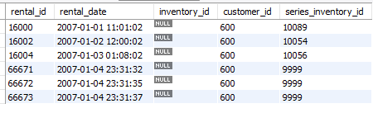

Και το payment γίνεται :

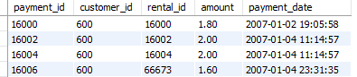

Παρατηρούμε, ότι το αποτέλεσμα (amount) είναι σωστό, καθώς η σειρά με **series_inventory_id το 9999** τη πρώτη season της **σειράς Suits**, με **16 επεισόδια**. Άρα στην πράξη, αφού **κάθε επεισόδιο κοστίζει στον πελάτη 0.2 ευρώ υπό κανονικές συνθήκες**, ωστόσο **με την έκπτωση, το κάθε επεισόδιο κοστίζει 0.1 ευρώ** και το **τελικό ποσό πληρωμής είναι 0.1(τιμή έκπτωσης)*16(επεισόδια) = 1.6 ευρώ,** κάτι που επαληθεύεται και από τον άνωθεν πίνακα.

**Κώδικας για trigger 4.2**

create table c(c_rentals TINYINT);

insert into c values(0);

DELIMITER $

CREATE PROCEDURE rental_count( IN c_email VARCHAR(50) , IN c_date DATE)

BEGIN

DECLARE c_film_pack BOOLEAN;

DECLARE c_series_pack BOOLEAN;

DECLARE c_full_pack BOOLEAN;

DECLARE x DATETIME;

DECLARE y DATETIME;

DECLARE DateAdd DATE;

declare c_rental tinyint;

DECLARE id smallint;

DECLARE film_rentals TINYINT;

DECLARE series_rentals TINYINT;

SELECT CAST(c_date AS DATETIME) AS 'START_TIME' INTO x;

SELECT date_add(x, INTERVAL 1 DAY) AS 'DATE_ADD' INTO DateAdd;

SELECT CAST(DateAdd AS DATETIME) AS 'END_TIME' INTO y;

SELECT customer_id INTO id FROM customer WHERE c_email = email;

SELECT film_pack INTO c_film_pack FROM customer WHERE id=customer_id;

SELECT series_pack INTO c_series_pack FROM customer WHERE id=customer_id;

SELECT full_pack INTO c_full_pack FROM customer WHERE id=customer_id;

IF(c_film_pack = TRUE) THEN -- Count rentals for Film Pack

SELECT count(rental.rental_id) into c_rental

FROM rental

INNER JOIN customer ON customer.customer_id = rental.customer_id

WHERE customer.email = c_email AND rental.rental_date >= x AND rental.rental_date < y;

update c set c_rentals = c_rental;

ELSEIF(c_series_pack = TRUE) THEN -- Count rentals for Series Pack

SELECT count(rental.rental_id) into c_rental

FROM rental

INNER JOIN customer ON customer.customer_id = rental.customer_id

WHERE customer.email = c_email AND rental.rental_date >= x AND rental.rental_date < y;

update c set c_rentals = c_rental;

ELSEIF(c_full_pack = TRUE) THEN -- Count rentals for Full Pack

SELECT count(rental.rental_id) into series_rentals

FROM rental

INNER JOIN customer ON customer.customer_id = rental.customer_id

WHERE customer.email = c_email AND rental.rental_date >= x AND rental.rental_date < y AND rental.inventory_id IS NULL;

-- SELECT series_rentals;

SELECT count(rental.rental_id) into film_rentals

FROM rental

INNER JOIN customer ON customer.customer_id = rental.customer_id

WHERE customer.email = c_email AND rental.rental_date >= x AND rental.rental_date < y AND rental.series_inventory_id IS NULL;

-- SELECT film_rentals;

SELECT (series_rentals + film_rentals) into c_rental;

update c set c_rentals = c_rental;

END IF;

END$

DELIMITER ;

-- CALL rental_count('LAUREN.HUDSON@sakilacustomer.org','2005-06-06');

-- CALL rental_count('LAUREN.HUDSON@sakilacustomer.org','2005-07-31');

-- CALL rental_count('LUIS.YANEZ@sakilacustomer.org','2005-06-06');

-- CALL rental_count('ALEXANDROS.DIMITRIOU@sakilacustomer.org','2007-01-01');

-- CALL rental_count('ALEXANDROS.DIMITRIOU@sakilacustomer.org','2007-01-01');

--

-- Trigger 4.2

--

DELIMITER $

CREATE TRIGGER t_4_2

AFTER INSERT ON rental

FOR EACH ROW

BEGIN

DECLARE c_rentalss TINYINT;

DECLARE c_email VARCHAR(50);

DECLARE r_d DATETIME;

declare film boolean;

declare series boolean;

declare full boolean;

declare cust_id tinyint;

declare sum_of_ep tinyint;

select film_pack,series_pack,full_pack into film,series,full from customer

where customer_id = new.customer_id;

if(film=true) then -- for film pack

SELECT email into c_email

from customer

inner join rental ON rental.customer_id = customer.customer_id

where New.rental_date = rental_date;

CALL rental_count(c_email,New.rental_date);

select c_rentals from c into c_rentalss;

update c set c_rentals = c_rentalss;

if(c_rentalss>=3) then

INSERT INTO `payment` (`payment_id`, `customer_id`, `rental_id`, `amount`, `payment_date`) VALUES

(NULL, new.customer_id, new.rental_id, 0.2, '2005-07-31 11:31:32');

end if;

end if;

if(series=true) then -- for series pack

SELECT email into c_email

from customer

inner join rental ON rental.customer_id = customer.customer_id

where New.rental_date = rental_date;

CALL rental_count(c_email,New.rental_date);

select c_rentals from c into c_rentalss;

update c set c_rentals = c_rentalss;

SELECT season.season_episodes into sum_of_ep

FROM season

INNER JOIN series_inventory ON series_inventory.season_id = season.season_id

inner join rental on rental.series_inventory_id = series_inventory.series_inventory_id

where rental.customer_id = new.customer_id

order by rental.rental_date desc

limit 1;

if(c_rentalss>=3) then

INSERT INTO `payment` (`payment_id`, `customer_id`, `rental_id`, `amount`, `payment_date`) VALUES

(NULL, new.customer_id, new.rental_id, (sum_of_ep*0.2)/2 , '2007-01-04 23:51:02');

end if;

end if;

if(full=true) then -- for full pack

SELECT email into c_email

from customer

inner join rental ON rental.customer_id = customer.customer_id

where New.rental_date = rental_date;

CALL rental_count(c_email,New.rental_date);

select c_rentals from c into c_rentalss;

update c set c_rentals = c_rentalss;

SELECT season.season_episodes into sum_of_ep

FROM season

INNER JOIN series_inventory ON series_inventory.season_id = season.season_id

inner join rental on rental.series_inventory_id = series_inventory.series_inventory_id

where rental.customer_id = new.customer_id

order by rental.rental_date desc

limit 1;

if(c_rentalss>=3) then

INSERT INTO `payment` (`payment_id`, `customer_id`, `rental_id`, `amount`, `payment_date`) VALUES

(NULL, new.customer_id, new.rental_id, (sum_of_ep*0.1 +0.3)/2 , '2007-01-04 23:51:02'); -- 0.1 for episodes kai 0.3 for films

end if;

end if;

end $

-- INSERT INTO `rental` (`rental_id`, `rental_date`, `inventory_id`, `customer_id`,`series_inventory_id`) VALUES

-- (null, '2007-01-04 23:31:32', null, 600,9999),

-- (null, '2007-01-04 23:31:35', null, 600,9999),

-- (null, '2007-01-04 23:31:37', null, 600,9999);

-- select * from c;

-- select * from rental where customer_id = 600;

-- select * from payment where customer_id = 600;

**4.3**

Για το ερώτημα 4.3 δημιουργήσαμε έναν trigger, ο οποίος αποτρέπει έναν πελάτη από το να αλλάξει το email του.

Παρακάτω παρουσιάζουμε δύο παραδείγματα πυροδότησης του trigger :

*Παράδειγμα 1 :*

Αν επιχειρήσουμε το παρακάτω update :

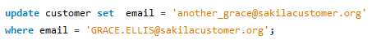

σαν output (έξοδο) θα λάβουμε το εξής μήνυμα :



Αυτό σημαίνει ότι αν επιχειρήσει ένας πελάτης να αλλάξει το email του, ο trigger που δημιουργήσαμε θα του εμφανίσει το μήνυμα **“ YOU CANNOT CHANGE TOUR EMAIL ADDRESS ”**, και η αλλαγή δεν θα πραγματοποιηθεί.

Έτσι αν εκτελέσουμε την εντολή :



θα λάβουμε το εξής αποτέλεσμα :



που μας οδηγεί στο συμπέρασμα ότι το email του συγκεκριμένου πελάτη δεν άλλαξε, αλλά παρέμεινε το ίδιο αποδεικνύοντας την ορθή λειτουργία του trigger .

Ένα ακόμα παράδειγμα παρουσιάζουμε παρακάτω

*Παράδειγμα 2 :*

Αν επιχειρήσουμε το παρακάτω update :

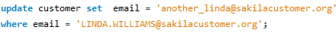

σαν output (έξοδο) θα λάβουμε το εξής μήνυμα :



Αυτό σημαίνει ότι αν επιχειρήσει ένας πελάτης να αλλάξει το email του, ο trigger που δημιουργήσαμε θα του εμφανίσει το μήνυμα **“ YOU CANNOT CHANGE TOUR EMAIL ADDRESS ”**, και η αλλαγή δεν θα πραγματοποιηθεί.

Έτσι αν εκτελέσουμε την εντολή :



θα λάβουμε το εξής αποτέλεσμα :



που μας οδηγεί στο συμπέρασμα ότι το email του συγκεκριμένου πελάτη δεν άλλαξε, αλλά παρέμεινε το ίδιο αποδεικνύοντας την ορθή λειτουργία του trigger .

**Κώδικας για trigger 4.3**

--

-- TRIGGER 4.3

--

DELIMITER $

CREATE TRIGGER er4_3

BEFORE UPDATE ON customer

FOR EACH ROW

BEGIN

IF NEW.email<>OLD.email THEN

SET NEW.email=OLD.email;

SIGNAL SQLSTATE VALUE '45000'

SET MESSAGE_TEXT = 'YOU CANNOT CHANGE YOUR EMAIL ADDRESS';

END IF;

END$

DELIMITER ;

-- update customer set email = 'another_grace@sakilacustomer.org'

-- where email = 'GRACE.ELLIS@sakilacustomer.org';

-- update customer set email = 'another_linda@sakilacustomer.org'

-- where email = 'LINDA.WILLIAMS@sakilacustomer.org';

-- select * from customer where email = 'GRACE.ELLIS@sakilacustomer.org';

-- select * from customer where email = 'LINDA.WILLIAMS@sakilacustomer.org';

**ΚΕΦΑΛΑΙΟ 5**

***Γενικά***

Για την δημιουργία του GUI της εφαρμογής μας αξιοποιήσαμε τα εξής εργαλεία:

* ***Java jdk 17.0.1*** ως τη βασική γλώσσα προγραμματισμού
* ***JavaFX 17.0.1*** για την δημιουργία του βασικού UI
* ***CSS*** για την δημιουργία ενός πιο όμορφου σώματος για τους πίνακές μας
* ***mysql-connector-java-8.0.27*** για την σύνδεση με την βάση δεδομένων μας
* ***NetBeans IDE 12.6*** για τη σύνθεση κώδικα σε java
* ***SceneBuilder*** για τη πιο εύκολη δημιουργία και επεξεργασία των fxml αρχείων

Βασικοί στόχοι κατά την δημιουργία του GUI ήταν αφενός η επίτευξη της καλύτερης δυνατής εμπειρίας για τον χρήστη (μέσω του περιορισμού εισαγωγής δεδομένων όπου αυτό δεν ήταν απαραίτητο αλλά και την ύπαρξη ορισμένων animation για πιο ομαλές μεταβάσεις μεταξύ των fxml αρχείων) και αφετέρου η ορθή λειτουργία του προγράμματος και αξιοποίηση των δεδομένων της βάσης μας για τις ανάγκες του κάθε ερωτήματος.

***Παρακάτω αναλύονται ορισμένες γενικές λειτουργίες που χρησιμοποιήθηκαν για την δημιουργία του GUI***

***Λειτουργία εισαγωγής δεδομένων στους πίνακες της εφαρμογής***

Έπειτα την λήψη των ορθών δεδομένων για κάθε πίνακα από την βάση δεδομένων καθίσταται αναγκαία η αποθήκευσή τους σε ορισμένους πίνακες για την αξιοποίησή τους από τον εκάστοτε χρήστη.

Αρχικά, δημιουργούμε μια νέα κλάση στην java στην οποία ορίζουμε τόσες μεταβλητές όσες θα είναι και οι στήλες στον πίνακά μας. Βάσει αυτών δημιουργούμε έναν **constructor** (που περιέχει όλες τις παραπάνω μεταβλητές) καθώς και μια μέθοδο **get** και **set** για εκάστη μεταβλητή. Στην κλάση τώρα που έχουμε ορίσει τον πίνακα μας, εκχωρούμε σαν όρισμα στον πίνακα την προηγούμενη κλάση και το ίδιο κάνουμε και για κάθε στήλη ξεχωριστά μόνο που εδώ εκχωρούμε επιπλέον και τον τύπο της μεταβλητής που θα αποθηκεύεται στην συγκεκριμένη στήλη(***string***,***int*** κτλ.). Έπειτα προχωράμε στην δημιουργία μιας observable λίστας η οποία παίρνει και αυτή σαν όρισμα την παραπάνω κλάση. Σκοπός της δημιουργίας της προαναφερθείσας κλάσης είναι η αποφυγή χρήσης πολλαπλών observable λιστών ενώ με την δημιουργία της παραπάνω κλάσης όλα τα στοιχεία του πίνακα μπορούν να αποθηκευτούν σε αυτή τη λίστα. Σε αντίθετη περίπτωση θα έπρεπε για κάθε στήλη του πίνακά μας να δημιουργούμε και μια καινούργια observable λίστα κάτι το οποίο -ειδικά σε πίνακες με μεγάλο αριθμό στηλών- δεν είναι επιθυμητό.

Π.χ. Έστω ο πίνακας **table** με τις στήλες ***col_1*** και ***col_2***. Έστω ακόμα η κλάση **Table.java** η οποία θα χρησιμοποιηθεί για την λήψη των στοιχείων από την βάση και την αποθήκευση τους σε μία observable λίστα **obs** μέσω της δημιουργίας ενός **Table** στιγμιότυπου.

Η αρχικοποίηση των παραπάνω έχει ως εξής:

***private TableView<Table.java> table;***

***private TableColumn< Table.java,String> col_1;***

***private TableColumn< Table.java,String> col_2;***

***ObservableList<Table> obs = FXCollections.observableArrayList();***

***…***

***while(rs.next()){***

***obs.add(new Table(rs.getString("dedomena1"),rs.getString("dedomena2") }***

***…***

***col_1.setCellValueFactory(new PropertyValueFactory<>(" data1"));***

***col_2.setCellValueFactory(new PropertyValueFactory<>(" data2"));***

***table.setItems(obs);***

όπου ***rs*** το **ResultSet** μέσω του οποίου αποκτούμε πρόσβαση στα στοιχεία της βάσης που επιθυμούμε να αποκτήσουμε , ***dedomena1,2*** η ονομασία των μεταβλητών στη βάση και ***data1,2*** η ονομασία των μεταβλητών όπως τις έχουμε ορίσει στην κλάση **Table**.

***Λειτουργία εισαγωγής δεδομένων στα ComboBox της εφαρμογής***

Σε περιπτώσεις στις οποίες καλείται ο χρήστης να επιλέξει μεταξύ ενός περιορισμένου αριθμού επιλογών(πχ πόλεις, βαθμολογία εργαζομένου κλπ.) θεωρείται αναγκαία η χρήση **ComboBox** για την καλύτερη δυνατή εμπειρία του χρήστη.

Για την εισαγωγή τιμών στο **ComboBox** χρησιμοποιούμε και πάλι μια observable λίστα στην οποία βάζουμε τις προκαθορισμένες μας τιμές αφού τις λάβουμε από την βάση μέσω ενός **ResultSet**.

***Λειτουργία search bar της εφαρμογής***

Σε πίνακες στους οποίους έχει εισαχθεί πλήθος δεδομένων η αναζήτηση ενός στοιχείου μεταξύ όλων των άλλων καθίσταται πολύ δύσκολή έως και ακατόρθωτη ειδικά σε περιπτώσεις που το πλήθος των στοιχείων αγγίζει ή ακόμη περνάει τις εκατοντάδες. Για αυτόν τον λόγο δημιουργήσαμε την επιλογή να μπορεί ο χρήστης να αναζητήσει το στοιχείο το οποίο επιθυμεί μέσω ενός ***search bar***.

Για την δημιουργία του συγκεκριμένου εργαλείου αναζήτησης χρησιμοποιήσαμε ένα **TextField** στο οποίο πληκτρολογεί ο χρήστης το στοιχείο το οποίο θέλει να αναζητήσει, την observable λίστα στην οποία είναι αποθηκευμένα τα στοιχεία του πίνακα (***ObservableList<Table> obs = FXCollections.observableArrayList();***), ένα observable list στο οποίο θα αποθηκεύονται τα αποτελέσματα της αναζήτησης καθώς και η δημιουργία ενός αντικειμένου της κλάσης **Table** ώστε να μπορούμε να εφαρμόσουμε πάνω του τις μεθόδους ***get*** και ***set*** για κάθε στήλη. Επομένως η αναζήτηση θα είναι δυνατή για κάθε στήλη του πίνακά μας καθιστώντας το περιβάλλον ακόμα πιο φιλικό στον χρήστη καθώς δεν περιορίζει την αναζήτησή του μόνο σε ένα στοιχείο, που ίσως και να μην θυμάται, αλλά σε όλα τα δυνατά στοιχεία του πίνακα. Επιπλέον λειτουργία του άνωθεν μπορεί να είναι και η εμφάνιση των αποτελεσμάτων τα οποία ανήκουν σε μια ειδική κατηγορία όπως όλες οι ταινίες που είναι κωμωδίες ή όλοι οι customer που μένουν στην ίδια πόλη κοκ.

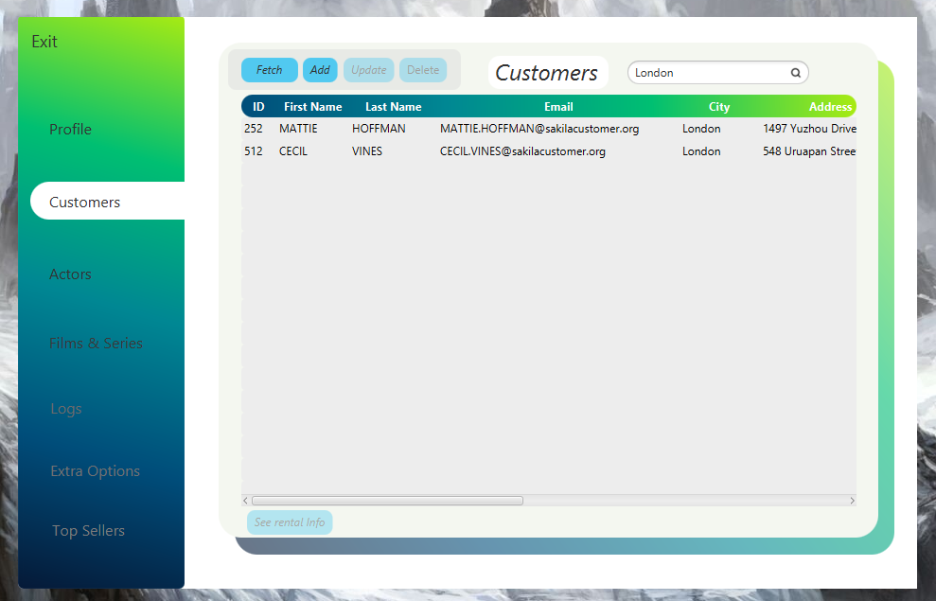

***Δημιουργία Εφαρμογής***

Πριν την έναρξη της υλοποίησης της εφαρμογής δημιουργήσαμε ένα προσχέδιο στο οποίο και βασιστήκαμε που περιγράφει περιληπτικά ολόκληρη την λειτουργία του προγράμματος το οποίο παρουσιάζεται παρακάτω:

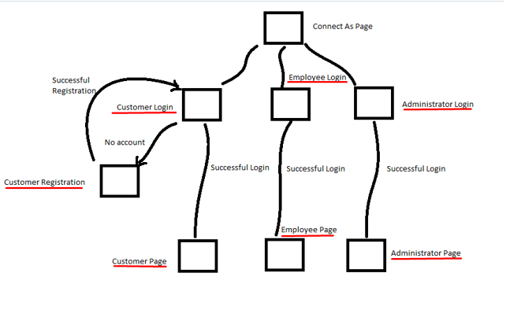

***Αρχική σελίδα***

 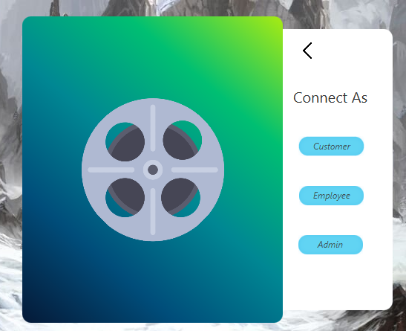

Στην αρχική σελίδα ο χρήστης πατώντας τον κεντρικό δίσκο ταινίας μπορεί να επιλέξει με ποιόν ρόλο επιθυμεί να συνδεθεί στην εφαρμογή καθώς εμφανίζεται το απαραίτητο *pane* παίζοντας ταυτόχρονα ένα μικρό *animation*.

Αρχίζουμε υποθέτοντας ότι ο χρήστης επιθυμεί να συνδεθεί ως **customer**.

***Customer***

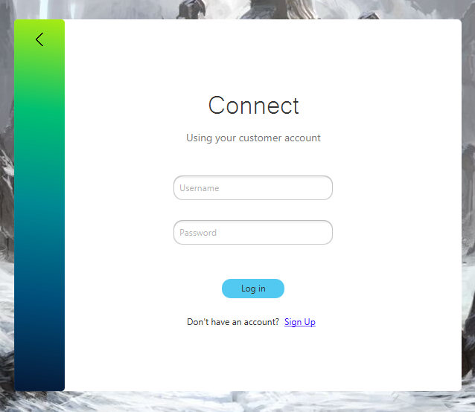

Στην οθόνη του φορτώνει το ***customer login***.

Στο συγκεκριμένο παράθυρο ο χρήστης έχει τις εξείς επιλογές:

1. *Να επιστρέψει στην αρχική σελίδα πατώντας το πίσω βέλος*



1. *Να δημιουργήσει ένα καινούργιο λογαριασμό εφόσον δεν διαθέτει ήδη κάποιον*



Επιλέγοντας αυτή την επιλογή στην οθόνη του χρήστη εμφανίζεται η φόρμα συμπλήρωσης για την εγγραφή του στην υπηρεσία όπως φαίνεται παρακάτω:

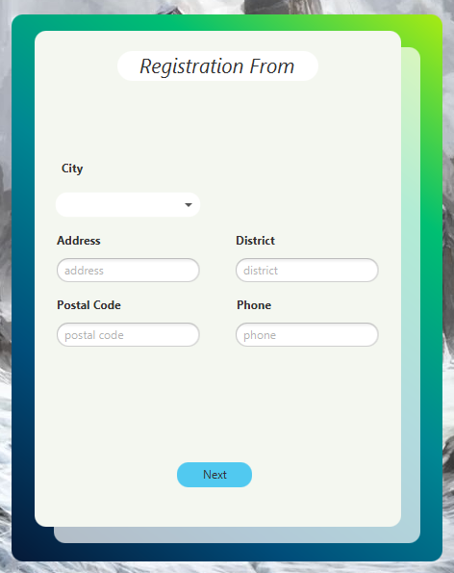

Στην φόρμα αυτή ο χρήστης πληκτρολογεί τα στοιχεία του και επιλέγει πόλη από τις διαθέσιμες επιλογές.

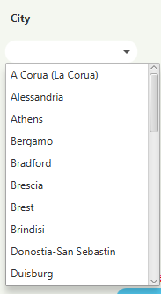

Ενώ εάν για κάποιο λόγο παραλήψει να συμπληρώσει κάποιο στοιχείο του εμφανίζεται το κατάλληλο μήνυμα.

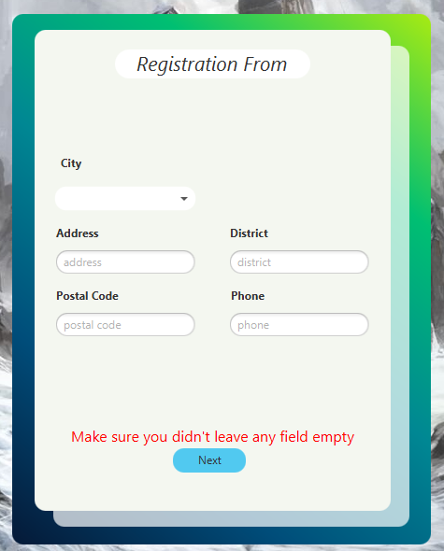

Αφού γίνει η σωστή είσοδος στοιχείων και πατήσει το κουμπί *Next* περνάει στην οθόνη του χρήστη με *slide animation* η επόμενη φόρμα συμπλήρωσης.

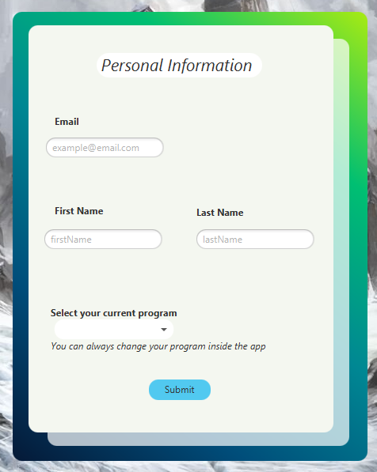

Όμοια ο χρήστης επιλέγει το πακέτο που επιθυμεί από το **comboBox.**



Ενώ σε περίπτωση μη συμπλήρωσης των αναγκαίων κενών εμφανίζεται ξανά μήνυμα λάθους.

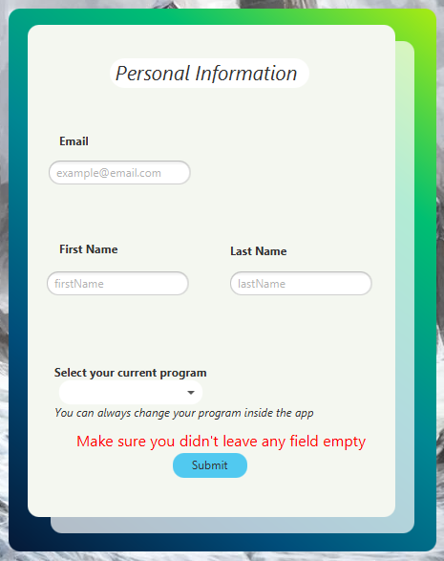

Έπειτα από την σωστή συμπλήρωση των στοιχείων και το τελικό *Submit* τα στοιχεία του χρήστη υποβάλονται στην βάση, του εμφανίζεται μήνυμα επιτυχίας και του φορτώνει ξάνά η σελίδα **Customer Login** στην οποία καλείται να εισάγει τα στοιχεία του και να εισέλθει στην υπηρεσία. Σε περίπτωση υποβολής λάθος στοιχείων του εμφανίζεται και πάλι μήνυμα λάθους.

1. *Να συνδεθεί στην υπηρεσία χρησιμοποιώντας τα στοιχεία του*

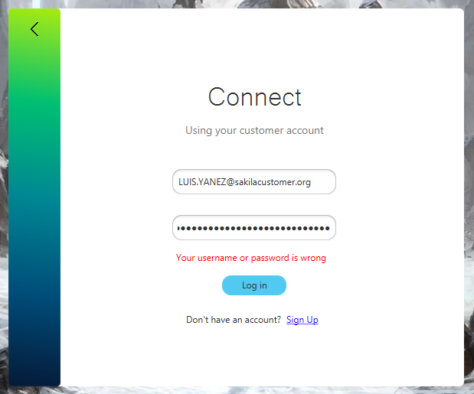

*Παρατήρηση:* για την υλοποίηση της συγκεκριμένης λειτουργίας και την παροχή μιας πιο ολοκληρωμένης εμπειρίας προσθέσαμε το πεδίο ***password*** ενώ υποθέσαμε ότι αυτό είναι το ίδιο με το ***username*** του χρήστη (το ίδιο ισχύει και για τους **employee** και **admin**).

Έπειτα από την ορθή εισαγωγή των στοιχείων του ο πελάτης εισέρχεται στην κεντρική του σελίδα.

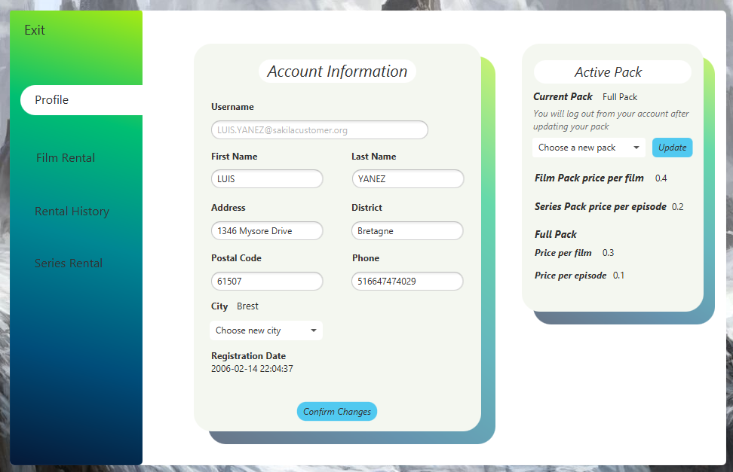

Η συγκεκριμένη απαρτίζεται από τις υποσελίδες *Exit,Profile,Film Rental, Rental History, Series Rental* που εμφανίζονται ως επιλογές στην αριστερή μπάρα*.*

**Αξίζει να σημειωθεί** εδώ ότι καθώς ο συγκεκριμένος πελάτης εχει γραφτεί στο ***full pack*** στην αριστερή στήλη του εμφανίζονται οι επιλογές **Film Rental** και **Series Rental**. Αν ωστόσο ήταν εγγεγραμένος σε άλλο πρόγραμμα οι αντίστοιχες επιλογές θα ήταν αντίστοιχες του τύπου εγγραφής του. Για παράδειγμα ο παρακάτω πελάτης ο οποίος είναι εγγεγραμένος στο ***film pack***.

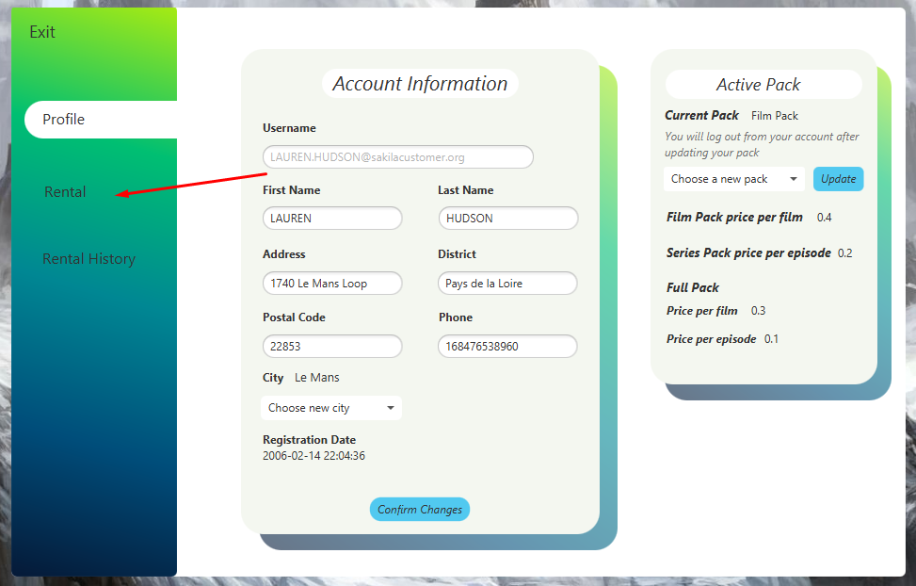

Στον πελάτη αυτόν εμφανίζεται μόνο η επιλογή **Rental** όπου εάν πατήσει πάνω θα του εμφανίζει τον κατάλογο με τις διαθέσιμες ταινίες που μπορεί να ενοικιάσει (αναλυτικότερα στην συνέχεια).

1. ***Profile***

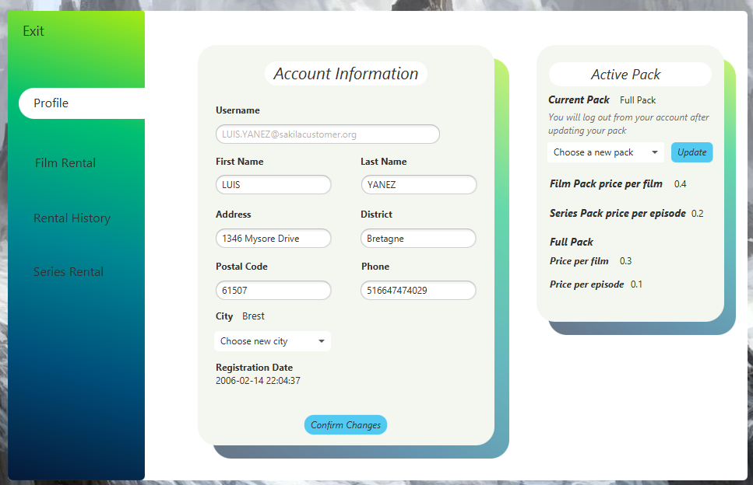

Είναι η πρώτη σελίδα που του εμφανίζεται κατά την είσοδό του στην υπηρεσία. Σε αυτή περιέχονται όλα τα στοιχεία του τα οποία μπορεί και να επεξεργαστεί εκτός από το *mail* του το οποίο εμφανίζεται και με λίγο πιο αχνό χρώμα ώστε να προϊδεάζει τον πελάτη.

Όμοια με πρίν σε περίπτωση που ξεχάσει να συμπληρώσει κάποιο πεδίο του εμφανίζεται μήνυμα λάθους ενώ κατά την επιτυχή ενημέρωση των στοιχείων του ,εμφανίζεται και πάλι κατάλληλο μήνυμα.

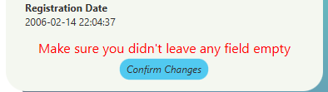

Με όμοιο τρόπο λειτουργεί και η αλλαγή του ενεργού πακέτου από τον πελάτη ενώ ταυτόχρονα του εμφανίζονται και οι τιμές για κάθε πακέτο οι οποίες ενημερώνονται δυναμικά από την βάση σε περίπτωση που τις αλλάξει κάποιος admin. Σε περίπτωση μη επιλογής πακέτου και πίεσης του κουμπιού *Update* εμφανίζεται και πάλι κατάλληλο μήνυμα.



1. ***Film Rental***

Στο παράθυρο αυτό ο πελάτης μπορεί να δεί τον διαθέσιμο κατάλογο σε ταινίες και έπειτα από την επιλογή συγκεκριμένης ταινίας να προχωράει και στην αγορά της.

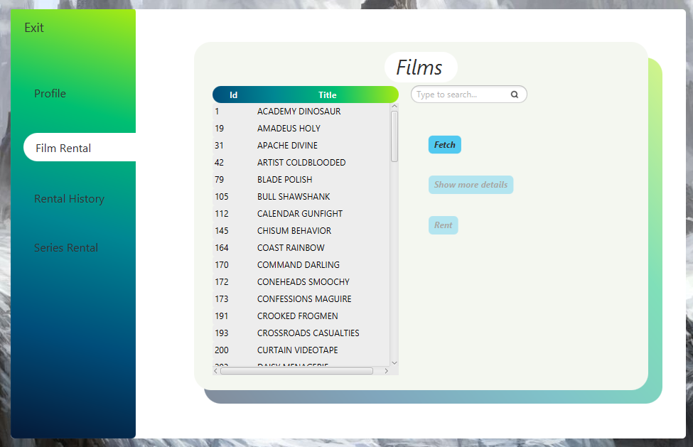

Στην από πάνω εικόνα μπορούμε να παρατηρήσουμε ότι τα κουμπιά *Show more details* και *Rent* είναι πιο αχνά από ότι το κουμπί *Fetch* (το οποίο ‘γεμίζει’ τον πίνακα με τις διαθέσιμες ταινίες) και δεν μπορεί να τα πατήσει. Αυτό συμβαίνει καθώς ο πελάτης δεν έχει επιλέξει κάποια ταινία της οποίας μπορεί να δεί να στοιχεία ή να την ενοικειάσει. Όταν ωστόσο επιλέξει κάποια ταινία κατευθείαν τα κουμπιά σταματάνε να είναι αχνά και μπορούν πλέον να πατηθούν. Ταυτόχρονα παρέχεται η δυνατότητα αναζήτησης κάποιας ταινίας από τον χρήστη μέσω του ***search bar***.

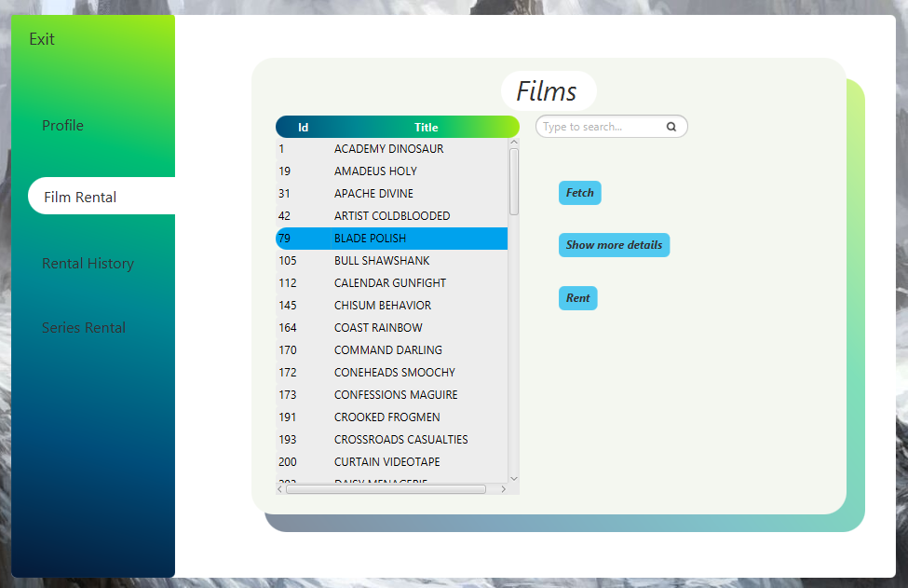

Κάνοντας κλικ στο κουμπί *Show more details* εμφανίζονται όλα τα στοιχεία της ταινίας αυτής σε ένα *pane* το οποίο εισέρχεται στην σκηνή με *slide up animation*.

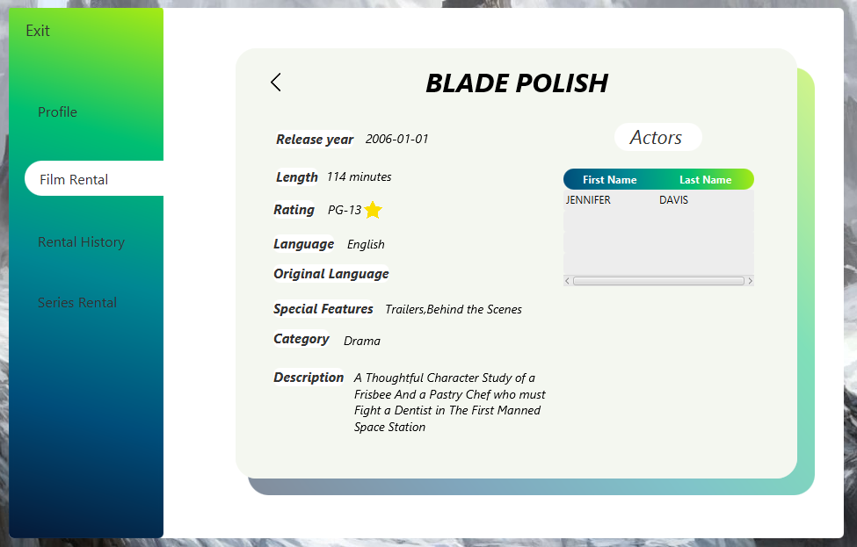

Έπειτα ο πελάτης μπορεί να επιστρέψει πίσω πατώντας το πίσω βέλος 

Για να ενοικειάσει μια ταινία ο πελάτης μπορεί να πατήσει το κουμπί *Rent* και να προχωρήσει στην πληρωμή μέσα από ένα μικρό παράθυρο το οποίο μπαίνει στην σκηνή.

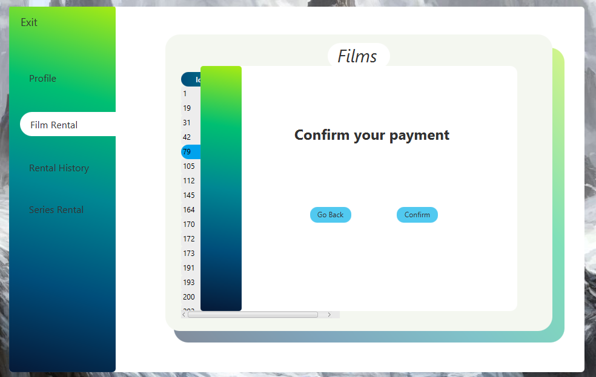

Πατώντας *Confirm* ο πελάτης εκτελεί την αγορά (εμφανίζεται και το κατάλληλο μήνυμα πληρωμής) ενώ με το *Go back* μπορει να επιστρέψει στον κατάλογο με τις ταινίες και να προχωρήσει εάν το επιθυμεί σε μια νέα ενοικίαση.

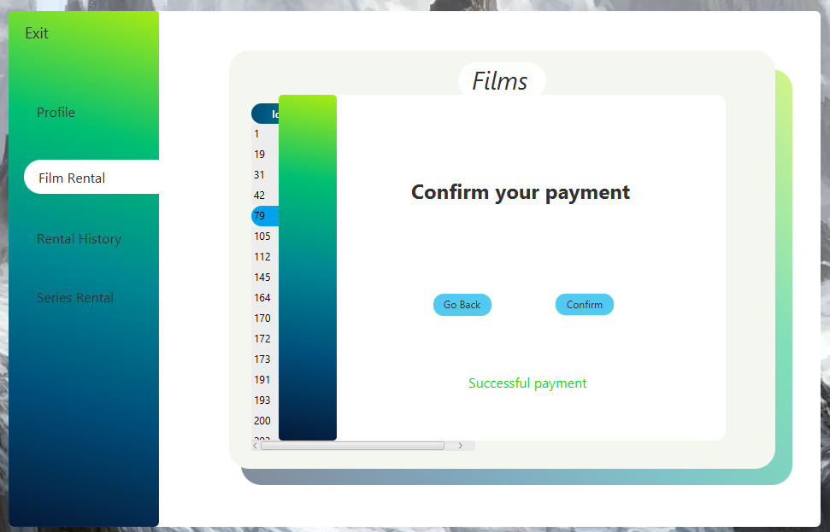

1. ***Series Rental***

Αντίστοιχα με την σελίδα *Film Rental* ο πελάτης μπορεί σε αυτή να δεί τον διαθέσιμο κατάλογο σειρών από τις οποίες μπορεί να αγοράσει ολόκληρη κάποια σεζόν του.

Η λειτουργία των κουμπιών: εμφάνιση περισσότερων πληροφοριών και ενοικείαση είναι η ίδια με αυτή των ταινιών καθώς και ο τρόπος ενοικείασης μιας σεζόν οπότε παρακάτω παρατίθονται απλά τα screenshot της σελίδας:

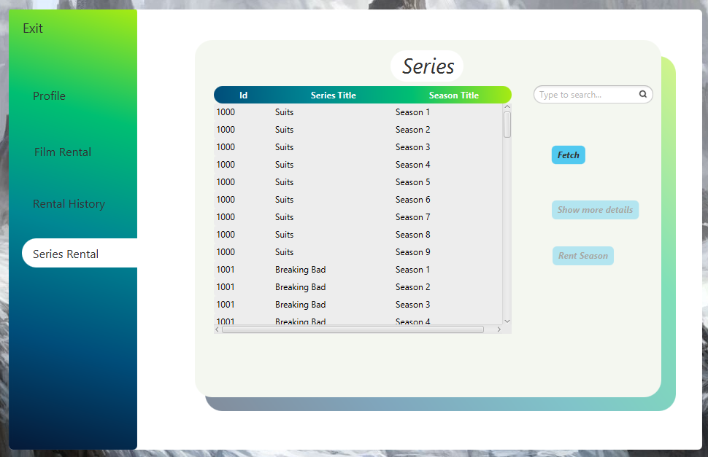

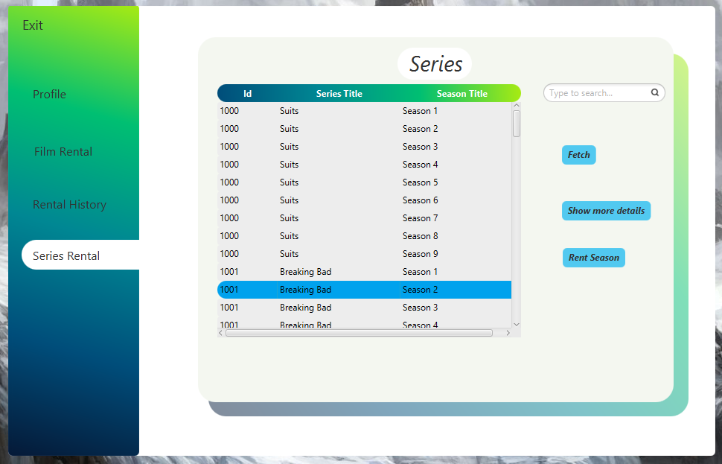

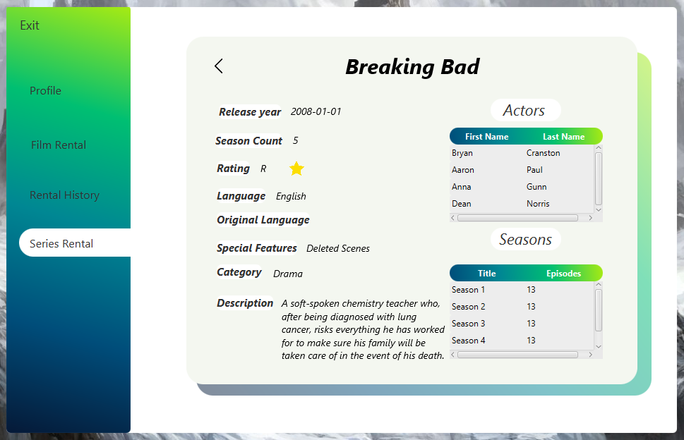

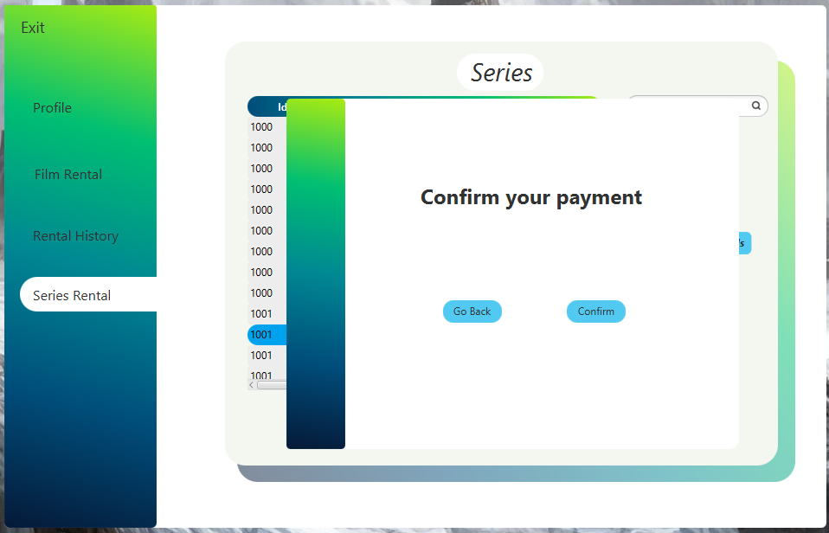

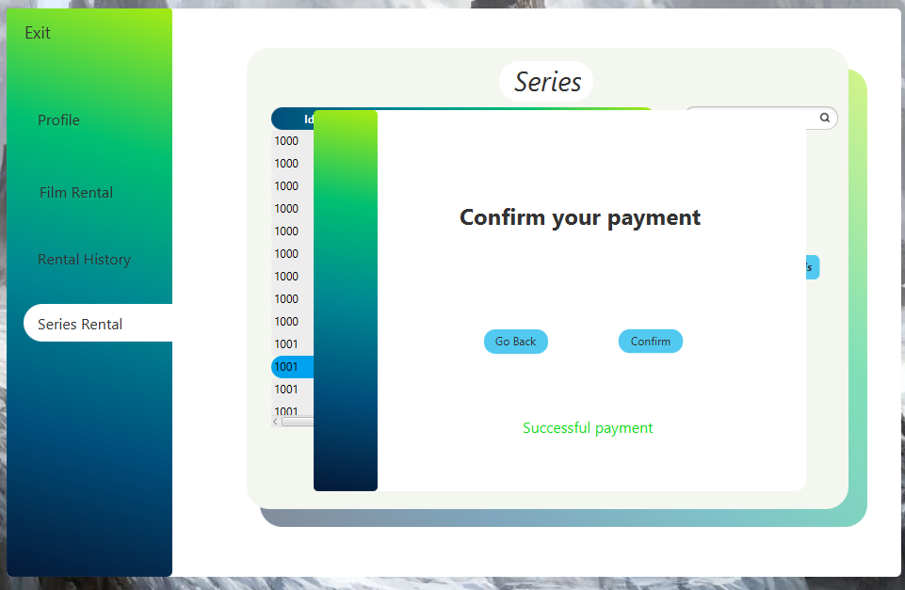

1. ***Rental History***

Κάνοντας κλικ στην συγκεκριμένη επιλογή από την μπάρα αριστερά ο πελάτης μεταφέρεται στην σελίδα με το ιστορικό των ενοικειάσεών του.

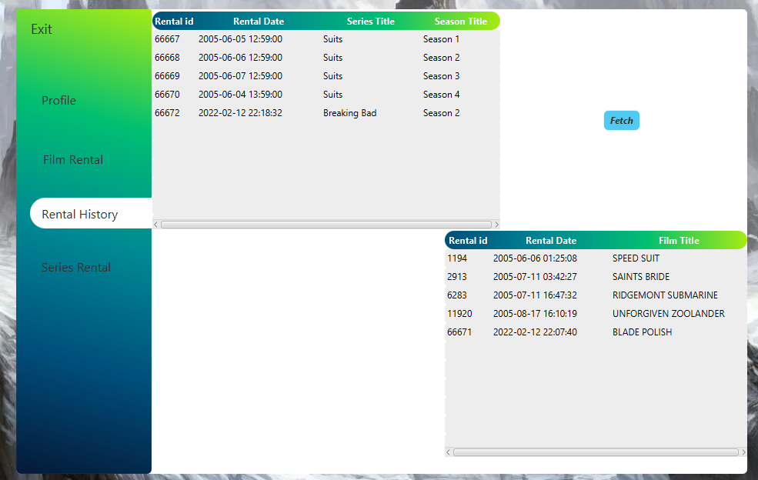

1. ***Exit***

Στη σελίδα αυτή μπορεί να πραγματοποιηθεί η έξοδος του χρήστη από την εφαρμογή. Η συγκεκριμένη επιτελεί και ένα σημαντικό έργο για τα **logs** τα οποία μπορούν να δούν οι **employee** και **admin** κάτι το οποίο θα αναληθεί πιο κάτω.

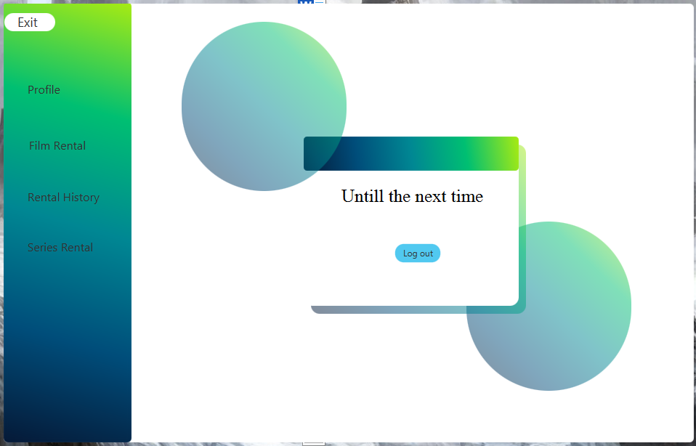

***Employee***

Όμοια με τον πελάτη εάν κάποιος χρήστης επιθυμεί να εισέλθει στην υπηρεσία σαν υπάλληλος πρέπει να πατήσει την επιλογή employee στην αρχική σελίδα όπου και θα του φορτώσει την σελίδα Employee Login.

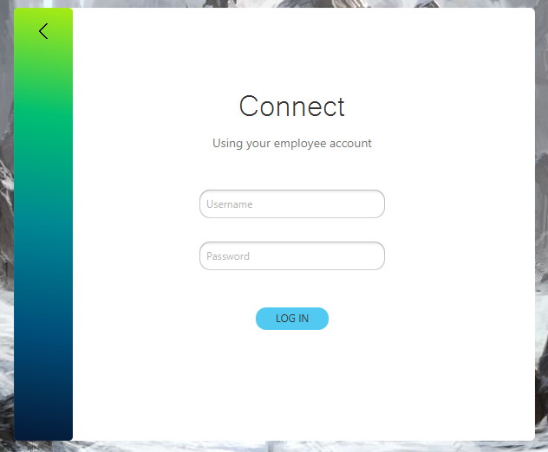

Στην συγκεκριμένη σελίδα δύο είναι επιλογές που μπορεί να πραγματοποιήσει ο χρήστης:

1. *Να επιστρέψει στην αρχική σελίδα πατώντας το πίσω βέλος*



1. *Να συνδεθεί στην υπηρεσία εκχωρώντας τα στοιχεία του*

Ξανά σε περίπτωση λάθους εμφανίζεται κατάλληλο μήνυμα

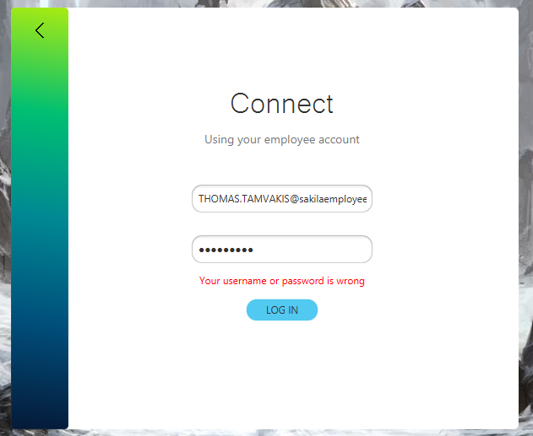

Ενώ σε αντίθετη περίπτωση εισέρχεται στην υπηρεσία

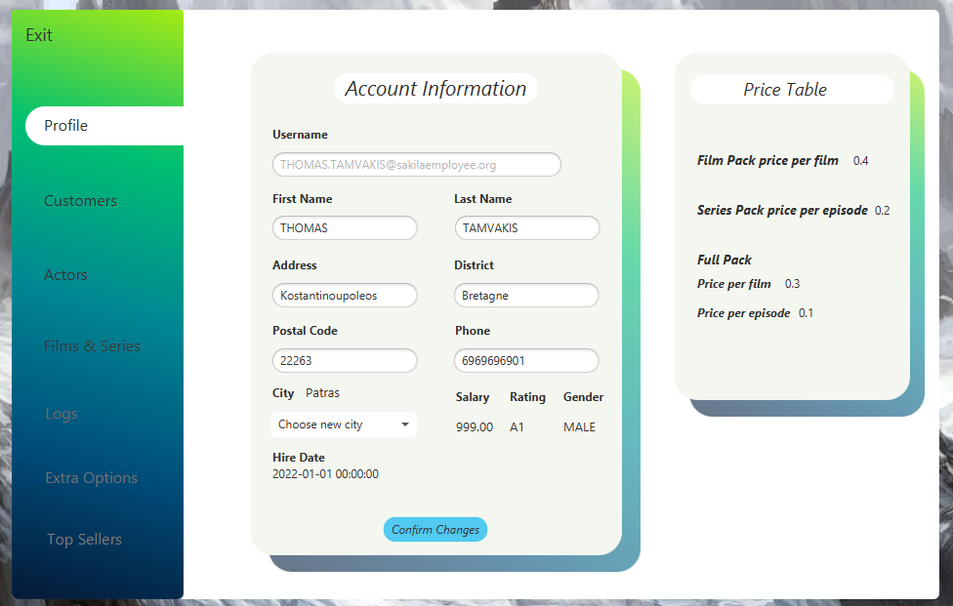

Η συγκεκριμένη απαρτίζεται από τις υποσελίδες *Exit, Profile, Customers, Actors,*

*Films & Series, Logs, Extra Options, Top Sellers* που εμφανίζονται ως επιλογές στην αριστερή μπάρα.

1. ***Profile***

Όπως και με τον Customer ο Employee μπορεί να δεί όλα τα στοιχεία του και να τα αλλάξει εκτός από το ***mail*** του, το ***salary***, το ***rating*** και το ***gender*** -τα 3 τελευταία μπορεί να τα επεξεργαστεί μόνο κάποιος **admin**-. Ταυτόχρονα μπορεί να δεί αλλά όχι να επεξεργαστεί τις τιμές των πακέτων τις οποίες επίσης μπορεί να επεξεργαστεί μόνο κάποιος **admin**.

Ξανά σε περίπτωση ελλιπής συμπλήρωσης στοιχείων εμφανίζονται τα σωστά μηνύματα.

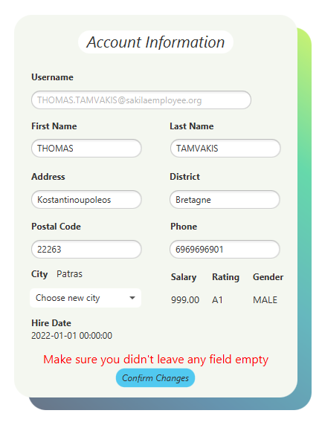

1. ***Customers***

Ο υπάλληλος έχει την δυνατότητα μα προσθέτει να αφαιρεί και να κάνει update τα στοιχεία των πελατών. Όλα τα παραπάνω μπορεί να πραγματοποιήσει στην συγκεκριμένη σελίδα.

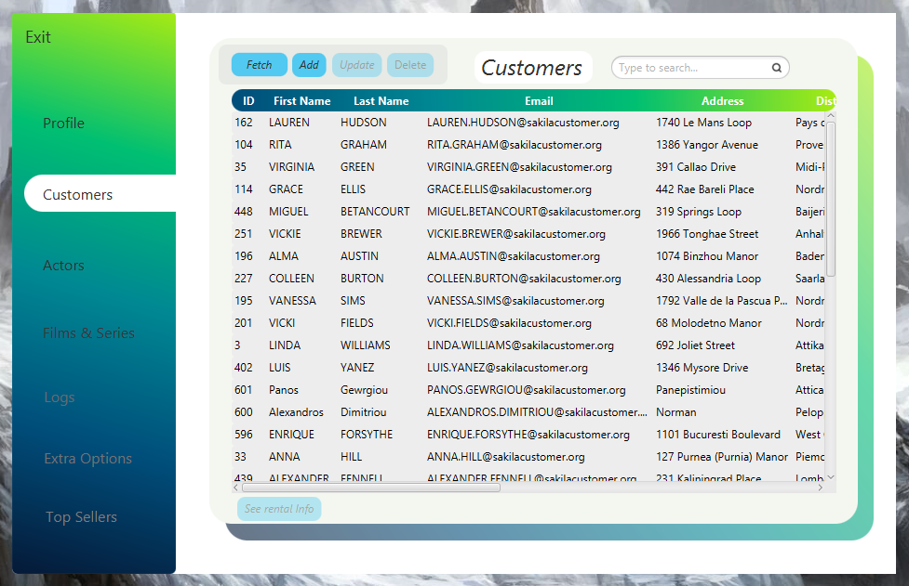

Παρατηρούμε ξανά ότι τα κουμπιά *Update* και *Delete* παραμένουν αχνά (ανενεργά) μέχρι να επιλέξει ο χρήστης κάποιον πελάτη του οποίου τα στοιχεία θα ενημερωθούν ή θα διαγραφούν αντίστοιχα. Το ίδιο ισχύει και για το κουμπί *See rental Info* το οποίο πατώντας εμφανίζει τα στοιχεία ενοικιάσεων του πελάτη που έχει επιλεγεί.

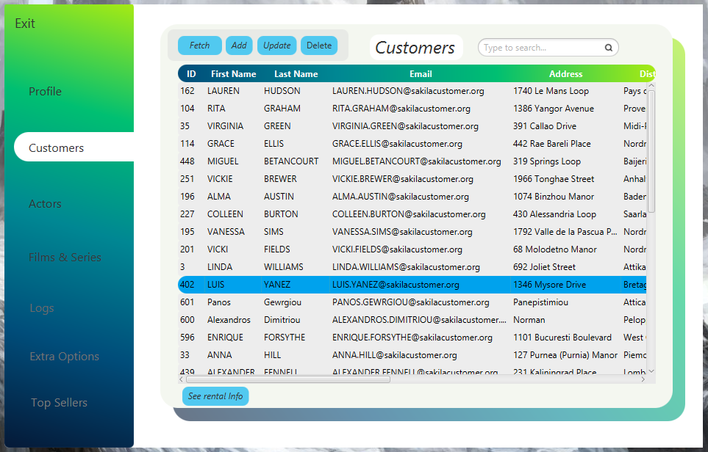

* ***Update***

Τα στοιχεία του πελάτη φορτώνονται σε ένα αναδυόμενο *pane* τα οποία μπορεί να επεξεργαστεί ο **employee** εκτός από το *mail* του.

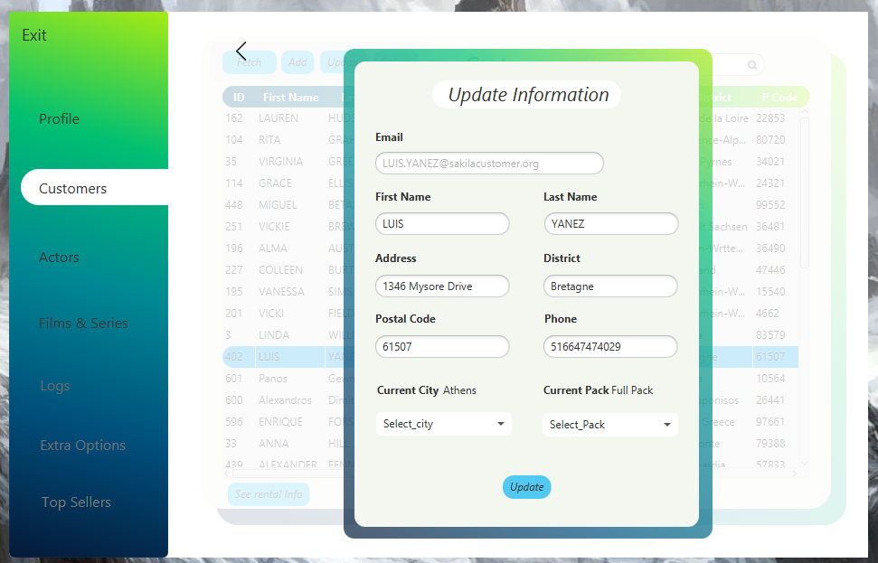

Ενώ εμφανίζεται μήνυμα λάθους σε περίπτωση παράληψης συμπλήρωσης κάποιου στοιχείου και μήνυμα επιτυχίας σε επιτυχή ενημέρωση.

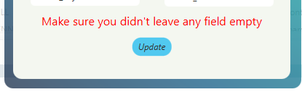

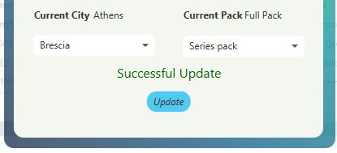

* ***Add***

Για την προσθήκη νέου πελάτη ακολουθείται μια διαδικασία ίδια με αυτή της εγγραφής ενός πελάτη που αναφέραμε στην ανάλυση του **customer**. Παρατίθονται οι σχετικές εικόνες.

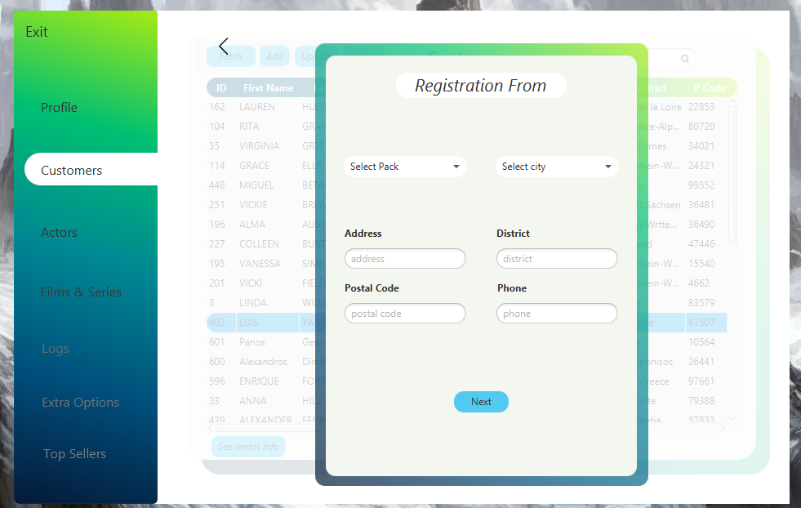

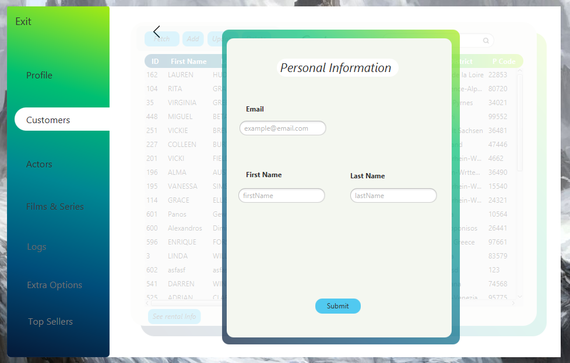





* ***Delete***

Για την διαγραφή ενός πελάτη από το σύστημα αρχικά επιλέγουμε τον πελάτη όπως αναφερθήκαμε πάνω και έπειτα πατάμε το κουμπί *Delete* για να προχωρήσουμε στην οριστική διαγραφή του.

Για να κάνουμε Refresh τα στοιχεία του πίνακα με όλες τις αλλαγές που πραγματοποιήσαμε κάνουμε κλικ στο κουμπί *Fetch.*

* ***See rental Info***

Τέλος για να μπορεί να δεί ο υπάλληλος τα στοιχεία ενοικιάσεων των πελατών αφότου έχει επιλέξει κάποιον πελάτη μπορεί να πατήσει το κουμπί *See Rental Info* και να δεί όλες τις ενοικιάσεις του.

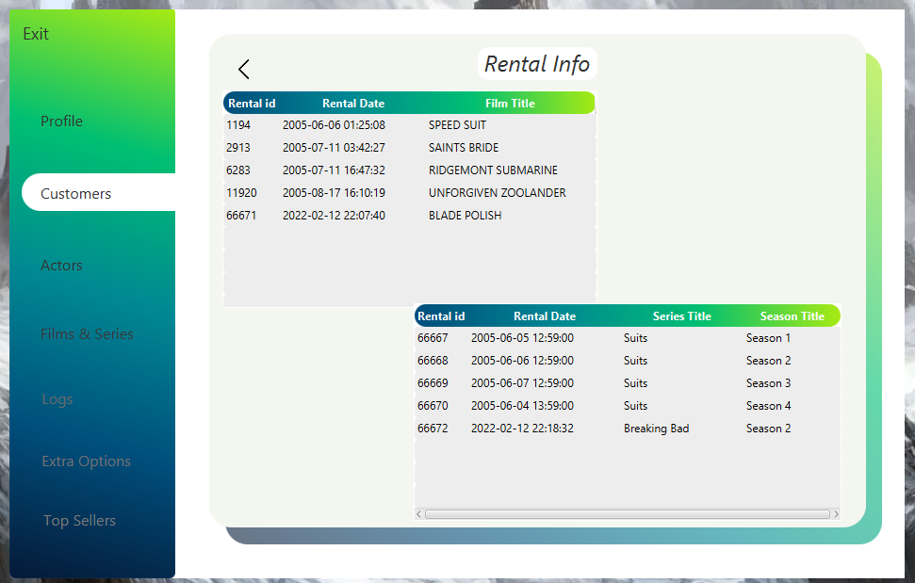

Σημείωση: Σε όλες τις παραπάνω επιλογές εμφανίζεται το αριστερό βέλος ώστε να μπορεί ο χρήστης να γυρίσει στην αρχική οθόνη της σελίδας *Customers*.

1. ***Actors***

Στη σελίδα αυτή ο **employee** μπορεί να δεί τον κατάλογο με όλους τους ηθοποιούς της βάσης καθώς και να προσθέσει και να κάνει *update* τα στοιχεία ενός επιλεγμένου **actor**.

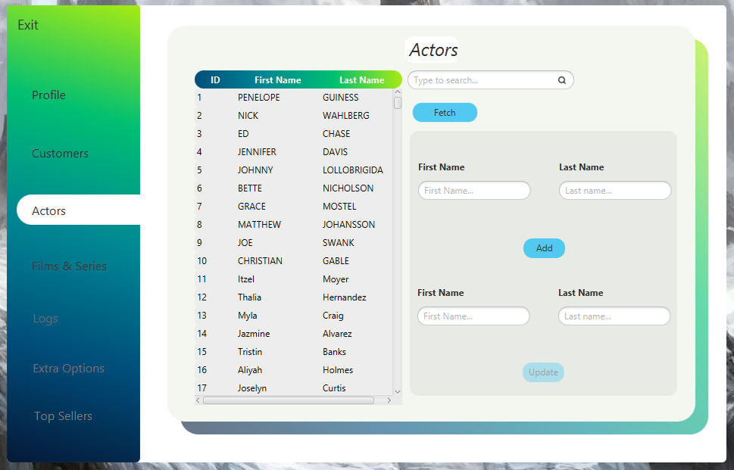

Όπως και με όλα τα παραπάνω το κουμπί *Update* είναι αχνό μέχρι την επιλογή κάποιου ηθοποιού.

Στα ***TextField*** του *add* μπορεί ο **employee** να γράψει το όνομα και το επώνυμο του ηθοποιού που θέλει να προσθέσει στη βάση. Μετά την προσθήκη μπορεί να πατήσει το κουμπί *Fetch* για να ανανεώσει τα στοιχεία του πίνακα με τις νέες εγγραφές και ενημερώσεις.

Με την επιλογή κάποιου ηθοποιού από τον κατάλογο αυτόματα τα ***TextField*** του *Update* λαμβάνουν το όνομα και το επίθετο του ηθοποιού που έχει επιλεγεί και τα οποία στοιχεία ο **employee** μπορεί να επεξεργαστεί και να ανανεώσει τη βάση.

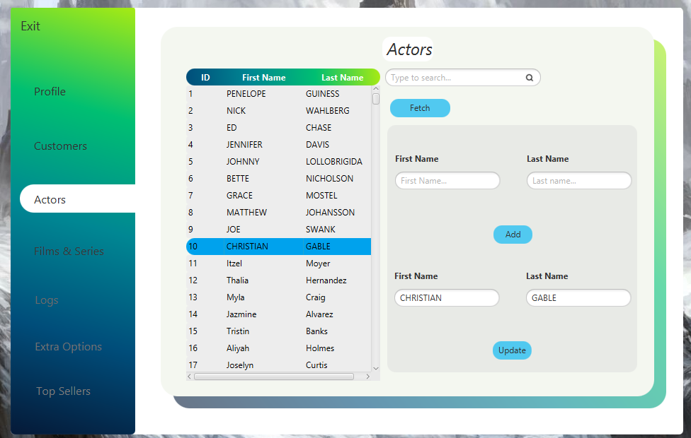

Ενώ πάντα εμφανίζονται τα κατάλληλα μηνύματα για πιο φιλική εμπειρία του χρήστη.

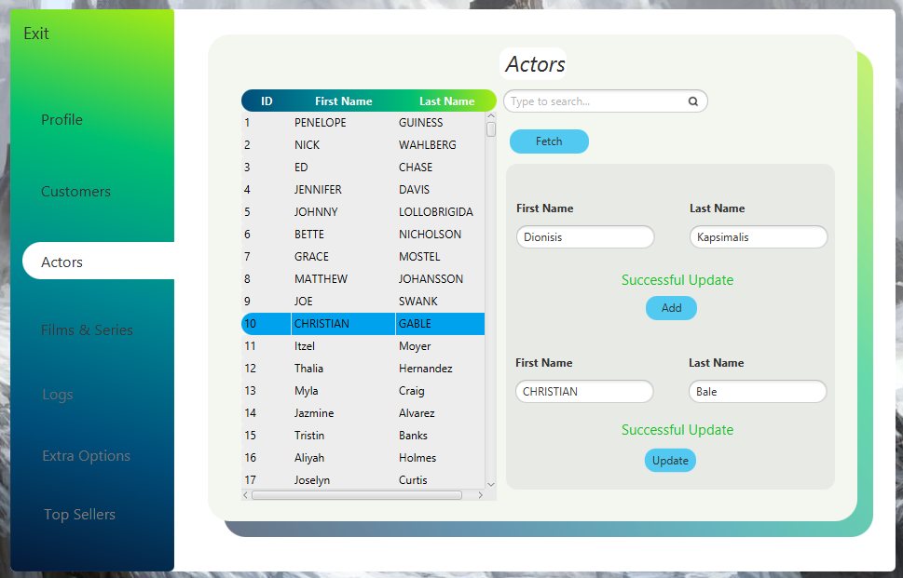

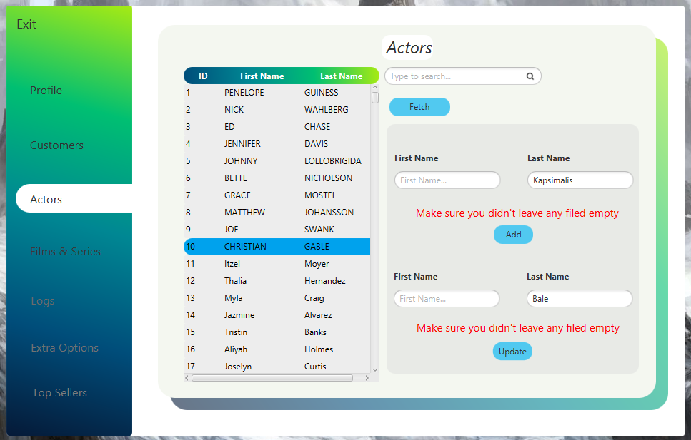

1. ***Films & Series***

Στη συγκεκριμένη σελίδα ο **employee** μπορεί να ενημερώνει την βάση με νέες ταινίες και σειρές. Για το ερώτημα αυτό χρησιμοποιήθηκε ένα *tabPane* του οποίου το ένα *tab* είναι αφιερομένο στις ταινίες και το άλλο στις σειρές όπως φαίνεται στην παρακάτω εικόνα.

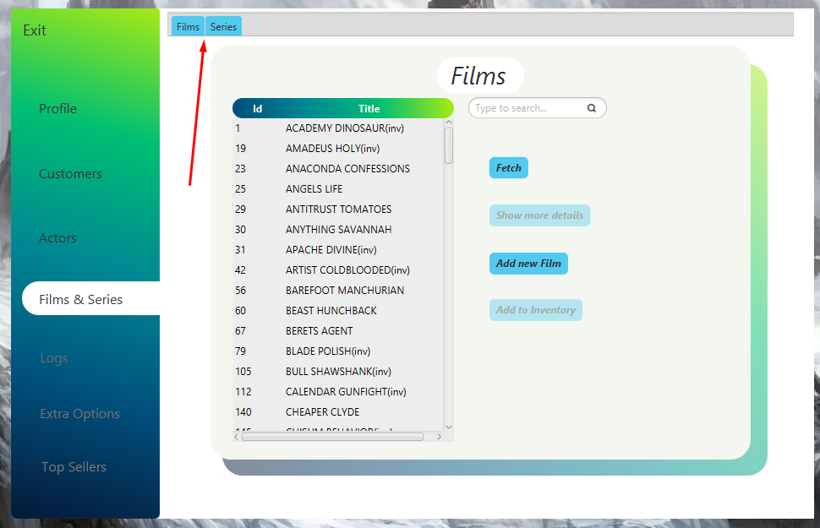

Στο συγκεκριμένο εμφανίζεται ο κατάλογος με τις ταινίες που υπάρχουν στη βάση. Πιο συγκεκριμένα, όσες από τις ταινίες αυτές βρίσκονται και στο *inventory* (δηλαδή μπορεί να τις δεί και να τις ενοικιασει κάποιος πελάτης) έχουν δίπλα από τον τίτλο τους τη φράση (inv). Για να δεί κάποιος **employee** όλες τις ταινίες το *inventory* συγκεντροτικά μπορεί στο *search bar* να αναζητήτηση τη λέξη inv.

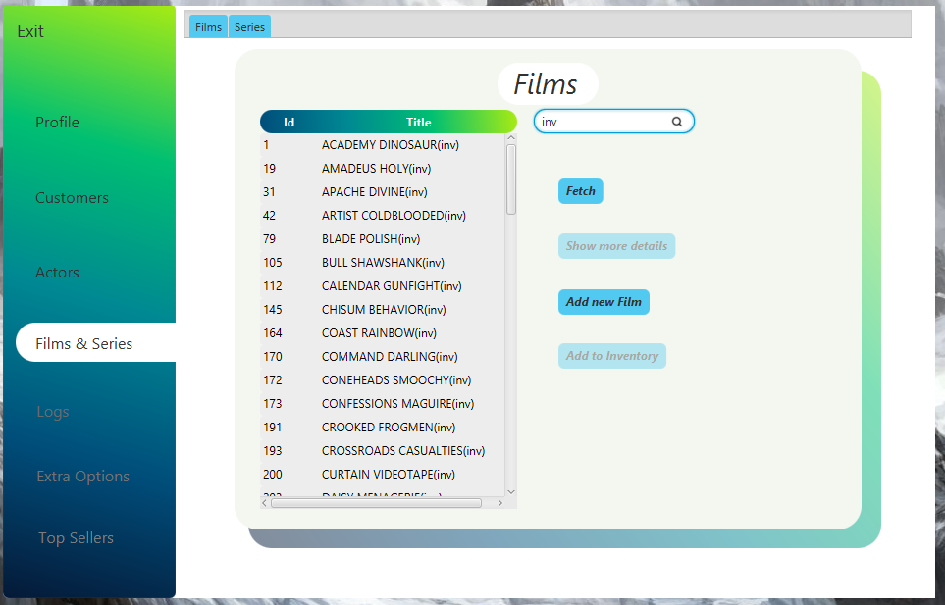

* ***Add***

Για την προσθήκη νέας ταινίας ο υπάλληλος πατάει στο κουμπί *Add new Film* και κάνει *slide* το επόμενο *pane*.

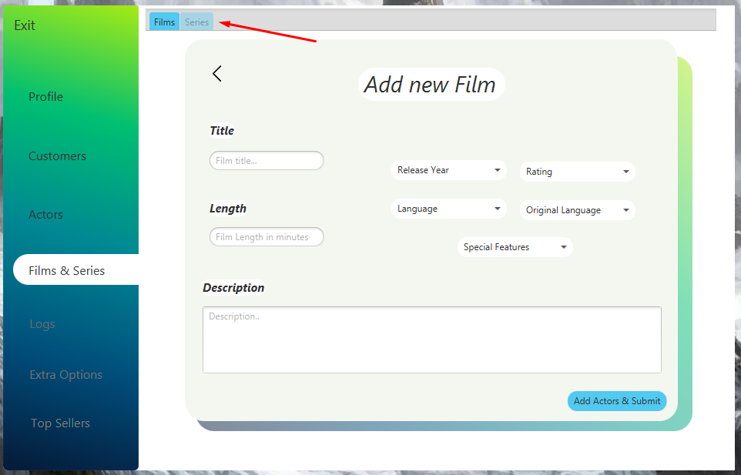

Ταυτόχρονα με την είσοδο στην πλατφόρμα προσθήκης ταινίας απενεργοποιείται και το *series tab* ώστε να μην μπορεί να το πατήσει ο υπάλληλος και να δημιουργηθεί καμία ανωμαλία.

Μετά την συμπλήρωση όλως των στοιχείων ο υπάλληλος πατάει το κάτω δεξιά κουμπί ώστε να εισέλθει ένα καινούργιο pane για την προσθήκη των ηθοποιών και της κατηγορίας της ταινίας.

Ξανα σε περίπτωση μη συμπλήρωσης όλων των κενών εμφανίζεται μήνυμα λάθους.

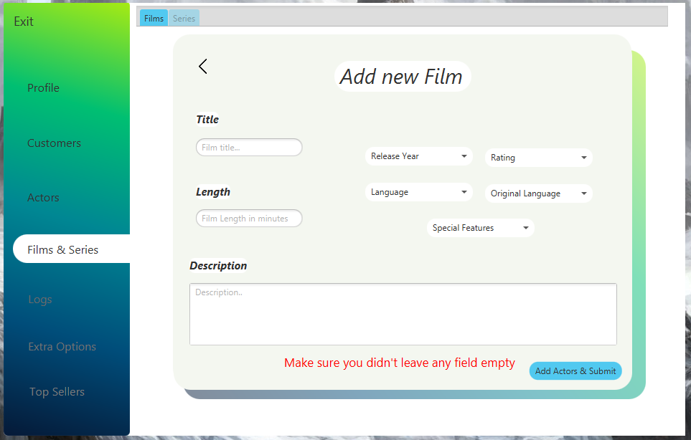

Η επόμενη φόρμα συμπλήρωσης είναι η εξής:

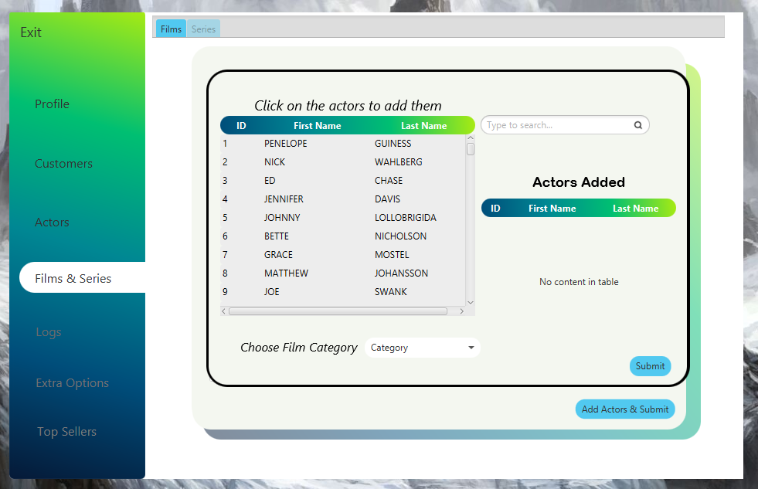

Στην οποία ο υπάλληλος επιλέγει τους ηθοποιούς της ταινίας καθός και την κατηγορία στην οποία ανήκει.

Σε κάθε περίπτωση εμφανίζεται ξανά κατάλληλο μήνυμα.

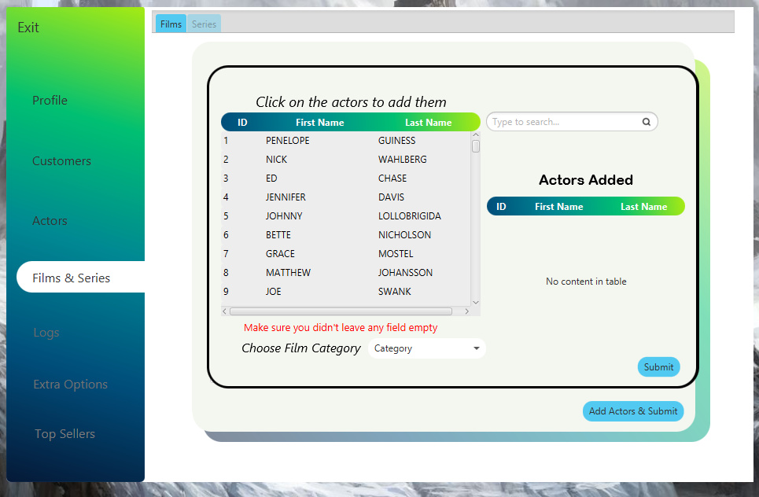

Όπως και σε παραπάνω σελίδες τα κουμπιά που φαίνονται αχνά ενεργοποιούνται μόνο μετά από την επιλογή κάποιας ταινίας από τον πίνακα.

Το *show more details* φορτώνει τα στοιχεία της ταινίας που έχει επιλεγεί σε ένα pane το οποίο μπαίνει στην σκηνή με *slide animation*.

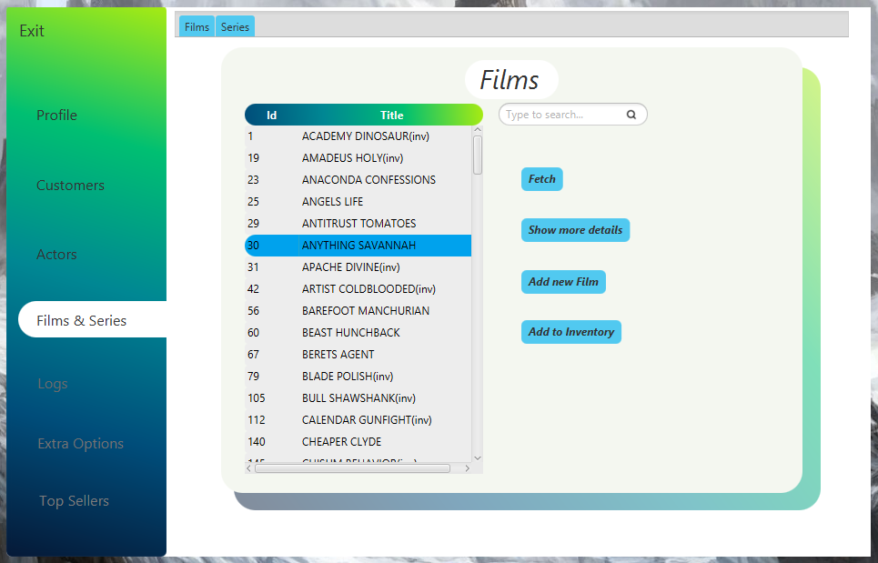

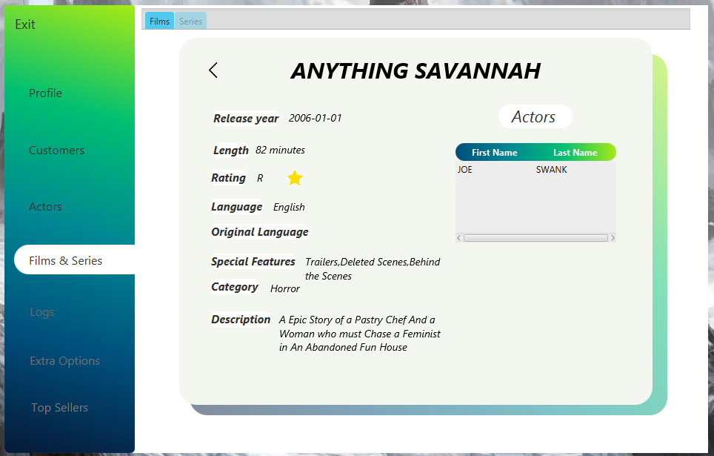

Το κουμπί *add to inventory* προσθέτει την ταινία στον κατάλογο διαθέσιμων ταινιών που μπορεί να ενοικιάσει κάποιος πελάτης.

Αν κάποια ταινία υπάρχει ήδη μέσα στο inventory εμφανίζεται το κατάλληλο μήνυμα.

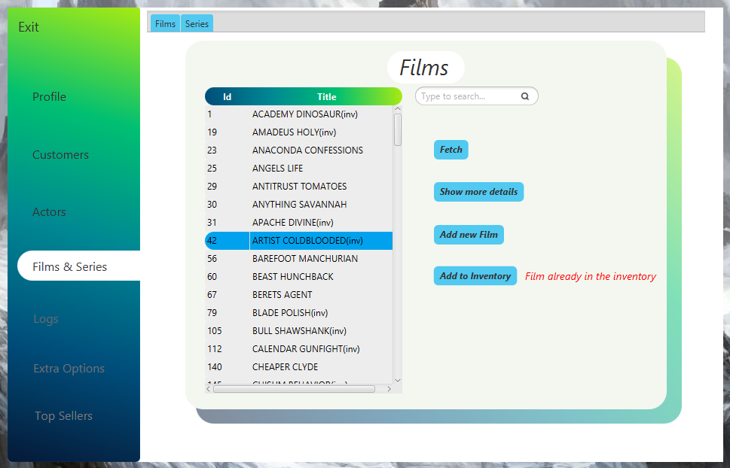

Με αντοίστοιχο τρόπο λειτουργεί και το tab των σειρών. Παρατίθονται από κάτω οι εικόνες.

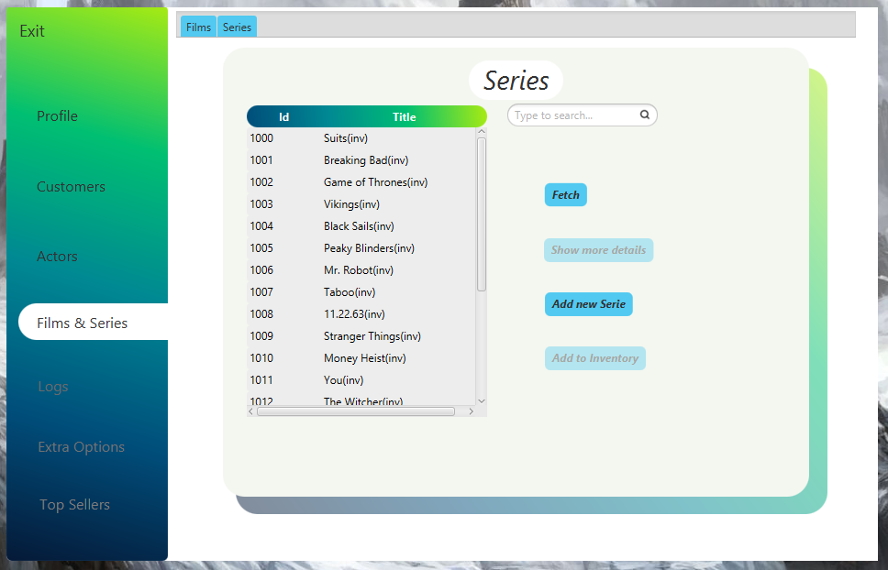

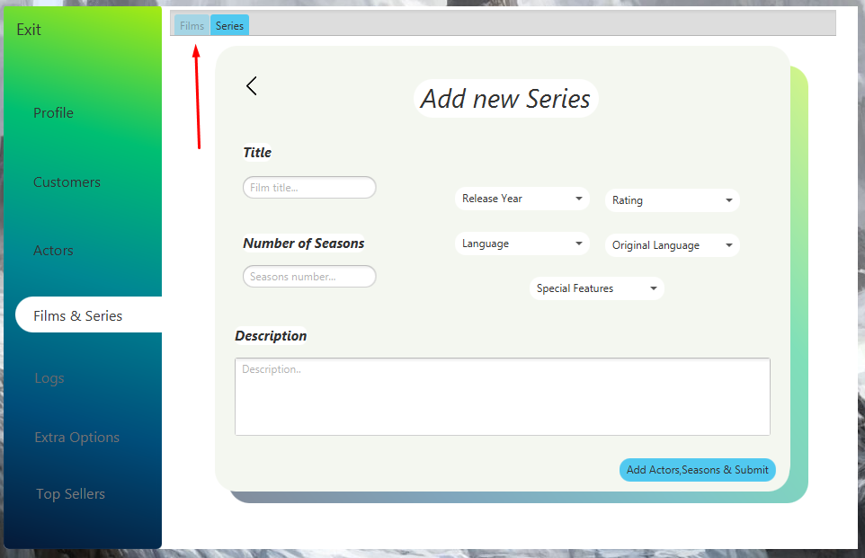

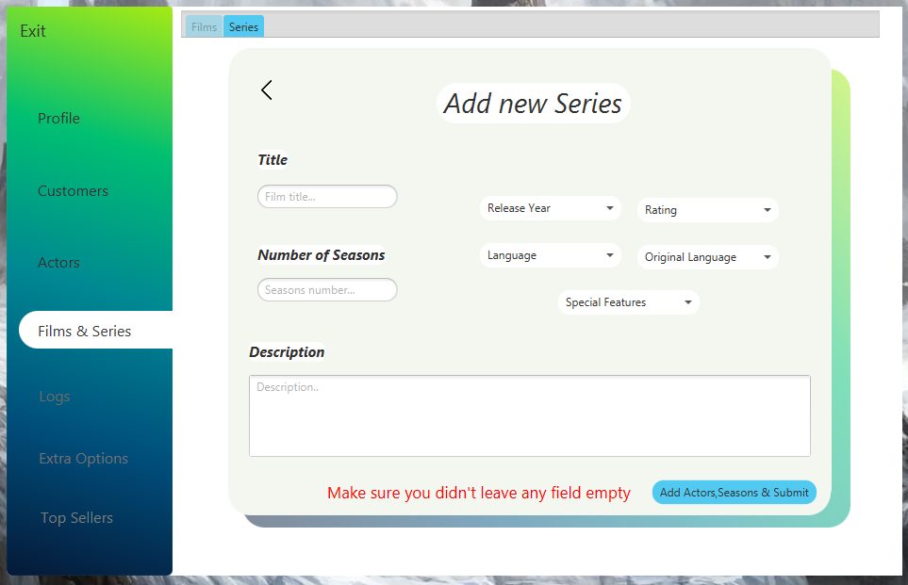

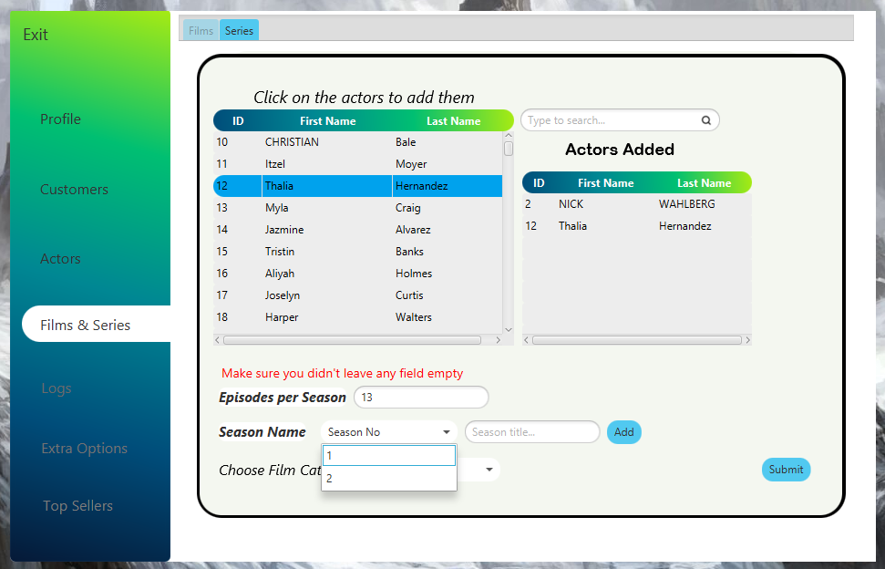

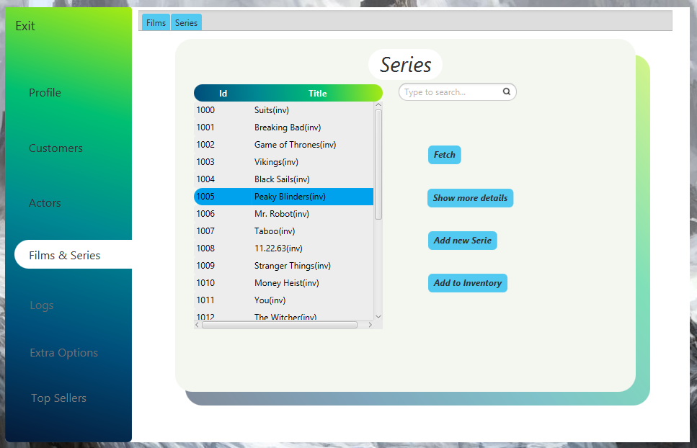

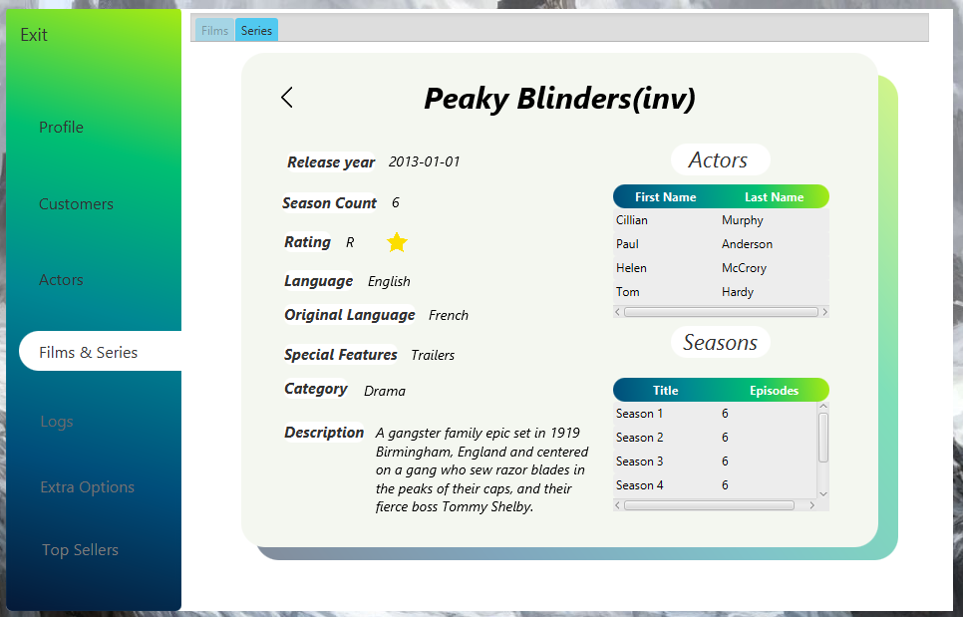

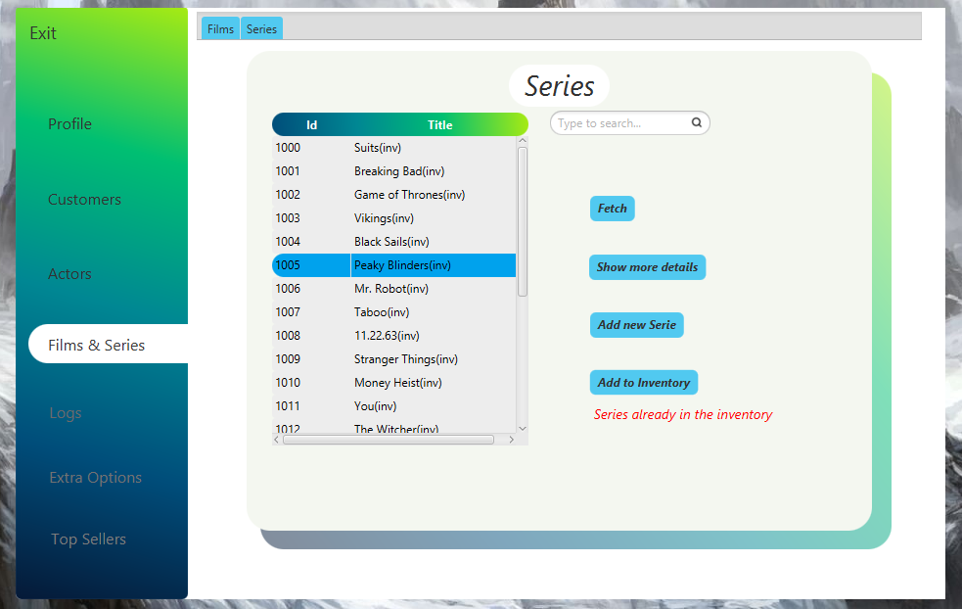

1. ***Logs***

Σελίδα στην οποία εμφανίζεται όλο το ιστορικό κινήσεων από κάθε χρήστη που πραγματοποίησε κάποια ενέργεια(insert,update,delete).

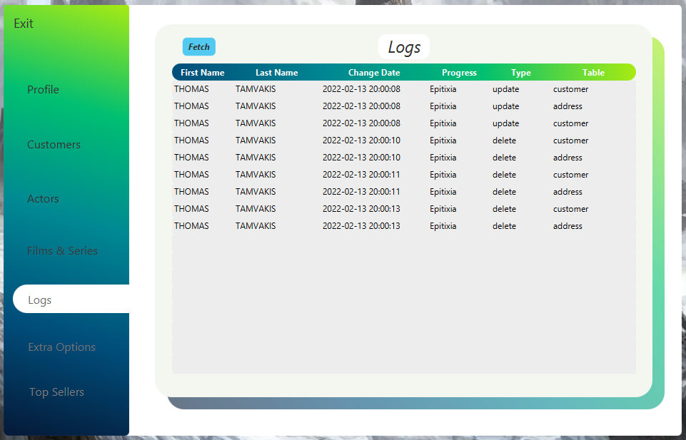

Για το συγκεκριμένο ερώτημα χρησιμοποιήθηκε μια παραλλαγή των trigger του ερωτήματος 4.1. Πιο συγκεκριμένα, στους πίνακες **current_customer**, **current_employee, current_administrator** (οι οποίοι αναλύονται στο κομμάτι της SQL) έγινε προσθήκη της μεταβλητής in_use (τύπου BOOLEAN) η οποία αρχικοποιείται με FALSE. Κάθε φορά που ένας χρήστης οποιουδήποτε τύπου (customer, employee, admin) κάνει login στην εφαρμογή το συγκεκριμένο πεδίο στον αντίστοιχο current πίνακα γίνεται update σε TRUE. Αυτό συμβαίνει ώστε κατά την πυροδότηση του trigger να αποθηκεύεται στον πίνακα των logs το κατάλληλο όνοματεπώνυμο του χρήστη που εκτέλεσε την αλλαγή. Ενώ όταν ο χρήστης αυτός προχωρήσει σε logout από την εφαρμογή η μεταβλητή in_use γίνεται update στον αντίστοιχο πίνακα σε τιμή FALSE.

Η συγκεκριμένη διαδικασία επαναλαμβάνεται για κάθε χρήστη σε οποιαδήποτε κατηγορία ανήκει.

1. ***Extra Options***

Σε αυτή τη σελίδα ο υπάλληλος μπορεί να προσθέσει στην βάση καινούργιες γλώσσες, κατηγορίες ταινιών και σειρών,πόλεις καθώς και χώρες.

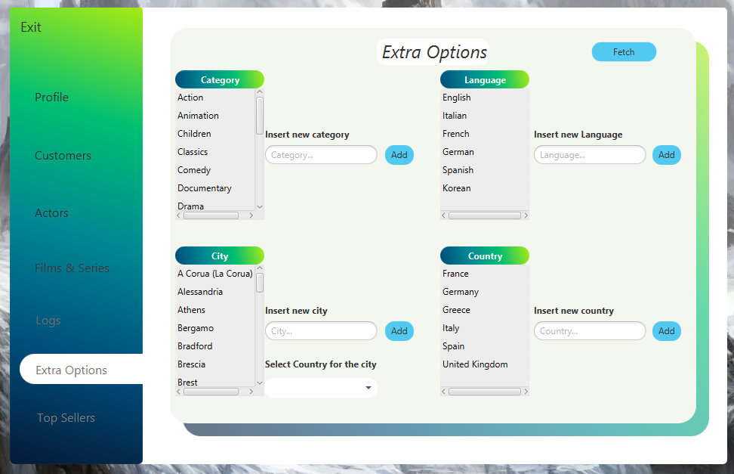

Συγκεκριμένα για την προσθήκη νέας πόλης πρέπει πρώτα να προσθέσει την χώρα στην οποία ανήκει.

Σε κάθε περίπτωση εμφανίζονται και πάλι τα κατάλληλα μηνύματα.

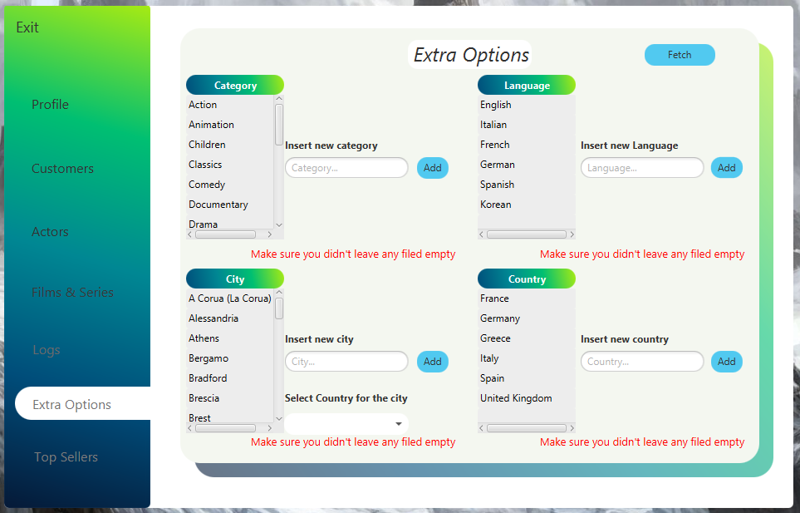

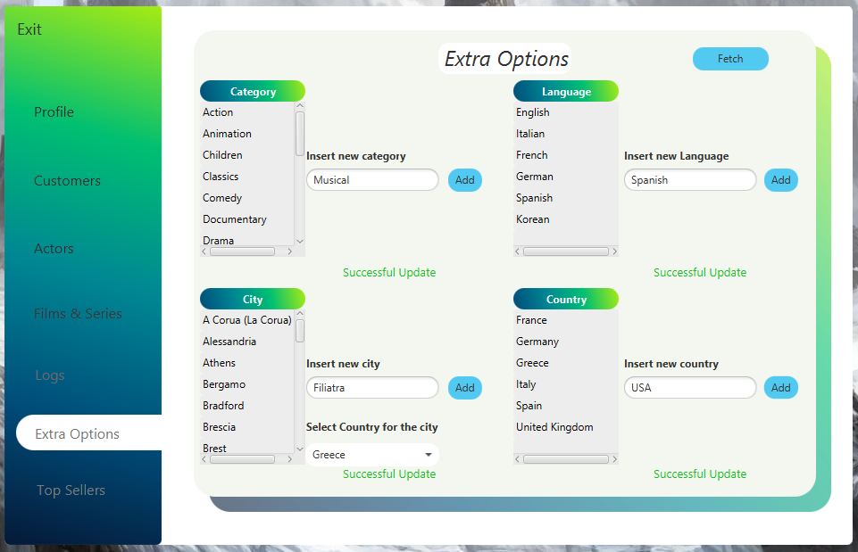

1. ***Top Sellers***

Στην συγκεκριμένη σελίδα εμφανίζονται οι τοπ 5 ταινίες και τοπ 5 σειρές με τις περισσότερες πωλήσεις αντίτυπων και επεισοδίων αντίστοιχα. Για το συγκεκριμένο ερώτημα χρησιμοποιήθηκε μια παραλλαγή της procedure του ερωτήματος 3.1 της SQL(πιο αναλυτικά στο πεδίο της SQL).

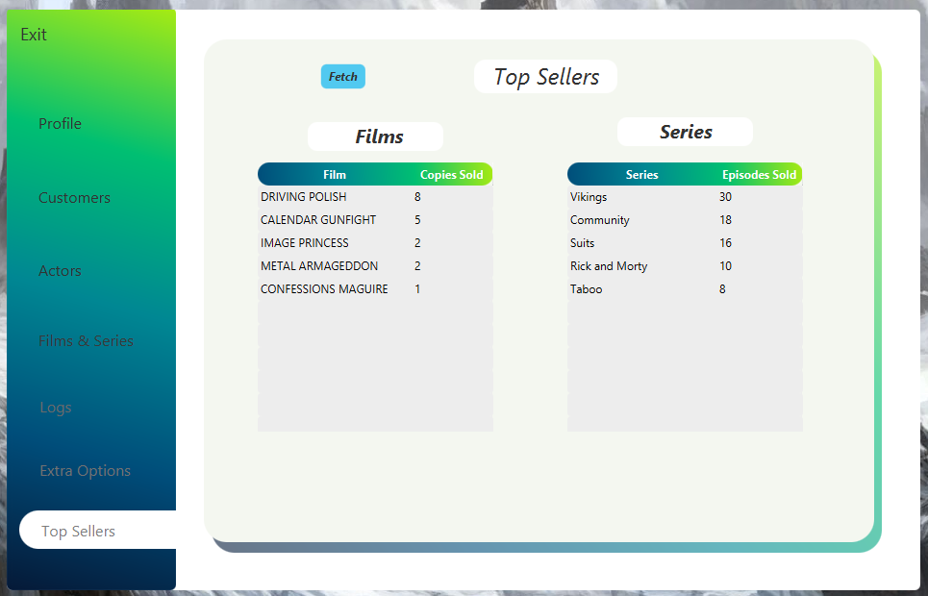

**Κώδικας για τροποποιημένη procedure 3.1**

--

-- PROCEDURE 3.1 for gui

--

create table top_films(film_id SMALLINT, title VARCHAR(128), inventory_id MEDIUMINT, sum tinyint);

create table top_series(series_id SMALLINT, title VARCHAR(128), sum tinyint);

DELIMITER $

CREATE PROCEDURE p(IN product ENUM('m','s'),IN count TINYINT, IN date_1 DATE, IN date_2 DATE)

BEGIN

DECLARE datetime_1 DATETIME;

DECLARE datetime_2 DATETIME;

DECLARE c_datetime DATETIME;

DECLARE date_add DATE;

SELECT CAST(date_1 AS DATETIME) AS 'START_TIME' INTO datetime_1;

SELECT CAST(date_2 AS DATETIME) AS 'TEMP' INTO c_datetime;

SELECT date_add(c_datetime, INTERVAL 1 DAY) AS 'DATE_ADD' INTO date_add; -- metatroph gia na upologizei oloklhrh thn mera tou deuterou orismatos

SELECT CAST(date_add AS DATETIME) AS 'END_TIME' INTO datetime_2;

IF(product = 'm') THEN -- if, gia tanies

insert into top_films (film_id, title, inventory_id , sum)

SELECT film.film_id AS 'FILM ID' , film.title AS 'FILM TITLE', rental.inventory_id, count(rental.rental_id) AS 'RENTAL COUNTS'

FROM rental

INNER JOIN inventory ON rental.inventory_id = inventory.inventory_id

INNER JOIN film ON film.film_id = inventory.film_id

WHERE rental.rental_date >= datetime_1 AND rental.rental_date < datetime_2

GROUP BY rental.inventory_id

order by count(rental.rental_id) desc, film.film_id

LIMIT count;

ELSEIF(product = 's') THEN

-- if, gia seires

insert into top_series (series_id, title, sum)

SELECT series.series_id AS 'SERIES ID' , series.title AS 'SERIES TITLE', sum(season.season_episodes) AS 'SUM OF EPISODES RENTED' -- season.season_episodes

FROM rental

INNER JOIN series_inventory ON rental.series_inventory_id = series_inventory.series_inventory_id

inner join season ON series_inventory.season_id = season.season_id

INNER JOIN series ON series.series_id = season.series_id

WHERE rental.rental_date >= datetime_1 AND rental.rental_date < datetime_2

GROUP BY series.series_id

ORDER BY sum(season.season_episodes) desc , series.series_id

LIMIT count;

END IF;

END$

DELIMITER ;

-- CALL p('s',5,'2007-01-01','2007-04-06');

-- select * from top_series;

-- CALL p('m',7,'2005-06-03','2005-09-20');

-- select * from top_films;

***Admin***

Όμοια με τον πελάτη και τον υπάλληλο εάν κάποιος χρήστης επιθυμεί να εισέλθει στην υπηρεσία με τον **admin** λογαριασμό του πρέπει να πατήσει την επιλογή **admin** στην αρχική σελίδα όπου και θα του φορτώσει την σελίδα ***Admin Login***.

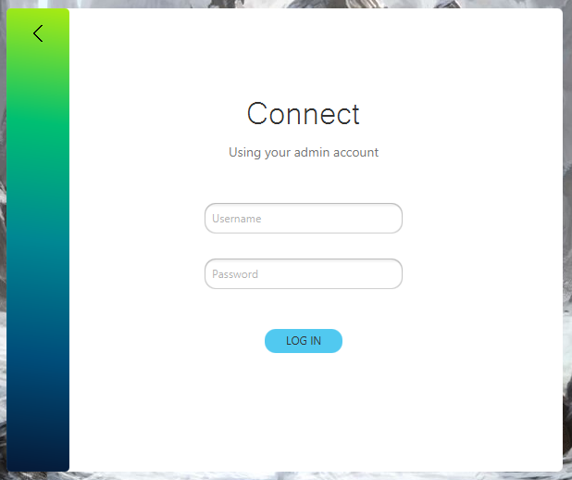

Στην συγκεκριμένη σελίδα δύο είναι επιλογές που μπορεί να πραγματοποιήσει ο χρήστης:

1. *Να επιστρέψει στην αρχική σελίδα πατώντας το πίσω βέλος*



1. *Να συνδεθεί στην υπηρεσία εκχωρώντας τα στοιχεία του*

Ξανά σε περίπτωση λάθους εμφανίζεται κατάλληλο μήνυμα.

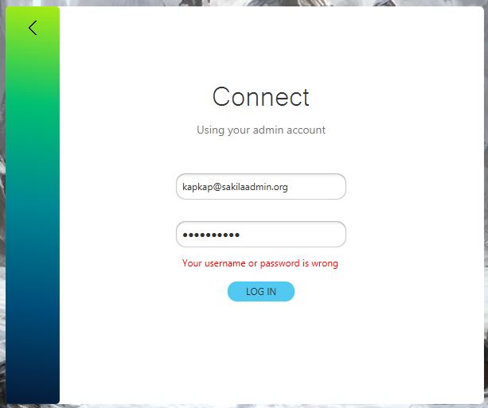

Ενώ σε αντίθετη περίπτωση εισέρχεται στην υπηρεσία.

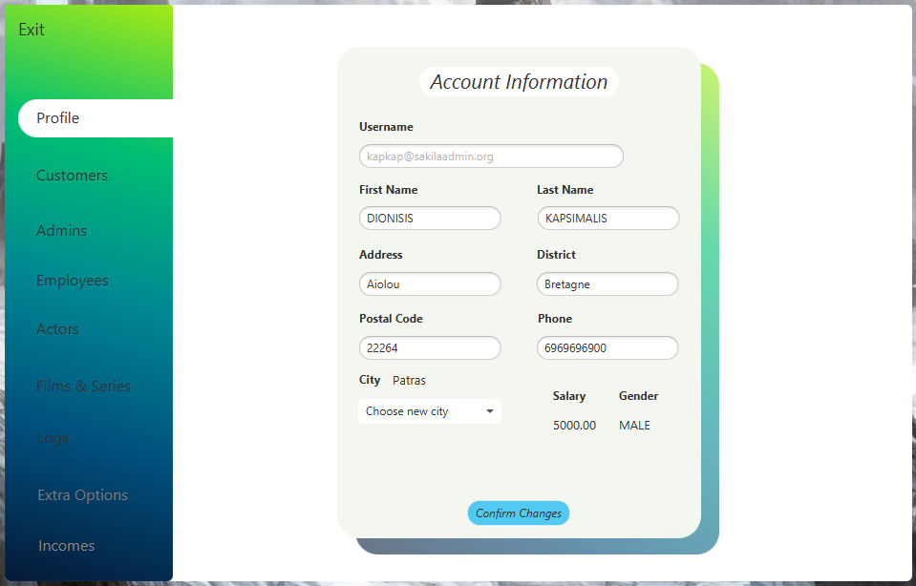

Η συγκεκριμένη απαρτίζεται από τις υποσελίδες *Exit, Profile, Customers, Admins, Employees, Actors, Films & Series, Logs, Extra Options, Incomes* που εμφανίζονται ως επιλογές στην αριστερή μπάρα*.*

1. ***Profile***

Όπως και με τον **Customer** ο **Employee** μπορεί να δεί όλα τα στοιχεία του και να τα αλλάξει εκτός από το ***mail*** του, το ***salary***, το ***rating*** και το ***gender*** -τα 3 τελευταία μπορεί να τα επεξεργαστεί μόνο κάποιος άλλος **admin**.

Ξανά σε περίπτωση ελλιπής συμπλήρωσης στοιχείων εμφανίζονται τα σωστά μηνύματα.

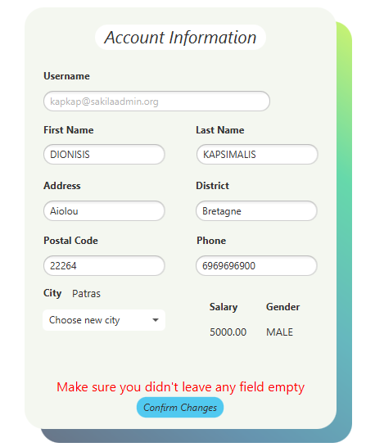

1. ***Customers***

Η λειτουργία της συγκεκριμένης σελίδας είναι κατά γράμμα ίδια με αυτή των employee παρακάτω παρατίθενται τα σχετικά screenshot

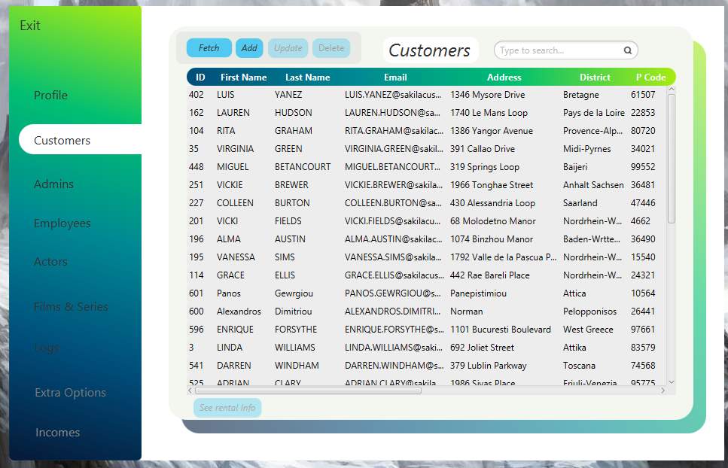

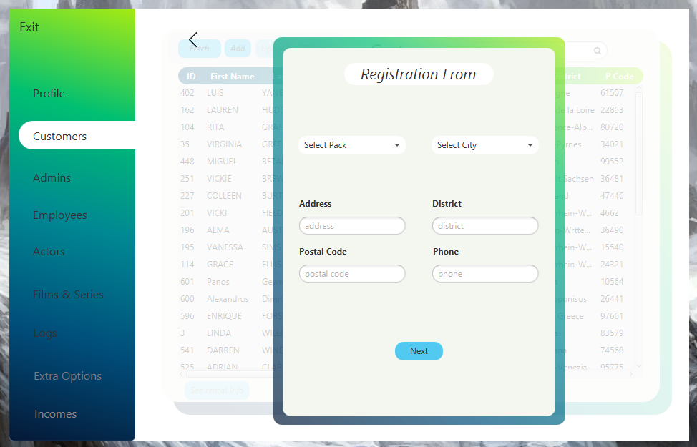

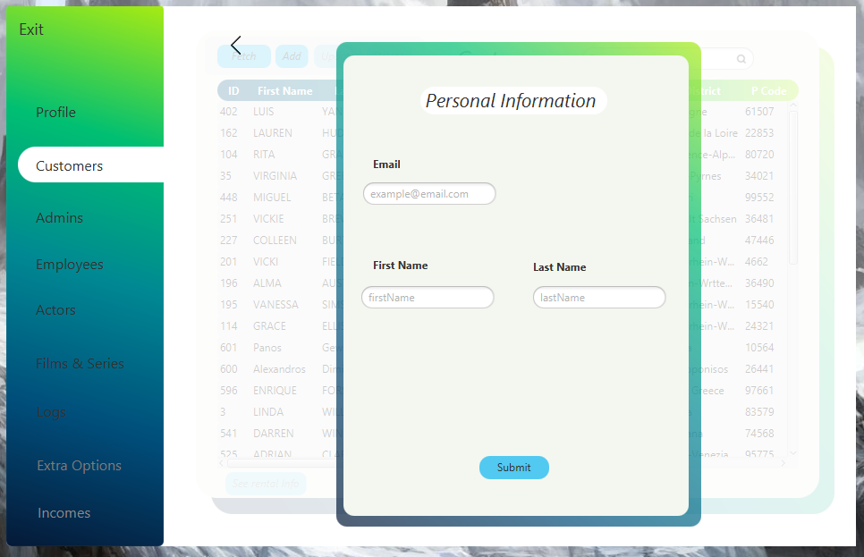





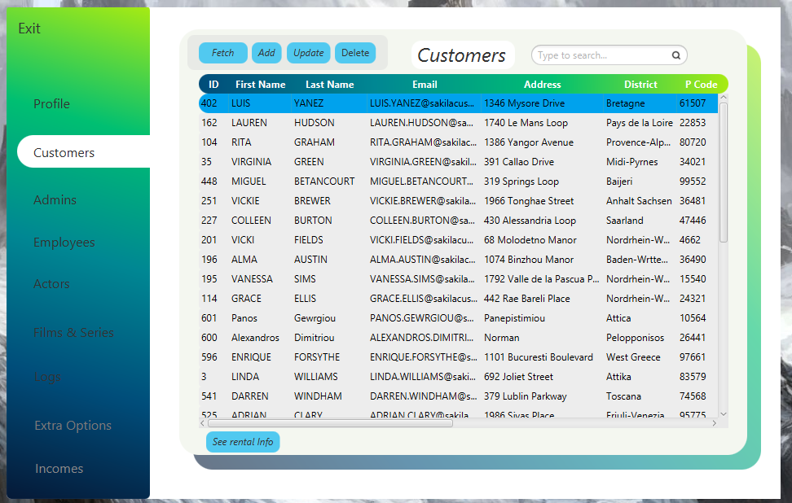

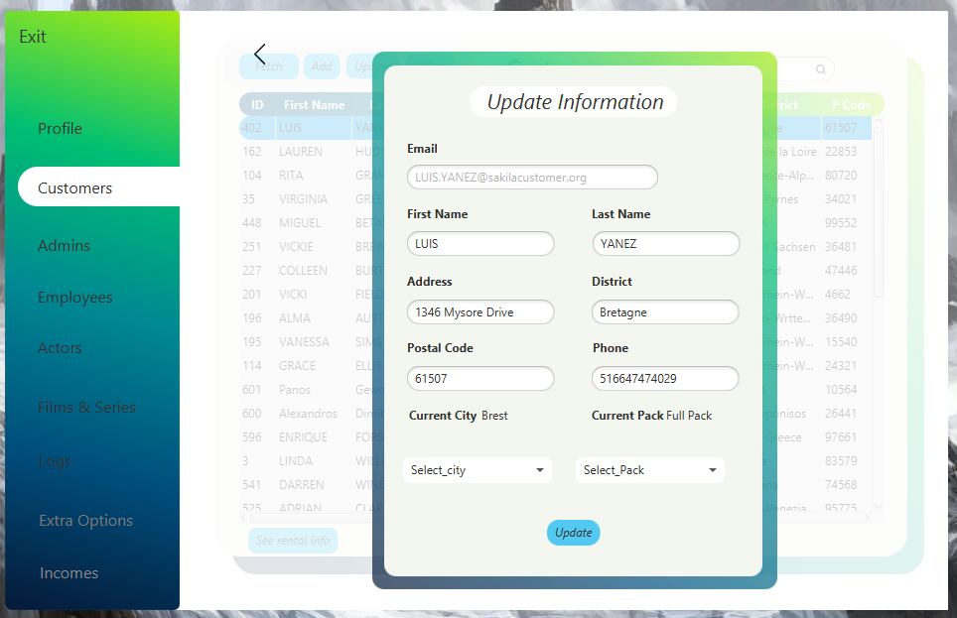

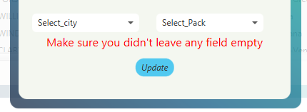

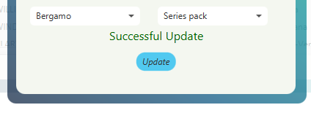

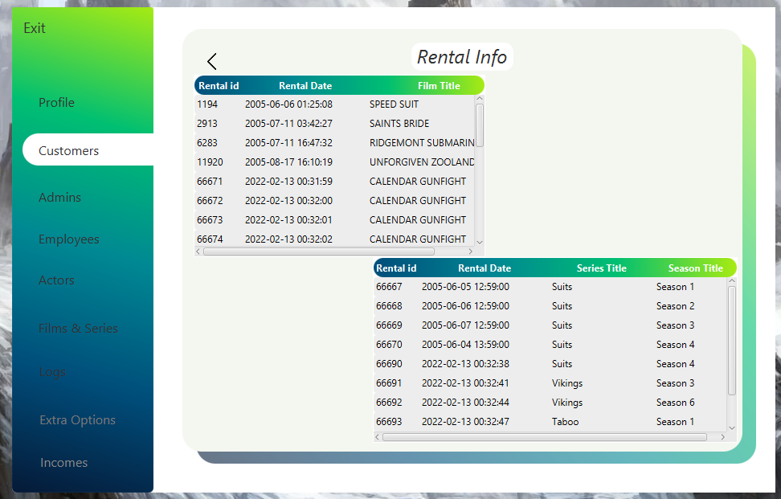

1. ***Admins***

Η συγκεκριμένη σελίδα παρουσιάζει όλα τα στοιχεία των **admin** καθώς και όλες τις λειτουργίες της σελίδας των **customer**. Μόνη προσθήκη στη συγκεκριμένη σελίδα είναι η επιλογή να μετατραπεί ένας **admin** σε **employee** μετα το κλικ ενός κουμπιού.

Παρακάτω παρουσιάζονται τα σχετικά screenshot:

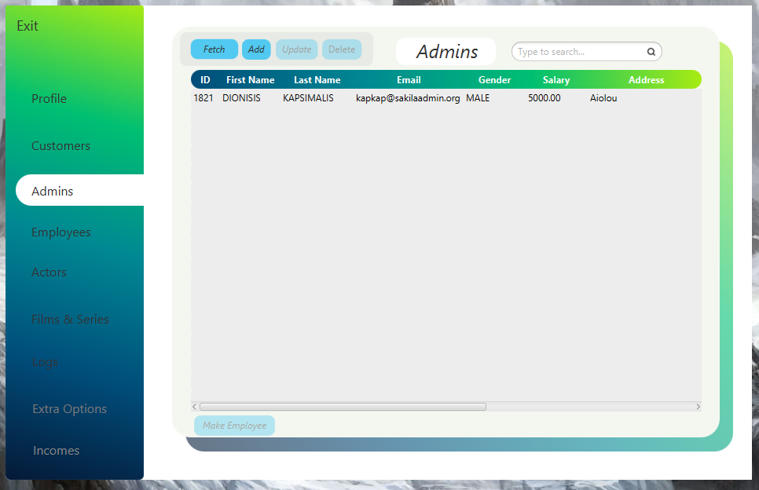

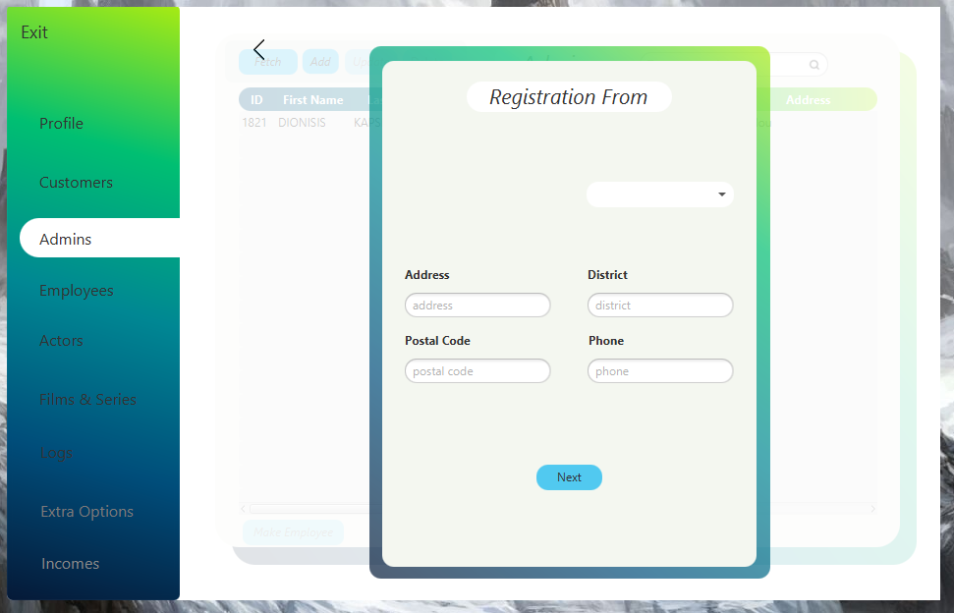

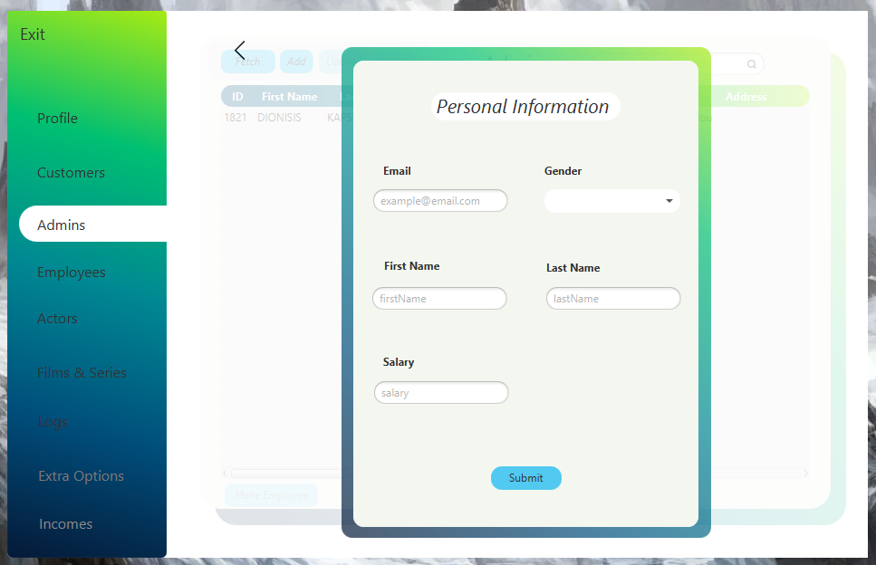



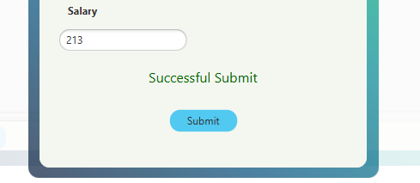

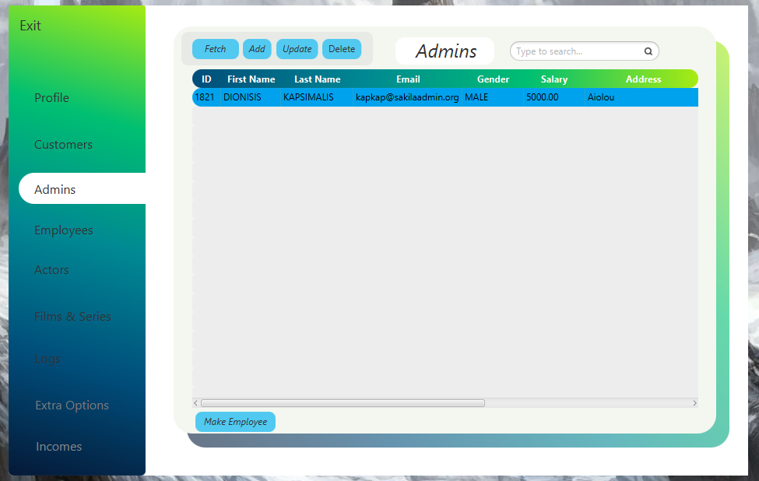

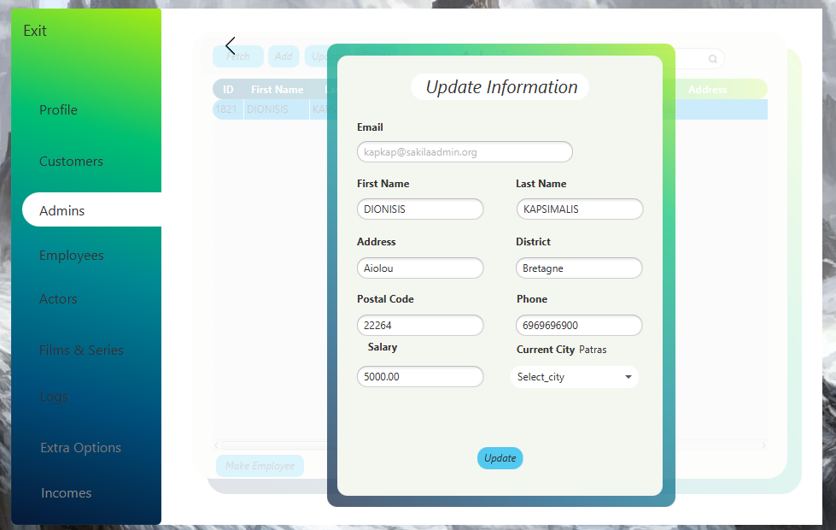

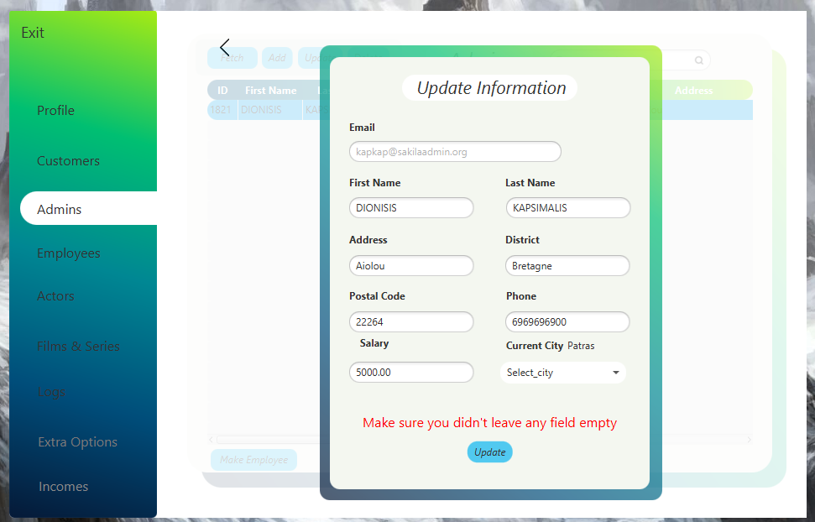

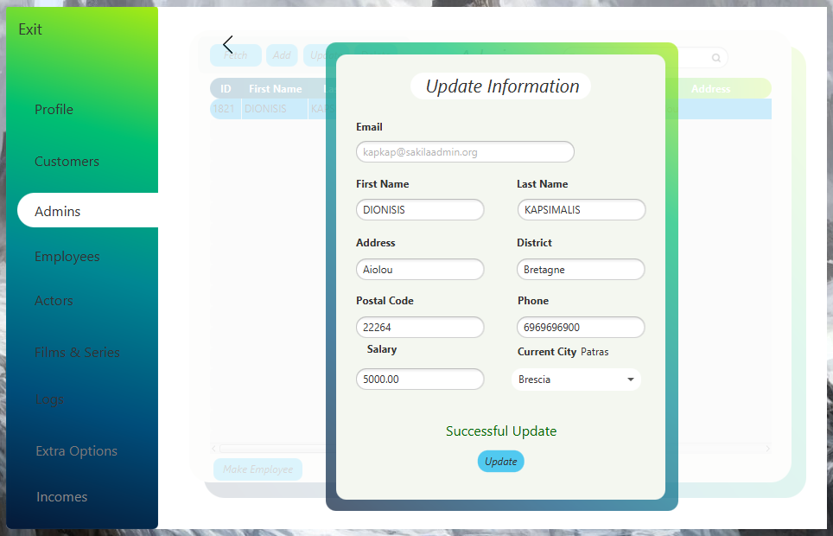

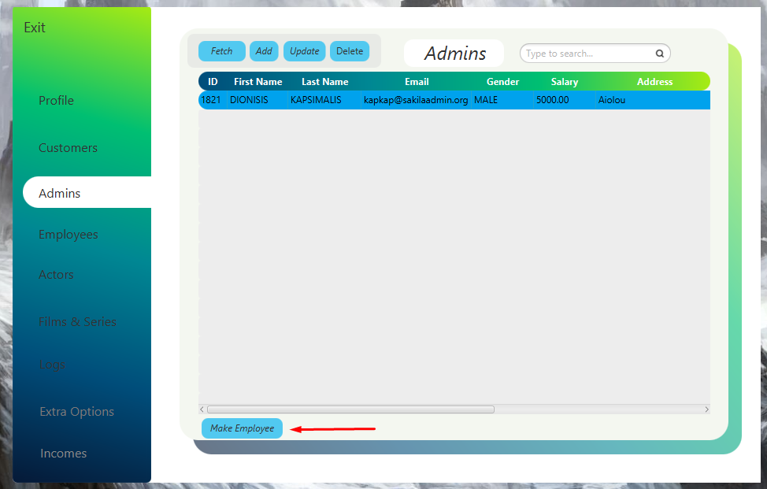

Με το πάτημα του συγκεκριμένου κουμπιού ο **admin** που έχουμε επιλέξει θα αφαιρεθει από τον πίνακα των **admin** και θα προστεθεί στον πίνακα των **employee** το οποίο θα φανέι στα παρακάτω screenshots από την σελίδα των **employee**.

1. ***Employees***

Ο συγκεκριμένος πίνακας παρουσιάζει τους υπαλλήλους που είναι καταχωρημένοι στην βάση και μπορεί να γίνει επεξεργασία των στοιχείων τους ακριβώς όπως και για τους **admin**.

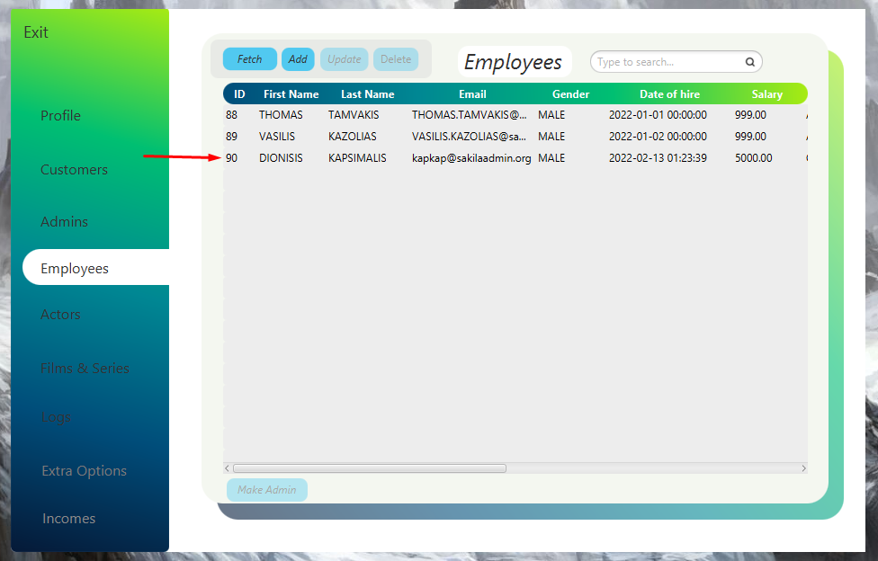

Βλέπουμε ότι η προηγούμενη εκχώρηση στον πίνακα των **employee** έγινε με επιτυχία.

Το ίδιο μπορεί να γίνει και για καποιον **employee**. Πατώντας το κουμπί *Make Admin* ο επιλεγμένος **employee** θα διαγραφεί από τον πίνακα των **employee** και θα γραφτεί στον πίνακα των **admin** ενημερώνοντας προφανώς κατάλληλα τους πίνακες της βάσης.

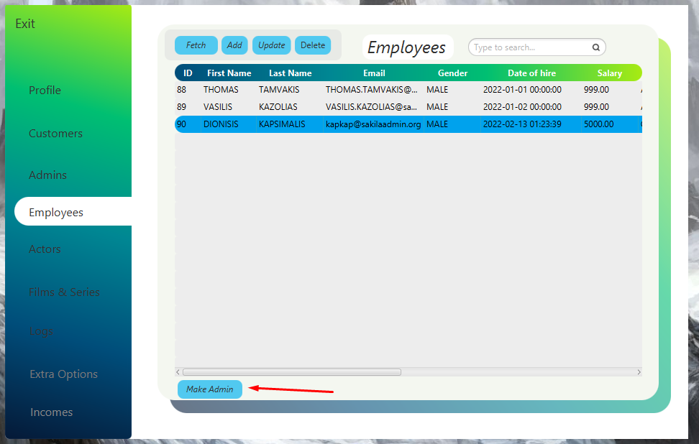

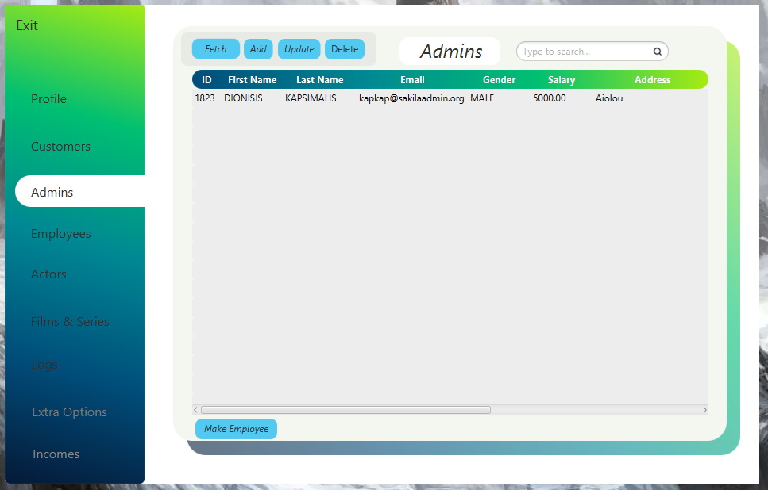

Ο επιλεγμένος **employee** μεταφέρθηκε επιτυχώς ξανά στον πίνακα των **admin**

1. ***Actors***
2. ***Films & Series***
3. ***Logs***

Οι τρείς παραπάνω σελίδες είναι ίδιες κατά γράμμα με αυτές των **employee** στον οποίο και εξηγούνται αναλυτικά.

1. ***Extra Options***

Και η συγκεκριμένη σελίδα είναι ίδια με αυτή των employee ωστόσο αυτή των admin διαθέτει ένα παραπάνω χαρακτηριστικό. Αυτό της δυνατότητας ενημέρωσης των τιμών για κάθε πακέτο που προσφέρεται στην υπηρεσία.

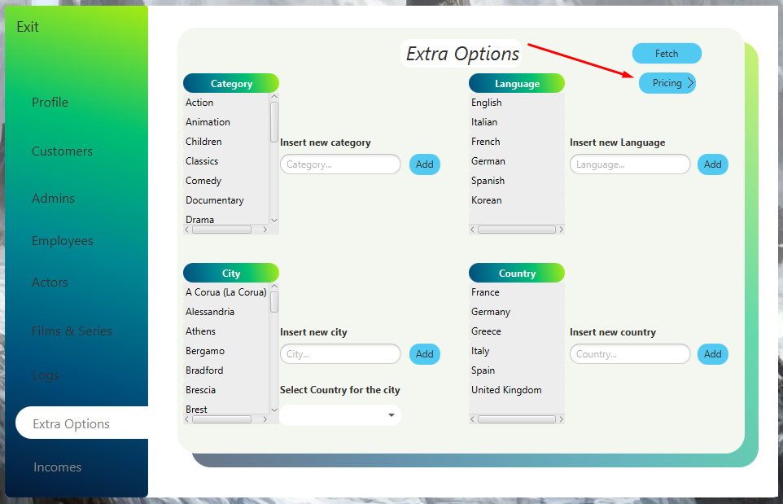

Με το πάτημα του κουμπιού Pricing εισέρχεται στη σκηνή το pane το οποίο αφορά την ενημέρωση των τιμών για το κάθε πακέτο.

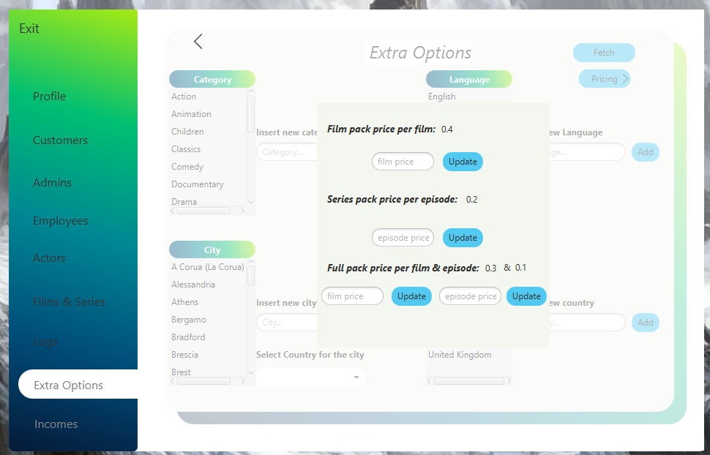

1. ***Incomes***

Στη συγκεκριμένη σελίδα εμφανίζονται τα έσοδα ενοικιάσεων ανά μήνα. Για να επιτευχθεί αυτό το ερώτημα, χρειάστηκε να χρησιμοποιήσουμε μια τροποιημένη εκδοχή της **procedure 3.3**. Συγκεκριμμένα, προσθέσαμε έναν πίνακα με όνομα **total**, στον οποίο εισάγουμε το άθροισμα των εισόδων από τις ενοικιάσεις ταινιών και σειρών, για κάθε μήνα ξεχωριστά από την αρχή λειτουργίας της υπηρεσίας μας, μέχρι την εκτέλεση του προγράμματος. Παρακάτω, παραθέτουμε τον κώδικα της τροποποιημένης procedure, καθώς και ορισμένα screenshot από το πρόγραμμα: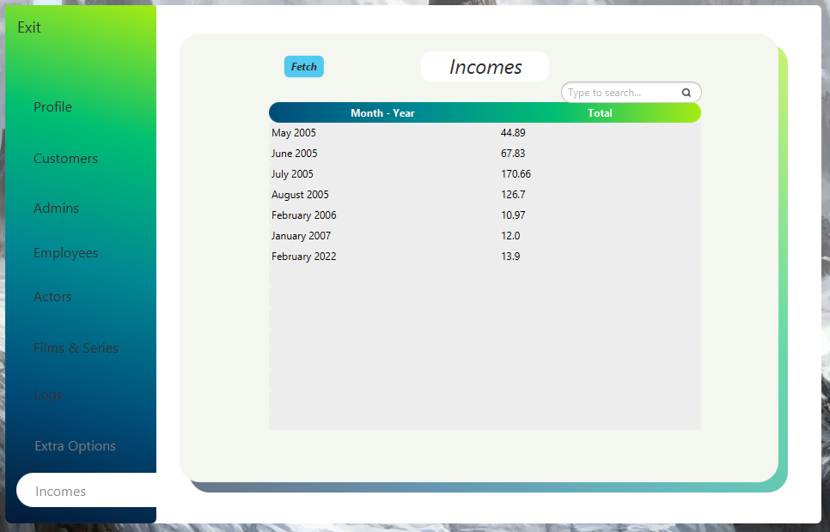

**Κώδικας για τροποποιημένη procedure 3.3**

--

-- 3.3 for GUI

--

CREATE TABLE total(month_year VARCHAR(50), sum DECIMAL(5,2));

DELIMITER $

CREATE PROCEDURE total_m()

BEGIN

DECLARE min_datetime datetime;

DECLARE max_datetime datetime;

DECLARE min_date date;

DECLARE max_date date;

DECLARE day_of_min TINYINT;

DECLARE day_of_max TINYINT;

DECLARE firstday_of_min_month DATE;

DECLARE firstday_of_max_month DATE;

DECLARE firstday_of_max_month_for_until DATE;

DECLARE month_repeat DATE;

DECLARE sum_amount DECIMAL(5,2);

DECLARE month_year VARCHAR(50);

DECLARE first_day_of_month DATE;

DECLARE first_day_of_next_month DATE;

SELECT min(payment_date) INTO min_datetime

FROM payment;

SELECT max(payment_date) INTO max_datetime

FROM payment;

SELECT CAST(min_datetime AS DATE) INTO min_date;

SELECT CAST(max_datetime AS DATE) INTO max_date;

SELECT DAY(min_date) INTO day_of_min;

SELECT DAY(max_date) INTO day_of_max;

SELECT DATE_ADD(min_date, INTERVAL (1-day_of_min) DAY) INTO firstday_of_min_month;

SELECT DATE_ADD(max_date, INTERVAL (1-day_of_max) DAY) INTO firstday_of_max_month;

SELECT DATE_ADD(firstday_of_max_month, INTERVAL 1 MONTH) INTO firstday_of_max_month_for_until;

SET month_repeat = firstday_of_min_month;

REPEAT

SET first_day_of_month = month_repeat;

SELECT DATE_ADD(first_day_of_month, INTERVAL 1 MONTH) INTO first_day_of_next_month;

SELECT DATE_FORMAT(month_repeat,'%M %Y') into month_year;

SELECT sum(payment.amount) as 'AMOUNT' into sum_amount

FROM payment

inner join rental ON rental.rental_id = payment.rental_id

where first_day_of_month<=payment.payment_date AND payment.payment_date < first_day_of_next_month;

INSERT INTO total VALUES (month_year,sum_amount);

-- SELECT month_year AS 'ON MONTH', sum AS 'INCOME';

SELECT DATE_ADD(month_repeat, INTERVAL 1 MONTH) INTO month_repeat;

SET sum_amount = 0.00;

UNTIL(month_repeat=firstday_of_max_month_for_until)

END REPEAT;

END$

DELIMITER ;

CALL total_m();

select distinct * from total where sum is not null;

***Κώδικας SQL***

Τέλος, παρακάτω παραθέτουμε τον κώδικα του πρώτου μέρους (SQL), ο οποίος περιέχει αρχικά τα **tables**, στη συνέχεια τα **inserts** και εν κατακλείδι τις απαντήσεις στα ερωτήματα των **stored procedures** και **triggers**(σε σχόλια το κάθε ερώτημα ξεχωριστά):

DROP SCHEMA IF EXISTS tvondemand;

CREATE SCHEMA tvondemand;

USE tvondemand;

--

-- Table structure for table `actor`

--

CREATE TABLE actor (

actor_id SMALLINT UNSIGNED NOT NULL AUTO_INCREMENT,

first_name VARCHAR(45) NOT NULL,

last_name VARCHAR(45) NOT NULL,

PRIMARY KEY (actor_id)

) ENGINE=InnoDB DEFAULT CHARSET=utf8mb4;

--

-- Table structure for table `country`

--

CREATE TABLE country (

country_id SMALLINT UNSIGNED NOT NULL AUTO_INCREMENT,

country VARCHAR(50) NOT NULL,

PRIMARY KEY (country_id)

) ENGINE=InnoDB DEFAULT CHARSET=utf8mb4;

--

-- Table structure for table `city`

--

CREATE TABLE city (

city_id SMALLINT UNSIGNED NOT NULL AUTO_INCREMENT,

city VARCHAR(50) NOT NULL,

country_id SMALLINT UNSIGNED NOT NULL,

PRIMARY KEY (city_id),

CONSTRAINT `fk_city_country` FOREIGN KEY (country_id) REFERENCES country (country_id) ON DELETE RESTRICT ON UPDATE CASCADE

) ENGINE=InnoDB DEFAULT CHARSET=utf8mb4;

--

-- Table structure for table `address`

--

CREATE TABLE address (

address_id SMALLINT UNSIGNED NOT NULL AUTO_INCREMENT,

address VARCHAR(50) NOT NULL,

district VARCHAR(20) DEFAULT NULL,

city_id SMALLINT UNSIGNED NOT NULL,

postal_code VARCHAR(10) DEFAULT NULL,

phone VARCHAR(20) NOT NULL,

PRIMARY KEY (address_id),

CONSTRAINT `fk_address_city` FOREIGN KEY (city_id) REFERENCES city (city_id) ON DELETE RESTRICT ON UPDATE CASCADE

) ENGINE=InnoDB DEFAULT CHARSET=utf8mb4;

--

-- Table structure for table `category`

--

CREATE TABLE category (

category_id TINYINT UNSIGNED NOT NULL AUTO_INCREMENT,

name VARCHAR(25) NOT NULL,

PRIMARY KEY (category_id)

) ENGINE=InnoDB DEFAULT CHARSET=utf8mb4;

--

-- Table structure for table `language`

--

CREATE TABLE language (

language_id TINYINT UNSIGNED NOT NULL AUTO_INCREMENT,

name CHAR(20) NOT NULL,

PRIMARY KEY (language_id)

) ENGINE=InnoDB DEFAULT CHARSET=utf8mb4;

--

-- Table structure for table `customer`

--

CREATE TABLE customer (

customer_id SMALLINT UNSIGNED NOT NULL AUTO_INCREMENT,

first_name VARCHAR(45) NOT NULL,

last_name VARCHAR(45) NOT NULL,

email VARCHAR(50) DEFAULT NULL,

address_id SMALLINT UNSIGNED NOT NULL,

active BOOLEAN NOT NULL DEFAULT TRUE,

create_date DATETIME NOT NULL,

film_pack BOOLEAN NOT NULL DEFAULT FALSE,

series_pack BOOLEAN NOT NULL DEFAULT FALSE,

full_pack BOOLEAN NOT NULL DEFAULT FALSE,

PRIMARY KEY (customer_id),

CONSTRAINT fk_customer_address FOREIGN KEY (address_id) REFERENCES address (address_id) ON DELETE RESTRICT ON UPDATE CASCADE

)ENGINE=InnoDB DEFAULT CHARSET=utf8mb4;

--

-- Table structure for table `film`

--

CREATE TABLE film (

film_id SMALLINT UNSIGNED NOT NULL AUTO_INCREMENT,

title VARCHAR(128) NOT NULL,

description TEXT DEFAULT NULL,

release_year YEAR DEFAULT NULL,

language_id TINYINT UNSIGNED NOT NULL,

original_language_id TINYINT UNSIGNED DEFAULT NULL,

length SMALLINT UNSIGNED DEFAULT NULL,

rating ENUM('G','PG','PG-13','R','NC-17') DEFAULT 'G',

special_features SET('Trailers','Commentaries','Deleted Scenes','Behind the Scenes','NOTHING') DEFAULT NULL,

PRIMARY KEY (film_id),

CONSTRAINT fk_film_language FOREIGN KEY (language_id) REFERENCES language (language_id) ON DELETE RESTRICT ON UPDATE CASCADE,

CONSTRAINT fk_film_language_original FOREIGN KEY (original_language_id) REFERENCES language (language_id) ON DELETE RESTRICT ON UPDATE CASCADE

) ENGINE=InnoDB DEFAULT CHARSET=utf8mb4;

--

-- table for series

--

CREATE TABLE series(

series_id SMALLINT UNSIGNED NOT NULL AUTO_INCREMENT,

title VARCHAR(128) NOT NULL,

description TEXT DEFAULT NULL,

release_year YEAR DEFAULT NULL,

language_id TINYINT UNSIGNED NOT NULL,

original_language_id TINYINT UNSIGNED DEFAULT NULL,

season_count TINYINT UNSIGNED NOT NULL,

rating ENUM('G','PG','PG-13','R','NC-17') DEFAULT 'G',

special_features SET('Trailers','Commentaries','Deleted Scenes','Behind the Scenes','NOTHING') DEFAULT NULL,

PRIMARY KEY (series_id),

CONSTRAINT fk_series_language FOREIGN KEY (language_id) REFERENCES language (language_id) ON DELETE RESTRICT ON UPDATE CASCADE,

CONSTRAINT fk_series_language_original FOREIGN KEY (original_language_id) REFERENCES language (language_id) ON DELETE RESTRICT ON UPDATE CASCADE

)ENGINE=InnoDB DEFAULT CHARSET=utf8mb4;

--

-- TABLE season

--

CREATE TABLE season(

season_id MEDIUMINT NOT NULL AUTO_INCREMENT,

series_id SMALLINT UNSIGNED NOT NULL,

season_no TINYINT NOT NULL,

season_episodes TINYINT UNSIGNED NOT NULL,

season_title VARCHAR(128) NOT NULL,

PRIMARY KEY(season_id),

CONSTRAINT fk_season_series FOREIGN KEY (series_id) REFERENCES series (series_id) ON DELETE RESTRICT ON UPDATE CASCADE

)ENGINE=InnoDB DEFAULT CHARSET=utf8mb4;

--

-- Table structure for table `film_actor`

--

CREATE TABLE film_series_actor (

actor_id SMALLINT UNSIGNED,

film_id SMALLINT UNSIGNED,

series_id SMALLINT UNSIGNED,

CONSTRAINT fk_film_series_actor_actor FOREIGN KEY (actor_id) REFERENCES actor (actor_id) ON DELETE RESTRICT ON UPDATE CASCADE,

CONSTRAINT fk_film_series__actor_film FOREIGN KEY (film_id) REFERENCES film (film_id) ON DELETE RESTRICT ON UPDATE CASCADE,

CONSTRAINT fk_film_series__actor_series FOREIGN KEY (series_id) REFERENCES series (series_id) ON DELETE RESTRICT ON UPDATE CASCADE

) ENGINE=InnoDB DEFAULT CHARSET=utf8mb4;

--

-- Table structure for table `film_category`

--

CREATE TABLE film_series_category (

film_id SMALLINT UNSIGNED,

category_id TINYINT UNSIGNED,

series_id SMALLINT UNSIGNED,

CONSTRAINT fk_film_series_category_film FOREIGN KEY (film_id) REFERENCES film (film_id) ON DELETE RESTRICT ON UPDATE CASCADE,

CONSTRAINT fk_film_series_category_category FOREIGN KEY (category_id) REFERENCES category (category_id) ON DELETE RESTRICT ON UPDATE CASCADE,

CONSTRAINT fk_film_series_category_series FOREIGN KEY (series_id) REFERENCES series (series_id) ON DELETE RESTRICT ON UPDATE CASCADE

) ENGINE=InnoDB DEFAULT CHARSET=utf8mb4;

--

-- Table structure for table `inventory`

--

CREATE TABLE inventory (

inventory_id MEDIUMINT UNSIGNED NOT NULL AUTO_INCREMENT,

film_id SMALLINT UNSIGNED NOT NULL,

PRIMARY KEY (inventory_id),

CONSTRAINT fk_inventory_film FOREIGN KEY (film_id) REFERENCES film (film_id) ON DELETE RESTRICT ON UPDATE CASCADE

) ENGINE=InnoDB DEFAULT CHARSET=utf8mb4;

--

-- table for series_inventory

--

CREATE TABLE series_inventory (

series_inventory_id MEDIUMINT UNSIGNED NOT NULL AUTO_INCREMENT,

series_id SMALLINT UNSIGNED NOT NULL,

season_id MEDIUMINT NOT NULL ,

PRIMARY KEY (series_inventory_id),

CONSTRAINT fk_series_inventory_series FOREIGN KEY (series_id) REFERENCES series (series_id) ON DELETE RESTRICT ON UPDATE CASCADE,

CONSTRAINT fk_series_inventory_season FOREIGN KEY (season_id) REFERENCES season (season_id) ON DELETE RESTRICT ON UPDATE CASCADE

) ENGINE=InnoDB DEFAULT CHARSET=utf8mb4;

--

-- Table structure for table `rental`

--

CREATE TABLE rental (

rental_id INT NOT NULL AUTO_INCREMENT,

rental_date DATETIME NOT NULL,

inventory_id MEDIUMINT UNSIGNED NULL,

customer_id SMALLINT UNSIGNED NOT NULL,

series_inventory_id MEDIUMINT UNSIGNED NULL,

PRIMARY KEY (rental_id),

UNIQUE KEY (rental_date,customer_id),

CONSTRAINT fk_rental_inventory FOREIGN KEY (inventory_id) REFERENCES inventory (inventory_id) ON DELETE RESTRICT ON UPDATE CASCADE,

CONSTRAINT fk_rental_series_inventory FOREIGN KEY (series_inventory_id) REFERENCES series_inventory (series_inventory_id) ON DELETE RESTRICT ON UPDATE CASCADE,

CONSTRAINT fk_rental_customer FOREIGN KEY (customer_id) REFERENCES customer (customer_id) ON DELETE RESTRICT ON UPDATE CASCADE

) ENGINE=InnoDB DEFAULT CHARSET=utf8mb4;

--

-- Table structure for table `payment`

--

CREATE TABLE payment (

payment_id SMALLINT UNSIGNED NOT NULL AUTO_INCREMENT,

customer_id SMALLINT UNSIGNED NOT NULL,

rental_id INT DEFAULT NULL,

amount DECIMAL(5,2) NOT NULL,

payment_date DATETIME NOT NULL,

PRIMARY KEY (payment_id),

CONSTRAINT fk_payment_rental FOREIGN KEY (rental_id) REFERENCES rental (rental_id) ON DELETE SET NULL ON UPDATE CASCADE,

CONSTRAINT fk_payment_customer FOREIGN KEY (customer_id) REFERENCES customer (customer_id) ON DELETE RESTRICT ON UPDATE CASCADE

) ENGINE=InnoDB DEFAULT CHARSET=utf8mb4;

--

-- table for employee

--

CREATE TABLE employee(

employee_id SMALLINT UNSIGNED NOT NULL AUTO_INCREMENT,

first_name VARCHAR(45) NOT NULL,

last_name VARCHAR(45) NOT NULL,

email VARCHAR(50) DEFAULT NULL,

gender ENUM('FEMALE','MALE') NOT NULL,

address_id SMALLINT UNSIGNED NOT NULL,

date_of_hire DATETIME NOT NULL,

salary DECIMAL(6,2) NOT NULL,

rating ENUM('A1','A2','A3','B1','B2','B3','C1','C2','C3') DEFAULT 'C3',

PRIMARY KEY(employee_id)

)ENGINE=InnoDB DEFAULT CHARSET=utf8mb4;

--

-- table for Admin

--

CREATE TABLE administrator(

admin_id SMALLINT UNSIGNED NOT NULL AUTO_INCREMENT,

first_name VARCHAR(45) NOT NULL,

last_name VARCHAR(45) NOT NULL,

email VARCHAR(50) DEFAULT NULL,

gender ENUM('FEMALE','MALE') NOT NULL,

address_id SMALLINT UNSIGNED NOT NULL,

salary DECIMAL(6,2) NOT NULL,

PRIMARY KEY(admin_id)

)ENGINE=InnoDB DEFAULT CHARSET=utf8mb4;

--

-- table for current_customer

--

CREATE TABLE current_customer (

customer_id SMALLINT UNSIGNED NOT NULL AUTO_INCREMENT,

first_name VARCHAR(45) NOT NULL,

last_name VARCHAR(45) NOT NULL,

email VARCHAR(50) DEFAULT NULL,

create_date DATETIME NOT NULL,

active BOOLEAN NOT NULL DEFAULT TRUE,

country VARCHAR(50) NOT NULL,

address VARCHAR(50) NOT NULL,

district VARCHAR(20) DEFAULT NULL,

city VARCHAR(50) NOT NULL,

postal_code VARCHAR(10) DEFAULT NULL,

phone VARCHAR(20) NOT NULL,

film_pack BOOLEAN NOT NULL DEFAULT FALSE,

series_pack BOOLEAN NOT NULL DEFAULT FALSE,

full_pack BOOLEAN NOT NULL DEFAULT FALSE,

in_use BOOLEAN,

PRIMARY KEY (customer_id)

)ENGINE=InnoDB DEFAULT CHARSET=utf8mb4;

--

-- table for current_Admin

--

CREATE TABLE current_administrator(

admin_id SMALLINT UNSIGNED NOT NULL AUTO_INCREMENT,

first_name VARCHAR(45) NOT NULL,

last_name VARCHAR(45) NOT NULL,

email VARCHAR(50) DEFAULT NULL,

gender ENUM('FEMALE','MALE') NOT NULL,

country VARCHAR(50) NOT NULL,

address VARCHAR(50) NOT NULL,

district VARCHAR(20) DEFAULT NULL,

city VARCHAR(50) NOT NULL,

postal_code VARCHAR(10) DEFAULT NULL,

phone VARCHAR(20) NOT NULL,

salary DECIMAL(6,2) NOT NULL,

in_use BOOLEAN,

PRIMARY KEY(admin_id)

)ENGINE=InnoDB DEFAULT CHARSET=utf8mb4;

--

-- table for current_employee

--

CREATE TABLE current_employee(

employee_id SMALLINT UNSIGNED NOT NULL AUTO_INCREMENT,

first_name VARCHAR(45) NOT NULL,

last_name VARCHAR(45) NOT NULL,

email VARCHAR(50) DEFAULT NULL,

gender ENUM('FEMALE','MALE') NOT NULL,

country VARCHAR(50) NOT NULL,

address VARCHAR(50) NOT NULL,

district VARCHAR(20) DEFAULT NULL,

city VARCHAR(50) NOT NULL,

postal_code VARCHAR(10) DEFAULT NULL,

phone VARCHAR(20) NOT NULL,

date_of_hire DATETIME NOT NULL,

salary DECIMAL(6,2) NOT NULL,

rating ENUM('A1','A2','A3','B1','B2','B3','C1','C2','C3') DEFAULT 'C3',

in_use BOOLEAN,

PRIMARY KEY(employee_id)

)ENGINE=InnoDB DEFAULT CHARSET=utf8mb4;

--

-- Logs Table

--

CREATE TABLE log_table(

first_name VARCHAR(45) NOT NULL,

last_name VARCHAR(45) NOT NULL,

change_date DATETIME NOT NULL DEFAULT '0000-00-00 00:00:00',

katastasi ENUM('Epitixia','Apotixia') NOT NULL,

eidos ENUM('insert','update','delete') NOT NULL,

table_name_ VARCHAR(45) NOT NULL

)ENGINE=InnoDB DEFAULT CHARSET=utf8mb4;

--

-- Pricing Table

--

CREATE TABLE pricing(

film_price DECIMAL(3,1) NOT NULL,

series_price DECIMAL(3,1) NOT NULL,

film_full_pack_price DECIMAL(3,1) NOT NULL,

series_full_pack_price DECIMAL(3,1) NOT NULL

)ENGINE=InnoDB DEFAULT CHARSET=utf8mb4;

-- --------------------------------------------------------------------

USE tvondemand;

--

-- Dumping data for table actor

--

INSERT INTO actor VALUES

(1,'PENELOPE','GUINESS'),

(2,'NICK','WAHLBERG'),

(3,'ED','CHASE'),

(4,'JENNIFER','DAVIS'),

(5,'JOHNNY','LOLLOBRIGIDA'),

(6,'BETTE','NICHOLSON'),

(7,'GRACE','MOSTEL'),

(8,'MATTHEW','JOHANSSON'),

(9,'JOE','SWANK'),

(10,'CHRISTIAN','GABLE'),

(11,'Itzel','Moyer'),

(12,'Thalia','Hernandez'),

(13,'Myla','Craig'),

(14,'Jazmine','Alvarez'),

(15,'Tristin','Banks'),

(16,'Aliyah','Holmes'),

(17,'Joselyn','Curtis'),

(18,'Harper','Walters'),

(19,'Augustus','Kent'),

(20,'Gaige','Compton'),

(21,'Tommy','Ewing'),

(22,'Denzel','Mathis'),

(23,'Karli','Vaughan'),

(24,'Milagros','Tate'),

(25,'Cordell','Richard'),

(26,'Adrien','Miranda'),

(27,'Denise','Wolf'),

(28,'Genesis','Zamora'),

(29,'Manuel','Livingston'),

(30,'Layla','Buckley'),

(31,'Ishaan','Moss'),

(32,'Gilberto','Berry'),

(33,'Deanna','Coffey'),

(34,'Mckenzie','Hutchinson'),

(35,'Jovanny','Webster'),

(36,'Samantha','Peterson'),

(37,'Mila','Frederick'),

(38,'Jaiden','Owens'),

(39,'Adelyn','Boyle'),

(40,'Jamir','Benitez'),

(41,'Josue','Rich'),

(42,'Mateo','Lester'),

(43,'Alisha','Calderon'),

(44,'Cassidy','Miranda'),

(45,'Jasmin','Goodwin'),

(46,'Yasmin','Olsen'),

(47,'Jacquelyn','Jenkins'),

(48,'Kaylyn','Copeland'),

(49,'Malcolm','Potts'),

(50,'Sanai','Greene'),

(51,'Urijah','Hood'),

(52,'Amara','Barr'),

(53,'Taniyah','Mcconnell'),

(54,'Kaelyn','Rangel'),

(55,'Turner','Schmidt'),

(56,'Lennon','Hester'),

(57,'Brooklyn','Banks'),

(58,'Maleah','Oneal'),

(59,'Natalia','Conrad'),

(60,'Ross','Ayers'),

(61,'Antoine','Nicholson'),

(62,'Rylie','Luna'),

(63,'Ramon','Huff'),

(64,'Celia','Nunez'),

(65,'Tabitha','Ho'),

(66,'Dexter','Vargas'),

(67,'Jimmy','Deleon'),

(68,'Micah','Mcintosh'),

(69,'Franklin','Friedman'),

(70,'Lisa','Rodriguez'),

(71,'Lizbeth','Morton'),

(72,'Johnny','Santiago'),

(73,'Jaron','Rowe'),

(74,'William','Pittman'),

(75,'Trevor','Livingston'),

(76,'Averi','Downs'),

(77,'Jordan','Duke'),

(78,'Kyleigh','Rollins'),

(79,'Jude','Galloway'),

(80,'Marcy','Cruz'),

(81,'Reed','Foster'),

(82,'Mauricio','Wiggins'),

(83,'Dax','Santiago'),

(84,'Lorelai','Willis'),

(85,'Aditya','Richardson'),

(86,'Nylah','Horn'),

(87,'Jace','Duran'),

(88,'Ramiro','Andrade'),

(89,'Jasmine','Glover'),

(90,'Freddy','Simon'),

(91,'Ray','Jarvis'),

(92,'Rylee','Duncan'),

(93,'Kadyn','Gentry'),

(94,'Chandler','Hart'),

(95,'Julianne','Gallagher'),

(96,'Rosa','Mccullough'),

(97,'Sofia','Perry'),

(98,'Amir','Fuller'),

(99,'Saul','Case'),

(100,'Itzel','Mendoza'),

(101,'Dario','Escobar'),

(102,'Abel','Juarez'),

(103,'Michaela','Everett'),

(104,'Terry','Meadows'),

(105,'Alice','Lindsey'),

(106,'Tess','Parks'),

(107,'Jaycee','Berg'),

(108,'Jordan','Crosby'),

(109,'Shayla','Dominguez'),

(110,'Greyson','Liu'),

(111,'Kimberly','Raymond'),

(112,'Brittany','Huffman'),

(113,'Marcel','Pennington'),

(114,'Asa','Sherman'),

(115,'Viviana','Mooney'),

(116,'Lillian','Buckley'),

(117,'Lorena','Johnson'),

(118,'Anabel','Hunt'),

(119,'Nina','Small'),

(120,'Rishi','Pope'),

(121,'Jaqueline','Watkins'),

(122,'Mariam','Wise'),

(123,'Dylan','Lambert'),

(124,'Tanner','Zhang'),

(125,'Janet','Cameron'),

(126,'Isabella','Crawford'),

(127,'Kyan','Tapia'),

(128,'Alexzander','Lin'),

(129,'Tyrone','Lamb'),

(130,'Cael','Welch'),

(131,'Gwendolyn','Savage'),

(132,'Monserrat','Curry'),

(133,'Addyson','Watkins'),

(134,'Lily','Wall'),

(135,'Davon','Sampson'),

(136,'Marissa','Mcconnell'),

(137,'Mitchell','Oconnell'),

(138,'Irvin','Booth'),

(139,'Teagan','Copeland'),

(140,'Victoria','Thomas'),

(141,'River','Barnes'),

(142,'Abel','Harvey'),

(143,'Genesis','Khan'),

(144,'Aden','Williams'),

(145,'Tyrell','Mclean'),

(146,'Trevor','Floyd'),

(147,'Declan','Kelly'),

(148,'Asia','Barber'),

(149,'Emilee','Bryant'),

(150,'Sophie','Fitzpatrick'),

(151,'Hazel','Bowman'),

(152,'Karla','Duarte'),

(153,'Levi','Mitchell'),

(154,'Emily','Gilmore'),

(155,'Donavan','Osborn'),

(156,'Yadira','Carey'),

(157,'Matteo','Campbell'),

(158,'Mareli','Shea'),

(159,'Carsen','Brooks'),

(160,'Jaylynn','Turner'),

(161,'Maleah','Fowler'),

(162,'Yosef','Maddox'),

(163,'Alessandro','Walls'),

(164,'Gideon','Durham'),

(165,'Aliana','Glover'),

(166,'Alia','Berg'),

(167,'Jada','Brennan'),

(168,'Aimee','Kirk'),

(169,'Rowan','Owen'),

(170,'Diamond','Monroe'),

(171,'Elliott','Blackwell'),

(172,'German','Oconnor'),

(173,'Glenn','Wallace'),

(174,'Conor','Willis'),

(175,'Breanna','Randall'),

(176,'Dylan','Roman'),

(177,'Simeon','Allen'),

(178,'Kali','Luna'),

(179,'Marin','Soto'),

(180,'Hillary','Meyer'),

(181,'Shania','Duffy'),

(182,'Kathleen','Hahn'),

(183,'Davin','Summers'),

(184,'Rashad','Noble'),

(185,'Judah','Doyle'),

(186,'Shaun','Mitchell'),

(187,'Kathryn','Fry'),

(188,'Lorena','Russo'),

(189,'Melanie','Tanner'),

(190,'Marely','Miranda'),

(191,'Reid','Lang'),

(192,'Easton','Torres'),

(193,'Krista','Romero'),

(194,'Arthur','Mcknight'),

(195,'Aldo','Clarke'),

(196,'Jan','Dillon'),

(197,'Brayan','Krueger'),

(198,'Zavier','Anthony'),

(199,'Alfredo','Greene'),

(200,'Kamila','Prince'),

(201,'Reese','Brennan'),

(202,'Jaylynn','Erickson'),

(203,'Madalynn','Black'),

(204,'Ella','West'),

(205,'Princess','Pace'),

(206,'Camila','Phelps'),

(207,'Elijah','Moore'),

(208,'Shirley','Buck'),

(209,'Simone','Hancock'),

(210,'Liliana','Dawson'),

(211,'Maxwell','Herman'),

(212,'Liana','Watkins'),

(213,'Abel','Mcclure'),

(214,'Lilah','Case'),

(215,'Braydon','Howe'),

(216,'Moises','Herrera'),

(217,'Omari','Butler'),

(218,'Reagan','Powers'),

(219,'Olive','Bullock'),

(220,'Athena','Guzman'),

(221,'Mckenna','Perkins'),

(222,'Ben','Decker'),

(223,'Sage','Pratt'),

(224,'Braden','English'),

(225,'Jaden','Neal'),

(226,'Kelvin','Petty'),

(227,'Kevin','Callahan'),

(228,'Josiah','Zhang'),

(229,'Emilio','Valdez'),

(230,'Emmett','Williamson'),

(231,'Meghan','Molina'),

(232,'Emilia','Fernandez'),

(233,'Amiyah','Fleming'),

(234,'Marlee','Welch'),

(235,'Cierra','Shea'),

(236,'Meadow','Campbell'),

(237,'Brady','Walker'),

(238,'Jonas','Forbes'),

(239,'Anton','Waller'),

(240,'Riley','Glenn'),

(241,'Ben','Mendez'),

(242,'Chase','Mclaughlin'),

(243,'Chasity','Sparks'),

(244,'Terrell','Whitehead'),

(245,'Kayley','Andersen'),

(246,'Paulina','Keith'),

(247,'Rylee','Charles'),

(248,'Areli','Romero'),

(249,'Tyrell','Patrick'),

(250,'Neveah','Davenport'),

(251,'Cristofer','Johns'),

(252,'Cannon','Giles'),

(253,'Zackery','Cruz'),

(254,'Jonah','Ho'),

(255,'Gabrielle','York'),

(256,'Emery','Aguirre'),

(257,'Gianni','Sheppard'),

(258,'Simone','Griffith'),

(259,'Brady','Leach'),

(260,'Cara','Mullins'),

(261,'Breanna','Burton'),

(262,'Franklin','Martinez'),

(263,'Maryjane','King'),

(264,'Aileen','Mcintyre'),

(265,'Jace','Moon'),

(266,'Libby','Rogers'),

(267,'Brooklynn','Gibbs'),

(268,'Kasey','Paul'),

(269,'Gideon','Walker'),

(270,'Alina','Payne'),

(271,'Ashlyn','Pope'),

(272,'Whitney','Berry'),

(273,'Kamden','Bowen'),

(274,'Aaliyah','Cooper'),

(275,'Derick','Hill'),

(276,'Jenny','Boyd'),

(277,'Makhi','Barber'),

(278,'Myla','Bradley'),

(279,'Beatrice','Murphy'),

(280,'Zachary','Mckenzie'),

(281,'Alberto','Walton'),

(282,'Dwayne','Sexton'),

(283,'Braylen','Ayala'),

(284,'Angela','Hays'),

(285,'Memphis','Mcgee'),

(286,'Kaley','Strickland'),

(287,'Beau','Schaefer'),

(288,'Kallie','Griffin'),

(289,'Aisha','Roberts'),

(290,'Lilly','Mccarthy'),

(291,'Adelyn','Payne'),

(292,'Julissa','Ballard'),

(293,'Jasmin','Powers'),

(294,'Colten','Glover'),

(295,'Liana','Buchanan'),

(296,'Viviana','Soto'),

(297,'Glenn','Ruiz'),

(298,'Breanna','Green'),

(299,'Leonardo','Farley'),

(300,'Sienna','Berger'),

(301,'Penelope','Becker'),

(302,'Carlo','Kerr'),

(303,'Marcus','Mack'),

(304,'Trey','Dean'),

(305,'Tomas','Barton'),

(306,'Haven','Townsend'),

(307,'Jaxon','Fry'),

(308,'Javon','Yu'),

(309,'Alfred','Rasmussen'),

(310,'Troy','Brewer'),

(311,'Colby','Holt'),

(312,'Jane','Lam'),

(313,'Nicholas','Werner'),

(314,'Stacy','Hutchinson'),

(315,'Jaiden','Martin'),

(316,'Makenna','Tanner'),

(317,'Nevaeh','Daniel'),

(318,'Darian','Mcclure'),

(319,'Lucille','Ritter'),

(320,'Georgia','Houston'),

(321,'Aleah','Lynch'),

(322,'Paloma','Hughes'),

(323,'Malachi','Rocha'),

(324,'June','Nixon'),

(325,'Frank','Baker'),

(326,'Shannon','Torres'),

(327,'Kamora','Small'),

(328,'Lawson','Mccormick'),

(329,'Keyon','Morton'),

(330,'Efrain','Salas'),

(331,'Royce','Graves'),

(332,'Albert','Huff'),

(333,'Clara','Underwood'),

(334,'Jovanny','Lin'),

(335,'Elena','Gill'),

(336,'Meredith','Mcconnell'),

(337,'Anna','Lucero'),

(338,'Kirsten','Daniel'),

(339,'Logan','Arellano'),

(340,'Aaliyah','Gilmore'),

(341,'Journey','Murray'),

(342,'Jordin','Krause'),

(343,'Quinn','Stanley'),

(344,'Gerald','Waller'),

(345,'Thaddeus','Myers'),

(346,'Martha','Osborn'),

(347,'Malakai','Greer'),

(348,'Jaylon','Davies'),

(349,'Talan','Bush'),

(350,'Louis','Spencer'),

(351,'Jaeden','Harrell'),

(352,'Payton','Mccoy'),

(353,'Marques','Gaines'),

(354,'Urijah','Arellano'),

(355,'Everett','Rush'),

(356,'Kymani','Greer'),

(357,'Lailah','Pearson'),

(358,'Kayley','Francis'),

(359,'Eliana','Calhoun'),

(360,'Jaxon','Benson'),

(361,'Mareli','Schneider'),

(362,'Lamont','Poole'),

(363,'Carley','Morton'),

(364,'Simon','Baker'),

(365,'Alissa','Maddox'),

(366,'Josie','Fernandez'),

(367,'Alia','Cobb'),

(368,'Rylie','Cline'),

(369,'Hannah','Mcbride'),

(370,'Adelaide','Lamb'),

(371,'Jarrett','Mckay'),

(372,'Kenzie','Patel'),

(373,'Jesus','Randall'),

(374,'Octavio','Davies'),

(375,'Dorian','Howe'),

(376,'Chance','Estes'),

(377,'Valerie','Warner'),

(378,'Lindsey','Harrison'),

(379,'Holden','Neal'),

(380,'Hunter','Madden'),

(381,'Mira','Mcguire'),

(382,'Lillian','Goodman'),

(383,'Lennon','Soto'),

(384,'Belen','Robertson'),

(385,'Carissa','Taylor'),

(386,'Killian','Sexton'),

(387,'Sierra','Espinoza'),

(388,'Brennan','Salazar'),

(389,'Kiara','Terrell'),

(390,'Kailey','Mooney'),

(391,'Samson','Mercado'),

(392,'Hezekiah','Harrison'),

(393,'Danna','Hahn'),

(394,'Kenyon','Strong'),

(395,'Cruz','Novak'),

(396,'Atticus','Robertsson'),

(397,'Makhi','Pollard'),

(398,'Raina','Floyd'),

(399,'Kathleen','Robertson'),

(400,'Adyson','Sparks'),

(401,'Jayden','Newton'),

(402,'Humberto','Byrd'),

(403,'German','King'),

(404,'Jaiden','Haynes'),

(405,'Emmalee','Diaz'),

(406,'Brianna','Wiley'),

(407,'Justine','Ashley'),

(408,'Cara','Park'),

(409,'Yael','Moss'),

(410,'Madyson','Harrell'),

(411,'Cole','Hunt'),

(412,'Alyvia','Pugh'),

(413,'Violet','Weeks'),

(414,'Jaylin','Kline'),

(415,'Gustavo','Mayo'),

(416,'Leonardo','Whitaker'),

(417,'Jalen','Wood'),

(418,'Aiyana','Vance'),

(419,'Gia','Stewart'),

(420,'Luke','Haas'),

(421,'Deven','Pham'),

(422,'Ashley','Gould'),

(423,'Patrick','Benson'),

(424,'Elaine','Dickson'),

(425,'Baron','Meyer'),

(426,'Riya','Ashley'),

(427,'Madilynn','Huynh'),

(428,'Angelo','Mitchell'),

(429,'Aydin','Silva'),

(430,'Malik','Haynes'),

(431,'Kody','Schneider'),

(432,'Dominique','Wolfe'),

(433,'Frankie','Smith'),

(434,'Urijah','Shelton'),

(435,'Julissa','Prince'),

(436,'Jesus','Watkins'),

(437,'Lea','Boone'),

(438,'Rowan','Morgan'),

(439,'Jaquan','Hancock'),

(440,'Ashton','Arroyo'),

(441,'Bailee','Phelps'),

(442,'Perla','Howard'),

(443,'Derrick','Rosario'),

(444,'Abdullah','Mcpherson'),

(445,'Donte','Rush'),

(446,'Cason','Guzman'),

(447,'Alexzander','Cooke'),

(448,'Jacey','David'),

(449,'Raelynn','Hicks'),

(450,'Katherine','Brewer'),

(451,'Eugene','Cowan'),

(452,'Patricia','Burton'),

(453,'Larry','Cantu'),

(454,'Nikolai','Mcintyre'),

(455,'Dana','Crawford'),

(456,'Mariana','Rowe'),

(457,'Lane','Bryan'),

(458,'Kirsten','Kane'),

(459,'Santino','Jackson'),

(460,'Quinn','Hamilton'),

(461,'Carlos','Ward'),

(462,'Edward','Galloway'),

(463,'Hope','Horton'),

(464,'Charlee','Torres'),

(465,'Aubree','Parrish'),

(466,'Kassandra','Strong'),

(467,'Alyssa','Barnett'),

(468,'Kiana','Bridges'),

(469,'Nora','Oliver'),

(470,'Darren','Rice'),

(471,'Isaias','Wilcox'),

(472,'Isiah','Fisher'),

(473,'Bryan','Hardy'),

(474,'Laila','Gross'),

(475,'Devyn','Wise'),

(476,'Martin','Banks'),

(477,'Cloe','Carrillo'),

(478,'Jaiden','Yu'),

(479,'Jaxson','Glenn'),

(480,'Kianna','King'),

(481,'Roman','Sellers'),

(482,'Jaelynn','Hurley'),

(483,'Amira','Montoya'),

(484,'Marley','Herman'),

(485,'Lara','Rice'),

(486,'Lawson','Guerra'),

(487,'Logan','Galloway'),

(488,'Emilee','Joyce'),

(489,'Maxim','Fitzgerald'),

(490,'Payten','Zuniga'),

(491,'Kael','Glass'),

(492,'Sharon','Ortega'),

(493,'Aliyah','Kirby'),

(494,'Kallie','Salinas'),

(495,'Bo','Thompson'),

(496,'Ezra','Michael'),

(497,'Andrew','Tucker'),

(498,'Elise','Johnson'),

(499,'Johnathan','Blair'),

(500,'Conrad','Irwin'),

(501,'Dahlia','Glenn'),

(502,'Adelaide','Mcknight'),

(503,'Emerson','Tucker'),

(504,'Mylee','Holden'),

(505,'Reed','Lucero'),

(506,'Elaina','Haney'),

(507,'Tabitha','Snyder'),

(508,'Talan','Lee'),

(509,'Jennifer','Simmons'),

(510,'Marley','Mcconnell'),

(511,'Roy','Stafford'),

(512,'Anton','Bush'),

(513,'Melina','Hebert'),

(514,'Aydin','Navarro'),

(515,'Kai','Mcpherson'),

(516,'Cristofer','Cunningham'),

(517,'Shiloh','Meza'),

(518,'Erika','Coleman'),

(519,'Jordan','Kaufman'),

(520,'Destiney','Stanley'),

(521,'Nicholas','Deleon'),

(522,'Deandre','Wolfe'),

(523,'Tania','Mueller'),

(524,'Eva','Clark'),

(525,'Raul','Ashley'),

(526,'Jakob','Weaver'),

(527,'Catalina','Duffy'),

(528,'Michelle','Shepherd'),

(529,'Emmy','Francis'),

(530,'Mekhi','Sanchez'),

(531,'Kailey','Arroyo'),

(532,'Julian','Weiss'),

(533,'Jazmine','Wallace'),

(534,'Lailah','Johnson'),

(535,'Kenya','Ballard'),

(536,'Noelle','Nichols'),

(537,'Amare','Mercer'),

(538,'Catalina','Dominguez'),

(539,'Eduardo','Knapp'),

(540,'Elaina','Byrd'),

(541,'Alfred','Curtis'),

(542,'Jaylon','Lester'),

(543,'Janiyah','Villegas'),

(544,'Serena','Ford'),

(545,'Nora','Stein'),

(546,'Laura','Sosa'),

(547,'Arnav','Davila'),

(548,'Miles','Haney'),

(549,'Tucker','Alvarez'),

(550,'Jacqueline','Potter'),

(551,'Demetrius','Durham'),

(552,'Jerry','Fletcher'),

(553,'Jaida','Lozano'),

(554,'August','Mccullough'),

(555,'Kaelyn','Chaney'),

(556,'Annalise','Hodge'),

(557,'Miracle','Hampton'),

(558,'Esperanza','Mcbride'),

(559,'Cordell','Mcconnell'),

(560,'Elliott','Flowers'),

(561,'Reese','Davenport'),

(562,'Kylan','Bean'),

(563,'Phillip','Frye'),

(564,'Jaylan','Salazar'),

(565,'Evelyn','Burnett'),

(566,'Gustavo','Ayala'),

(567,'Cadence','Schultz'),

(568,'Dulce','Coleman'),

(569,'Trystan','Kane'),

(570,'Gael','Douglas'),

(571,'River','Noble'),

(572,'Donte','Frank'),

(573,'Allie','Fry'),

(574,'Jan','West'),

(575,'Jewel','Figueroa'),

(576,'Alexia','Li'),

(577,'Hayden','Wall'),

(578,'Chad','Richardson'),

(579,'Gilbert','Velez'),

(580,'Fisher','Hayden'),

(581,'Reed','Sutton'),

(582,'Tianna','Romero'),

(583,'Aubrey','Reilly'),

(584,'Eleanor','Ortega'),

(585,'Owen','Cline'),

(586,'Nylah','Rush'),

(587,'Miley','Mathews'),

(588,'Beau','Vaughan'),

(589,'Marcel','Clark'),

(590,'Dallas','Vaughn'),

(591,'Hugh','Arroyo'),

(592,'Urijah','Hendricks'),

(593,'Jolie','Harris'),

(594,'Krish','Mcguire'),

(595,'Frida','Stanley'),

(596,'Judith','Strickland'),

(597,'Marlie','Terry'),

(598,'Nigel','Dorsey'),

(599,'Areli','Booth'),

(600,'Cheyanne','Hardy'),

(601,'Taliyah','Farrell'),

(602,'Sarah','Berg'),

(603,'Macie','Huynh'),

(604,'Malaki','Sellers'),

(605,'Cedric','Matthews'),

(606,'Justine','Barr'),

(607,'Eden','Moran'),

(608,'Tobias','Davenport'),

(609,'Brendan','Ramirez'),

(610,'Skylar','Cochran'),

(611,'Ian','Wilkins'),

(612,'Craig','Cox'),

(613,'Sanaa','Mercer'),

(614,'Rodolfo','Knox'),

(615,'Leyla','Baker'),

(616,'Simone','Hernandez'),

(617,'Jace','Richards'),

(618,'Ashley','Barnett'),

(619,'Rylan','Romero'),

(620,'Baron','Arroyo'),

(621,'Mayra','Short'),

(622,'Donovan','Mccullough'),

(623,'Amaris','Salas'),

(624,'Charlize','Roberts'),

(625,'Mckayla','Hanson'),

(626,'Leo','Church'),

(627,'Carina','Wood'),

(628,'Marisa','Delgado'),

(629,'Gabriella','Pham'),

(630,'Grayson','Colon'),

(631,'Isiah','Miranda'),

(632,'Akira','Robbins'),

(633,'Jaeden','Wong'),

(634,'Janet','Mcmahon'),

(635,'Alena','Livingston'),

(636,'Everett','Braun'),

(637,'Isaac','Cordova'),

(638,'Trace','Pineda'),

(639,'Bryson','Dalton'),

(640,'Aditya','Good'),

(641,'Clare','Poole'),

(642,'Jacob','Dickerson'),

(643,'Alexis','Zavala'),

(644,'Santino','Powers'),

(645,'Maurice','Huff'),

(646,'Anna','Herrera'),

(647,'Landin','Herring'),

(648,'Casey','Livingston'),

(649,'Paul','Sampson'),

(650,'Jakayla','Alvarado'),

(651,'Ellie','Moody'),

(652,'Makaila','Stanley'),

(653,'Chace','Schmidt'),

(654,'Danielle','Dennis'),

(655,'Hadassah','Pennington'),

(656,'Deacon','Tanner'),

(657,'Hunter','Ramirez'),

(658,'Belen','Keith'),

(659,'Hector','Hines'),

(660,'Marianna','Chaney'),

(661,'Isiah','Barry'),

(662,'Karma','Zavala'),

(663,'Coleman','Rosario'),

(664,'Cash','Morgan'),

(665,'Eliana','Burgess'),

(666,'Courtney','Hunter'),

(667,'Jaelynn','Hardin'),

(668,'Kobe','Levy'),

(669,'Anne','Byrd'),

(670,'Malcolm','Coleman'),

(671,'Kierra','Cisneros'),

(672,'Charlie','Huff'),

(673,'Leon','Dominguez'),

(674,'Nikolai','Sosa'),

(675,'Braiden','Strong'),

(676,'Felipe','Mcclain'),

(677,'Mckenna','Werner'),

(678,'Carissa','Barry'),

(679,'Trystan','Jensen'),

(680,'Dante','Little'),

(681,'Jaeden','Jones'),

(682,'Kailee','Chase'),

(683,'Ximena','Wood'),

(684,'Nadia','Douglas'),

(685,'Reagan','Ibarra'),

(686,'Rigoberto','Guerra'),

(687,'Miriam','Hayes'),

(688,'Sage','Camacho'),

(689,'Adalynn','Bowers'),

(690,'Jerome','Heath'),

(691,'Heaven','Carr'),

(692,'Vaughn','Robertson'),

(693,'Maverick','Moore'),

(694,'Jensen','Simpson'),

(695,'Madden','Huang'),

(696,'Khloe','Moore'),

(697,'Jack','Schaefer'),

(698,'Karley','Gay'),

(699,'Savion','Compton'),

(700,'Braden','Fuller'),

(701,'Memphis','Carroll'),

(702,'Daniella','Mathews'),

(703,'Semaj','Harrington'),

(704,'Giselle','Hendrix'),

(705,'Marisa','Kirk'),

(706,'Valery','Sullivan'),

(707,'Elena','Preston'),

(708,'Trystan','Reeves'),

(709,'Mayra','Frazier'),

(710,'Carlee','Blackburn'),

(711,'Stephany','Walton'),

(712,'Aaliyah','Hendrix'),

(713,'Gaige','Potter'),

(714,'Julio','Fowler'),

(715,'Alyvia','Kline'),

(716,'Lamar','Goodwin'),

(717,'Kyan','Mullins'),

(718,'Rohan','Lopez'),

(719,'Lily','Reynolds'),

(720,'Tate','Gates'),

(721,'Gabrielle','Horn'),

(722,'Azul','Sims'),

(723,'Annika','Fitzgerald'),

(724,'Odin','Clements'),

(725,'Louis','Orozco'),

(726,'Emilia','Robinson'),

(727,'Abigayle','Mclean'),

(728,'Selena','Griffin'),

(729,'Pierre','Stevens'),

(730,'Jake','Suarez'),

(731,'Preston','Willis'),

(732,'Iliana','Schaefer'),

(733,'Josie','West'),

(734,'Justice','Torres'),

(735,'Damaris','Gibbs'),

(736,'Taylor','Ayala'),

(737,'Andy','Hopkins'),

(738,'Brenton','Hays'),

(739,'Maximilian','Ward'),

(740,'Ismael','Randolph'),

(741,'Cheyanne','Shepherd'),

(742,'Hunter','Dougherty'),

(743,'Demarcus','Cuevas'),

(744,'Davin','Frazier'),

(745,'Willie','Skinner'),

(746,'Gerald','Gomez'),

(747,'Kaylie','Santana'),

(748,'Julissa','Yang'),

(749,'Chloe','Villa'),

(750,'Evelin','Mosley'),

(751,'Lincoln','Delgado'),

(752,'Ryder','Ellis'),

(753,'Erin','Sellers'),

(754,'Maddox','Gill'),

(755,'Ayden','Scott'),

(756,'Damaris','Oneill'),

(757,'Cailyn','Guerra'),

(758,'Lillian','Richardson'),

(759,'Aliyah','Fischer'),

(760,'Payton','Davidson'),

(761,'Matias','Henry'),

(762,'Jorge','Hardy'),

(763,'Corey','Frederick'),

(764,'Fiona','Pitts'),

(765,'Charlie','Harrell'),

(766,'Nathalia','Pacheco'),

(767,'Zane','Duffy'),

(768,'Brooks','Randall'),

(769,'Nikolai','Cooke'),

(770,'Chaz','Pittman'),

(771,'Timothy','Cain'),

(772,'Charlotte','Stafford'),

(773,'Amina','Wilkinson'),

(774,'Cullen','Walls'),

(775,'Aldo','Costa'),

(776,'Alex','Barry'),

(777,'Eliana','Booth'),

(778,'Boston','Everett'),

(779,'Douglas','Wu'),

(780,'Ella','Paul'),

(781,'Pranav','Mcmillan'),

(782,'Kobe','Orr'),

(783,'Kendal','Hobbs'),

(784,'Claire','Barton'),

(785,'Saige','Serrano'),

(786,'Milo','Rojas'),

(787,'Anthony','Haley'),

(788,'Kimberly','Middleton'),

(789,'Tristian','Maxwell'),

(790,'Reid','Blevins'),

(791,'Trent','Kirby'),

(792,'Alma','Ochoa'),

(793,'Bentley','Barrera'),

(794,'Jaydin','Werner'),

(795,'Dominik','Higgins'),

(796,'Abagail','Wiggins'),

(797,'Grayson','Bartlett'),

(798,'Sadie','Mckinney'),

(799,'Hamza','George'),

(800,'Chad','Mcdonald'),

(801,'Quinn','Raymond'),

(802,'Desirae','Bridges'),

(803,'Michaela','Andersen'),

(804,'Edward','Lamb'),

(805,'Kolby','Maldonado'),

(806,'Kaelyn','Mueller'),

(807,'Muhammad','Eaton'),

(808,'Lyric','Turner'),

(809,'Zaniyah','Freeman'),

(810,'Tanner','Stanton'),

(811,'Jaylah','Mcintosh'),

(812,'Dayton','Farrell'),

(813,'Carmen','Thomas'),

(814,'Alisson','Owens'),

(815,'Jeffrey','Galvan'),

(816,'Aria','Pennington'),

(817,'Silas','Beard'),

(818,'Lea','Jenkins'),

(819,'Abdullah','Haley'),

(820,'Nia','Underwood'),

(821,'Kaylah','Parsons'),

(822,'Lucia','Sosa'),

(823,'Francis','Mcknight'),

(824,'Clayton','Vaughn'),

(825,'Leila','Joseph'),

(826,'Gianna','Cisneros'),

(827,'Andres','Parsons'),

(828,'Justin','Kaiser'),

(829,'Salvatore','Cummings'),

(830,'Campbell','Woods'),

(831,'Kayley','Burgess'),

(832,'Emilie','Bauer'),

(833,'Cullen','Chapman'),

(834,'Ruby','Ray'),

(835,'Larissa','Osborne'),

(836,'Jenna','Salas'),

(837,'Donald','Warner'),

(838,'Ashly','Foster'),

(839,'Kash','Mitchell'),

(840,'Lauren','Shaffer'),

(841,'Sawyer','Barr'),

(842,'Kenley','Vaughn'),

(843,'Averie','Cherry'),

(844,'Megan','Newton'),

(845,'Ariella','Farrell'),

(846,'Christina','Simmons'),

(847,'Selah','Farmer'),

(848,'Adalynn','Greene'),

(849,'Aedan','Bean'),

(850,'Aiden','Welch'),

(851,'Caroline','Mccall'),

(852,'Margaret','Daniel'),

(853,'Aspen','Davis'),

(854,'Tristian','Lin'),

(855,'Andre','Calderon'),

(856,'Ashly','Jensen'),

(857,'Anna','Strickland'),

(858,'Tyshawn','Mcbride'),

(859,'Kylee','Gallagher'),

(860,'Nathanial','Kline'),

(861,'Leyla','Wagner'),

(862,'Nikhil','Crane'),

(863,'Xiomara','Orr'),

(864,'Helen','Russo'),

(865,'Patience','Wise'),

(866,'Ramon','Rose'),

(867,'Ty','Gamble'),

(868,'Emely','Nguyen'),

(869,'Donna','Ferrell'),

(870,'Kolby','Solis'),

(871,'Ashlyn','Conway'),

(872,'Alexander','Hubbard'),

(873,'Brylee','Best'),

(874,'Lainey','Hester'),

(875,'River','Diaz'),

(876,'Angela','Singh'),

(877,'Kallie','Lynch'),

(878,'Lily','Morales'),

(879,'Donna','Shepard'),

(880,'Jazmyn','White'),

(881,'Elaine','Rowland'),

(882,'Sabrina','Mann'),

(883,'Emma','Weiss'),

(884,'Dawson','Bishop'),

(885,'Branden','Anderson'),

(886,'Darwin','Chandler'),

(887,'Myah','Koch'),

(888,'Cheyanne','Duran'),

(889,'Zaniyah','Nguyen'),

(890,'Conor','Ayers'),

(891,'Nickolas','Welch'),

(892,'Aliyah','Francis'),

(893,'Jamya','Dixon'),

(894,'Isis','Rivers'),

(895,'Hadassah','Macdonald'),

(896,'Hazel','Parsons'),

(897,'Lorena','Lewis'),

(898,'Meredith','Khan'),

(899,'Damion','Dawson'),

(900,'Ruth','Abbott'),

(901,'Shiloh','Combs'),

(902,'Greta','Schmitt'),

(903,'Gerald','Hayden'),

(904,'Willie','Gallagher'),

(905,'Draven','Hess'),

(906,'Hayden','Roach'),

(907,'Alejandro','Alvarez'),

(908,'Karley','Solomon'),

(909,'Sasha','Roach'),

(910,'Shea','Robertson'),

(911,'Fiona','Moran'),

(912,'Adriana','Nicholson'),

(913,'Clarissa','Paul'),

(914,'Anne','Hubbard'),

(915,'Jaliyah','Reynolds'),

(916,'Areli','Bentley'),

(917,'Ashtyn','Newton'),

(918,'America','Caldwell'),

(919,'Payton','Best'),

(920,'Johan','Potts'),

(921,'Amani','Morrow'),

(922,'Ariana','Howard'),

(923,'Hudson','Good'),

(924,'Autumn','Molina'),

(925,'Brogan','Walker'),

(926,'Alessandra','Rivers'),

(927,'Nikolas','Bonilla'),

(928,'Jaydin','Cervantes'),

(929,'Luciana','Flowers'),

(930,'Jovanni','Little'),

(931,'Selena','Hunt'),

(932,'Maxim','French'),

(933,'Conrad','Ryan'),

(934,'Josie','Oneill'),

(935,'Marquis','Key'),

(936,'Luna','Roberson'),

(937,'Bronson','Hunt'),

(938,'Georgia','Rasmussen'),

(939,'Bryson','French'),

(940,'Brenda','Manning'),

(941,'Shea','Porter'),

(942,'Sydney','Hatfield'),

(943,'Celeste','Hendrix'),

(944,'Lainey','Benton'),

(945,'Slade','Bridges'),

(946,'Jordan','Farmer'),

(947,'Shaniya','Castro'),

(948,'Ryder','Mckee'),

(949,'Nathan','Mayer'),

(950,'Dallas','Parks'),

(951,'Mckayla','Riddle'),

(952,'Harley','Barber'),

(953,'Sarah','Bray'),

(954,'Meadow','Willis'),

(955,'Kayden','Fuller'),

(956,'Jace','Nichols'),

(957,'Paula','Mcpherson'),

(958,'Aliza','Morrow'),

(959,'Dominic','Mayo'),

(960,'Paola','Rogers'),

(961,'Kayla','David'),

(962,'Ignacio','Vance'),

(963,'Leon','Miranda'),

(964,'Oscar','Gomez'),

(965,'Mohammad','Valencia'),

(966,'Autumn','Haynes'),

(967,'Sidney','Vasquez'),

(968,'Eleanor','Lawson'),

(969,'Koen','Vang'),

(970,'Broderick','Weiss'),

(971,'Daniela','Gillespie'),

(972,'Anna','Marsh'),

(973,'Miriam','Perez'),

(974,'Ari','Roman'),

(975,'Yurem','Saunders'),

(976,'Bennett','Parrish'),

(977,'Trey','Randall'),

(978,'Jazmin','Wolfe'),

(979,'Ryan','Sandoval'),

(980,'Elizabeth','Lynn'),

(981,'Myles','Pineda'),

(982,'Laura','Fleming'),

(983,'Sasha','Duran'),

(984,'Reagan','Carney'),

(985,'Sage','Randall'),

(986,'Desmond','Gillespie'),

(987,'Jabari','Blake'),

(988,'Virginia','Williamson'),

(989,'Aldo','Merritt'),

(990,'Julien','Joseph'),

(991,'Elsie','Aguirre'),

(992,'Julia','Crane'),

(993,'Luciano','Lowery'),

(994,'Madyson','Kerr'),

(995,'Jade','Franco'),

(996,'Konner','Hubbard'),

(997,'Nora','Russell'),

(998,'George','Compton'),

(999,'Adeline','Lee'),

(1000,'Kaliyah','Bailey'),

(1001,'Kolby','Campos'),

(1002,'Dakota','Bautista'),

(1003,'Brady','Murillo'),

(1004,'Kayden','Franklin'),

(1005,'Anya','Lawson'),

(1006,'Talon','Herring'),

(1007,'Desirae','Everett'),

(1008,'Britney','Villa'),

(1009,'Chelsea','Mcbride'),

(1010,'Jaida','Lynch'),

(1011,'Raymond','Arnold'),

(1012,'Darion','Sexton'),

(1013,'Kellen','Paul'),

(1014,'Kyle','Reynolds'),

(1015,'Cash','Mercado'),

(1016,'Kristina','Robles'),

(1017,'Alisa','Huffman'),

(1018,'Helen','Meadows'),

(1019,'Tabitha','Simpson'),

(1020,'Karma','Jones'),

(1021,'Craig','Cohen'),

(1022,'Talon','Hughes'),

(1023,'Taniya','Chase'),

(1024,'Payton','Cole'),

(1025,'Johnathan','Mendez'),

(1026,'Rowan','Vincent'),

(1027,'Mckinley','Lewis'),

(1028,'Ace','Reynolds'),

(1029,'Chandler','Rodriguez'),

(1030,'Madeline','Fernandez'),

(1031,'Kenny','Pollard'),

(1032,'Kayley','Hanson'),

(1033,'Jaxon','Anthony'),

(1034,'Jett','Gibson'),

(1035,'Aliya','Huynh'),

(1036,'Fernando','Delacruz'),

(1037,'Nathen','Kaufman'),

(1038,'Emilia','Boyle'),

(1039,'Alessandro','Jennings'),

(1040,'Dean','Good'),

(1041,'Ivan','Miller'),

(1042,'Arielle','Rivera'),

(1043,'Sarahi','Olsen'),

(1044,'Braelyn','Pham'),

(1045,'Sanaa','Chung'),

(1046,'Serenity','Cantrell'),

(1047,'Braydon','Atkinson'),

(1048,'Dillon','Strickland'),

(1049,'Litzy','Whitehead'),

(1050,'Isabella','Drake'),

(1051,'Alisha','Clements'),

(1052,'Deegan','Allen'),

(1053,'Finley','Klein'),

(1054,'Maurice','Carroll'),

(1055,'Payton','Barajas'),

(1056,'Marvin','Barr'),

(1057,'Cohen','Todd'),

(1058,'Darwin','Macdonald'),

(1059,'Jasmine','Bowman'),

(1060,'Cassandra','Skinner'),

(1061,'Craig','Sellers'),

(1062,'Marina','Cannon'),

(1063,'Reuben','Rangel'),

(1064,'Marquis','Mays'),

(1065,'Edgar','Mcintyre'),

(1066,'Yandel','Ibarra'),

(1067,'Kara','Donovan'),

(1068,'Linda','Eaton'),

(1069,'Adalynn','Bautista'),

(1070,'Brycen','Dudley'),

(1071,'Tyrell','Huber'),

(1072,'Reuben','Moses'),

(1073,'Ryan','Eaton'),

(1074,'Evelyn','Best'),

(1075,'Gabriela','Mayo'),

(1076,'Izayah','Bell'),

(1077,'Kody','Archer'),

(1078,'Konner','Banks'),

(1079,'Karina','Fitzgerald'),

(1080,'Kenneth','Parks'),

(1081,'Mattie','Phelps'),

(1082,'Roselyn','Estradas'),

(1083,'Aileen','Deleon'),

(1084,'Ana','Cowan'),

(1085,'Bronson','Pratt'),

(1086,'Kaley','Lin'),

(1087,'Jaelyn','Sweeney'),

(1088,'Reagan','Hartman'),

(1089,'Efrain','Randall'),

(1090,'Aleah','Paul'),

(1091,'Asia','Rios'),

(1092,'Selah','Bender'),

(1093,'Regan','Zuniga'),

(1094,'Cierra','Grimes'),

(1095,'Rodrigo','Mckay'),

(1096,'Bennett','Kline'),

(1097,'Breanna','Bolton'),

(1098,'Moses','Allen'),

(1099,'Damon','Edwards'),

(1100,'Jayvion','Kaufman'),

(1101,'Carson','Moran'),

(1102,'Larry','Reynolds'),

(1103,'Tamia','Summers'),

(1104,'Karina','Randall'),

(1105,'Sophia','Short'),

(1106,'Trevor','Sherman'),

(1107,'Emmalee','Olson'),

(1108,'Erika','House'),

(1109,'Charlize','Horn'),

(1110,'Dorian','Webster'),

(1111,'Jonas','Ayala'),

(1112,'Alan','Hooper'),

(1113,'Zane','Buck'),

(1114,'Nickolas','Craig'),

(1115,'Misael','Yates'),

(1116,'Ryleigh','Lara'),

(1117,'Kaitlyn','Wilcox'),

(1118,'Henry','Herman'),

(1119,'Josie','Thomas'),

(1120,'Jabari','Decker'),

(1121,'Krista','Hendricks'),

(1122,'Marlon','Mccoy'),

(1123,'Esteban','Park'),

(1124,'Mariela','Ayala'),

(1125,'Elisabeth','Peterson'),

(1126,'Logan','Villa'),

(1127,'Fernanda','Miranda'),

(1128,'Kash','Carter'),

(1129,'Pamela','Bean'),

(1130,'King','Powell'),

(1131,'Deja','Hayes'),

(1132,'Destiney','Kirby'),

(1133,'Malik','Meyers'),

(1134,'Gordon','Leblanc'),

(1135,'Orlando','Barrera'),

(1136,'Demarion','Arroyo'),

(1137,'Ezequiel','Carney'),

(1138,'Neveah','Wade'),

(1139,'Melvin','Norton'),

(1140,'Derek','Hess'),

(1141,'Dania','Dennis'),

(1142,'Jasmin','Manning'),

(1143,'Shaniya','Boyer'),

(1144,'Ava','Rocha'),

(1145,'Adrian','Macdonald'),

(1146,'Jair','Powers'),

(1147,'Marques','Hoover'),

(1148,'Milo','Myers'),

(1149,'Mckenzie','Hines'),

(1150,'Patrick','Cuevas'),

(1151,'Asher','Ritter'),

(1152,'Celia','Blanchard'),

(1153,'Arielle','Madden'),

(1154,'Alannah','Estrada'),

(1155,'Arely','Hines'),

(1156,'Bryanna','Garcia'),

(1157,'Nyasia','Morris'),

(1158,'Kaylee','Underwood'),

(1159,'Malik','Chung'),

(1160,'Ahmed','Green'),

(1161,'Lizbeth','Gibson'),

(1162,'Esperanza','Rose'),

(1163,'Chandler','Donovan'),

(1164,'Bryson','Copeland'),

(1165,'Maci','Bryan'),

(1166,'Elle','Mccann'),

(1167,'Jorden','Schwartz'),

(1168,'Keagan','Montoya'),

(1169,'Joselyn','Leblanc'),

(1170,'Shirley','Gilbert'),

(1171,'Santino','Cook'),

(1172,'Terrell','Gibbs'),

(1173,'Dereon','Nunez'),

(1174,'Camilla','Horn'),

(1175,'Oliver','Howell'),

(1176,'Paisley','Trujillo'),

(1177,'Bridger','Walters'),

(1178,'Ann','Matthews'),

(1179,'Itzel','Chandler'),

(1180,'Erin','Baird'),

(1181,'Kristian','Boyer'),

(1182,'Julianne','Hudson'),

(1183,'Brogan','Best'),

(1184,'Owen','Glass'),

(1185,'Yuliana','Young'),

(1186,'Joe','Macias'),

(1187,'Ella','Cannon'),

(1188,'Roy','Calderon'),

(1189,'Carson','Sawyer'),

(1190,'Annika','Adkins'),

(1191,'Anthony','Jensen'),

(1192,'Malia','Hammond'),

(1193,'Zane','Mack'),

(1194,'Atticus','Hatfield'),

(1195,'Fernanda','Sanford'),

(1196,'Anabel','Delacruz'),

(1197,'Arthur','Hopkins'),

(1198,'Joyce','Kennedy'),

(1199,'Dane','Romero'),

(1200,'Lucy','Patterson'),

(1201,'Livia','Parsons'),

(1202,'Gunnar','Leon'),

(1203,'Alexus','Parks'),

(1204,'Luna','Mathis'),

(1205,'Jimena','Buckley'),

(1206,'Katherine','Callahan'),

(1207,'Joyce','Rogers'),

(1208,'Asa','Forbes'),

(1209,'Ellie','Franklin'),

(1210,'Olivia','Richardson'),

(1211,'Jadyn','Porter'),

(1212,'Kenyon','Carroll'),

(1213,'Carmen','Glenn'),

(1214,'Jaslene','Villegas'),

(1215,'Neveah','Boltoni'),

(1216,'Elliot','Reed'),

(1217,'Paris','Baker'),

(1218,'Kadence','Dillon'),

(1219,'Jayda','Roach'),

(1220,'Shane','Floyd'),

(1221,'Karla','Mathews'),

(1222,'Kaiden','Chapman'),

(1223,'Ian','Johnson'),

(1224,'Macey','Mata'),

(1225,'Carolyn','Juarez'),

(1226,'Avah','Bass'),

(1227,'Donte','Gates'),

(1228,'Jaydon','Terry'),

(1229,'Clayton','Gomez'),

(1230,'Patricia','Peterson'),

(1231,'Wilson','Vaughan'),

(1232,'Kamari','Irwin'),

(1233,'Beckett','Escobar'),

(1234,'Jean','Collins'),

(1235,'Keyon','Tran'),

(1236,'Asher','Raymond'),

(1237,'Sariah','Fischer'),

(1238,'Londyn','Park'),

(1239,'Abbigail','Arnold'),

(1240,'Steve','Harrell'),

(1241,'Will','Oneal'),

(1242,'Peter','Blackwell'),

(1243,'Kaley','Nielsen'),

(1244,'Roland','Oconnor'),

(1245,'Austin','Rivas'),

(1246,'Damaris','Ayala'),

(1247,'Junior','Kent'),

(1248,'Tommy','Gross'),

(1249,'Riley','Dunlap'),

(1250,'Jaylin','Anthony'),

(1251,'Sariah','Eaton'),

(1252,'River','Hardin'),

(1253,'Mckayla','Blackwell'),

(1254,'Carsen','Shields'),

(1255,'Haley','Hampton'),

(1256,'Jan','Alexander'),

(1257,'Yasmin','Mendez'),

(1258,'Tiara','Sexton'),

(1259,'Alexa','Peters'),

(1260,'Elias','Holder'),

(1261,'Danny','Mueller'),

(1262,'Zariah','Rodriguez'),

(1263,'Anton','Herman'),

(1264,'Kareem','Coleman'),

(1265,'Caden','Collier'),

(1266,'Lucia','Finley'),

(1267,'Alexis','Mullins'),

(1268,'Demetrius','Lozano'),

(1269,'Alexandra','Schwartz'),

(1270,'Leah','Nicholson'),

(1271,'Stephany','Foley'),

(1272,'Amara','Choi'),

(1273,'Duncan','Wolfe'),

(1274,'Brogan','Rowland'),

(1275,'Rosa','Jackson'),

(1276,'Cecilia','Stanton'),

(1277,'April','Kent'),

(1278,'Michael','Myers'),

(1279,'Semaj','Boyle'),

(1280,'Makai','Mcdowell'),

(1281,'Avah','Villanueva'),

(1282,'Antony','Mcguire'),

(1283,'Immanuel','Horne'),

(1284,'Dakota','Barron'),

(1285,'Zachary','Gay'),

(1286,'Felicity','Espinoza'),

(1287,'Krista','Murray'),

(1288,'Ryleigh','Ballard'),

(1289,'Mila','Rose'),

(1290,'Averi','Browning'),

(1291,'Markus','Crosby'),

(1292,'Theodore','Sweeney'),

(1293,'Jaylynn','Haynes'),

(1294,'Kathleen','Baird'),

(1295,'Jocelyn','Dickson'),

(1296,'Felipe','Hood'),

(1297,'Khloe','Mendoza'),

(1298,'Mallory','Barrera'),

(1299,'Alejandro','Khan'),

(1300,'Lillie','Jenkins'),

(1301,'Riley','Hurley'),

(1302,'Rene','Levine'),

(1303,'Osvaldo','Lyons'),

(1304,'Anaya','Jimenez'),

(1305,'Sydnee','Lam'),

(1306,'Elise','Valdez'),

(1307,'Devin','Huerta'),

(1308,'Scarlett','Hardin'),

(1309,'Cole','Franklin'),

(1310,'Dominik','Yates'),

(1311,'Janelle','Palmers'),

(1312,'Alanna','Montes'),

(1313,'Briana','Fitzgerald'),

(1314,'Amy','Strickland'),

(1315,'Jaylin','Delacruz'),

(1316,'Isla','Shea'),

(1317,'Cristina','Huang'),

(1318,'Lisa','Foley'),

(1319,'Konner','Bolton'),

(1320,'Regan','Johnson'),

(1321,'Jagger','Griffith'),

(1322,'Jacey','Randolph'),

(1323,'Jared','Hoover'),

(1324,'Christina','Simpson'),

(1325,'Zechariah','Hudson'),

(1326,'Elaina','Knapp'),

(1327,'Brycen','Jensen'),

(1328,'Jazmine','Forbes'),

(1329,'Ruben','Hines'),

(1330,'Erika','Tucker'),

(1331,'Dakota','Murray'),

(1332,'Dereon','Bennett'),

(1333,'Selena','Branch'),

(1334,'Jeffrey','Arroyo'),

(1335,'Maddox','Henson'),

(1336,'Heidy','Miller'),

(1337,'Jewel','Carroll'),

(1338,'Aedan','Chung'),

(1339,'Jocelynn','Pope'),

(1340,'Bobby','Gill'),

(1341,'Marshall','Estes'),

(1342,'Alex','Robertson'),

(1343,'Maleah','Espinoza'),

(1344,'Messiah','Hopkins'),

(1345,'Misael','Preston'),

(1346,'Zackary','Leon'),

(1347,'Elizabeth','Watts'),

(1348,'Alayna','Forbes'),

(1349,'Mckenzie','Galloway'),

(1350,'Clara','Obrien'),

(1351,'Addyson','Villarreal'),

(1352,'Aria','Morris'),

(1353,'Mohamed','Glover'),

(1354,'Krish','Bennett'),

(1355,'Alfonso','Vaughn'),

(1356,'Samira','Osborn'),

(1357,'Julissa','Riggs'),

(1358,'Mayra','Pope'),

(1359,'Dominik','Cervantes'),

(1360,'Jack','Prince'),

(1361,'Lukas','Noble'),

(1362,'Ellis','Scott'),

(1363,'Sylvia','Singh'),

(1364,'Elsa','Holloway'),

(1365,'Emely','Hammond'),

(1366,'Aryanna','Davidson'),

(1367,'Mayra','Raymond'),

(1368,'Jaiden','Petersen'),

(1369,'Jeffery','Winters'),

(1370,'Jacoby','Stone'),

(1371,'Camryn','Schroeder'),

(1372,'Alice','Haley'),

(1373,'Liam','Sanchez'),

(1374,'Ingrid','Graves'),

(1375,'Jacquelyn','York'),

(1376,'Bethany','Dorsey'),

(1377,'Leonel','Dodson'),

(1378,'Laura','Alvarado'),

(1379,'Harley','Levine'),

(1380,'Carlos','Crosby'),

(1381,'Ibrahim','Woodward'),

(1382,'Haylie','Blankenship'),

(1383,'April','Fry'),

(1384,'Slade','Cooper'),

(1385,'Juan','Preston'),

(1386,'Levi','Brandt'),

(1387,'Liam','Carroll'),

(1388,'Winston','Vega'),

(1389,'Naima','Barnett'),

(1390,'Payton','Hawkins'),

(1391,'Drake','Aguirre'),

(1392,'Quinton','Mcknight'),

(1393,'Brynn','Kidd'),

(1394,'Liberty','Byrd'),

(1395,'Ari','Cervantes'),

(1396,'Davis','Doyle'),

(1397,'Allisson','Nolan'),

(1398,'Rodolfo','Hudson'),

(1399,'Elliana','Hutchinson'),

(1400,'Brynlee','Rich'),

(1401,'Meadow','Logan'),

(1402,'Adelyn','Rios'),

(1403,'Lesly','Dixon'),

(1404,'Layla','Sosa'),

(1405,'Seth','Ochoa'),

(1406,'Maddox','Pratt'),

(1407,'Demarcus','Estrada'),

(1408,'Simeon','Cuevas'),

(1409,'Makenna','Cooper'),

(1410,'Ahmed','Lindsey'),

(1411,'Deborah','Macdonald'),

(1412,'Mikaela','Pittman'),

(1413,'Luca','Cobb'),

(1414,'Dominick','Barrera'),

(1415,'Mckenzie','Hernandez'),

(1416,'Araceli','Rogers'),

(1417,'Samson','Ferguson'),

(1418,'Danielle','Bonilla'),

(1419,'Lucian','Dorsey'),

(1420,'Diego','Dillon'),

(1421,'Gordon','Lucas'),

(1422,'Samir','Bowen'),

(1423,'Delaney','Bartlett'),

(1424,'Nyla','Gonzalez'),

(1425,'Krystal','Benton'),

(1426,'Haleigh','Willis'),

(1427,'Maurice','Holland'),

(1428,'Korbin','Beck'),

(1429,'Mohamed','Floyd'),

(1430,'Keagan','Newton'),

(1431,'Michaela','Sellers'),

(1432,'Jaylan','Parsons'),

(1433,'Jamie','Green'),

(1434,'Raelynn','Preston'),

(1435,'Emery','Haas'),

(1436,'Yasmin','Hull'),

(1437,'Lea','Frey'),

(1438,'Angelique','Malone'),

(1439,'Karsyn','Flynn'),

(1440,'Sebastian','Craig'),

(1441,'Finn','Jennings'),

(1442,'Danica','Mueller'),

(1443,'Angelica','Holloway'),

(1444,'Johnathon','Hahn'),

(1445,'Eduardo','Chase'),

(1446,'Stanley','Livingston'),

(1447,'Drew','Cordova'),

(1448,'Nick','Nguyen'),

(1449,'Brynn','Johnston'),

(1450,'Sidney','Nicholson'),

(1451,'Kaeden','Manning'),

(1452,'Konner','Silva'),

(1453,'Leslie','Roberson'),

(1454,'Braylon','Hahn'),

(1455,'Desmond','Swanson'),

(1456,'Amare','Raymond'),

(1457,'Micah','Schultz'),

(1458,'Samantha','Harvey'),

(1459,'Libby','Boyle'),

(1460,'Anaya','House'),

(1461,'Leonard','Forbes'),

(1462,'Esteban','Chan'),

(1463,'Gaven','Andrews'),

(1464,'Cayden','Rubio'),

(1465,'Lilianna','Zimmerman'),

(1466,'Rigoberto','Zavala'),

(1467,'Sierra','Romero'),

(1468,'Olivia','Li'),

(1469,'Kelly','Watts'),

(1470,'Quentin','Moses'),

(1471,'Marlie','Sherman'),

(1472,'Heath','Gallagher'),

(1473,'Albert','Blake'),

(1474,'Jase','Gibbs'),

(1475,'Alissa','Reilly'),

(1476,'Tessa','Simpson'),

(1477,'Adrien','Lee'),

(1478,'Lucas','Woodard'),

(1479,'Kieran','Chase'),

(1480,'Tripp','Hartman'),

(1481,'Eleanor','Lucero'),

(1482,'Elliot','Herman'),

(1483,'Dustin','Adams'),

(1484,'Kasey','Ryan'),

(1485,'Veronica','Diaz'),

(1486,'Clarissa','Harding'),

(1487,'Abbigail','Mcmahon'),

(1488,'Tobias','Maddox'),

(1489,'Talan','Bailey'),

(1490,'Jamir','Holloway'),

(1491,'Jasper','Wilkinson'),

(1492,'Javon','Calderon'),

(1493,'Amiyah','Kidd'),

(1494,'Karla','Kent'),

(1495,'Tess','Copeland'),

(1496,'Bryanna','Marks'),

(1497,'Warren','Montgomery'),

(1498,'Hector','Swanson'),

(1499,'Shyanne','Molina'),

(1500,'Guillermo','Burnett'),

(1501,'Jaeden','Suarez'),

(1502,'Rylan','Carroll'),

(1503,'Edith','Ibarra'),

(1504,'Joy','Hancock'),

(1505,'Nikolai','Kidd'),

(1506,'Gracie','Murillo'),

(1507,'Braden','Melton'),

(1508,'Lacey','Chase'),

(1509,'Janiya','Hanna'),

(1510,'Scarlett','Day'),

(1511,'Lea','Stevens'),

(1512,'Elisabeth','Dominguez'),

(1513,'Shawn','Valenzuela'),

(1514,'Natalee','Craig'),

(1515,'Kathleen','Sellers'),

(1516,'Heidy','Decker'),

(1517,'Korbin','Harrison'),

(1518,'Jaylin','Harrington'),

(1519,'Yosef','Cantrell'),

(1520,'Fletcher','Rivers'),

(1521,'Emilia','Dillon'),

(1522,'Ali','Dudley'),

(1523,'Ashlee','Browning'),

(1524,'Jonas','Valenzuela'),

(1525,'Kyle','Peters'),

(1526,'Jett','Webster'),

(1527,'Solomon','Greer'),

(1528,'Clara','Keith'),

(1529,'Wade','Mayer'),

(1530,'Sophie','Petersen'),

(1531,'Kiera','Boone'),

(1532,'Kaya','Vaughan'),

(1533,'Finley','Gould'),

(1534,'Kaia','Carroll'),

(1535,'Nicholas','Oliver'),

(1536,'Ari','Church'),

(1537,'Jovany','Frazier'),

(1538,'Corbin','Best'),

(1539,'Raquel','Castaneda'),

(1540,'Brennan','Hoover'),

(1541,'Kian','Mercer'),

(1542,'Hudson','Irwin'),

(1543,'Gisselle','Garrett'),

(1544,'Erick','Singh'),

(1545,'Winston','Huffman'),

(1546,'Aliana','Wall'),

(1547,'Jennifer','Pollard'),

(1548,'Marlon','Wright'),

(1549,'Amanda','Marks'),

(1550,'Moshe','Green'),

(1551,'Dixie','Walters'),

(1552,'Nola','Tate'),

(1553,'Ariana','Solomon'),

(1554,'Mackenzie','Oliver'),

(1555,'Amber','Dunn'),

(1556,'Jacqueline','Shields'),

(1557,'Chaya','Zavala'),

(1558,'Genesis','Castro'),

(1559,'Atticus','Taylor'),

(1560,'Gavin','Baker'),

(1561,'Will','Sutton'),

(1562,'Simeon','Marshall'),

(1563,'Naima','Burch'),

(1564,'Dante','Hampton'),

(1565,'Luciana','Hicks'),

(1566,'Karley','Moses'),

(1567,'Valentin','Proctor'),

(1568,'Zaid','Drake'),

(1569,'Drew','Barton'),

(1570,'Ross','Gordon'),

(1571,'Giada','Dorsey'),

(1572,'Lucia','Everett'),

(1573,'Kaelyn','Chung'),

(1574,'Bailey','Chung'),

(1575,'Diana','Griffith'),

(1576,'Silas','Sanders'),

(1577,'Elisha','Bean'),

(1578,'Kale','Diaz'),

(1579,'Lukas','Duncan'),

(1580,'Lisa','Freeman'),

(1581,'Lesly','Ware'),

(1582,'Anika','Richard'),

(1583,'Adelaide','Klein'),

(1584,'Broderick','West'),

(1585,'Madelynn','Bond'),

(1586,'Damian','Mckee'),

(1587,'Karly','Cordova'),

(1588,'Shaylee','Hendrix'),

(1589,'Andreas','Vega'),

(1590,'Ayaan','Branch'),

(1591,'Terrence','Stanley'),

(1592,'Kayden','Gay'),

(1593,'Alina','Donaldson'),

(1594,'Naomi','Burch'),

(1595,'Francisco','Patterson'),

(1596,'David','Huff'),

(1597,'Julianna','Mcintyre'),

(1598,'Barrett','Jennings'),

(1599,'Eugene','Banks'),

(1600,'Kaden','Banks'),

(1601,'Abril','Burnett'),

(1602,'Alejandra','Price'),

(1603,'Skyler','Fleming'),

(1604,'Callum','Morse'),

(1605,'Jamari','Mueller'),

(1606,'Brenden','Hutchinson'),

(1607,'Lilian','Kelley'),

(1608,'Melvin','Curry'),

(1609,'Amelie','Hernandez'),

(1610,'Madison','Lang'),

(1611,'Ben','Flowers'),

(1612,'Brooklyn','Chung'),

(1613,'Lorelei','Rogers'),

(1614,'Felix','Hardin'),

(1615,'Denisse','Robinson'),

(1616,'Marin','Singleton'),

(1617,'Tiana','Mcconnell'),

(1618,'Harper','Wolf'),

(1619,'Kassidy','Turner'),

(1620,'Terrence','Alexander'),

(1621,'Miah','Mcclain'),

(1622,'Emerson','Lester'),

(1623,'Maxim','Manning'),

(1624,'Campbell','Beltran'),

(1625,'Kamila','Chambers'),

(1626,'Asher','Boone'),

(1627,'Fernando','Farmer'),

(1628,'Omari','Church'),

(1629,'Amelia','Carney'),

(1630,'Molly','Everett'),

(1631,'Belen','Neal'),

(1632,'Johnathon','Washington'),

(1633,'Byron','Garza'),

(1634,'Raina','Fitzpatrick'),

(1635,'Stella','Duncan'),

(1636,'Joel','Moyer'),

(1637,'Gabrielle','Ray'),

(1638,'Samuel','Hardin'),

(1639,'Maximilian','Stevenson'),

(1640,'Reynaldo','Lambert'),

(1641,'Cecilia','Short'),

(1642,'Zoe','Strong'),

(1643,'Lee','Bird'),

(1644,'Emilio','Joyce'),

(1645,'Karlee','Tate'),

(1646,'Tyrone','Hobbs'),

(1647,'Abram','Henson'),

(1648,'Nicholas','Hogan'),

(1649,'Rylee','Heath'),

(1650,'Devyn','Dickerson'),

(1651,'Parker','Barnes'),

(1652,'Andreas','Boyd'),

(1653,'Lane','Best'),

(1654,'Keyon','Pennington'),

(1655,'Clark','Walton'),

(1656,'Keira','Delgado'),

(1657,'Solomon','Hodges'),

(1658,'Carmen','Day'),

(1659,'Leandro','Mayo'),

(1660,'Tate','Meza'),

(1661,'Kelly','Cochran'),

(1662,'Danika','Sanford'),

(1663,'Deon','Garrison'),

(1664,'Simeon','Holmes'),

(1665,'Amani','Terrell'),

(1666,'Ishaan','Forbes'),

(1667,'Julissa','Banks'),

(1668,'Aidyn','Quinn'),

(1669,'Athena','Hayse'),

(1670,'Heather','Waller'),

(1671,'Paloma','Pittman'),

(1672,'Jade','Clark'),

(1673,'German','Stevens'),

(1674,'Hailey','Moon'),

(1675,'Lindsay','Ross'),

(1676,'Samuel','Strickland'),

(1677,'Paige','Bass'),

(1678,'Lillie','Schroeder'),

(1679,'Corinne','Chung'),

(1680,'Lainey','Rojas'),

(1681,'Camilla','Price'),

(1682,'Raelynn','Santana'),

(1683,'Damarion','Potter'),

(1684,'Andre','Bird'),

(1685,'Kiana','Price'),

(1686,'Boston','Sullivan'),

(1687,'Makai','Horn'),

(1688,'Tiara','Snyder'),

(1689,'Taliyah','Caldwell'),

(1690,'Brooks','Cochran'),

(1691,'Caleb','Shelton'),

(1692,'Halle','Williams'),

(1693,'Livia','Strong'),

(1694,'Ayla','Frost'),

(1695,'Cade','Liu'),

(1696,'Dayami','Wagner'),

(1697,'Kirsten','Acevedo'),

(1698,'Aisha','Rose'),

(1699,'Kamron','Pacheco'),

(1700,'Taylor','Pollard'),

(1701,'Josh','Fletcher'),

(1702,'Markus','Aguilar'),

(1703,'Nadia','Krause'),

(1704,'Logan','Lynn'),

(1705,'Troy','Mathis'),

(1706,'Jaylee','Mccarthy'),

(1707,'Macie','Reeves'),

(1708,'Zoie','Walls'),

(1709,'Tessa','Conley'),

(1710,'Courtney','Reilly'),

(1711,'Damon','Lindsey'),

(1712,'Alina','Christensen'),

(1713,'Mohamed','Lamb'),

(1714,'Jadyn','Nixon'),

(1715,'Scott','Villarreal'),

(1716,'Diya','Robles'),

(1717,'Andrea','Raymond'),

(1718,'Rohan','Haney'),

(1719,'Walter','Wyatt'),

(1720,'Corinne','Boyer'),

(1721,'Amy','Torres'),

(1722,'Cara','Carpenter'),

(1723,'Jalen','Lindsey'),

(1724,'Eileen','Keith'),

(1725,'Elias','Cardenas'),

(1726,'Maddison','Singh'),

(1727,'Skyler','Hatfield'),

(1728,'Gabrielle','Love'),

(1729,'Luciano','Garrett'),

(1730,'Ashanti','Duarte'),

(1731,'Shaun','Blankenship'),

(1732,'Jada','Shepard'),

(1733,'Sergio','Lin'),

(1734,'Rosemary','Lutz'),

(1735,'Harry','Hudson'),

(1736,'Aniyah','Ballard'),

(1737,'Kaeden','Park'),

(1738,'Eliezer','Randolph'),

(1739,'Paxton','Conway'),

(1740,'Neveah','Franco'),

(1741,'Jaquan','Le'),

(1742,'Payton','Mcintyre'),

(1743,'Emily','Hayden'),

(1744,'Lauren','Wiley'),

(1745,'Sydney','Vazquez'),

(1746,'Pamela','Bass'),

(1747,'Sullivan','Gates'),

(1748,'Averi','Huff'),

(1749,'Maverick','Douglas'),

(1750,'Kolton','Key'),

(1751,'Kylee','Cameron'),

(1752,'Javion','Carson'),

(1753,'Hazel','Franklin'),

(1754,'Leticia','Sawyer'),

(1755,'Kenya','Bolton'),

(1756,'Kendall','James'),

(1757,'Xander','Sanders'),

(1758,'Areli','Michael'),

(1759,'Chandler','Ruiz'),

(1760,'Kylie','Montgomery'),

(1761,'Victor','Jones'),

(1762,'Carlos','Everett'),

(1763,'Lexie','Walters'),

(1764,'Rodrigo','Walls'),

(1765,'Josiah','Jackson'),

(1766,'George','Howell'),

(1767,'Brenna','Cherry'),

(1768,'Harley','Vaughan'),

(1769,'Arjun','Valenzuela'),

(1770,'Reuben','Bright'),

(1771,'Amare','Pena'),

(1772,'Grant','Fletcher'),

(1773,'Damon','Kline'),

(1774,'Giovani','Hobbs'),

(1775,'Alia','Snow'),

(1776,'Esperanza','Carey'),

(1777,'Keira','Reynolds'),

(1778,'Uriah','Watts'),

(1779,'Rayne','Pollard'),

(1780,'Sasha','Stephens'),

(1781,'Krystal','Perez'),

(1782,'Anna','Wilkins'),

(1783,'Nicolas','Haley'),

(1784,'Kasey','Leon'),

(1785,'Heather','Hunt'),

(1786,'Grayson','Parsons'),

(1787,'Nathanial','Hardy'),

(1788,'Zaniyah','Love'),

(1789,'Skyler','Booth'),

(1790,'Armando','Conway'),

(1791,'Charles','Barajas'),

(1792,'Daniella','Holtt'),

(1793,'Londyn','Khan'),

(1794,'Zaiden','Murphy'),

(1795,'Janelle','Blevins'),

(1796,'Ian','Ruiz'),

(1797,'Deacon','Hunter'),

(1798,'Dawson','Berger'),

(1799,'Angel','Dyer'),

(1800,'Reina','Peck'),

(1801,'Heidi','Blankenship'),

(1802,'Gideon','Thompson'),

(1803,'Clare','Herman'),

(1804,'Marcel','Cuevas'),

(1805,'Augustus','Long'),

(1806,'Kylee','Simpson'),

(1807,'Kael','Crane'),

(1808,'Ross','Howell'),

(1809,'Frida','Madden'),

(1810,'Edwin','Arnold'),

(1811,'Holly','Ruiz'),

(1812,'Dereon','Compton'),

(1813,'Marina','Conway'),

(1814,'Juan','Lyons'),

(1815,'Monique','Doyle'),

(1816,'Ariana','Riley'),

(1817,'Hector','Orr'),

(1818,'Morgan','Velazquez'),

(1819,'Zayden','Bender'),

(1820,'Deshawn','Singleton'),

(1821,'Journey','Mcbride'),

(1822,'Julie','Abbott'),

(1823,'Ryan','Chandler'),

(1824,'Hillary','Pittman'),

(1825,'Andy','Mcgee'),

(1826,'Olivia','Hicks'),

(1827,'Aracely','Paul'),

(1828,'Jordyn','Jordan'),

(1829,'Angel','Suarez'),

(1830,'Joanna','Middleton'),

(1831,'Zackary','Suarez'),

(1832,'Kelton','Hall'),

(1833,'London','Cisneros'),

(1834,'Dalton','Hudson'),

(1835,'Elvis','Scott'),

(1836,'Felix','Merritt'),

(1837,'Jaydin','Branch'),

(1838,'Brycen','Mata'),

(1839,'Thalia','Holmes'),

(1840,'Jerry','Barrera'),

(1841,'Cesar','Huynh'),

(1842,'Glenn','Christensen'),

(1843,'Charlie','Wiley'),

(1844,'Amelie','Hess'),

(1845,'Bailee','Dickson'),

(1846,'Jazlyn','Erickson'),

(1847,'Rudy','Winters'),

(1848,'Martin','Haynes'),

(1849,'Alayna','Huber'),

(1850,'Francis','Wall'),

(1851,'Aileen','Cuevas'),

(1852,'Lyric','Princo'),

(1853,'Ezra','Mullins'),

(1854,'Jakayla','Daniels'),

(1855,'Darryl','Poole'),

(1856,'Thaddeus','Gallegos'),

(1857,'Elena','Whitehead'),

(1858,'Lilia','Mooney'),

(1859,'Noe','Guzman'),

(1860,'Quincy','Grimes'),

(1861,'Kade','Weeks'),

(1862,'Roland','Lester'),

(1863,'Ana','Stanton'),

(1864,'Makena','Logan'),

(1865,'Mitchell','Washington'),

(1866,'Logan','Allison'),

(1867,'Reed','Sexton'),

(1868,'Alberto','Francis'),

(1869,'Jakobe','Ayers'),

(1870,'Diego','Small'),

(1871,'Mallory','Prince'),

(1872,'Rylan','Farrell'),

(1873,'Jayson','Higgins'),

(1874,'Aydan','House'),

(1875,'Davon','Banks'),

(1876,'Kobe','Reyes'),

(1877,'Lea','Meyer'),

(1878,'David','Chang'),

(1879,'August','Morales'),

(1880,'Kameron','Rubio'),

(1881,'Tristen','Oneill'),

(1882,'Angeline','Daniel'),

(1883,'Eden','Cowan'),

(1884,'Tanya','Navarro'),

(1885,'Antony','Garza'),

(1886,'Rex','Harper'),

(1887,'Mary','Rollins'),

(1888,'Nevaeh','Mills'),

(1889,'Yandel','Brennan'),

(1890,'Brycen','Flynn'),

(1891,'Louis','Hardy'),

(1892,'Mila','Velasquez'),

(1893,'German','Mckenzie'),

(1894,'Casey','Orr'),

(1895,'Pablo','Vargas'),

(1896,'Kenny','Liu'),

(1897,'Brooklyn','Gould'),

(1898,'Isla','Booker'),

(1899,'Addisyn','Holt'),

(1900,'Tyrell','Santana'),

(1901,'Declan','Reid'),

(1902,'Emmalee','Ponce'),

(1903,'Alejandro','Cruz'),

(1904,'Kobe','Lee'),

(1905,'Harper','Buchanan'),

(1906,'Jordan','Hawkins'),

(1907,'Camron','Rubio'),

(1908,'Simon','Ruiz'),

(1909,'Dane','Hoover'),

(1910,'Dominique','Rush'),

(1911,'Danny','Decker'),

(1912,'Camren','Rush'),

(1913,'Tommy','Johnston'),

(1914,'Savion','Beard'),

(1915,'Oswaldo','Berry'),

(1916,'Phoenix','Levine'),

(1917,'Braedon','Garner'),

(1918,'Brett','Hodge'),

(1919,'Lucy','Lawrence'),

(1920,'Regan','Hogan'),

(1921,'Arjun','Stafford'),

(1922,'Diamond','Rhodes'),

(1923,'Haylie','Warner'),

(1924,'Kaya','Shelton'),

(1925,'Devin','Kemp'),

(1926,'Larry','Lambert'),

(1927,'Colten','Fisher'),

(1928,'Romeo','Tate'),

(1929,'Genesis','Stevenson'),

(1930,'Priscilla','Gould'),

(1931,'Jaylee','Nolan'),

(1932,'Breanna','Henry'),

(1933,'Deangelo','Wade'),

(1934,'Priscilla','Roman'),

(1935,'Finley','Mays'),

(1936,'Miguel','Miles'),

(1937,'Gretchen','Baird'),

(1938,'Tatum','Johnston'),

(1939,'Mariam','Butler'),

(1940,'Isabel','Macdonald'),

(1941,'Maxim','Maxwell'),

(1942,'Timothy','Schmidt'),

(1943,'Marisa','Mathews'),

(1944,'Santino','Washington'),

(1945,'Zane','Orozco'),

(1946,'Cloe','Carlson'),

(1947,'Cristal','Edwards'),

(1948,'Israel','Salas'),

(1949,'Emanuel','Mcdaniel'),

(1950,'Harmony','Sellers'),

(1951,'Damian','Gibbs'),

(1952,'Lorelai','Petty'),

(1953,'Ayana','Colon'),

(1954,'Rory','Brooks'),

(1955,'Ava','Nash'),

(1956,'Lydia','Ray'),

(1957,'Jaida','Chambers'),

(1958,'Jesus','Silva'),

(1959,'Ezra','Foley'),

(1960,'Jenna','Richmond'),

(1961,'Uriah','Stanton'),

(1962,'Theodore','Woods'),

(1963,'Kash','Anderson'),

(1964,'Leland','Pace'),

(1965,'Jacquelyn','Strickland'),

(1966,'Alvaro','Frye'),

(1967,'Ashton','Carr'),

(1968,'Rose','Hayden'),

(1969,'Audrey','Cowan'),

(1970,'Lacey','Sims'),

(1971,'Bryce','Frye'),

(1972,'Marely','Lamb'),

(1973,'Rayna','Sparks'),

(1974,'Glenn','Leon'),

(1975,'Cameron','Huber'),

(1976,'Lucy','Simpson'),

(1977,'Sonny','Tran'),

(1978,'Clara','Alexander'),

(1979,'Aidan','Frank'),

(1980,'Saul','Dudley'),

(1981,'Tara','Yates'),

(1982,'Adan','Noble'),

(1983,'Jax','Johnson'),

(1984,'Deon','Rosales'),

(1985,'Ulises','Perkins'),

(1986,'Jabari','Crane'),

(1987,'Riley','Ellis'),

(1988,'Raiden','Nielsen'),

(1989,'Jessie','Stout'),

(1990,'Geovanni','Morrison'),

(1991,'Karma','Mora'),

(1992,'Adyson','Esparza'),

(1993,'Daniela','Clayton'),

(1994,'Chaim','Winters'),

(1995,'Tyrell','Snow'),

(1996,'Greyson','Berg'),

(1997,'Annalise','Reynolds'),

(1998,'Seth','Mills'),

(1999,'Ashlee','Snow'),

(2000,'Nathan','Gutierrez'),

(2001,'Kian','Ashley'),

(2002,'Clarence','Abbott'),

(2003,'Kenyon','Hill'),

(2004,'Juliette','Cruz'),

(2005,'Teagan','Melton'),

(2006,'Kenley','Chung'),

(2007,'August','Schwartz'),

(2008,'Oswaldo','Villanueva'),

(2009,'Rubi','Lopez'),

(2010,'Carolyn','Lara'),

(2011,'Yahir','Cooley'),

(2012,'Shiloh','Mcpherson'),

(2013,'Kai','Singleton'),

(2014,'Amy','Ingram'),

(2015,'Draven','Fox'),

(2016,'Riya','Dillon'),

(2017,'Kasey','Yu'),

(2018,'Cameron','Bender'),

(2019,'Hugo','Backley'),

(2020,'Maximo','Landry'),

(2021,'Maribel','Costa'),

(2022,'Alexis','Downs'),

(2023,'Johnny','Solis'),

(2024,'Blaze','Martinez'),

(2025,'Jerome','Adkins'),

(2026,'Heidi','Payne'),

(2027,'Gina','Goodman'),

(2028,'Kaitlynn','Dawson'),

(2029,'Todd','Gill'),

(2030,'Joe','Villegas'),

(2031,'Henry','Wilson'),

(2032,'Danny','Tran'),

(2033,'Keyon','Adams'),

(2034,'Brooklynn','Poole'),

(2035,'Laylah','Delgado'),

(2036,'Eddie','Tate'),

(2037,'Lilianna','Keller'),

(2038,'Cindy','Thompson'),

(2039,'Solomon','Carney'),

(2040,'Michaela','Wade'),

(2041,'Kenna','Bernard'),

(2042,'Rowan','Carroll'),

(2043,'Tabitha','Hammond'),

(2044,'Deandre','Winters'),

(2045,'Zoie','Osborne'),

(2046,'Ayla','Webster'),

(2047,'Dakota','Shepard'),

(2048,'Cassidy','Sexton'),

(2049,'Harmony','Massey'),

(2050,'Carlee','Palmer'),

(2051,'Mila','Price'),

(2052,'Abigail','Nguyen'),

(2053,'Franco','Gamble'),

(2054,'Armani','Rodgers'),

(2055,'Haylie','Boyer'),

(2056,'Warren','Scott'),

(2057,'Zion','Atkinson'),

(2058,'Maverick','Oconnor'),

(2059,'Finn','Hahn'),

(2060,'Lennon','Vazquez'),

(2061,'Hillary','Stout'),

(2062,'Mia','Huff'),

(2063,'Peyton','Bowman'),

(2064,'Ricardo','Payne'),

(2065,'Jazlene','Gentry'),

(2066,'Anabella','Singh'),

(2067,'Skyla','Roth'),

(2068,'Mareli','Bautista'),

(2069,'Irvin','Harrington'),

(2070,'Mia','Garrett'),

(2071,'Adalynn','Shah'),

(2072,'Justice','Rios'),

(2073,'Quentin','Beard'),

(2074,'Spencer','Rogers'),

(2075,'Ada','Macias'),

(2076,'Lucia','Medina'),

(2077,'Scarlet','Best'),

(2078,'Levi','Cross'),

(2079,'Mary','Bentley'),

(2080,'Ann','Dalton'),

(2081,'Karsyn','Peterson'),

(2082,'Tristin','Wilson'),

(2083,'Colin','Young'),

(2084,'Rodrigo','Fry'),

(2085,'Bo','Hughes'),

(2086,'Jaylin','Norris'),

(2087,'Athena','Holland'),

(2088,'Meadow','Jimenez'),

(2089,'Jameson','Liu'),

(2090,'Bronson','Terry'),

(2091,'Jayden','Clarke'),

(2092,'Taylor','Fitzpatrick'),

(2093,'Camille','Bernard'),

(2094,'Kiara','Osborn'),

(2095,'Savanah','Cox'),

(2096,'Coleman','Sweeney'),

(2097,'Alena','Wolfe'),

(2098,'Sterling','Arnold'),

(2099,'Kendal','Alvarado'),

(2100,'Anabella','Herring'),

(2101,'Katherine','Robinson'),

(2102,'Maya','Murillo'),

(2103,'Izaiah','Haley'),

(2104,'Dax','Deleon'),

(2105,'Killian','Quinn'),

(2106,'Daisy','Pratt'),

(2107,'Sheldon','David'),

(2108,'Saul','Stafford'),

(2109,'Natalia','Dyer'),

(2110,'Anya','Barry'),

(2111,'Braxton','Flores'),

(2112,'Pranav','Huff'),

(2113,'Kamari','Bright'),

(2114,'Edward','Brock'),

(2115,'Micaela','Zamora'),

(2116,'Kaylah','Torres'),

(2117,'Krish','Watkins'),

(2118,'Julissa','Payne'),

(2119,'Rhett','Everett'),

(2120,'Kenley','Mcintyre'),

(2121,'Kason','Underwood'),

(2122,'Antony','Adkins'),

(2123,'Ximena','Estes'),

(2124,'Madelynn','Patton'),

(2125,'Case','Giles'),

(2126,'Courtney','Leblanc'),

(2127,'Harper','Zavala'),

(2128,'Leroy','Hill'),

(2129,'Perla','Mccormick'),

(2130,'Nayeli','Baxter'),

(2131,'Rolando','Archer'),

(2132,'Chris','Ramirez'),

(2133,'Zaria','Farmer'),

(2134,'Santos','Foley'),

(2135,'Salvador','Hubbard'),

(2136,'Anabelle','Dickson'),

(2137,'Cedric','Clarke'),

(2138,'Lawrence','Duffy'),

(2139,'Edward','Pace'),

(2140,'Dashawn','Pope'),

(2141,'Ezekiel','Sampson'),

(2142,'Trenton','Patterson'),

(2143,'Abraham','Hurst'),

(2144,'Alessandra','Robinson'),

(2145,'Valery','Murray'),

(2146,'Uriah','Houston'),

(2147,'Bailey','Willis'),

(2148,'Kaylee','Neal'),

(2149,'Leroy','Phelps'),

(2150,'Wade','Snyder'),

(2151,'Jasmine','Brennan'),

(2152,'Jaidyn','Charles'),

(2153,'Hayley','Stanley'),

(2154,'Frances','Fischer'),

(2155,'Amir','Trujillo'),

(2156,'Jade','Trevino'),

(2157,'Craig','Brown'),

(2158,'Jasper','Donaldson'),

(2159,'Skylar','Berry'),

(2160,'Jovani','Villarreal'),

(2161,'Davian','Michael'),

(2162,'Alayna','Wolf'),

(2163,'Joe','Kaiser'),

(2164,'Carley','Bautista'),

(2165,'June','Callahan'),

(2166,'Brennen','Prince'),

(2167,'Valentina','Cooley'),

(2168,'Enzo','Patterson'),

(2169,'Jovan','Tucker'),

(2170,'Elsa','Ayers'),

(2171,'Macey','Osborne'),

(2172,'Kaya','Welch'),

(2173,'Keely','Butler'),

(2174,'Denisse','Mcintosh'),

(2175,'Angelique','Rogers'),

(2176,'Carlos','Wagner'),

(2177,'Beau','Fowler'),

(2178,'Mary','Conrad'),

(2179,'Amare','Hopkins'),

(2180,'Izayah','Woodward'),

(2181,'Shania','Ryan'),

(2182,'Landin','Glass'),

(2183,'Isaac','Stuart'),

(2184,'Talon','Clements'),

(2185,'Korbin','Davenport'),

(2186,'Josephine','Mckinney'),

(2187,'Kimora','Gillespie'),

(2188,'Jeffery','Leon'),

(2189,'Kristina','Pruitt'),

(2190,'Zackery','Ferguson'),

(2191,'Lorelei','Walsh'),

(2192,'Nataly','Bates'),

(2193,'Elliot','Patel'),

(2194,'Chana','Kirby'),

(2195,'Allen','Peterson'),

(2196,'Carmelo','Branch'),

(2197,'Avery','Cross'),

(2198,'Kaila','Brady'),

(2199,'Kenneth','Moore'),

(2200,'Averie','Richardson'),

(2201,'Wilson','Sloan'),

(2202,'Braeden','Maddox'),

(2203,'Amy','Fry'),

(2204,'Phillip','Burch'),

(2205,'Elisha','Macdonald'),

(2206,'Brianna','Sharp'),

(2207,'Mathew','Krueger'),

(2208,'Amina','Bowers'),

(2209,'Muhammad','Sweeney'),

(2210,'Dereon','Perez'),

(2211,'Simeon','Richards'),

(2212,'Bridget','Hebert'),

(2213,'Jaelyn','Escobar'),

(2214,'Karter','Larson'),

(2215,'Dana','Shannon'),

(2216,'Macie','Riggs'),

(2217,'Lauryn','Glenn'),

(2218,'Lena','Roach'),

(2219,'Amira','Shelton'),

(2220,'Adrien','Turner'),

(2221,'Yadira','Haas'),

(2222,'Justin','Arias'),

(2223,'Broderick','Vazquez'),

(2224,'Sincere','Webster'),

(2225,'Mariam','Gordon'),

(2226,'Isabell','Yang'),

(2227,'Luciana','Orr'),

(2228,'Scarlett','Peters'),

(2229,'Kayley','Hood'),

(2230,'Fabian','Monroe'),

(2231,'Sophia','Townsend'),

(2232,'Fletcher','Black'),

(2233,'Katie','Townsend'),

(2234,'Greta','Gonzalez'),

(2235,'Kash','Daugherty'),

(2236,'Rachel','Odom'),

(2237,'Peyton','Mayer'),

(2238,'Gianni','Davenport'),

(2239,'Harper','Burns'),

(2240,'Aurora','Summers'),

(2241,'Jamari','Wolfe'),

(2242,'Sean','Lewis'),

(2243,'Jayden','Reynolds'),

(2244,'Benjamin','Callahan'),

(2245,'Jakob','Thomas'),

(2246,'Kayden','Reeves'),

(2247,'Charlize','Hurst'),

(2248,'Mylee','Chen'),

(2249,'Marlon','Rodgers'),

(2250,'Steve','Coffey'),

(2251,'Gracelyn','Waller'),

(2252,'Amari','Gutierrez'),

(2253,'Moriah','Peck'),

(2254,'Cannon','Luna'),

(2255,'Nathalia','Warner'),

(2256,'Sullivan','Vega'),

(2257,'Ryann','Barrera'),

(2258,'Jocelyn','Anderson'),

(2259,'Jacob','Olsen'),

(2260,'Alisha','Grimes'),

(2261,'Luciana','Strong'),

(2262,'Kenley','Barajas'),

(2263,'Adrianna','Mathis'),

(2264,'Leticia','Green'),

(2265,'Nola','Howe'),

(2266,'Genevieve','Caldwell'),

(2267,'Sarah','Bradshaw'),

(2268,'Devin','Barton'),

(2269,'Blaze','Harvey'),

(2270,'Katelynn','Arellano'),

(2271,'Savanna','Cain'),

(2272,'Addyson','Collins'),

(2273,'Jaden','Trujillo'),

(2274,'Yaritza','Hamilton'),

(2275,'Savion','Sutton'),

(2276,'Donovan','Weaver'),

(2277,'Janessa','Randolph'),

(2278,'Ashton','Walters'),

(2279,'Jair','Carey'),

(2280,'Amelia','Walton'),

(2281,'Coleman','Cuevas'),

(2282,'Antonio','Fox'),

(2283,'Eli','Keith'),

(2284,'Lila','Willis'),

(2285,'Rachael','Lawrence'),

(2286,'Leyla','Bridges'),

(2287,'Ross','Villanueva'),

(2288,'Tiana','Barnett'),

(2289,'Eugene','Gonzalez'),

(2290,'Eduardo','Mejia'),

(2291,'Marshall','Cross'),

(2292,'Jamie','Howell'),

(2293,'Jazmin','Woods'),

(2294,'Abigail','Beard'),

(2295,'Finnegan','Robertson'),

(2296,'Rene','English'),

(2297,'Lexie','Durham'),

(2298,'Emerson','Austin'),

(2299,'Eduardo','Bowman'),

(2300,'Laney','Villarreal'),

(2301,'James','Hunter'),

(2302,'Eve','Mann'),

(2303,'Dakota','Schultz'),

(2304,'Dangelo','Shepard'),

(2305,'Isai','Browning'),

(2306,'Terry','Frederick'),

(2307,'Kaelyn','Beasley'),

(2308,'Brianna','Hebert'),

(2309,'Mareli','Mclaughlin'),

(2310,'Ace','Daugherty'),

(2311,'Talia','Finley'),

(2312,'Rhett','Whitaker'),

(2313,'Moses','Levy'),

(2314,'Avery','Stafford'),

(2315,'Jaida','Duran'),

(2316,'Maia','Flores'),

(2317,'Carolina','Contreras'),

(2318,'Esteban','Burns'),

(2319,'Jaylan','Norton'),

(2320,'Bailee','Stokes'),

(2321,'Seamus','Walters'),

(2322,'Vivian','Clay'),

(2323,'Keegan','Washington'),

(2324,'Cecelia','Fleming'),

(2325,'Tomas','Booker'),

(2326,'Belen','Joyce'),

(2327,'Giuliana','Burns'),

(2328,'Malik','Barton'),

(2329,'Niko','Sanford'),

(2330,'Tiana','Vance'),

(2331,'Amy','Hatfield'),

(2332,'Pierre','Charles'),

(2333,'Gregory','Fry'),

(2334,'Kayley','Chaney'),

(2335,'Payton','Daugherty'),

(2336,'Jaron','Mcdowell'),

(2337,'Tristen','Shelton'),

(2338,'Bradyn','Baxter'),

(2339,'Danny','Wade'),

(2340,'Vincent','Le'),

(2341,'Raven','Trevino'),

(2342,'Monique','Ellison'),

(2343,'Eduardo','Nelson'),

(2344,'Michelle','Jensen'),

(2345,'Daphne','French'),

(2346,'Amiyah','David'),

(2347,'Giselle','Bradford'),

(2348,'Nicholas','Cross'),

(2349,'Bennett','Mcfarland'),

(2350,'Kamora','West'),

(2351,'Javier','Jennings'),

(2352,'Nicole','Ross'),

(2353,'Iyana','Fischer'),

(2354,'Khalil','Cantu'),

(2355,'Trent','Morse'),

(2356,'Christopher','Chaney'),

(2357,'Claudia','Hunt'),

(2358,'Jacoby','Galloway'),

(2359,'Hudson','Green'),

(2360,'Allan','Sanchez'),

(2361,'Celia','Hart'),

(2362,'Sierra','Horn'),

(2363,'Chloe','Gillespie'),

(2364,'Rylee','Wallace'),

(2365,'Sanaa','Nunez'),

(2366,'Liberty','Day'),

(2367,'Victoria','Perry'),

(2368,'Timothy','Wilkins'),

(2369,'Charlie','Moore'),

(2370,'Natalee','Buck'),

(2371,'Sawyer','Conway'),

(2372,'Jakobe','Reed'),

(2373,'Elise','Powell'),

(2374,'Damien','Conrad'),

(2375,'Bailee','Davenport'),

(2376,'Jase','Baxter'),

(2377,'Dorian','Salazar'),

(2378,'Jolie','Burnett'),

(2379,'Sammy','Carr'),

(2380,'Jillian','Lucas'),

(2381,'Alijah','Klein'),

(2382,'Sam','Villanueva'),

(2383,'Gemma','Pierce'),

(2384,'Jeremiah','Koch'),

(2385,'Mckenzie','Kent'),

(2386,'Zaria','Fletcher'),

(2387,'Julia','Cole'),

(2388,'Luciana','Jacobs'),

(2389,'Cody','Shepard'),

(2390,'Dallas','Gilmore'),

(2391,'Veronica','Becker'),

(2392,'Alondra','Key'),

(2393,'Cassie','Galloway'),

(2394,'Mohamed','Holloway'),

(2395,'Demetrius','Hensley'),

(2396,'Allyson','Evans'),

(2397,'Ricardo','Mccarty'),

(2398,'Jack','Blackwell'),

(2399,'Campbell','Blackburn'),

(2400,'Kadence','Ryan'),

(2401,'Dominique','Henson'),

(2402,'Natalee','Rubio'),

(2403,'Callum','Frye'),

(2404,'Lawson','Alvarez'),

(2405,'Uriel','Travis'),

(2406,'Yosef','Vega'),

(2407,'Jimmy','Oconnell'),

(2408,'Anika','Ramos'),

(2409,'Cedric','Daugherty'),

(2410,'Alfredo','Ayala'),

(2411,'Heath','Travis'),

(2412,'Giancarlo','Townsend'),

(2413,'Joe','Herman'),

(2414,'Aryan','Schaefer'),

(2415,'Zoe','Orozco'),

(2416,'Amirah','Salazar'),

(2417,'Walter','Herman'),

(2418,'Bryanna','Snyder'),

(2419,'Shane','Vargas'),

(2420,'Chasity','Stevenson'),

(2421,'Riya','Moreno'),

(2422,'Kelsie','Palmer'),

(2423,'Abigail','Stein'),

(2424,'Tristin','Walls'),

(2425,'Tyrone','Yang'),

(2426,'Willie','Hodges'),

(2427,'Jazmyn','Melton'),

(2428,'Janessa','Vasquez'),

(2429,'Elijah','Skinner'),

(2430,'Damaris','Watkins'),

(2431,'Nylah','Bullock'),

(2432,'Cyrus','Carr'),

(2433,'Billy','Cooper'),

(2434,'Ronnie','Baldwin'),

(2435,'Arthur','Raymond'),

(2436,'Nash','Heath'),

(2437,'Imani','Rowland'),

(2438,'Madison','Bean'),

(2439,'Braxton','Macdonald'),

(2440,'Destiny','Fitzpatrick'),

(2441,'Shiloh','Curtis'),

(2442,'Mason','Lawson'),

(2443,'Akira','Vincent'),

(2444,'Cohen','Griffin'),

(2445,'Aryanna','Contreras'),

(2446,'Cadence','Huang'),

(2447,'Paige','Shea'),

(2448,'Isabelle','Nolan'),

(2449,'Lisa','Gross'),

(2450,'Ciara','Wagner'),

(2451,'Lorenzo','Solomon'),

(2452,'Markus','Beard'),

(2453,'Liana','Douglas'),

(2454,'Stanley','Rose'),

(2455,'Rylie','Coleman'),

(2456,'Tanya','Shaw'),

(2457,'Humberto','Oliver'),

(2458,'Paisley','Blanchard'),

(2459,'Mikayla','Moreno'),

(2460,'Leah','Lam'),

(2461,'Laurel','Newton'),

(2462,'Ireland','Spencer'),

(2463,'Eddie','Gilbert'),

(2464,'Bryant','Woodward'),

(2465,'Preston','Donovan'),

(2466,'Jordan','Hall'),

(2467,'Marco','Hahn'),

(2468,'Maverick','Chandler'),

(2469,'Ari','Gray'),

(2470,'Reilly','Ball'),

(2471,'Violet','Bernard'),

(2472,'Ashtyn','George'),

(2473,'Danna','Gillespie'),

(2474,'Laura','Woodard'),

(2475,'Peter','Carney'),

(2476,'Brendan','Rodgers'),

(2477,'Adelaide','Silva'),

(2478,'Tanya','Wang'),

(2479,'Anabella','Giles'),

(2480,'Sadie','Schmitt'),

(2481,'Keon','Carrillo'),

(2482,'Jack','Bass'),

(2483,'Norah','Daugherty'),

(2484,'Ximena','Sanchez'),

(2485,'Adriel','Anderson'),

(2486,'Valentin','Kerr'),

(2487,'Micah','Bennett'),

(2488,'Zachary','Park'),

(2489,'Desmond','Parks'),

(2490,'Keaton','Dalton'),

(2491,'Iris','Wagner'),

(2492,'Donna','Wang'),

(2493,'Alvaro','Livingston'),

(2494,'Darien','Harrington'),

(2495,'Yoselin','Gates'),

(2496,'Carissa','Jacobson'),

(2497,'Mikaela','Cherry'),

(2498,'Gilberto','Ward'),

(2499,'Braylen','French'),

(2500,'Sabrina','Herman'),

(2501,'Mohammad','Burnett'),

(2502,'Damion','Moore'),

(2503,'Beckett','Rosario'),

(2504,'Miley','White'),

(2505,'Dorian','Wolfe'),

(2506,'Emmy','Keith'),

(2507,'Emilio','Mejia'),

(2508,'Shiloh','Andrews'),

(2509,'Colton','Hogan'),

(2510,'Jordan','Ryan'),

(2511,'Deacon','Hinton'),

(2512,'Emilie','Donaldson'),

(2513,'Nickolas','Harris'),

(2514,'John','Small'),

(2515,'Diamond','Casey'),

(2516,'Franklin','Hayden'),

(2517,'Jagger','Russo'),

(2518,'Dax','Andrade'),

(2519,'Skylar','Graves'),

(2520,'Yuliana','Doyle'),

(2521,'Leticia','Murphy'),

(2522,'Milo','Fischer'),

(2523,'Norah','Ewing'),

(2524,'Callie','Zavala'),

(2525,'Kamari','Lucas'),

(2526,'Marianna','Fox'),

(2527,'Adeline','Walker'),

(2528,'Malia','Fox'),

(2529,'Guadalupe','Allison'),

(2530,'Milo','Gonzalez'),

(2531,'Maya','Randall'),

(2532,'Anne','Ponce'),

(2533,'Konnor','Cochran'),

(2534,'Jolie','Barr'),

(2535,'Jennifer','Floyd'),

(2536,'Eugene','Hess'),

(2537,'Abdullah','Montgomery'),

(2538,'Dayana','Owens'),

(2539,'Raul','Chaney'),

(2540,'Gabriel','Kane'),

(2541,'Gisselle','Villanueva'),

(2542,'Haven','Lambert'),

(2543,'Gregory','Walsh'),

(2544,'Katelynn','Diaz'),

(2545,'Jamarcus','Jensen'),

(2546,'Summer','Cervantes'),

(2547,'Roderick','Murray'),

(2548,'Cayden','Zuniga'),

(2549,'Jairo','York'),

(2550,'Kyra','Boone'),

(2551,'Alexzander','Miles'),

(2552,'Moriah','Wu'),

(2553,'Kadin','Huang'),

(2554,'Reed','Maxwell'),

(2555,'Evelyn','Patterson'),

(2556,'Remington','Marsh'),

(2557,'Cassandra','Schwartz'),

(2558,'Damaris','Giles'),

(2559,'Solomon','Mcdowell'),

(2560,'Korbin','Hanson'),

(2561,'Urijah','Bishop'),

(2562,'Nathanael','Pollard'),

(2563,'Katie','Donaldson'),

(2564,'Hailey','Dodson'),

(2565,'Blaze','Winters'),

(2566,'Madalynn','Reid'),

(2567,'Tomas','Lucero'),

(2568,'Deanna','Buck'),

(2569,'Alessandro','Morse'),

(2570,'Jermaine','Friedman'),

(2571,'Nasir','Underwood'),

(2572,'Adonis','Downs'),

(2573,'Stephany','Yang'),

(2574,'Nikolai','Mann'),

(2575,'Terrence','Doyle'),

(2576,'Yaretzi','Good'),

(2577,'Payton','Chandler'),

(2578,'Alessandra','Donovan'),

(2579,'Raymond','Cross'),

(2580,'Pranav','Acosta'),

(2581,'Kaley','Burch'),

(2582,'Dennis','House'),

(2583,'Damarion','Cherry'),

(2584,'Salvador','Vargas'),

(2585,'Bailey','Sharp'),

(2586,'Bridget','House'),

(2587,'Aniya','Santana'),

(2588,'Aracely','Drake'),

(2589,'Landon','West'),

(2590,'Milton','Chaney'),

(2591,'Leonard','Kelly'),

(2592,'Hallie','Coffey'),

(2593,'Chloe','Davila'),

(2594,'Ruth','Aguirre'),

(2595,'Paulina','Tapia'),

(2596,'Abril','Perkins'),

(2597,'Donavan','Small'),

(2598,'Ashlynn','Molina'),

(2599,'Nathanael','Benjamin'),

(2600,'Celia','Henry'),

(2601,'Kadence','Nolan'),

(2602,'Miguel','Leach'),

(2603,'Skyla','Odonnell'),

(2604,'Myles','Oconnell'),

(2605,'Samara','Ballard'),

(2606,'Elijah','Sims'),

(2607,'Maxwell','Little'),

(2608,'Charity','Everett'),

(2609,'Arnav','Sharp'),

(2610,'Heidy','Williams'),

(2611,'Benjamin','Pugh'),

(2612,'Raymond','Prince'),

(2613,'Autumn','Moses'),

(2614,'Maria','Hurley'),

(2615,'Jose','Phillips'),

(2616,'Claire','Mcfarland'),

(2617,'Raven','Oneal'),

(2618,'Antoine','Vazquez'),

(2619,'Zaid','Pearson'),

(2620,'Fletcher','Huynh'),

(2621,'Reid','Jensen'),

(2622,'Jason','Oneill'),

(2623,'Gunnar','Baker'),

(2624,'Jimmy','Pearson'),

(2625,'Selena','Rush'),

(2626,'Adrien','Ewing'),

(2627,'Bryan','Brady'),

(2628,'Edward','Fisher'),

(2629,'Jaslyn','Arias'),

(2630,'Emery','Estrada'),

(2631,'Zayne','Galvan'),

(2632,'Greta','Figueroa'),

(2633,'Clara','Kirby'),

(2634,'Bryanna','Ashley'),

(2635,'Karlie','Santos'),

(2636,'Martin','Kent'),

(2637,'Ally','Torres'),

(2638,'Amira','Guzman'),

(2639,'Leonard','Santana'),

(2640,'Jovan','Skinner'),

(2641,'Paloma','Gay'),

(2642,'Tyrell','Raymond'),

(2643,'Viviana','Santos'),

(2644,'Pedro','Montes'),

(2645,'Gavin','Downs'),

(2646,'Aspen','Norris'),

(2647,'Nathalia','Parsons'),

(2648,'Jovani','Johns'),

(2649,'Freddy','Collins'),

(2650,'Dana','Mckay'),

(2651,'Ian','Rojas'),

(2652,'Fiona','Hubbard'),

(2653,'Rylan','Richmond'),

(2654,'Terry','Blanchard'),

(2655,'Harley','Blanchard'),

(2656,'Barrett','Benitez'),

(2657,'Laurel','Fuentes'),

(2658,'Alisha','Ballard'),

(2659,'Donna','Ramos'),

(2660,'Pierre','Riggs'),

(2661,'Jaidyn','Hester'),

(2662,'Shirley','Becker'),

(2663,'Lucille','Chapman'),

(2664,'Skyler','Mcneil'),

(2665,'Gabrielle','Maddox'),

(2666,'Emmy','Klein'),

(2667,'Arjun','Valdez'),

(2668,'Bruno','Hardin'),

(2669,'Mohammad','Riggs'),

(2670,'Elliana','Barry'),

(2671,'William','Curry'),

(2672,'Tania','Aguilar'),

(2673,'Roman','Harris'),

(2674,'Serenity','Maldonado'),

(2675,'Brenton','Branch'),

(2676,'Miya','Dougherty'),

(2677,'Genesis','Mccall'),

(2678,'Kenyon','Cabrera'),

(2679,'Camryn','Weiss'),

(2680,'Aurora','Le'),

(2681,'Efrain','Reyes'),

(2682,'Pierce','Clements'),

(2683,'Blake','Garrison'),

(2684,'Mattie','Drake'),

(2685,'Colin','Ayers'),

(2686,'Noe','Griffith'),

(2687,'Zaria','Moody'),

(2688,'Reese','Baker'),

(2689,'Byron','Leblanc'),

(2690,'Micaela','Wagner'),

(2691,'Lukas','Greer'),

(2692,'Jaylon','Crosby'),

(2693,'Rex','Bradford'),

(2694,'Mylee','Cox'),

(2695,'Ismael','York'),

(2696,'Amani','Hull'),

(2697,'Avery','Gallegos'),

(2698,'Kaleb','Molina'),

(2699,'Chaya','Fleming'),

(2700,'Karter','Robbins'),

(2701,'Adriel','Franklin'),

(2702,'Taniya','Ayala'),

(2703,'Abril','Joseph'),

(2704,'Evan','Barr'),

(2705,'Jada','Reyes'),

(2706,'Julius','Walter'),

(2707,'Johnny','Lawrence'),

(2708,'Emmalee','Kirk'),

(2709,'Gunnar','Case'),

(2710,'Micah','Best'),

(2711,'Leroy','Ramsey'),

(2712,'Terry','Walters'),

(2713,'Amy','Salinas'),

(2714,'Patience','Hartman'),

(2715,'Koen','Faulkner'),

(2716,'Lesly','Wolfe'),

(2717,'Hope','Spence'),

(2718,'Hillary','Goodman'),

(2719,'Deshawn','Scott'),

(2720,'Diya','Oneal'),

(2721,'Corey','Hoover'),

(2722,'Aaliyah','Contreras'),

(2723,'Isiah','Bradshaw'),

(2724,'Emily','Stevens'),

(2725,'Marlie','Flores'),

(2726,'Faith','Murphy'),

(2727,'Jonathon','Guerrero'),

(2728,'Lorenzo','Rose'),

(2729,'Leilani','Carey'),

(2730,'Konnor','Fields'),

(2731,'Edgar','Morales'),

(2732,'Jada','Kramer'),

(2733,'Journey','Ellison'),

(2734,'Ahmad','Matthews'),

(2735,'Nina','Coleman'),

(2736,'Delilah','Villarreal'),

(2737,'Zaire','Salas'),

(2738,'Jon','Stokes'),

(2739,'Chaim','Patel'),

(2740,'Kamari','Harvey'),

(2741,'Gabrielle','Mckenzie'),

(2742,'Zack','Pham'),

(2743,'Adolfo','Harrison'),

(2744,'Paola','Patrick'),

(2745,'Rachael','Potts'),

(2746,'Clara','Copeland'),

(2747,'Keshawn','Schroeder'),

(2748,'Vanessa','Day'),

(2749,'Jordin','Griffith'),

(2750,'Emmalee','Valencia'),

(2751,'Gina','Kirk'),

(2752,'Diya','Dunlap'),

(2753,'Clayton','Fernandez'),

(2754,'Khloe','Leblanc'),

(2755,'Bridger','Maddox'),

(2756,'Pamela','Mcclain'),

(2757,'Dalton','Jenkins'),

(2758,'Mauricio','Stephens'),

(2759,'Vanessa','Becker'),

(2760,'Teagan','Kennedy'),

(2761,'Kody','Mayo'),

(2762,'Zander','Cohen'),

(2763,'Cole','Hull'),

(2764,'Mark','Wilkinson'),

(2765,'Dashawn','Reid'),

(2766,'Gustavo','Kelley'),

(2767,'Yaretzi','Patel'),

(2768,'Aurora','Mckenzie'),

(2769,'Giana','Norton'),

(2770,'Harper','Mcdonald'),

(2771,'Ariella','Massey'),

(2772,'Jairo','Davila'),

(2773,'Milton','Bradley'),

(2774,'Jaylee','Hendricks'),

(2775,'Anabel','Lewis'),

(2776,'Cristofer','Henson'),

(2777,'Esmeralda','Frey'),

(2778,'Tyson','Lowery'),

(2779,'Halle','Andrade'),

(2780,'German','Beasley'),

(2781,'Preston','Mcknight'),

(2782,'Jenna','Leblanc'),

(2783,'Van','Watkins'),

(2784,'Jada','Landry'),

(2785,'Randall','Oliver'),

(2786,'Rashad','Horn'),

(2787,'Ignacio','Pope'),

(2788,'Danielle','Kidd'),

(2789,'Rubi','Skinner'),

(2790,'Kian','Dodson'),

(2791,'Essence','Shea'),

(2792,'Cindy','Orozco'),

(2793,'Cecelia','Wilcox'),

(2794,'Jadiel','Gomez'),

(2795,'Jack','Hoffman'),

(2796,'Jacoby','Houston'),

(2797,'Maryjane','English'),

(2798,'Jane','Sloan'),

(2799,'Konner','Weiss'),

(2800,'Kolten','Hubbard'),

(2801,'Ezra','Bennett'),

(2802,'Ashanti','Zhang'),

(2803,'Raul','Hensley'),

(2804,'Giovani','Butler'),

(2805,'Zechariah','Rubio'),

(2806,'Annie','Green'),

(2807,'Aydin','Wright'),

(2808,'Efrain','Mclaughlin'),

(2809,'Margaret','Grimes'),

(2810,'Krista','Banks'),

(2811,'Kailyn','Dunlap'),

(2812,'Hezekiah','Hebert'),

(2813,'Emmett','Warren'),

(2814,'Ronnie','Best'),

(2815,'Linda','Klein'),

(2816,'Jensen','Stanley'),

(2817,'Miguel','Richardson'),

(2818,'Gavin','Williamson'),

(2819,'Lance','Patrick'),

(2820,'Estrella','Wagner'),

(2821,'Zoie','Haas'),

(2822,'Gabriella','Morrison'),

(2823,'Kiara','Lester'),

(2824,'Logan','Marks'),

(2825,'Yusuf','Odom'),

(2826,'Bo','Fisher'),

(2827,'Kiera','Mueller'),

(2828,'Nancy','Hawkins'),

(2829,'Jabari','Joseph'),

(2830,'Kaitlyn','Stevenson'),

(2831,'Ethan','Richmond'),

(2832,'Davon','Tapia'),

(2833,'Mckayla','Dunlap'),

(2834,'Kenley','Blake'),

(2835,'Mario','Kim'),

(2836,'Byron','Solis'),

(2837,'Yamilet','Avery'),

(2838,'Cherish','Patton'),

(2839,'Johnathon','Ibarra'),

(2840,'Charity','Hanna'),

(2841,'Derek','Meadows'),

(2842,'Julian','Savage'),

(2843,'Frankie','Wright'),

(2844,'Keshawn','Howard'),

(2845,'Nina','Carey'),

(2846,'Ramiro','Marsh'),

(2847,'Rubi','Velez'),

(2848,'Tiara','Mclaughlin'),

(2849,'Bentley','Berger'),

(2850,'Brandon','Pacheco'),

(2851,'Hailee','Hart'),

(2852,'Bailey','Galvan'),

(2853,'Perla','Mcclure'),

(2854,'Kenley','Lawrence'),

(2855,'Brennan','Salas'),

(2856,'Nadia','Norris'),

(2857,'Addyson','Cantu'),

(2858,'Sammy','Good'),

(2859,'Pranav','Mcguire'),

(2860,'Helena','Fletcher'),

(2861,'Sierra','Lowery'),

(2862,'Gary','Payne'),

(2863,'Yadira','Schaefer'),

(2864,'Urijah','Hess'),

(2865,'Elliana','Sparks'),

(2866,'Liam','Friedman'),

(2867,'Branden','Mccall'),

(2868,'Georgia','Cobb'),

(2869,'Josue','Hogan'),

(2870,'Maurice','Casey'),

(2871,'Jayden','Pitts'),

(2872,'Conrad','Berry'),

(2873,'Brice','Morgan'),

(2874,'Abbie','Armstrong'),

(2875,'Mallory','Soto'),

(2876,'Jayson','Hunt'),

(2877,'Macy','Cruz'),

(2878,'Avery','Mccann'),

(2879,'Deon','Holmes'),

(2880,'Jade','Thomas'),

(2881,'Messiah','Barrera'),

(2882,'Keyon','Daniels'),

(2883,'Ronin','Kelly'),

(2884,'Miranda','Gallowy'),

(2885,'Semaj','Navarro'),

(2886,'Alena','Kramer'),

(2887,'Dayanara','Gallagher'),

(2888,'Madisyn','Lynch'),

(2889,'Cali','Deleon'),

(2890,'Ayanna','Michael'),

(2891,'Shaun','Barker'),

(2892,'Zion','Erickson'),

(2893,'Cailyn','Sullivan'),

(2894,'Isaias','Nguyen'),

(2895,'Harper','Rich'),

(2896,'Mathias','Nolan'),

(2897,'Addison','Strong'),

(2898,'June','Farley'),

(2899,'Raymond','Hubbard'),

(2900,'Dwayne','Oneal'),

(2901,'Rhett','Todd'),

(2902,'Kelton','Phillips'),

(2903,'Zaiden','Berry'),

(2904,'Tatum','Hanna'),

(2905,'Fernando','Santiago'),

(2906,'Rayna','Flynn'),

(2907,'Wyatt','Cervantes'),

(2908,'Salvador','Clay'),

(2909,'Kaylyn','Vargas'),

(2910,'Jaylene','Carson'),

(2911,'Abigail','Mccullough'),

(2912,'Amiya','Santos'),

(2913,'Dixie','Walter'),

(2914,'Tara','Jefferson'),

(2915,'Coleman','Glass'),

(2916,'Leslie','Sanford'),

(2917,'Rodney','Parker'),

(2918,'Justin','Odonnell'),

(2919,'Eduardo','Steele'),

(2920,'Summer','Ray'),

(2921,'Phoebe','Thornton'),

(2922,'Brooklynn','Wall'),

(2923,'Zayne','Conley'),

(2924,'Dallas','Orr'),

(2925,'Izabelle','Holmes'),

(2926,'Leilani','Pacheco'),

(2927,'Peter','Walsh'),

(2928,'Lillie','Perry'),

(2929,'Harper','Crane'),

(2930,'Sebastian','Leonard'),

(2931,'Sophie','Montoya'),

(2932,'Donavan','Hester'),

(2933,'Yasmine','Ferrell'),

(2934,'Robert','Rojas'),

(2935,'Branden','Mccullough'),

(2936,'Nola','Brooks'),

(2937,'Jaydon','Mccann'),

(2938,'Selina','Larsen'),

(2939,'Valentino','Lucero'),

(2940,'Taylor','Davies'),

(2941,'Hope','Stephens'),

(2942,'Kassidy','Richards'),

(2943,'Mariam','Sellers'),

(2944,'Laila','Reed'),

(2945,'Juliet','Stein'),

(2946,'Kaya','Huffman'),

(2947,'Mara','Shaw'),

(2948,'Finnegan','Floyd'),

(2949,'Milo','Blackburn'),

(2950,'Marlee','Meza'),

(2951,'Sharon','Guerra'),

(2952,'Braedon','Benton'),

(2953,'Lisa','Leblanc'),

(2954,'Shania','Adkins'),

(2955,'Camden','Carroll'),

(2956,'Jaylen','Myers'),

(2957,'Camryn','Gillespie'),

(2958,'Lilia','Brandt'),

(2959,'Terrance','White'),

(2960,'Elsa','Barnett'),

(2961,'Jordyn','Miller'),

(2962,'Karson','Cantu'),

(2963,'Miley','Sampson'),

(2964,'Jordin','Carey'),

(2965,'Alijah','Mckay'),

(2966,'Presley','Tyler'),

(2967,'Max','Cunningham'),

(2968,'Abigayle','Pennington'),

(2969,'Joy','Mcclain'),

(2970,'Krista','Cain'),

(2971,'Lily','Garner'),

(2972,'Amirah','Meyers'),

(2973,'Izabelle','Carney'),

(2974,'Jimmy','Nielsen'),

(2975,'Sidney','Horton'),

(2976,'Isabell','Villarreal'),

(2977,'London','Davenport'),

(2978,'Jaylee','Jefferson'),

(2979,'Katelynn','Castillo'),

(2980,'Isis','Beard'),

(2981,'Giada','Blake'),

(2982,'Edgar','Weber'),

(2983,'Kate','Duarte'),

(2984,'Cassius','Velez'),

(2985,'Chad','Thompson'),

(2986,'Max','Dudley'),

(2987,'Damien','Baxter'),

(2988,'Kobe','Lewis'),

(2989,'Matteo','Keller'),

(2990,'Valentina','Duke'),

(2991,'Skylar','Mercer'),

(2992,'Lyla','Hodge'),

(2993,'Krish','Meyers'),

(2994,'Jayvon','Dawson'),

(2995,'Mitchell','Burgess'),

(2996,'Alejandra','Perez'),

(2997,'Fisher','Frederick'),

(2998,'Kallie','Vance'),

(2999,'Shyla','Villegas'),

(3000,'Chloe','Schaefer'),

(3001,'Keith','Perry'),

(3002,'Zackary','Vaughan'),

(3003,'Ireland','Hartman'),

(3004,'Sara','Gross'),

(3005,'Van','Hall'),

(3006,'Miah','Patton'),

(3007,'Giancarlo','Mullen'),

(3008,'Leyla','Booth'),

(3009,'Ariel','Dennis'),

(3010,'Nicholas','Klein'),

(3011,'Tomas','Blackwell'),

(3012,'Allie','Wolf'),

(3013,'Bridger','Holden'),

(3014,'Vicente','Grant'),

(3015,'Tabitha','Caldwell'),

(3016,'Heaven','Hampton'),

(3017,'Ricardo','Espinoza'),

(3018,'Samara','Shannon'),

(3019,'Lawson','Munoz'),

(3020,'Giada','Cabrera'),

(3021,'Jocelyn','Logan'),

(3022,'Beatrice','Murray'),

(3023,'Jolie','Hurley'),

(3024,'Heath','Downs'),

(3025,'Ayla','Charles'),

(3026,'Alfonso','Payne'),

(3027,'Adrianna','Silva'),

(3028,'Santiago','Moon'),

(3029,'Winston','Harrison'),

(3030,'Anna','Hamilton'),

(3031,'Marquise','Zimmerman'),

(3032,'Destiny','Butler'),

(3033,'Mylee','Foster'),

(3034,'Olive','Mathews'),

(3035,'Chad','Harvey'),

(3036,'Amya','Boyd'),

(3037,'Elle','Allison'),

(3038,'Devin','Bray'),

(3039,'Myla','Roberson'),

(3040,'Cornelius','Moyer'),

(3041,'Amaris','Goodman'),

(3042,'James','Zhang'),

(3043,'Annabella','Huang'),

(3044,'Vanessa','Barker'),

(3045,'Brogan','Dawson'),

(3046,'Giada','Dennis'),

(3047,'Emilio','Mckee'),

(3048,'Leah','Spencer'),

(3049,'Aryan','Anderson'),

(3050,'Kailey','Webster'),

(3051,'Case','Hodges'),

(3052,'Tony','Park'),

(3053,'Fletcher','Lawrence'),

(3054,'Viviana','Owen'),

(3055,'Clarence','Sutton'),

(3056,'Laura','Murray'),

(3057,'Philip','Blackburn'),

(3058,'Johnathon','Ferrell'),

(3059,'Nicole','Holmes'),

(3060,'Lizbeth','Chandler'),

(3061,'Camren','Spence'),

(3062,'Kael','Mayer'),

(3063,'Max','Cox'),

(3064,'Ann','Holland'),

(3065,'Luke','Martinez'),

(3066,'Nehemiah','Munoz'),

(3067,'Leticia','Wiggins'),

(3068,'Amari','King'),

(3069,'Kasey','Mason'),

(3070,'Rex','Blackwell'),

(3071,'Jaidyn','Todd'),

(3072,'Evan','Preston'),

(3073,'Rhys','Brooks'),

(3074,'Lydia','Pacheco'),

(3075,'Aydan','Acosta'),

(3076,'Averie','Bryant'),

(3077,'Marie','Hurst'),

(3078,'Miya','Pennington'),

(3079,'Rylee','Cline'),

(3080,'Anabelle','Vasquez'),

(3081,'Niko','Hooper'),

(3082,'Haiden','Booker'),

(3083,'Karson','Brown'),

(3084,'Jane','Butler'),

(3085,'Matthew','Weeks'),

(3086,'Jaylin','Pearson'),

(3087,'Jensen','Joyce'),

(3088,'Margaret','Hughes'),

(3089,'Taryn','Baker'),

(3090,'Charles','Wilkinson'),

(3091,'Phoebe','House'),

(3092,'Jasper','Brock'),

(3093,'Emily','Matthews'),

(3094,'Janet','Holmes'),

(3095,'Lilia','Benitez'),

(3096,'Elsie','Herman'),

(3097,'Kyla','Carson'),

(3098,'Leah','Hernandez'),

(3099,'Braden','Salinas'),

(3100,'Gisselle','Holt'),

(3101,'Jordyn','Hanna'),

(3102,'Marlene','Solomon'),

(3103,'Jonathon','Larsen'),

(3104,'Claudia','Blevins'),

(3105,'Darren','Pugh'),

(3106,'Diego','Deleon'),

(3107,'Macy','Blackburn'),

(3108,'Cassandra','Burnett'),

(3109,'Bronson','Nichols'),

(3110,'Anaya','Oneal'),

(3111,'Tony','Payne'),

(3112,'Brayden','Pierce'),

(3113,'Stephen','Hayden'),

(3114,'Jaquan','Casey'),

(3115,'Noe','Mckenzie'),

(3116,'Coby','Rivas'),

(3117,'Enrique','Davis'),

(3118,'Georgia','Wyatt'),

(3119,'Justine','Cochran'),

(3120,'Ryker','Kelley'),

(3121,'Antony','Macdonald'),

(3122,'Cristal','Suarez'),

(3123,'Theodore','Nguyen'),

(3124,'Mila','Bauer'),

(3125,'Randall','Franco'),

(3126,'Tristian','Sandoval'),

(3127,'Raiden','Simon'),

(3128,'Karla','Nelson'),

(3129,'Samson','Maldonado'),

(3130,'Alaina','Tucker'),

(3131,'Aryana','Harris'),

(3132,'Waylon','Wilkinson'),

(3133,'Glenn','Willis'),

(3134,'Jessica','Stewart'),

(3135,'Presley','Mclean'),

(3136,'Brooklynn','Robles'),

(3137,'Skye','Wong'),

(3138,'Marianna','Soto'),

(3139,'Alexis','Melendez'),

(3140,'Alexzander','Harvey'),

(3141,'Noelle','Barajas'),

(3142,'Nickolas','Yang'),

(3143,'Jaylen','Randolph'),

(3144,'Charlie','Michael'),

(3145,'Quinn','Scott'),

(3146,'Damaris','Willis'),

(3147,'Lorelei','Stanton'),

(3148,'Brenton','Rodgers'),

(3149,'Elliot','Bartlett'),

(3150,'Joanna','Hoffman'),

(3151,'Dashawn','Morse'),

(3152,'Tori','Ellis'),

(3153,'Audrina','Rose'),

(3154,'Amelia','Calhoun'),

(3155,'Shaylee','Poole'),

(3156,'Karma','Jenkins'),

(3157,'Clinton','Whitney'),

(3158,'Lena','Cisneros'),

(3159,'Kathleen','Colon'),

(3160,'Andres','Valentine'),

(3161,'Shania','Sparks'),

(3162,'Hugo','Buckley'),

(3163,'Ty','Mcgee'),

(3164,'Lucia','Scott'),

(3165,'Ibrahim','Whitehead'),

(3166,'Kelly','Barnett'),

(3167,'Van','Rubio'),

(3168,'Charlee','Holden'),

(3169,'Alison','Roberts'),

(3170,'Joy','Koch'),

(3171,'Elaina','Le'),

(3172,'Mauricio','Chan'),

(3173,'Stacy','Finley'),

(3174,'Naima','Clark'),

(3175,'Keenan','Carson'),

(3176,'Jade','Summers'),

(3177,'Natasha','Wu'),

(3178,'Bridger','Macias'),

(3179,'Paris','Lewis'),

(3180,'Denisse','Prince'),

(3181,'Chandler','Lang'),

(3182,'Wendy','Swanson'),

(3183,'Ruben','Thompson'),

(3184,'Laney','Cervantes'),

(3185,'Harry','Barker'),

(3186,'Eva','Khan'),

(3187,'Myah','Tate'),

(3188,'Dalia','Hoffman'),

(3189,'Jair','Douglas'),

(3190,'Romeo','Walls'),

(3191,'Lillianna','Shaw'),

(3192,'Scarlet','Blake'),

(3193,'Case','Hutchinson'),

(3194,'Angelique','Whitehead'),

(3195,'Mckenna','Zhang'),

(3196,'Gerald','Thomas'),

(3197,'Isaiah','Wu'),

(3198,'Rose','Jackson'),

(3199,'Marques','Tate'),

(3200,'Cale','Pearson'),

(3201,'Kevin','Ruiz'),

(3202,'Mariyah','Carter'),

(3203,'Leia','Bernard'),

(3204,'Danny','Compton'),

(3205,'Jacqueline','Hanna'),

(3206,'Norah','Parker'),

(3207,'Shawn','Silva'),

(3208,'Bryce','Hebert'),

(3209,'Lee','Blackwell'),

(3210,'Eileen','Wood'),

(3211,'Esther','Benton'),

(3212,'Skyla','Vaughan'),

(3213,'Eden','Stafford'),

(3214,'Hector','Santiago'),

(3215,'Rayne','Reese'),

(3216,'Lee','Anderson'),

(3217,'Javier','Christensen'),

(3218,'Christina','Patel'),

(3219,'Arjun','Chapman'),

(3220,'Alma','Park'),

(3221,'Jorge','Villa'),

(3222,'Abbie','Benson'),

(3223,'Mallory','Fowler'),

(3224,'Monserrat','Mccall'),

(3225,'Charlize','Dillon'),

(3226,'Lauryn','Mcconnell'),

(3227,'Heather','Lester'),

(3228,'Keira','Mccarty'),

(3229,'Muhammad','Brennan'),

(3230,'Hayley','Lyons'),

(3231,'Emilie','Oliver'),

(3232,'Cristina','Bishop'),

(3233,'Fiona','Price'),

(3234,'Karli','Day'),

(3235,'Dayton','Anderson'),

(3236,'Braelyn','Frey'),

(3237,'Niko','Hawkins'),

(3238,'Jasmin','Mayo'),

(3239,'Leonard','Cruz'),

(3240,'Branden','Best'),

(3241,'Eliana','Jacobson'),

(3242,'Trinity','Tate'),

(3243,'Wayne','Dunn'),

(3244,'Misael','Zhang'),

(3245,'Noemi','Bender'),

(3246,'Clark','Kelley'),

(3247,'Ingrid','Holden'),

(3248,'Shania','Hebert'),

(3249,'Tara','Cabrera'),

(3250,'Briley','Mcfarland'),

(3251,'Nevaeh','Hardy'),

(3252,'Alfredo','Macdonald'),

(3253,'Glenn','Espinoza'),

(3254,'Zariah','Bentley'),

(3255,'Ruth','Montes'),

(3256,'Julius','Hodge'),

(3257,'Claire','Meyer'),

(3258,'Maya','Harrell'),

(3259,'Charity','Rangel'),

(3260,'Ahmed','Huerta'),

(3261,'Josie','Webster'),

(3262,'Mallory','Hensley'),

(3263,'Diya','Proctor'),

(3264,'Kiara','Choi'),

(3265,'Jordyn','Knapp'),

(3266,'Molly','Hodge'),

(3267,'Lorena','Huffman'),

(3268,'Yamilet','Carlson'),

(3269,'Randy','Bernard'),

(3270,'Aria','Coleman'),

(3271,'Ashlyn','Mitchell'),

(3272,'Waylon','Mays'),

(3273,'Selena','Moreno'),

(3274,'Rebecca','Schaefer'),

(3275,'Gretchen','May'),

(3276,'Shannon','Hernandez'),

(3277,'Alivia','Willis'),

(3278,'Kristina','Glover'),

(3279,'Gideon','Hull'),

(3280,'Kamari','Oneal'),

(3281,'Danica','Reeves'),

(3282,'Sheldon','Becker'),

(3283,'Leonardo','Horne'),

(3284,'Nico','Knight'),

(3285,'Kirsten','Espinoza'),

(3286,'Avery','Yoder'),

(3287,'Marco','Fischer'),

(3288,'Maya','Michael'),

(3289,'Nicholas','Lopez'),

(3290,'Aidan','Stephens'),

(3291,'Miranda','Galloway'),

(3292,'Gauge','Dickson'),

(3293,'Diamond','Hahn'),

(3294,'Ali','Mccormick'),

(3295,'Carmelo','Roberts'),

(3296,'Meghan','Brandt'),

(3297,'Kathleen','Cisneros'),

(3298,'Rigoberto','Bryant'),

(3299,'Kassidy','Fletcher'),

(3300,'Mateo','Ashley'),

(3301,'Jaylen','Webster'),

(3302,'Amir','Humphrey'),

(3303,'Ayden','Payne'),

(3304,'Lina','Simpson'),

(3305,'Abbigail','Day'),

(3306,'Hadassah','Benton'),

(3307,'Skylar','Downs'),

(3308,'Tiana','Clay'),

(3309,'Haley','York'),

(3310,'Jorden','Mays'),

(3311,'Samir','Osborn'),

(3312,'Selah','Stephenson'),

(3313,'Paloma','Ward'),

(3314,'Jaylene','Murillo'),

(3315,'Paris','Bright'),

(3316,'Katherine','Mills'),

(3317,'Avah','Lara'),

(3318,'Cale','Knight'),

(3319,'Kimora','Atkinson'),

(3320,'Amir','Alvarado'),

(3321,'Chelsea','Zamora'),

(3322,'Yael','Doyle'),

(3323,'Yesenia','Sexton'),

(3324,'Aldo','Simpson'),

(3325,'Dante','Mosley'),

(3326,'Kenna','Ford'),

(3327,'Callum','Barker'),

(3328,'Linda','Phelps'),

(3329,'Ronald','Whitehead'),

(3330,'Tamara','Fletcher'),

(3331,'Alexzander','Fuentes'),

(3332,'Annabella','Mann'),

(3333,'Alana','Griffin'),

(3334,'Roderick','Solomon'),

(3335,'Konner','Mayer'),

(3336,'Micaela','Pena'),

(3337,'Mayra','Carson'),

(3338,'Tanner','Weiss'),

(3339,'Mckayla','Becker'),

(3340,'Dayami','Rasmussen'),

(3341,'Winston','Haas'),

(3342,'Irvin','Reed'),

(3343,'Allan','Manning'),

(3344,'Danika','Tapia'),

(3345,'Annalise','Warren'),

(3346,'Gael','Atkins'),

(3347,'Dylan','Callahan'),

(3348,'Harrison','Gill'),

(3349,'Gaige','Liu'),

(3350,'Bethany','Simpson'),

(3351,'Aryana','Hendrix'),

(3352,'Dayanara','Whitney'),

(3353,'Aliza','Noble'),

(3354,'Kenley','Wilson'),

(3355,'Abdullah','Hickman'),

(3356,'Jamiya','Cain'),

(3357,'Cristal','Adkins'),

(3358,'Kyra','Reynolds'),

(3359,'Brianna','Moon'),

(3360,'Nathan','Velazquez'),

(3361,'Diya','Valenzuela'),

(3362,'Kierra','Peck'),

(3363,'Laci','Horne'),

(3364,'Trey','Mcfarland'),

(3365,'Trent','Browning'),

(3366,'Gloria','Hawkins'),

(3367,'Tommy','Odonnell'),

(3368,'Bernard','Dunlap'),

(3369,'Marquis','Kline'),

(3370,'Jovany','Potts'),

(3371,'Elliot','Stanley'),

(3372,'Alisson','Schroeder'),

(3373,'Bella','Floyd'),

(3374,'Julien','Benton'),

(3375,'Gustavo','Blair'),

(3376,'Chelsea','Osborn'),

(3377,'Patricia','Levine'),

(3378,'Lewis','Mendoza'),

(3379,'Anika','Noble'),

(3380,'Kody','Garcia'),

(3381,'Delilah','Boyd'),

(3382,'Richard','Watkins'),

(3383,'Brynn','Deleon'),

(3384,'Sebastian','Tran'),

(3385,'Eve','Acevedo'),

(3386,'Ada','Lee'),

(3387,'Jadyn','Bass'),

(3388,'Adam','Kramer'),

(3389,'Abigayle','Atkinson'),

(3390,'Terrence','Curry'),

(3391,'Sanaa','Randall'),

(3392,'Aniyah','Colon'),

(3393,'Amber','Ellison'),

(3394,'Paula','Mccarty'),

(3395,'Saniya','Weber'),

(3396,'Rudy','Parks'),

(3397,'Dulce','Frederick'),

(3398,'Marley','Wilkinson'),

(3399,'Justice','Shields'),

(3400,'Dennis','Burch'),

(3401,'Tony','Jennings'),

(3402,'Lauren','Russo'),

(3403,'Warren','Cowan'),

(3404,'Matias','Callahan'),

(3405,'Esperanza','Warren'),

(3406,'Alec','Escobar'),

(3407,'Briana','Good'),

(3408,'Jair','Baldwin'),

(3409,'Brooklyn','Sullivan'),

(3410,'Morgan','Chase'),

(3411,'Beatrice','Frank'),

(3412,'Daphne','Gross'),

(3413,'Britney','Sheppard'),

(3414,'Paloma','Holland'),

(3415,'Saniyah','Buckley'),

(3416,'Colten','Rice'),

(3417,'Malaki','Kent'),

(3418,'Leticia','Cruz'),

(3419,'Jadiel','Mathis'),

(3420,'Malik','Pratt'),

(3421,'Roselyn','Salazar'),

(3422,'Phillip','Ware'),

(3423,'Iliana','Ruiz'),

(3424,'Maximus','Best'),

(3425,'Devon','Curry'),

(3426,'Juliet','Braun'),

(3427,'Celia','Sparks'),

(3428,'Marques','Hines'),

(3429,'Camron','Bray'),

(3430,'Billy','Ray'),

(3431,'Cristian','Bullock'),

(3432,'Ricardo','Villarreal'),

(3433,'Mohamed','Bradshaw'),

(3434,'Ada','Frederick'),

(3435,'Malik','Avila'),

(3436,'Santiago','Suarez'),

(3437,'Micaela','Contreras'),

(3438,'Sonia','Wagner'),

(3439,'Yazmin','Jones'),

(3440,'Gaven','Meadows'),

(3441,'Jacquelyn','Peck'),

(3442,'Kristopher','Hinton'),

(3443,'Cindy','Sullivan'),

(3444,'Naomi','Collins'),

(3445,'Darian','Serrano'),

(3446,'Joel','Collins'),

(3447,'Porter','Lucas'),

(3448,'Keith','Roberson'),

(3449,'Kiersten','Duran'),

(3450,'Lamar','Oconnell'),

(3451,'Keith','Rowland'),

(3452,'Max','Gilmore'),

(3453,'Gabrielle','Koch'),

(3454,'Mariam','Doyle'),

(3455,'Marisol','Jennings'),

(3456,'Nicholas','Santiago'),

(3457,'Phoebe','Odom'),

(3458,'Tate','Waters'),

(3459,'Yuliana','Perkins'),

(3460,'Amani','Mayo'),

(3461,'Rogelio','Petty'),

(3462,'Wade','Schwartz'),

(3463,'Uriah','Wilkins'),

(3464,'Luna','Wood'),

(3465,'Clare','Anderson'),

(3466,'Shayna','Medina'),

(3467,'Ashtyn','Callahan'),

(3468,'Darwin','Bean'),

(3469,'Miah','Carpenter'),

(3470,'Summer','Estrada'),

(3471,'Owen','Hull'),

(3472,'Kaya','Rivas'),

(3473,'Kiana','Robertson'),

(3474,'Breanna','Gardner'),

(3475,'Franklin','Atkinson'),

(3476,'Aaliyah','Tran'),

(3477,'Salvatore','Hill'),

(3478,'Colt','Price'),

(3479,'Alonso','Parrish'),

(3480,'Jaylah','Mcclain'),

(3481,'Liberty','Martin'),

(3482,'John','Sexton'),

(3483,'Braelyn','Ewing'),

(3484,'Marlie','Drake'),

(3485,'Kennedy','Phelps'),

(3486,'Malachi','Lambert'),

(3487,'Chandler','Kerr'),

(3488,'Deja','Gonzalez'),

(3489,'Phoebe','Daniel'),

(3490,'Clay','Mckenzie'),

(3491,'Jada','Weeks'),

(3492,'Clarissa','Christensen'),

(3493,'Jasmine','Blackwell'),

(3494,'Peter','Kirk'),

(3495,'Cassidy','Mercado'),

(3496,'Mireya','Dillon'),

(3497,'Elisabeth','Molina'),

(3498,'Ashton','Byrd'),

(3499,'Tyson','Hess'),

(3500,'Lennon','Spencer'),

(3501,'Elliana','Marsh'),

(3502,'Brian','Clayton'),

(3503,'Marquis','Crawford'),

(3504,'Dax','Douglas'),

(3505,'Jett','Gamble'),

(3506,'Mathew','Holt'),

(3507,'Marcel','Avery'),

(3508,'Giselle','Hurst'),

(3509,'Valeria','Bean'),

(3510,'Maleah','Mccarthy'),

(3511,'Evelyn','Vazquez'),

(3512,'Atticus','Rivers'),

(3513,'Lizeth','Valdez'),

(3514,'Vaughn','Kaiser'),

(3515,'Juliana','Rivas'),

(3516,'Colten','Rivera'),

(3517,'Cloe','Carney'),

(3518,'Brianna','Andrews'),

(3519,'Justine','Mullen'),

(3520,'Brayan','Browning'),

(3521,'Gunnar','Gallagher'),

(3522,'Kailey','Chambers'),

(3523,'Fletcher','Savage'),

(3524,'Jamison','Ferguson'),

(3525,'Marley','Vasquez'),

(3526,'Selina','George'),

(3527,'Kevin','Delgado'),

(3528,'Lena','Shepherd'),

(3529,'Edith','Randall'),

(3530,'Aiden','Riggs'),

(3531,'Frank','Walsh'),

(3532,'Annie','Guzman'),

(3533,'Anastasia','Rice'),

(3534,'Christine','Hood'),

(3535,'Ingrid','Glover'),

(3536,'Ashton','Lester'),

(3537,'Brodie','Hansen'),

(3538,'Haiden','Rowland'),

(3539,'Tia','Hughes'),

(3540,'Eva','Horn'),

(3541,'Roger','Zimmerman'),

(3542,'Cody','Peters'),

(3543,'Kamron','Walsh'),

(3544,'Elsa','Farley'),

(3545,'Frida','Christensen'),

(3546,'Felicity','Key'),

(3547,'Margaret','Bates'),

(3548,'Julianne','Blake'),

(3549,'Patrick','French'),

(3550,'Essence','Benton'),

(3551,'Conner','Russell'),

(3552,'Kristin','Carson'),

(3553,'Kylee','Figueroa'),

(3554,'Rodrigo','Webster'),

(3555,'Natasha','Townsend'),

(3556,'Fiona','Barton'),

(3557,'Alden','Oneill'),

(3558,'Jaiden','Mullen'),

(3559,'Shamar','Franklin'),

(3560,'Emmy','Mayer'),

(3561,'Emma','Carpenter'),

(3562,'Isaias','Mclaughlin'),

(3563,'Chandler','Floyd'),

(3564,'Rhys','Nguyen'),

(3565,'Yair','Stevenson'),

(3566,'Destiney','Mcfarland'),

(3567,'Julia','Petersen'),

(3568,'Valerie','Nicholson'),

(3569,'Zoey','Dodson'),

(3570,'Nicolas','Adkins'),

(3571,'Angel','Valdez'),

(3572,'Johan','Wiggins'),

(3573,'Athena','Hays'),

(3574,'Janiya','Stafford'),

(3575,'Lauren','Williams'),

(3576,'Finnegan','Holloway'),

(3577,'Yusuf','Lynn'),

(3578,'Fatima','Duran'),

(3579,'Chloe','Galvan'),

(3580,'Skyla','Bennett'),

(3581,'Donavan','Huerta'),

(3582,'Lilliana','Frazier'),

(3583,'Julian','Bryant'),

(3584,'Abbie','King'),

(3585,'Dylan','Navarro'),

(3586,'Samara','Bautista'),

(3587,'Jayvon','Griffith'),

(3588,'Seamus','Gibbs'),

(3589,'Janae','Cowan'),

(3590,'Amirah','Pearson'),

(3591,'Kianna','Underwood'),

(3592,'Laci','Wolfe'),

(3593,'Litzy','Dawson'),

(3594,'Brycen','Hahn'),

(3595,'Bobby','Potts'),

(3596,'Travis','Garcia'),

(3597,'Ezekiel','Frank'),

(3598,'Rodolfo','Farley'),

(3599,'Jaxon','Moore'),

(3600,'Judith','Hickman'),

(3601,'Zoe','Snyder'),

(3602,'Wayne','Suarez'),

(3603,'Abagail','Hammond'),

(3604,'Mekhi','Vincent'),

(3605,'Halle','Ewing'),

(3606,'Leticia','Peck'),

(3607,'Emiliano','Atkins'),

(3608,'Jabari','Chambers'),

(3609,'Jackson','Huffman'),

(3610,'Mohammad','Deleon'),

(3611,'Brett','Fitzgerald'),

(3612,'Cassius','Boyd'),

(3613,'Autumn','Blackwell'),

(3614,'Giovani','Reyes'),

(3615,'Justine','Mcgee'),

(3616,'Kaylynn','Salinas'),

(3617,'Kiara','Baird'),

(3618,'Yesenia','Proctor'),

(3619,'Brennan','Vance'),

(3620,'Cailyn','Peterson'),

(3621,'Abby','Ortega'),

(3622,'Rory','Wells'),

(3623,'Manuel','Cruz'),

(3624,'Bryanna','Baird'),

(3625,'Rebecca','Kemp'),

(3626,'Ellen','Rivas'),

(3627,'Yoselin','Oliver'),

(3628,'Jax','Trujillo'),

(3629,'Tia','Chaney'),

(3630,'Alex','Warren'),

(3631,'Johnathan','Calson'),

(3632,'Colby','Pollard'),

(3633,'Deangelo','Padilla'),

(3634,'Jaylin','Bond'),

(3635,'Alia','Christensen'),

(3636,'Baron','Fowler'),

(3637,'Abel','Carr'),

(3638,'Roberto','Frye'),

(3639,'Shiloh','Mcintosh'),

(3640,'Sarah','Reid'),

(3641,'Jaylan','Higgins'),

(3642,'Madalyn','Higgins'),

(3643,'Alexis','Ryan'),

(3644,'Cristian','Carrillo'),

(3645,'Wyatt','Garrett'),

(3646,'Daniella','Holt'),

(3647,'Lilianna','Pitts'),

(3648,'Niko','Woodward'),

(3649,'Christina','Baldwin'),

(3650,'Drew','Becker'),

(3651,'Pierre','Henson'),

(3652,'Cassidy','Bean'),

(3653,'Marshall','Vasquez'),

(3654,'Dylan','Khan'),

(3655,'Colin','Avery'),

(3656,'Rylee','Ochoa'),

(3657,'Tiana','Barber'),

(3658,'Jonathan','Snow'),

(3659,'Chace','Macias'),

(3660,'Braedon','Navarro'),

(3661,'Kristian','Mercado'),

(3662,'Valentina','Patel'),

(3663,'Trace','Cuevas'),

(3664,'Anya','Valdez'),

(3665,'Alberto','Douglas'),

(3666,'Mila','Shaw'),

(3667,'Emely','Marks'),

(3668,'Katherine','White'),

(3669,'Malcolm','Stevenson'),

(3670,'Nick','Hurley'),

(3671,'Ibrahim','Wall'),

(3672,'Elsa','Mendoza'),

(3673,'Koen','Navarro'),

(3674,'Gemma','Cantu'),

(3675,'Zara','Gaines'),

(3676,'Cornelius','Morgan'),

(3677,'Kate','Aguilar'),

(3678,'Melina','Meza'),

(3679,'Ryleigh','Mcgee'),

(3680,'Courtney','Alvarado'),

(3681,'Brielle','Cranes'),

(3682,'Kael','Diaz'),

(3683,'Ezequiel','Warren'),

(3684,'Alejandro','Frank'),

(3685,'Winston','Bass'),

(3686,'Mauricio','Wade'),

(3687,'Dylan','Salas'),

(3688,'Aryan','Chen'),

(3689,'Aaden','Finley'),

(3690,'Mauricio','Murray'),

(3691,'Kellen','Waters'),

(3692,'Kyler','Delacruz'),

(3693,'Armando','Beltran'),

(3694,'Giancarlo','Fernandez'),

(3695,'Cannon','Odonnell'),

(3696,'Elise','Hall'),

(3697,'Emmalee','Cross'),

(3698,'Danica','French'),

(3699,'Seth','Cruz'),

(3700,'Ashlee','Mccormick'),

(3701,'Aylin','Gaines'),

(3702,'Joe','Carlson'),

(3703,'Juliana','Stewart'),

(3704,'Eli','Floyd'),

(3705,'Deshawn','Gamble'),

(3706,'Azaria','Briggs'),

(3707,'Camilla','Mccall'),

(3708,'Cali','Bradshaw'),

(3709,'Mark','Pennington'),

(3710,'Kaley','Mcclain'),

(3711,'Zaniyah','Mccullough'),

(3712,'Cara','Francis'),

(3713,'Jaycee','Ramirez'),

(3714,'Emerson','Sosa'),

(3715,'Chaz','Richardson'),

(3716,'Alex','Mayer'),

(3717,'Brenton','Terrell'),

(3718,'Robert','Case'),

(3719,'Keagan','Beasley'),

(3720,'Donavan','Hoover'),

(3721,'Dillan','Hensley'),

(3722,'Lorenzo','Bartlett'),

(3723,'Carl','Glass'),

(3724,'Cornelius','Lewis'),

(3725,'Barbara','Whitney'),

(3726,'Whitney','Holland'),

(3727,'Natasha','Gross'),

(3728,'Harrison','Mercado'),

(3729,'August','Salinas'),

(3730,'Liana','Drake'),

(3731,'Alfredo','Hopkins'),

(3732,'Ellis','Hogan'),

(3733,'Lina','Clayton'),

(3734,'Salvador','Fields'),

(3735,'Cael','Callahan'),

(3736,'Andy','Hampton'),

(3737,'Erick','Alvarado'),

(3738,'Derrick','Morse'),

(3739,'Jett','Garrison'),

(3740,'Alivia','Cannon'),

(3741,'Karter','Hurst'),

(3742,'Kylee','Spencer'),

(3743,'Lukas','Hale'),

(3744,'Kenneth','Conley'),

(3745,'Dania','Spence'),

(3746,'Melissa','Molina'),

(3747,'Ximena','Mcbride'),

(3748,'Alexia','Ponce'),

(3749,'Belinda','Duran'),

(3750,'Esteban','Cortez'),

(3751,'Lukas','Fowler'),

(3752,'Marcel','Delacruz'),

(3753,'Adriana','Mcguire'),

(3754,'Wyatt','Hester'),

(3755,'Shyann','Nielsen'),

(3756,'Caitlin','Harper'),

(3757,'Jamir','Ortiz'),

(3758,'Marcel','Evans'),

(3759,'Summer','Lutz'),

(3760,'Dalton','Mathis'),

(3761,'Boston','Merritt'),

(3762,'Isabella','Durham'),

(3763,'Breanna','Leach'),

(3764,'Kael','Huang'),

(3765,'Arely','Collier'),

(3766,'Emmett','Cantu'),

(3767,'Destiny','Boyd'),

(3768,'Belinda','Robles'),

(3769,'Kassandra','Molina'),

(3770,'Lilliana','Mckenzie'),

(3771,'Dana','Warner'),

(3772,'Araceli','Rios'),

(3773,'Haylee','Serrano'),

(3774,'Jillian','Mccarthy'),

(3775,'Keyon','Cervantes'),

(3776,'Kamila','Cruz'),

(3777,'Savanna','Andersen'),

(3778,'Gemma','Walton'),

(3779,'Ryker','Ortiz'),

(3780,'Khalil','Grimes'),

(3781,'Mareli','Cummings'),

(3782,'Malachi','Ruiz'),

(3783,'Jennifer','Vaughan'),

(3784,'Michaela','Sharp'),

(3785,'Skyla','Keith'),

(3786,'Jennifer','Jordan'),

(3787,'Alvaro','Briggs'),

(3788,'Reid','Carlson'),

(3789,'Danielle','Conway'),

(3790,'Alfred','Nash'),

(3791,'Summer','Porter'),

(3792,'Skyla','Murray'),

(3793,'Alexa','Thomas'),

(3794,'Trace','Bonilla'),

(3795,'Marely','Hansen'),

(3796,'Alisson','Patel'),

(3797,'Rylie','Murphy'),

(3798,'Karen','Cook'),

(3799,'Cash','Li'),

(3800,'Paris','Carroll'),

(3801,'Kyson','Mclean'),

(3802,'Hope','Brown'),

(3803,'Ezekiel','Abbott'),

(3804,'Bennett','Sutton'),

(3805,'Noah','Willis'),

(3806,'Maximillian','Barton'),

(3807,'Julius','Morris'),

(3808,'Delaney','Jones'),

(3809,'Amya','Myers'),

(3810,'Janiyah','Madden'),

(3811,'Lauryn','Barrera'),

(3812,'Zackery','Owens'),

(3813,'Valentina','Thompson'),

(3814,'Sanai','Moody'),

(3815,'Dean','Tran'),

(3816,'Carla','Tucker'),

(3817,'Carl','Pope'),

(3818,'Pablo','Daniel'),

(3819,'Leroy','Galvan'),

(3820,'Brady','Howe'),

(3821,'Wendy','Kim'),

(3822,'Evangeline','Stafford'),

(3823,'Virginia','Mendez'),

(3824,'Reginald','Dawson'),

(3825,'Trace','Perry'),

(3826,'Briley','Macias'),

(3827,'Darnell','Shannon'),

(3828,'Marquise','Stout'),

(3829,'Wyatt','Pineda'),

(3830,'Rylan','Curry'),

(3831,'Autumn','Harding'),

(3832,'Violet','Jacobs'),

(3833,'Ryan','Paul'),

(3834,'Jazlynn','Velez'),

(3835,'Laylah','Ewing'),

(3836,'Jazmin','Garrison'),

(3837,'Hailey','Noble'),

(3838,'Mikayla','Wolfe'),

(3839,'Shiloh','Wilkerson'),

(3840,'Lilah','Fleming'),

(3841,'Alejandro','Blackwell'),

(3842,'Cason','Beard'),

(3843,'Maci','Tucker'),

(3844,'Zaria','Maynard'),

(3845,'Allison','Payne'),

(3846,'Jaylin','Elliott'),

(3847,'Nataly','Cantu'),

(3848,'Yoselin','Hunter'),

(3849,'Levi','Mccormick'),

(3850,'Quinton','Bush'),

(3851,'Gary','Arias'),

(3852,'Evangeline','Chase'),

(3853,'Haley','Lin'),

(3854,'Tripp','Krueger'),

(3855,'Griffin','Owens'),

(3856,'Iris','Holt'),

(3857,'Jovanny','Mcpherson'),

(3858,'Melvin','Vance'),

(3859,'Blake','Perez'),

(3860,'Tyrone','Cortez'),

(3861,'Shaylee','Hampton'),

(3862,'Anna','Cain'),

(3863,'Valeria','Deleoni'),

(3864,'Rey','Dyer'),

(3865,'Armani','Higgins'),

(3866,'Dayton','Petersen'),

(3867,'Ariana','Torres'),

(3868,'Ann','Hicks'),

(3869,'Journey','Nelson'),

(3870,'Charlotte','Santos'),

(3871,'Jenny','Ayala'),

(3872,'Estrella','Sandoval'),

(3873,'Allisson','Mathews'),

(3874,'Lance','King'),

(3875,'Anya','Clay'),

(3876,'Tyshawn','Hardy'),

(3877,'Charity','Murillo'),

(3878,'Teagan','Figueroa'),

(3879,'Libby','Ballard'),

(3880,'Brennen','Cochran'),

(3881,'Keenan','Wood'),

(3882,'Cornelius','Pierce'),

(3883,'Caiden','Chang'),

(3884,'Hadassah','Jenkins'),

(3885,'Oscar','Scott'),

(3886,'Louis','Nguyen'),

(3887,'Messiah','Humphrey'),

(3888,'Cristofer','Reese'),

(3889,'Linda','Barr'),

(3890,'Abby','Martinez'),

(3891,'Donald','Tyler'),

(3892,'Walker','May'),

(3893,'Jaiden','Gonzales'),

(3894,'Jabari','Bishop'),

(3895,'Darrell','Mcdowell'),

(3896,'Callie','Stark'),

(3897,'Solomon','Rivera'),

(3898,'Marcos','Boone'),

(3899,'Kinsley','Madden'),

(3900,'Guadalupe','Larsen'),

(3901,'Noel','Stout'),

(3902,'Regina','Wyatt'),

(3903,'Amina','Rowland'),

(3904,'Kirsten','Melendez'),

(3905,'Carleigh','Levy'),

(3906,'Katrina','Velazquez'),

(3907,'Dale','Mora'),

(3908,'Addison','Townsend'),

(3909,'Miah','Burch'),

(3910,'Amari','Hendricks'),

(3911,'Sara','Atkins'),

(3912,'Krish','Hopkins'),

(3913,'Rylie','Pace'),

(3914,'Greyson','Mcintosh'),

(3915,'Kameron','Odonnell'),

(3916,'Macy','Daniels'),

(3917,'Daniel','Rosario'),

(3918,'Marlene','Kerr'),

(3919,'Esteban','Terrell'),

(3920,'Micah','Combs'),

(3921,'Samson','Chandler'),

(3922,'Cierra','Steele'),

(3923,'Scarlet','Chase'),

(3924,'Hallie','Gaines'),

(3925,'Nayeli','Foley'),

(3926,'Alisa','Graham'),

(3927,'Aiden','Collins'),

(3928,'Maia','Wang'),

(3929,'Dania','Maynard'),

(3930,'Deja','Christian'),

(3931,'Makayla','Miranda'),

(3932,'Enrique','Richard'),

(3933,'Imani','Kramer'),

(3934,'Ryland','Jefferson'),

(3935,'Keegan','Rubio'),

(3936,'Rodolfo','Ayers'),

(3937,'Francisco','Olson'),

(3938,'Ali','Morris'),

(3939,'Deangelo','Lindsey'),

(3940,'Caroline','Clarke'),

(3941,'Dashawn','Underwood'),

(3942,'Guadalupe','Griffin'),

(3943,'Dalia','Paul'),

(3944,'Reed','Ellis'),

(3945,'Camren','Roach'),

(3946,'Rylie','Tanner'),

(3947,'Marvin','Forbes'),

(3948,'Carl','Jacobson'),

(3949,'Oswaldo','Clark'),

(3950,'Judith','Davis'),

(3951,'Salvador','Beasley'),

(3952,'Brock','Lucas'),

(3953,'Deegan','Schmidt'),

(3954,'Noah','Chaney'),

(3955,'Yareli','Shaw'),

(3956,'Harper','Robbins'),

(3957,'Colten','Benson'),

(3958,'Asia','Graham'),

(3959,'Parker','Perez'),

(3960,'Mckenna','Ballard'),

(3961,'Rafael','Graham'),

(3962,'Mila','Mckee'),

(3963,'Luciano','Lane'),

(3964,'Dalia','Melton'),

(3965,'Rylan','Krause'),

(3966,'Trevor','Zimmerman'),

(3967,'Roland','Mcdowell'),

(3968,'Mckenna','Mueller'),

(3969,'Payton','Harding'),

(3970,'Yurem','Hall'),

(3971,'Soren','Francis'),

(3972,'Kenna','Webb'),

(3973,'Alondra','Curtis'),

(3974,'Jazmyn','Acosta'),

(3975,'Kaleigh','Frederick'),

(3976,'Camille','Ryan'),

(3977,'Irene','Allison'),

(3978,'Daniela','Hess'),

(3979,'Francisco','Shields'),

(3980,'Jazlene','Crosby'),

(3981,'Terrence','Rhodes'),

(3982,'Mark','Osborn'),

(3983,'Esteban','Vance'),

(3984,'Siena','Benson'),

(3985,'Jacoby','Galvan'),

(3986,'Isis','Brennan'),

(3987,'Ross','Huffman'),

(3988,'Dixie','Dean'),

(3989,'Averi','Thomas'),

(3990,'Javon','Olsen'),

(3991,'India','Salazar'),

(3992,'Leandro','York'),

(3993,'Eve','Burke'),

(3994,'Abraham','Mcknight'),

(3995,'Kadin','Ayers'),

(3996,'Jordan','Long'),

(3997,'Silas','Wilson'),

(3998,'Jaylyn','Lewis'),

(3999,'Emelia','Thornton'),

(4000,'Haley','Gonzalez'),

(4001,'Gaige','Nguyen'),

(4002,'Alexis','House'),

(4003,'Aidyn','Floyd'),

(4004,'Jesus','Tanner'),

(4005,'Keon','Hayes'),

(4006,'Raiden','Acosta'),

(4007,'Ignacio','Burch'),

(4008,'Angelina','Melendez'),

(4009,'Gloria','Rogers'),

(4010,'Lana','Walsh'),

(4011,'Karson','Ramirez'),

(4012,'Alma','Burch'),

(4013,'Alyvia','Hooper'),

(4014,'Kaylee','Flores'),

(4015,'Susan','Hanson'),

(4016,'Damian','Mercado'),

(4017,'Ellis','Mcfarland'),

(4018,'Shyann','Holmes'),

(4019,'Macey','Wheeler'),

(4020,'Neil','Peterson'),

(4021,'Isis','Cantrell'),

(4022,'Amira','Myers'),

(4023,'Isis','Fritz'),

(4024,'Kian','Pearson'),

(4025,'Laney','Sloan'),

(4026,'Camille','Morton'),

(4027,'Lyric','Estes'),

(4028,'Alejandro','Holder'),

(4029,'Kamila','Andersen'),

(4030,'Emilio','Nielsen'),

(4031,'Fletcher','Mercado'),

(4032,'Steve','Brewer'),

(4033,'Cierra','Costa'),

(4034,'Marques','Cook'),

(4035,'Raelynn','Velazquez'),

(4036,'Jagger','Gaines'),

(4037,'Annabella','Parsons'),

(4038,'Emmanuel','Bush'),

(4039,'Aspen','Frey'),

(4040,'Ximena','Pham'),

(4041,'Kaylyn','Prince'),

(4042,'Augustus','Bullock'),

(4043,'Ronnie','Henson'),

(4044,'Nigel','Colon'),

(4045,'Vaughn','Huynh'),

(4046,'Whitney','Roberson'),

(4047,'Ronald','Golden'),

(4048,'Seamus','Sparks'),

(4049,'Chloe','Valdez'),

(4050,'Cooper','Wyatt'),

(4051,'Viviana','Woodward'),

(4052,'Rory','Murillo'),

(4053,'Dominique','Noble'),

(4054,'Kelton','Cain'),

(4055,'Johan','Morgan'),

(4056,'Yaritza','Mclean'),

(4057,'Izaiah','Woodard'),

(4058,'Charlee','Ball'),

(4059,'Moises','Foley'),

(4060,'Amara','Snow'),

(4061,'Monique','Proctor'),

(4062,'Emmett','Morris'),

(4063,'Zaria','Stout'),

(4064,'Kadyn','Todd'),

(4065,'Anthony','Holder'),

(4066,'Tiana','Strong'),

(4067,'Lewis','Munoz'),

(4068,'Jonas','Wagner'),

(4069,'Nathalia','Cline'),

(4070,'Celeste','Hays'),

(4071,'Adelyn','Cherry'),

(4072,'Sasha','Ramirez'),

(4073,'Teagan','Mcbride'),

(4074,'Charlie','Bray'),

(4075,'Nikolai','Knapp'),

(4076,'Sofia','Lester'),

(4077,'Reagan','Snow'),

(4078,'Aliyah','Turner'),

(4079,'Aspen','Meza'),

(4080,'Santos','Russell'),

(4081,'Kiersten','Webb'),

(4082,'Princess','Willis'),

(4083,'Jermaine','Wilcox'),

(4084,'Yahir','Glenn'),

(4085,'Isabella','Huerta'),

(4086,'Lilyana','Pacheco'),

(4087,'Paityn','Phillips'),

(4088,'Ana','Stokes'),

(4089,'Davin','Terrell'),

(4090,'Cade','Villanueva'),

(4091,'Jaidyn','Perez'),

(4092,'Cora','Briggs'),

(4093,'Titus','Hinton'),

(4094,'Khalil','Boyle'),

(4095,'Natalee','Mcmahon'),

(4096,'Sloane','Browning'),

(4097,'Scarlett','Cervantes'),

(4098,'Max','Sheppard'),

(4099,'Cristal','Beard'),

(4100,'Nathanael','Ramsey'),

(4101,'Eva','Bowen'),

(4102,'Rose','Orozco'),

(4103,'Griffin','Frey'),

(4104,'Gianna','Pace'),

(4105,'America','Tapia'),

(4106,'Kylan','Stanton'),

(4107,'Valeria','Nicholson'),

(4108,'Rayna','Bell'),

(4109,'Kaia','Nelson'),

(4110,'Isis','Austin'),

(4111,'Cohen','Conner'),

(4112,'Brogan','Krueger'),

(4113,'Reynaldo','Shaw'),

(4114,'Annie','Frye'),

(4115,'Angie','Greene'),

(4116,'Zachary','Cantrell'),

(4117,'Lucas','Cantrell'),

(4118,'Serenity','Vega'),

(4119,'Roselyn','Massey'),

(4120,'Kamari','Gutierrez'),

(4121,'Hailee','Gillespie'),

(4122,'Troy','Melton'),

(4123,'Sofia','Sherman'),

(4124,'Jessica','Parker'),

(4125,'Randy','Fischer'),

(4126,'Ivy','Clements'),

(4127,'Andre','Mercer'),

(4128,'Tripp','Armstrong'),

(4129,'Clayton','Osborne'),

(4130,'Jackson','Bartlett'),

(4131,'Jaylee','Holmes'),

(4132,'Luka','Ferguson'),

(4133,'Frankie','Fitzpatrick'),

(4134,'Armando','Kirk'),

(4135,'Alan','Callahan'),

(4136,'Jase','Mills'),

(4137,'Amelia','Maynard'),

(4138,'Raven','Barnett'),

(4139,'Lorelei','Gilmore'),

(4140,'Ethan','Mckee'),

(4141,'Nicole','Warren'),

(4142,'Aidyn','Farley'),

(4143,'Vaughn','Mayo'),

(4144,'Grayson','Reyes'),

(4145,'Draven','Martinez'),

(4146,'Santos','Ellison'),

(4147,'Fiona','Lutz'),

(4148,'Kinsley','Higgins'),

(4149,'Chance','Spence'),

(4150,'Kyle','Drake'),

(4151,'Bruce','Sanchez'),

(4152,'Roberto','Ruiz'),

(4153,'Barrett','Powell'),

(4154,'Malia','Buck'),

(4155,'Evelyn','Khan'),

(4156,'Lana','Tran'),

(4157,'Moises','Madden'),

(4158,'Rayna','Gomez'),

(4159,'Jack','Blair'),

(4160,'Turner','Galloway'),

(4161,'Tristen','Elliott'),

(4162,'Hillary','Mccarthy'),

(4163,'Jacqueline','Khan'),

(4164,'America','Spears'),

(4165,'Edwin','Decker'),

(4166,'Tara','Oneill'),

(4167,'Ethen','Frye'),

(4168,'Kendall','Juarez'),

(4169,'Pablo','Lopez'),

(4170,'Cherish','Castillo'),

(4171,'Natalya','Beasley'),

(4172,'Eric','Brock'),

(4173,'Hailey','Higgins'),

(4174,'Amari','Thompson'),

(4175,'Jerome','Ware'),

(4176,'Scarlett','Garrison'),

(4177,'Broderick','Mcmillan'),

(4178,'Noel','Douglas'),

(4179,'Osvaldo','Jackson'),

(4180,'Tiffany','Lucero'),

(4181,'Leonidas','Hunt'),

(4182,'Julio','Dean'),

(4183,'Emanuel','Park'),

(4184,'Donovan','Cantrell'),

(4185,'Ronnie','Hickman'),

(4186,'Madalyn','Holt'),

(4187,'Emerson','Erickson'),

(4188,'Vivian','Moss'),

(4189,'Laci','Robertson'),

(4190,'Reagan','Heath'),

(4191,'Darrell','Avery'),

(4192,'Lillie','Patel'),

(4193,'Braden','Hays'),

(4194,'Rayne','Cunningham'),

(4195,'Sierra','George'),

(4196,'Abel','Combs'),

(4197,'Aedan','Pineda'),

(4198,'Erik','Franco'),

(4199,'Chance','Werner'),

(4200,'Lailah','Woodard'),

(4201,'Ayla','Green'),

(4202,'Francesca','Carroll'),

(4203,'Lara','Dyer'),

(4204,'Joanna','Ho'),

(4205,'Madalyn','Ingram'),

(4206,'Ariel','Mitchell'),

(4207,'Kendra','Spears'),

(4208,'Hayden','Elliott'),

(4209,'Clarence','Payne'),

(4210,'Aubrey','Thomas'),

(4211,'Isaiah','Bryant'),

(4212,'Keith','Joyce'),

(4213,'Armani','Cooley'),

(4214,'Devon','Duarte'),

(4215,'Adriel','Brennan'),

(4216,'Meredith','Mejia'),

(4217,'Tessa','Yu'),

(4218,'Zoie','Frazier'),

(4219,'Giana','Vazquez'),

(4220,'Giancarlo','Bullock'),

(4221,'Alice','Wolf'),

(4222,'Kiley','Carrillo'),

(4223,'Aedan','Guzman'),

(4224,'Trace','Atkinson'),

(4225,'Rhys','Dominguez'),

(4226,'Willie','Levy'),

(4227,'Mila','Stuart'),

(4228,'Miranda','Sellers'),

(4229,'Abagail','Roberts'),

(4230,'Jocelyn','Woods'),

(4231,'Anabella','Hawkins'),

(4232,'Miguel','Pacheco'),

(4233,'Destiney','Cameron'),

(4234,'Aditya','Farmer'),

(4235,'Brittany','Maddox'),

(4236,'Myla','Holder'),

(4237,'Jennifer','Alexander'),

(4238,'Karter','Freeman'),

(4239,'Autumn','Stewart'),

(4240,'Octavio','Suarez'),

(4241,'Kayleigh','Huff'),

(4242,'Imani','Fernandez'),

(4243,'Amirah','Rivas'),

(4244,'Carla','Shelton'),

(4245,'Johnny','Graves'),

(4246,'Joselyn','Cowan'),

(4247,'Emilie','Bishop'),

(4248,'Krystal','Acosta'),

(4249,'Marie','Cervantes'),

(4250,'Camryn','Reynolds'),

(4251,'Noelle','Bright'),

(4252,'Emery','Randall'),

(4253,'Zariah','Fischer'),

(4254,'Hana','Martin'),

(4255,'Aisha','Stone'),

(4256,'Cynthia','Rowland'),

(4257,'Rachel','Stafford'),

(4258,'Devyn','Guerrero'),

(4259,'Hailie','Cline'),

(4260,'Ariana','Barker'),

(4261,'Zavier','Hebert'),

(4262,'Nikhil','George'),

(4263,'Dax','Shea'),

(4264,'Annabel','Odom'),

(4265,'Phoenix','Cox'),

(4266,'Jillian','Stanton'),

(4267,'Karla','Kelly'),

(4268,'Wyatt','Warren'),

(4269,'Gilberto','Craig'),

(4270,'Grayson','Benson'),

(4271,'Johnathon','Macias'),

(4272,'Samson','Miles'),

(4273,'Gavin','Benton'),

(4274,'Isai','Hamilton'),

(4275,'Sylvia','Oconnor'),

(4276,'Sienna','Proctor'),

(4277,'Mckinley','Kirby'),

(4278,'Ainsley','Lamb'),

(4279,'Kiana','Morgan'),

(4280,'Griffin','Holloway'),

(4281,'Damaris','Branch'),

(4282,'Raul','Silva'),

(4283,'Reyna','Mckay'),

(4284,'Selena','Simon'),

(4285,'Carlie','Wilson'),

(4286,'Amya','Spears'),

(4287,'Olivia','Booker'),

(4288,'Clare','Cunningham'),

(4289,'Todd','Oneal'),

(4290,'Antony','Hart'),

(4291,'Jaime','Hammond'),

(4292,'Raphael','Hunt'),

(4293,'Lucian','Conner'),

(4294,'Hailee','Harding'),

(4295,'Charlie','Hunter'),

(4296,'Katie','Guerra'),

(4297,'Madyson','Lowe'),

(4298,'Callum','Martin'),

(4299,'Axel','Krueger'),

(4300,'Robert','Grimes'),

(4301,'Lilah','Jacobson'),

(4302,'Armani','Villa'),

(4303,'Moses','Douglas'),

(4304,'Raquel','Moody'),

(4305,'Ariel','Durham'),

(4306,'Alisha','Nunez'),

(4307,'Melissa','Berger'),

(4308,'Elias','Frey'),

(4309,'Scott','Mills'),

(4310,'Scarlet','Nielsen'),

(4311,'Ally','Pacheco'),

(4312,'Cassandra','Atkins'),

(4313,'Carl','Patton'),

(4314,'Kayden','Mayo'),

(4315,'Dominic','Huber'),

(4316,'Steve','Kramer'),

(4317,'Adison','Sexton'),

(4318,'Liberty','Farley'),

(4319,'Mckinley','Hull'),

(4320,'Jaidyn','French'),

(4321,'Eddie','Park'),

(4322,'Armani','Floyd'),

(4323,'Linda','Branch'),

(4324,'Kaeden','Chambers'),

(4325,'Alijah','Johnston'),

(4326,'Genesis','Gibbs'),

(4327,'Edgar','Roth'),

(4328,'Lina','Ali'),

(4329,'Denzel','Holder'),

(4330,'Fernanda','Brewer'),

(4331,'Colton','Alvarez'),

(4332,'Dax','Atkinson'),

(4333,'Cash','Mcgee'),

(4334,'German','Barber'),

(4335,'Keith','Barr'),

(4336,'Glenn','Boyle'),

(4337,'Paula','Miller'),

(4338,'Skyler','Bates'),

(4339,'Quinn','Cummings'),

(4340,'Evelyn','Pruitt'),

(4341,'Immanuel','Christian'),

(4342,'Angelo','Grant'),

(4343,'Alisha','Flores'),

(4344,'Jaden','Kelley'),

(4345,'Katie','Hancock'),

(4346,'Gary','Tyler'),

(4347,'Braiden','Keith'),

(4348,'Jaxson','Carter'),

(4349,'Shelby','Wood'),

(4350,'Alyvia','Frey'),

(4351,'Dale','Zamora'),

(4352,'Janessa','Nicholson'),

(4353,'Marquise','Andersen'),

(4354,'Jakob','Ochoa'),

(4355,'Sawyer','Hobbs'),

(4356,'Amari','Levy'),

(4357,'Dario','Houston'),

(4358,'Mitchell','Olsen'),

(4359,'Aniyah','Kramer'),

(4360,'Alyvia','Clark'),

(4361,'Kasey','Oneill'),

(4362,'Donte','Snow'),

(4363,'Jaime','Hancock'),

(4364,'Kailyn','Schaefer'),

(4365,'Madilynn','Huang'),

(4366,'Valentina','Gill'),

(4367,'Felicity','Swanson'),

(4368,'Brayden','Jimenez'),

(4369,'Mattie','Dalton'),

(4370,'Aron','Kane'),

(4371,'Londyn','Day'),

(4372,'Conor','Chase'),

(4373,'Parker','Randall'),

(4374,'Shamar','Roach'),

(4375,'Matias','Douglas'),

(4376,'Oliver','James'),

(4377,'Josh','Faulkner'),

(4378,'Caitlin','Collier'),

(4379,'Kimberly','Ho'),

(4380,'Darius','Hernandez'),

(4381,'Leanna','Salinas'),

(4382,'Lance','Day'),

(4383,'Maria','Ibarra'),

(4384,'Jax','Cowan'),

(4385,'Tamara','Davies'),

(4386,'Heidy','Reed'),

(4387,'Leo','Vang'),

(4388,'Lisa','Shannon'),

(4389,'Jett','Pugh'),

(4390,'Annabel','Rocha'),

(4391,'Marc','Villa'),

(4392,'Anna','Wong'),

(4393,'Tamara','Berg'),

(4394,'Penelope','Hardin'),

(4395,'Donavan','Cervantes'),

(4396,'Tate','Harrington'),

(4397,'Kara','Zimmerman'),

(4398,'Kathleen','Coffey'),

(4399,'Russell','Orr'),

(4400,'Riley','Watkins'),

(4401,'Luna','Holland'),

(4402,'Marisol','Potter'),

(4403,'Colten','Vincent'),

(4404,'Nyla','Valentine'),

(4405,'Nataly','Cameron'),

(4406,'Moises','Watkins'),

(4407,'Tiffany','Curry'),

(4408,'Hannah','Schaefer'),

(4409,'Alisson','Acevedo'),

(4410,'Veronica','Hancock'),

(4411,'Rory','Bradford'),

(4412,'Bryan','Matthews'),

(4413,'Maxim','Franco'),

(4414,'Vance','Joseph'),

(4415,'Sean','Berger'),

(4416,'Devin','Hayden'),

(4417,'Owen','Moreno'),

(4418,'Jasmin','Morgan'),

(4419,'Jack','Drake'),

(4420,'Areli','Raymond'),

(4421,'Elvis','Thornton'),

(4422,'Addyson','Dominguez'),

(4423,'Ariana','Frederick'),

(4424,'Mike','Santos'),

(4425,'Jaylon','Duke'),

(4426,'Brendon','Proctor'),

(4427,'Jaylynn','Williams'),

(4428,'Jadiel','Carney'),

(4429,'Lauryn','Humphrey'),

(4430,'Aarav','Bowen'),

(4431,'Paisley','Alvarado'),

(4432,'Marvin','Craig'),

(4433,'Adalynn','Harrell'),

(4434,'Ian','Ortega'),

(4435,'Princess','Collier'),

(4436,'Izabella','Mclaughlin'),

(4437,'Tristian','Webb'),

(4438,'Weston','Schwartz'),

(4439,'Paola','Patterson'),

(4440,'Essence','Wade'),

(4441,'Savanah','Huff'),

(4442,'Leonel','Rodriguez'),

(4443,'Branden','Smith'),

(4444,'Joel','Aguirre'),

(4445,'Averi','Travis'),

(4446,'Alyvia','Garner'),

(4447,'Xiomara','Carson'),

(4448,'Chris','Wu'),

(4449,'Aliya','Robinson'),

(4450,'Kylie','Rivera'),

(4451,'Ariana','Winters'),

(4452,'Axel','Aguirre'),

(4453,'Izayah','Keith'),

(4454,'Hassan','Cabrera'),

(4455,'Frida','Jennings'),

(4456,'Alondra','Blair'),

(4457,'Lainey','Woods'),

(4458,'Lyric','Schaefer'),

(4459,'Allie','Ballard'),

(4460,'Jamie','Knox'),

(4461,'Kamron','Cook'),

(4462,'Saige','Duran'),

(4463,'Giovanna','Andrews'),

(4464,'Jagger','Holmes'),

(4465,'Cason','Cowan'),

(4466,'Lamont','Francis'),

(4467,'Keyon','Esparza'),

(4468,'Natalia','Tapia'),

(4469,'Jaylin','Lane'),

(4470,'Jaylan','Gates'),

(4471,'Jabari','Rhodes'),

(4472,'Elaina','Pugh'),

(4473,'Azul','Powell'),

(4474,'Jaylin','Montoya'),

(4475,'Troy','Ibarra'),

(4476,'Penelope','Stone'),

(4477,'Emanuel','Mueller'),

(4478,'Alonso','Fuentes'),

(4479,'Jaiden','Cohen'),

(4480,'Kole','Travis'),

(4481,'Ariel','Peck'),

(4482,'Jayce','Mason'),

(4483,'Mira','Powers'),

(4484,'Elise','York'),

(4485,'Ava','Bolton'),

(4486,'Riley','Smith'),

(4487,'Jefferson','Zhang'),

(4488,'Nicolas','Mckay'),

(4489,'Rowan','Quinn'),

(4490,'Amari','Holden'),

(4491,'Ryker','Poole'),

(4492,'Sonny','Leblanc'),

(4493,'Tyson','Glover'),

(4494,'Jaylyn','Pugh'),

(4495,'Kaylie','Ramirez'),

(4496,'Sawyer','Carpenter'),

(4497,'Noel','Melton'),

(4498,'Matias','Carr'),

(4499,'Ezekiel','Holt'),

(4500,'Quinn','Ingram'),

(4501,'Fletcher','Hanna'),

(4502,'Jovanny','Bullock'),

(4503,'Emilio','Jacobson'),

(4504,'Micheal','Quinn'),

(4505,'Ryleigh','Olson'),

(4506,'Jason','Buchanan'),

(4507,'Shiloh','Donovan'),

(4508,'Maryjane','Case'),

(4509,'Molly','Carney'),

(4510,'Julius','Duke'),

(4511,'Cole','Reese'),

(4512,'Evelyn','Villanueva'),

(4513,'Makayla','Strickland'),

(4514,'Morgan','Zavala'),

(4515,'Dixie','Jefferson'),

(4516,'Sydney','Novak'),

(4517,'Roland','Jordan'),

(4518,'Shyann','Stone'),

(4519,'Lena','Cooley'),

(4520,'Marco','Villegas'),

(4521,'Jordyn','Newton'),

(4522,'Maria','Taylor'),

(4523,'Jazmyn','Mitchell'),

(4524,'Kenneth','Berg'),

(4525,'Colin','Gilmore'),

(4526,'Alison','Armstrong'),

(4527,'Kara','Reilly'),

(4528,'Peter','Sloan'),

(4529,'Shaun','Waters'),

(4530,'Kamren','Colon'),

(4531,'Amelie','Gates'),

(4532,'Zoey','Daniel'),

(4533,'Kristen','Zamora'),

(4534,'Bryant','Rodriguez'),

(4535,'Jaden','Mcknight'),

(4536,'Audrey','Harrell'),

(4537,'Roger','Parrish'),

(4538,'Deshawn','Cobb'),

(4539,'Jayda','Perkins'),

(4540,'Rosa','Townsend'),

(4541,'Nathen','Moore'),

(4542,'Camila','Kaiser'),

(4543,'Evangeline','Hendricks'),

(4544,'Evangeline','Fisher'),

(4545,'Shania','Koch'),

(4546,'Jace','Stein'),

(4547,'Hallie','Dean'),

(4548,'Grace','Atkinson'),

(4549,'Sage','Alvarado'),

(4550,'Ishaan','Russell'),

(4551,'Davian','Gates'),

(4552,'Kayden','Chung'),

(4553,'Andy','Page'),

(4554,'Hailee','Cook'),

(4555,'Cornelius','Kramer'),

(4556,'Abbie','Becker'),

(4557,'Khalil','Spencer'),

(4558,'Imani','Conrad'),

(4559,'Mariela','Jacobson'),

(4560,'Phillip','Watson'),

(4561,'Brooke','Velazquez'),

(4562,'Alissa','Swanson'),

(4563,'Amani','Arroyo'),

(4564,'Elise','Murray'),

(4565,'Cash','Friedman'),

(4566,'Noah','Hunter'),

(4567,'Kathy','Meadows'),

(4568,'Maximo','Holland'),

(4569,'Zion','Small'),

(4570,'Jake','Ware'),

(4571,'Cash','Greer'),

(4572,'Kassidy','Heath'),

(4573,'Karsyn','Little'),

(4574,'Avery','Nielsen'),

(4575,'Daphne','Pope'),

(4576,'Mary','Perry'),

(4577,'Martha','Chase'),

(4578,'Aria','Livingston'),

(4579,'Marques','Murphy'),

(4580,'Danica','Underwood'),

(4581,'Connor','Morris'),

(4582,'Deja','Shea'),

(4583,'Jeremiah','Ross'),

(4584,'Jadon','Montes'),

(4585,'Amaris','Burgess'),

(4586,'Zaire','Bishop'),

(4587,'Jesus','Sanchez'),

(4588,'Sloane','Rojas'),

(4589,'Emmett','Benjamin'),

(4590,'Harper','Mckee'),

(4591,'Josh','Dougli'),

(4592,'Darius','Mccann'),

(4593,'Amirah','Duran'),

(4594,'Finnegan','Vega'),

(4595,'Ricardo','Forbes'),

(4596,'Jennifer','Weber'),

(4597,'Victor','Larson'),

(4598,'Eve','Terry'),

(4599,'Charlee','Mcpherson'),

(4600,'Raegan','Conrad'),

(4601,'Janelle','Palmer'),

(4602,'Corey','Hall'),

(4603,'Shane','Humphrey'),

(4604,'Konner','Duffy'),

(4605,'Rudy','Villegas'),

(4606,'Ulises','Duarte'),

(4607,'Marley','Mursh'),

(4608,'Sydnee','Chen'),

(4609,'Jennifer','Deleon'),

(4610,'Abbie','Hurley'),

(4611,'James','Wagner'),

(4612,'Logan','Frederick'),

(4613,'Alexia','Blackwell'),

(4614,'Travis','Murray'),

(4615,'Kinsley','Mays'),

(4616,'Madeline','Glass'),

(4617,'Reilly','Rose'),

(4618,'Kaitlin','House'),

(4619,'Joshua','Braun'),

(4620,'Darnell','Weeks'),

(4621,'Alyson','Bishop'),

(4622,'Cristal','Elliott'),

(4623,'Jameson','Sloan'),

(4624,'Macy','Harrington'),

(4625,'Dalia','Rosales'),

(4626,'Urijah','Silva'),

(4627,'Haiden','Haney'),

(4628,'Keenan','Valdez'),

(4629,'Sophia','Ballard'),

(4630,'Braylon','Kaufman'),

(4631,'Marin','Harrell'),

(4632,'Areli','Lozano'),

(4633,'Evelyn','Bell'),

(4634,'Kennedy','Montoya'),

(4635,'Lawson','Reid'),

(4636,'Everett','Blackwell'),

(4637,'Humberto','Jenkins'),

(4638,'Maribel','Sullivan'),

(4639,'Hope','Hurst'),

(4640,'Koen','Huynh'),

(4641,'Augustus','Escobar'),

(4642,'Madison','Ray'),

(4643,'Lucas','Stanton'),

(4644,'Gabriela','Sutton'),

(4645,'Jared','Meyers'),

(4646,'Ezekiel','Finley'),

(4647,'Maia','Ford'),

(4648,'Kasey','Ayers'),

(4649,'Laci','Flores'),

(4650,'Max','Shea'),

(4651,'Kody','Fleming'),

(4652,'Christopher','Gould'),

(4653,'Alex','Donaldson'),

(4654,'Alexis','Hahn'),

(4655,'Mark','Burke'),

(4656,'Madalynn','Rodriguez'),

(4657,'Marley','Riddle'),

(4658,'Macie','Black'),

(4659,'Brogan','Hood'),

(4660,'Kason','Trevino'),

(4661,'Arianna','Preston'),

(4662,'Sydnee','Werner'),

(4663,'Mark','Ortiz'),

(4664,'Cannon','Tate'),

(4665,'Baylee','Ray'),

(4666,'Xiomara','Hatfield'),

(4667,'Elaine','Duarte'),

(4668,'Adalyn','Kirby'),

(4669,'Shayla','Stevenson'),

(4670,'Jerimiah','Reynolds'),

(4671,'Malia','Fuller'),

(4672,'Cory','Murray'),

(4673,'Frankie','Meyers'),

(4674,'Gunner','Taylor'),

(4675,'Barrett','Mcdonald'),

(4676,'Mylie','Hamilton'),

(4677,'Lena','Farmer'),

(4678,'Isabela','York'),

(4679,'Madilyn','Parsons'),

(4680,'Helen','Knapp'),

(4681,'Brynn','Harper'),

(4682,'Kristopher','Blake'),

(4683,'Clark','Morrow'),

(4684,'Danielle','Myers'),

(4685,'Jesus','Mercer'),

(4686,'Joshua','Finley'),

(4687,'Henry','Melton'),

(4688,'Isabell','Cole'),

(4689,'Isaiah','Trujillo'),

(4690,'Coleman','Hayes'),

(4691,'Shyla','Clayton'),

(4692,'Rachael','Valenzuela'),

(4693,'Cheyanne','Trujillo'),

(4694,'Anika','Proctor'),

(4695,'Micheal','Serrano'),

(4696,'Eliza','Wagner'),

(4697,'Holly','Salas'),

(4698,'Liliana','Hayden'),

(4699,'Zachary','Buck'),

(4700,'Julio','Shaffer'),

(4701,'Bernard','Frederick'),

(4702,'Naima','Shannon'),

(4703,'Jasmine','Campos'),

(4704,'Jose','Parrish'),

(4705,'Chasity','Johnson'),

(4706,'Jessie','Boyer'),

(4707,'Kasey','Koch'),

(4708,'Mckinley','Kaufman'),

(4709,'Gaven','Ashley'),

(4710,'Joyce','Woods'),

(4711,'Travis','Roy'),

(4712,'Saniyah','Palmer'),

(4713,'Mackenzie','Mcknight'),

(4714,'Mohamed','Mcdowell'),

(4715,'Isla','Montes'),

(4716,'Jada','Hart'),

(4717,'Carolina','Yoder'),

(4718,'Ashlee','Wyatt'),

(4719,'Gia','Rowland'),

(4720,'Jaylee','Mays'),

(4721,'Serena','Hodges'),

(4722,'Arielle','Simmons'),

(4723,'Franklin','Huang'),

(4724,'Parker','Daugherty'),

(4725,'Judah','Kim'),

(4726,'Emmanuel','Johns'),

(4727,'Mylee','Meyers'),

(4728,'Cecilia','Maynard'),

(4729,'Ada','Clay'),

(4730,'Kendra','Acevedo'),

(4731,'Thomas','Munoz'),

(4732,'Leticia','Petersen'),

(4733,'Brice','Pierce'),

(4734,'Hanna','Camacho'),

(4735,'August','Lyons'),

(4736,'Kade','Hamilton'),

(4737,'Gael','Tanner'),

(4738,'Barrett','Franklin'),

(4739,'Jordin','Huynh'),

(4740,'Charlee','Cruz'),

(4741,'Oswaldo','Barnett'),

(4742,'Macie','Chavez'),

(4743,'Diana','Pollard'),

(4744,'Micah','Downs'),

(4745,'Norah','Montgomery'),

(4746,'Mattie','Weiss'),

(4747,'Kaleb','Archer'),

(4748,'Deja','Johns'),

(4749,'Randall','Compton'),

(4750,'Ramiro','Sweeney'),

(4751,'Braelyn','Conway'),

(4752,'Nikolai','Sutton'),

(4753,'Anne','Irwin'),

(4754,'Akira','Warren'),

(4755,'Kenley','Sanders'),

(4756,'Helena','Farley'),

(4757,'Avery','Velasquez'),

(4758,'Raven','Nixon'),

(4759,'Cristina','Chapman'),

(4760,'Leanna','Esparza'),

(4761,'Madyson','Salas'),

(4762,'Colby','Perry'),

(4763,'Lindsey','Singleton'),

(4764,'Rafael','Gould'),

(4765,'Jacqueline','Rhodes'),

(4766,'Jaylynn','Garcia'),

(4767,'Brielle','Myers'),

(4768,'Annabelle','Hodge'),

(4769,'Jacey','Forbes'),

(4770,'Cruz','Frazier'),

(4771,'Shyla','Patrick'),

(4772,'Shelby','Mcguire'),

(4773,'Raphael','Stevenson'),

(4774,'Daphne','Hale'),

(4775,'Landon','Sweeney'),

(4776,'Malakai','Davila'),

(4777,'Amira','Woods'),

(4778,'Bridger','Jarvis'),

(4779,'Carlo','Walter'),

(4780,'Dante','Cuevas'),

(4781,'Madilynn','Roth'),

(4782,'Terrance','Li'),

(4783,'Camilla','Lamb'),

(4784,'Gisselle','Parsons'),

(4785,'Abraham','Bradford'),

(4786,'Valery','Casey'),

(4787,'Enzo','Raymond'),

(4788,'Destinee','Mejia'),

(4789,'Kristopher','Blevins'),

(4790,'Louis','Santos'),

(4791,'Nylah','Nielsen'),

(4792,'Fisher','Acevedo'),

(4793,'Reece','Zavala'),

(4794,'Jordan','Mahoney'),

(4795,'Alyvia','Pearson'),

(4796,'Joe','Bird'),

(4797,'Aarav','Norton'),

(4798,'Chloe','Gross'),

(4799,'Celeste','Lopez'),

(4800,'Kellen','Roberts'),

(4801,'Martin','Fisher'),

(4802,'Beatrice','Koch'),

(4803,'Aubrie','Guerrero'),

(4804,'Ben','Stanton'),

(4805,'Nola','Horne'),

(4806,'Tristin','Underwood'),

(4807,'Matilda','Byrd'),

(4808,'Heath','Poole'),

(4809,'Marlene','Duke'),

(4810,'Gabriel','Cook'),

(4811,'Milton','Allison'),

(4812,'Branson','Fry'),

(4813,'Issac','Burke'),

(4814,'Israel','Bonilla'),

(4815,'Chris','Avery'),

(4816,'Diya','Rhodes'),

(4817,'Kaden','Mccarty'),

(4818,'Leilani','Spence'),

(4819,'Cheyanne','Garrison'),

(4820,'Sadie','Mcdowell'),

(4821,'Josephine','Adkins'),

(4822,'Adeline','Tapia'),

(4823,'Chaya','Miranda'),

(4824,'Julio','Dougherty'),

(4825,'Conrad','Garner'),

(4826,'Keagan','Dominguez'),

(4827,'Ashton','Weiss'),

(4828,'Semaj','Logan'),

(4829,'Ashlyn','Baker'),

(4830,'Derek','Key'),

(4831,'Damarion','York'),

(4832,'Aliana','Ashley'),

(4833,'Quinn','Burch'),

(4834,'Douglas','Gutierrez'),

(4835,'Quintin','Villanueva'),

(4836,'Ansley','Craig'),

(4837,'Skyler','Cortez'),

(4838,'Layton','Herring'),

(4839,'Jovany','Serrano'),

(4840,'Keegan','Huerta'),

(4841,'Ronan','Fischer'),

(4842,'Valerie','Sheppard'),

(4843,'Adonis','Stafford'),

(4844,'Ansley','Mcbride'),

(4845,'Rodolfo','Good'),

(4846,'Jaylah','Santiago'),

(4847,'Kamora','Reed'),

(4848,'Lilly','King'),

(4849,'Shyanne','Daniels'),

(4850,'Gianni','Morse'),

(4851,'Brielle','Hooper'),

(4852,'Hadassah','Salazar'),

(4853,'Andy','Cooley'),

(4854,'Zavier','Hayden'),

(4855,'Mohamed','Robbins'),

(4856,'Trace','Woodward'),

(4857,'Edwin','Carson'),

(4858,'Danica','Hays'),

(4859,'Kiersten','Sims'),

(4860,'Izabelle','Barr'),

(4861,'Rosa','Vaughan'),

(4862,'Virginia','Patrick'),

(4863,'Valentino','Blair'),

(4864,'Jimmy','Jacobs'),

(4865,'Muhammad','Davidson'),

(4866,'Edith','Ingram'),

(4867,'Felix','Bailey'),

(4868,'Andreas','Dudley'),

(4869,'Kaden','Elliott'),

(4870,'Triston','Young'),

(4871,'Tyshawn','Bishop'),

(4872,'Alexus','Dodson'),

(4873,'Cassius','Frost'),

(4874,'Karli','Stanton'),

(4875,'Eric','Carpenter'),

(4876,'Fernando','Ramsey'),

(4877,'Easton','Ballard'),

(4878,'Donavan','Sparks'),

(4879,'Laura','Hale'),

(4880,'Oscar','Keith'),

(4881,'Camryn','Mitchell'),

(4882,'Danielle','Moran'),

(4883,'Dean','Avery'),

(4884,'Lorelei','Cantu'),

(4885,'Harold','Greene'),

(4886,'Reese','Browning'),

(4887,'Haley','Ferguson'),

(4888,'London','Hart'),

(4889,'Aylin','Zamora'),

(4890,'Lyric','Valenzuela'),

(4891,'Madelynn','Mccann'),

(4892,'Leonard','Harding'),

(4893,'Ishaan','Chapman'),

(4894,'Raymond','Howell'),

(4895,'Yareli','Harrell'),

(4896,'Julio','Potter'),

(4897,'Tia','Garrison'),

(4898,'Josie','Esparza'),

(4899,'Dominique','Lucas'),

(4900,'Lisa','Tanner'),

(4901,'Donte','Fleming'),

(4902,'Gillian','Kaiser'),

(4903,'Isabelle','Kaiser'),

(4904,'Krish','Cantu'),

(4905,'Dayami','Bender'),

(4906,'Anika','Chavez'),

(4907,'Dayami','Peters'),

(4908,'Landin','Klein'),

(4909,'Lilian','Ford'),

(4910,'Michelle','Bautista'),

(4911,'Luz','Hess'),

(4912,'Ezekiel','Hull'),

(4913,'Kadin','Valentine'),

(4914,'Lawson','Stanton'),

(4915,'Theresa','Trevino'),

(4916,'Nikolas','Krause'),

(4917,'Cora','Barnes'),

(4918,'Cecelia','Gamble'),

(4919,'Diamond','Fisher'),

(4920,'Rohan','Stuart'),

(4921,'Arely','Rivers'),

(4922,'Prince','Yang'),

(4923,'Akira','French'),

(4924,'Warren','Goodwin'),

(4925,'Kameron','Parker'),

(4926,'Lyric','Prince'),

(4927,'Logan','Briggs'),

(4928,'Madison','Vega'),

(4929,'Litzy','Hendricks'),

(4930,'Cooper','Nixon'),

(4931,'Enzo','Kidd'),

(4932,'Guillermo','Church'),

(4933,'Cherish','Romero'),

(4934,'Annabella','Kemp'),

(4935,'Chaz','Cantrell'),

(4936,'Rosa','Mccormick'),

(4937,'Luna','Buck'),

(4938,'Malcolm','Huang'),

(4939,'Stephen','Frey'),

(4940,'Mckayla','Sims'),

(4941,'Greyson','Macias'),

(4942,'Jaiden','Monroe'),

(4943,'Averi','Mann'),

(4944,'Royce','Moore'),

(4945,'Bria','Simpson'),

(4946,'Rory','Mayer'),

(4947,'Guillermo','Castro'),

(4948,'Cesar','Hughes'),

(4949,'Hassan','Yu'),

(4950,'Asher','Mcdonald'),

(4951,'Julian','Hancock'),

(4952,'Reina','Santiago'),

(4953,'Luca','Bright'),

(4954,'Sloane','Montes'),

(4955,'Avery','Pena'),

(4956,'Sierra','Francis'),

(4957,'Cannon','Lee'),

(4958,'Ronan','Harris'),

(4959,'Muhammad','Bond'),

(4960,'Miracle','Murillo'),

(4961,'Elizabeth','Bean'),

(4962,'Elise','Duke'),

(4963,'Rowan','Arnold'),

(4964,'David','Sherman'),

(4965,'Cason','Blevins'),

(4966,'Gilbert','Snyder'),

(4967,'Litzy','Mooney'),

(4968,'Alannah','York'),

(4969,'Maurice','David'),

(4970,'Gilbert','Zavala'),

(4971,'Halle','Boyd'),

(4972,'Alberto','Glass'),

(4973,'Geovanni','Wall'),

(4974,'Jennifer','Compton'),

(4975,'Dominique','Roach'),

(4976,'Donald','Kelley'),

(4977,'Brenton','Day'),

(4978,'Maximilian','Hardy'),

(4979,'Amari','Crosby'),

(4980,'Jake','Leonard'),

(4981,'Susan','Lester'),

(4982,'Brianna','Ramos'),

(4983,'Garrett','Taylor'),

(4984,'Celia','Salazar'),

(4985,'Amiah','Cannon'),

(4986,'Donte','Stevens'),

(4987,'Crystal','Blair'),

(4988,'Amiah','Santiago'),

(4989,'Amirah','Morton'),

(4990,'Kathy','Haney'),

(4991,'Emmanuel','Benton'),

(4992,'Donald','Howell'),

(4993,'Ariel','Chambers'),

(4994,'Zain','Lawrence'),

(4995,'Seth','Serrano'),

(4996,'Josh','Swanson'),

(4997,'Penelope','Hays'),

(4998,'Michaela','Mccann'),

(4999,'Mario','Moon'),

(5000,'Elsie','Lowe'),

(5001,'Teagan','Huang'),

(5002,'Deegan','Gillespie'),

(5003,'Moshe','Mcdonald'),

(5004,'Jaslene','Poole'),

(5005,'Emanuel','Crosby'),

(5006,'Elijah','Lang'),

(5007,'Yusuf','Chen'),

(5008,'Sanaa','Newton'),

(5009,'Taniya','Duran'),

(5010,'Neil','Yates'),

(5011,'Steve','Coleman'),

(5012,'Pablo','Cobb'),

(5013,'Ansley','Frey'),

(5014,'Alvin','Moody'),

(5015,'Colton','Long'),

(5016,'Aliana','Chapman'),

(5017,'Quinn','Hughes'),

(5018,'Anne','Case'),

(5019,'Elise','Vargas'),

(5020,'Isabela','Lawson'),

(5021,'Ally','Larson'),

(5022,'Colby','Mcbride'),

(5023,'Jude','Pierce'),

(5024,'Mariela','Roy'),

(5025,'Danika','Mcdaniel'),

(5026,'Winston','Willis'),

(5027,'Cade','Ryan'),

(5028,'Milton','Mosley'),

(5029,'Anika','Carter'),

(5030,'Porter','Harris'),

(5031,'Abram','Parrish'),

(5032,'Ava','Fleming'),

(5033,'George','Choi'),

(5034,'Elliana','Davidson'),

(5035,'Collin','Schmitt'),

(5036,'Jake','Roy'),

(5037,'Jaylin','Higgins'),

(5038,'Russell','Norton'),

(5039,'Jax','Stevens'),

(5040,'Braylon','Quinn'),

(5041,'Carlo','Blackburn'),

(5042,'Kaleigh','Arellano'),

(5043,'Rodrigo','James'),

(5044,'Steven','West'),

(5045,'Kolby','Santiago'),

(5046,'Miles','Lawrence'),

(5047,'Darrell','Haney'),

(5048,'Alani','Nolan'),

(5049,'Gia','Bernard'),

(5050,'Nikolas','Morgan'),

(5051,'Jackson','Novak'),

(5052,'Mylee','Stout'),

(5053,'Jakob','Diaz'),

(5054,'Kaiya','Spears'),

(5055,'Leon','Osborn'),

(5056,'Kallie','Watkins'),

(5057,'Kaylin','Cuevas'),

(5058,'Randy','Blankenship'),

(5059,'Muhammad','Fry'),

(5060,'Quinton','Lyons'),

(5061,'Leah','Rice'),

(5062,'Kasen','Moon'),

(5063,'Amina','Garrett'),

(5064,'Maggie','Parrish'),

(5065,'Graham','Zimmerman'),

(5066,'Gideon','Grant'),

(5067,'Vaughn','Oconnor'),

(5068,'Cooper','Acosta'),

(5069,'Dallas','Hawkins'),

(5070,'Brycen','Ellison'),

(5071,'Maeve','Hernandez'),

(5072,'Jayden','Morales'),

(5073,'Chris','Salazar'),

(5074,'Jonas','Crawford'),

(5075,'Brenden','Holder'),

(5076,'Leah','Rowland'),

(5077,'Samara','Andersen'),

(5078,'Tania','Molina'),

(5079,'Dangelo','Goodman'),

(5080,'Darian','Long'),

(5081,'Leandro','Wheeler'),

(5082,'Amya','Wilson'),

(5083,'Adyson','Buck'),

(5084,'Quintin','Potter'),

(5085,'Aron','Cardenas'),

(5086,'Anastasia','Porter'),

(5087,'Ariel','Robinson'),

(5088,'Liam','Chase'),

(5089,'Yair','Gallagher'),

(5090,'Kash','Richard'),

(5091,'Nikolas','Braun'),

(5092,'Jaiden','Avila'),

(5093,'Yoselin','Mckenzie'),

(5094,'Juan','Shields'),

(5095,'Holly','Cisneros'),

(5096,'Keyon','Pope'),

(5097,'Ashanti','Paul'),

(5098,'Giuliana','Singleton'),

(5099,'Ashlee','Eaton'),

(5100,'Desiree','Maxwell'),

(5101,'Briana','Nicholson'),

(5102,'Tripp','Todd'),

(5103,'Cierra','Armstrong'),

(5104,'Bryce','Gomez'),

(5105,'Leia','Koch'),

(5106,'Joaquin','Hess'),

(5107,'Noah','Ferguson'),

(5108,'Jadyn','Aguilar'),

(5109,'Barrett','Weaver'),

(5110,'Nathalie','Shaw'),

(5111,'Alicia','Gamble'),

(5112,'Ricardo','Bernard'),

(5113,'Eddie','Gray'),

(5114,'Yaretzi','Barnes'),

(5115,'Aidyn','Cervantes'),

(5116,'Ralph','Porter'),

(5117,'Ashleigh','Leon'),

(5118,'Jovanni','Harvey'),

(5119,'Clark','Lee'),

(5120,'Matilda','Lewis'),

(5121,'Madisyn','Allen'),

(5122,'Demarion','Moon'),

(5123,'Mckenna','Haas'),

(5124,'Walter','Castillo'),

(5125,'Terrell','Patel'),

(5126,'Hector','Payne'),

(5127,'Keyon','Savage'),

(5128,'Tori','Leach'),

(5129,'Riley','Pollard'),

(5130,'Kristina','Lawrence'),

(5131,'Cynthia','Anthony'),

(5132,'Carlo','Meza'),

(5133,'Annie','Yates'),

(5134,'Ross','Doyle'),

(5135,'Valery','Osborne'),

(5136,'Joel','Escobar'),

(5137,'Charlie','Case'),

(5138,'Mina','Hebert'),

(5139,'Patience','Mcfarland'),

(5140,'Tristin','Cooper'),

(5141,'Pranav','Hubbard'),

(5142,'Jameson','May'),

(5143,'Turner','Watson'),

(5144,'Felix','Flowers'),

(5145,'Barbara','Gay'),

(5146,'Anabelle','Buck'),

(5147,'Kael','Gates'),

(5148,'Santino','Fischer'),

(5149,'Malachi','Owen'),

(5150,'Melina','Barton'),

(5151,'Frances','Kelly'),

(5152,'Kendall','Kline'),

(5153,'Angela','Price'),

(5154,'Danny','Ryan'),

(5155,'Elyse','Lawson'),

(5156,'Ruth','Boone'),

(5157,'Jovanni','Woodard'),

(5158,'Lyla','Knox'),

(5159,'Lilah','Grimes'),

(5160,'Taylor','Ray'),

(5161,'Tristen','Blake'),

(5162,'Kolten','Snow'),

(5163,'Aditya','Wolfe'),

(5164,'Nayeli','Parker'),

(5165,'Grant','Beck'),

(5166,'Terrence','Chen'),

(5167,'Jayden','Bartlett'),

(5168,'Moises','Fletcher'),

(5169,'Carson','Holloway'),

(5170,'Lamar','Werner'),

(5171,'Belinda','Rowe'),

(5172,'Emiliano','Collier'),

(5173,'Oliver','Powell'),

(5174,'Ryland','Fischer'),

(5175,'Terrance','Lindsey'),

(5176,'Ellie','Decker'),

(5177,'Brayden','Benjamin'),

(5178,'Isai','Graham'),

(5179,'Shaun','Bernard'),

(5180,'Catalina','Morales'),

(5181,'Shirley','Cain'),

(5182,'Aden','Jordan'),

(5183,'Hana','Baldwin'),

(5184,'Tristin','Cortez'),

(5185,'Sharon','Fisher'),

(5186,'Leonardo','Lynch'),

(5187,'Hayley','Bowers'),

(5188,'Kasey','Norris'),

(5189,'Alexia','Brown'),

(5190,'Ayaan','Dickerson'),

(5191,'Roger','Melendez'),

(5192,'Mercedes','Dixon'),

(5193,'Alonzo','Pitts'),

(5194,'Malaki','Chang'),

(5195,'Jaquan','Singh'),

(5196,'Catherine','Conley'),

(5197,'Kaylie','Galvan'),

(5198,'Erica','Austin'),

(5199,'Zaid','Tapia'),

(5200,'Luke','Collins'),

(5201,'Yaritza','Griffin'),

(5202,'Tommy','Ellison'),

(5203,'Jaydan','Cameron'),

(5204,'Steve','Hudson'),

(5205,'Layne','Lee'),

(5206,'Aryan','Andersen'),

(5207,'Lizeth','Dunn'),

(5208,'Tyshawn','Riley'),

(5209,'Leilani','Todd'),

(5210,'Holden','Weaver'),

(5211,'Natalee','Chavez'),

(5212,'Hannah','Glass'),

(5213,'Rene','Wilson'),

(5214,'Cameron','Mullen'),

(5215,'Brynn','Robles'),

(5216,'Sidney','Cowan'),

(5217,'Jamari','Browning'),

(5218,'Callie','Michael'),

(5219,'Kyson','Zimmerman'),

(5220,'Makaila','Hurley'),

(5221,'Natalie','Hudson'),

(5222,'Judah','Zavala'),

(5223,'Taryn','Clarke'),

(5224,'Maurice','Cooke'),

(5225,'Rylee','Sellers'),

(5226,'Randall','Fletcher'),

(5227,'Alanna','Green'),

(5228,'Johnathon','Mitchell'),

(5229,'Kailyn','Ballard'),

(5230,'Joel','Rojas'),

(5231,'Areli','Crosby'),

(5232,'Kaleb','Small'),

(5233,'Javon','Joyce'),

(5234,'Kamora','Estrada'),

(5235,'Max','Wolf'),

(5236,'Porter','Pratt'),

(5237,'Chandler','Cooke'),

(5238,'Olive','Aguirre'),

(5239,'Kaliyah','Riddle'),

(5240,'Coby','Strickland'),

(5241,'Gilbert','Pennington'),

(5242,'Evangeline','Lin'),

(5243,'Eliza','Briggs'),

(5244,'Jase','Mayer'),

(5245,'Savion','Parsons'),

(5246,'Kason','Castaneda'),

(5247,'Reilly','Cox'),

(5248,'Angel','Gilmore'),

(5249,'Abigail','Erickson'),

(5250,'Cooper','Hubbard'),

(5251,'Dillan','Hayden'),

(5252,'Emmett','Moyer'),

(5253,'Kade','Harding'),

(5254,'Elisa','Wiggins'),

(5255,'Aryana','Maynard'),

(5256,'Janelle','Mccoy'),

(5257,'Skyler','Abbott'),

(5258,'Lara','Gaines'),

(5259,'Anabel','Dodson'),

(5260,'Jadon','Love'),

(5261,'Maya','Frost'),

(5262,'Marques','Odonnell'),

(5263,'Adrienne','Lewis'),

(5264,'Jaida','Wiggins'),

(5265,'Adrianna','Nguyen'),

(5266,'Greyson','Parrish'),

(5267,'River','Stanton'),

(5268,'Kierra','Richmond'),

(5269,'Davis','Griffith'),

(5270,'Wade','Huang'),

(5271,'Corinne','Schultz'),

(5272,'Andrew','Andersen'),

(5273,'Felicity','Armstrong'),

(5274,'Jaylin','Rangel'),

(5275,'Julio','Ewing'),

(5276,'Hugh','Mendoza'),

(5277,'Leticia','Ferrell'),

(5278,'Danika','Horne'),

(5279,'Khloe','Mueller'),

(5280,'Caleb','Proctor'),

(5281,'Octavio','Buchanan'),

(5282,'Simon','Castro'),

(5283,'Ross','Kemp'),

(5284,'Phoebe','Ibarra'),

(5285,'Gloria','Mccall'),

(5286,'Caroline','Anderson'),

(5287,'Adonis','Bell'),

(5288,'Omar','Ross'),

(5289,'Neil','Saunders'),

(5290,'Trey','Terry'),

(5291,'Raquel','Hamilton'),

(5292,'Alonzo','Fuller'),

(5293,'Giovani','Spears'),

(5294,'Sandra','Ball'),

(5295,'Jorge','Tate'),

(5296,'Phoebe','Norris'),

(5297,'Carissa','Harrington'),

(5298,'Bella','Harvey'),

(5299,'Braylon','Cortez'),

(5300,'Mohammed','Bonilla'),

(5301,'Paola','Campos'),

(5302,'Guillermo','Novak'),

(5303,'Dana','Hogan'),

(5304,'Clinton','Castro'),

(5305,'Jordan','Mcknight'),

(5306,'Zackery','Mckay'),

(5307,'Neveah','Dominguez'),

(5308,'Hezekiah','Rojas'),

(5309,'Jesus','Becker'),

(5310,'Nick','Payne'),

(5311,'Luz','Huffman'),

(5312,'Skyla','Holder'),

(5313,'Linda','Mcfarland'),

(5314,'Monique','Jackson'),

(5315,'Donte','Haney'),

(5316,'Henry','Taylor'),

(5317,'Danika','Craig'),

(5318,'Gianni','Frazier'),

(5319,'Kamari','Church'),

(5320,'Cael','Ellis'),

(5321,'Aurora','Nichols'),

(5322,'Diamond','Estrada'),

(5323,'Jaquan','Smith'),

(5324,'Kyleigh','Montoya'),

(5325,'Lucas','Cabrera'),

(5326,'Savannah','Cuevas'),

(5327,'Krish','Graves'),

(5328,'Kaitlin','Vance'),

(5329,'Darion','Duke'),

(5330,'Davion','Vincent'),

(5331,'Selena','Jensen'),

(5332,'Elliot','Snow'),

(5333,'Rose','Woods'),

(5334,'Peter','Choi'),

(5335,'Alayna','Sanders'),

(5336,'Ricardo','Fleming'),

(5337,'Dean','Burns'),

(5338,'Halle','Carson'),

(5339,'Arely','Bowen'),

(5340,'Leonidas','Stein'),

(5341,'Laci','Chase'),

(5342,'Jase','Moreno'),

(5343,'Wyatt','Hess'),

(5344,'Sadie','Ellison'),

(5345,'Jenny','Murray'),

(5346,'Elianna','Patton'),

(5347,'Elise','Dorsey'),

(5348,'Sharon','Long'),

(5349,'Richard','Woods'),

(5350,'Shamar','Huffman'),

(5351,'Myah','Rodriguez'),

(5352,'Brendan','Liu'),

(5353,'Lilah','Hutchinson'),

(5354,'Jazmyn','Burns'),

(5355,'Rylee','Zimmerman'),

(5356,'Bryson','Gentry'),

(5357,'Tyler','Bauer'),

(5358,'Malachi','Casey'),

(5359,'Marcos','Turner'),

(5360,'Jaylen','Graves'),

(5361,'Alessandro','Christian'),

(5362,'Layton','Mcpherson'),

(5363,'Leonidas','Stevenson'),

(5364,'Kennedy','Shaw'),

(5365,'Xavier','Porter'),

(5366,'Miley','Salazar'),

(5367,'Finn','Herrera'),

(5368,'Alan','Graves'),

(5369,'Alanna','Mcintosh'),

(5370,'Shannon','Roman'),

(5371,'Antwan','Decker'),

(5372,'German','Oliver'),

(5373,'Nicholas','Juarez'),

(5374,'Jaqueline','Bray'),

(5375,'Deacon','Mccoy'),

(5376,'Leonel','Morton'),

(5377,'Braelyn','Pennington'),

(5378,'Adalyn','Lutz'),

(5379,'Jeremiah','Harrison'),

(5380,'Marquise','Kidd'),

(5381,'Adriana','Bolton'),

(5382,'Josephine','Reese'),

(5383,'Sara','Reyes'),

(5384,'Milagros','Mahoney'),

(5385,'Everett','Miranda'),

(5386,'Esteban','Powers'),

(5387,'Camron','Sloan'),

(5388,'Deshawn','Ferguson'),

(5389,'Ezra','Roach'),

(5390,'Neil','Stark'),

(5391,'Nia','Petersen'),

(5392,'Mina','Erickson'),

(5393,'Enzo','Rosales'),

(5394,'Lizbeth','Sanchez'),

(5395,'Ella','Berger'),

(5396,'Mariyah','Bonilla'),

(5397,'Cooper','Santos'),

(5398,'Finnegan','Evans'),

(5399,'Camren','Copeland'),

(5400,'Jayson','Moyer'),

(5401,'Zoey','Vargas'),

(5402,'Ezra','Webster'),

(5403,'Cierra','Bryan'),

(5404,'Lennon','Walsh'),

(5405,'Ahmed','Montes'),

(5406,'Lilyana','Levy'),

(5407,'Lailah','Ferguson'),

(5408,'Carolina','Grant'),

(5409,'Allan','Bean'),

(5410,'Jairo','Shannon'),

(5411,'Iliana','Reeves'),

(5412,'Ashlyn','Barrera'),

(5413,'Carlee','Foster'),

(5414,'Elian','Ayala'),

(5415,'Lena','Walsh'),

(5416,'Christine','Frey'),

(5417,'Alexis','Peterson'),

(5418,'Kaiya','Hale'),

(5419,'River','Clarke'),

(5420,'Gerald','Cook'),

(5421,'Janiya','Pham'),

(5422,'Corey','Lowe'),

(5423,'Kiara','Howard'),

(5424,'Jaylen','Ritter'),

(5425,'Cade','Ellison'),

(5426,'Brianna','David'),

(5427,'Howard','Bradford'),

(5428,'Thalia','Lin'),

(5429,'Maddox','Faulkner'),

(5430,'Kaylee','Khan'),

(5431,'Jakob','Morales'),

(5432,'Melanie','Horn'),

(5433,'Yasmin','Aguilar'),

(5434,'Kaiya','Patton'),

(5435,'Tabitha','Forbes'),

(5436,'Jordan','Odom'),

(5437,'Frances','Rojas'),

(5438,'Santos','Boyer'),

(5439,'Derrick','Jenkins'),

(5440,'Marvin','Vasquez'),

(5441,'Jamya','Mcintosh'),

(5442,'Jonas','Caldwell'),

(5443,'Jane','Gaines'),

(5444,'Zaria','Thornton'),

(5445,'Katelyn','Osborn'),

(5446,'Malia','Cook'),

(5447,'Zion','Bolton'),

(5448,'Phoenix','Lewis'),

(5449,'Ivy','Molina'),

(5450,'Nikhil','York'),

(5451,'Rigoberto','Ramirez'),

(5452,'Bryant','Mckenzie'),

(5453,'Jasmine','Chen'),

(5454,'Jamiya','Acosta'),

(5455,'Matias','Nunez'),

(5456,'Harley','French'),

(5457,'Layne','Vincent'),

(5458,'Cecilia','Hamilton'),

(5459,'Marlie','Sharp'),

(5460,'Cindy','Santiago'),

(5461,'Uriel','Dyer'),

(5462,'Damarion','Walls'),

(5463,'Whitney','Jackson'),

(5464,'Darius','Woodard'),

(5465,'Addison','Gaines'),

(5466,'Cassidy','Dennis'),

(5467,'Evelin','Morales'),

(5468,'Janiyah','Lamb'),

(5469,'Tabitha','Hancock'),

(5470,'Dallas','Lutz'),

(5471,'Shannon','Simon'),

(5472,'William','Fuller'),

(5473,'Jadyn','Hendrix'),

(5474,'Brayan','Mooney'),

(5475,'Efrain','Holloway'),

(5476,'Leila','Haney'),

(5477,'Heather','Wilson'),

(5478,'Shannon','Michael'),

(5479,'Leila','Booth'),

(5480,'Gabriella','Mcgee'),

(5481,'Aden','Noble'),

(5482,'Zackery','Alexander'),

(5483,'Jonah','Gibson'),

(5484,'Travis','Mitchell'),

(5485,'Darien','Hammond'),

(5486,'Trevon','Russell'),

(5487,'Dante','Dean'),

(5488,'Annabelle','Pittman'),

(5489,'Grady','Harding'),

(5490,'London','Li'),

(5491,'Irvin','Alexander'),

(5492,'Johnathon','Valdez'),

(5493,'Belinda','Faulkner'),

(5494,'Darrell','Ortega'),

(5495,'Manuel','Nolan'),

(5496,'Campbell','Orozco'),

(5497,'Jameson','Stokes'),

(5498,'Elena','Hanna'),

(5499,'Jennifer','Pierce'),

(5500,'Luna','Yates'),

(5501,'Jerimiah','Mosley'),

(5502,'Terrell','Bradshaw'),

(5503,'Alisha','Duncan'),

(5504,'Noemi','Kim'),

(5505,'Jay','Ashley'),

(5506,'Zara','Craig'),

(5507,'Travis','Hartman'),

(5508,'Giovanna','Zimmerman'),

(5509,'Nicolas','Stanton'),

(5510,'Guillermo','Pierce'),

(5511,'Frederick','White'),

(5512,'Santino','Nguyen'),

(5513,'Kobe','Donaldson'),

(5514,'Brock','Decker'),

(5515,'Eddie','Rivas'),

(5516,'Lexi','Costa'),

(5517,'Bethany','Gonzalez'),

(5518,'Maverick','Hendrix'),

(5519,'Moriah','Barrera'),

(5520,'Keyon','Brandt'),

(5521,'Matias','Choi'),

(5522,'Mitchell','Montoya'),

(5523,'Issac','Christian'),

(5524,'Terry','Kline'),

(5525,'Adalynn','Blake'),

(5526,'Yahir','Juarez'),

(5527,'Nancy','Branch'),

(5528,'Tamara','Walters'),

(5529,'Neveah','Bolton'),

(5530,'Kade','Wilcox'),

(5531,'Demarion','Howell'),

(5532,'Carl','Short'),

(5533,'Omari','Farmer'),

(5534,'Samara','Roberts'),

(5535,'Hadley','Strong'),

(5536,'Adonis','Guzman'),

(5537,'Kaleb','Robbins'),

(5538,'Jerry','Harding'),

(5539,'Slade','Duran'),

(5540,'Spencer','Zhang'),

(5541,'Stephany','Good'),

(5542,'Gaven','Sullivan'),

(5543,'Tucker','Hood'),

(5544,'Travis','Barrera'),

(5545,'Keith','Kerr'),

(5546,'Breanna','Stein'),

(5547,'Alexander','Frazier'),

(5548,'Makaila','Riley'),

(5549,'Marilyn','Willis'),

(5550,'Miles','Chang'),

(5551,'London','James'),

(5552,'Skylar','Vincent'),

(5553,'Isai','Mcintosh'),

(5554,'Vaughn','Wall'),

(5555,'Brennen','Gonzalez'),

(5556,'Elvis','Villegas'),

(5557,'Lacey','Sparks'),

(5558,'Ryker','Kelly'),

(5559,'Aryana','Dyer'),

(5560,'Jazmyn','Krause'),

(5561,'Amiyah','Day'),

(5562,'Gianni','Todd'),

(5563,'Diya','Sloan'),

(5564,'Kingston','Harrell'),

(5565,'Emiliano','Barrett'),

(5566,'Eden','Conrad'),

(5567,'Jaelyn','Chambers'),

(5568,'Lauren','Parks'),

(5569,'Juliette','Rosales'),

(5570,'Jaquan','Schroeder'),

(5571,'Alina','Morris'),

(5572,'Aylin','Mcknight'),

(5573,'Kenyon','Delacruz'),

(5574,'Alma','Blair'),

(5575,'Santiago','Wilkerson'),

(5576,'Zane','Olsen'),

(5577,'Kieran','Arias'),

(5578,'Paisley','Barnett'),

(5579,'Asa','Hart'),

(5580,'Maya','Olsen'),

(5581,'Antoine','Schroeder'),

(5582,'Heath','Quinn'),

(5583,'Sincere','Velazquez'),

(5584,'Carsen','Mcbride'),

(5585,'Iyana','Chang'),

(5586,'Jackson','Tucker'),

(5587,'Nikolas','Potts'),

(5588,'Shania','Khan'),

(5589,'Skylar','Walker'),

(5590,'Ronan','Walters'),

(5591,'Amari','Everett'),

(5592,'Pablo','Rich'),

(5593,'Madeline','Cantu'),

(5594,'Alma','Copeland'),

(5595,'Manuel','Michael'),

(5596,'Emelia','Alvarado'),

(5597,'Rafael','Pugh'),

(5598,'Everett','Aguirre'),

(5599,'Evan','Knight'),

(5600,'Jabari','Orozco'),

(5601,'Alonso','Hensley'),

(5602,'Arielle','Webb'),

(5603,'Kayleigh','Cervantes'),

(5604,'Emilio','Cowan'),

(5605,'Ernest','Miles'),

(5606,'Halle','Wagner'),

(5607,'Deegan','Boyd'),

(5608,'Aylin','Ayala'),

(5609,'Mitchell','Burton'),

(5610,'Kaila','Macias'),

(5611,'Jonas','Rogers'),

(5612,'Cristal','English'),

(5613,'Seamus','Hammond'),

(5614,'Mallory','Mcneil'),

(5615,'Alanna','Gay'),

(5616,'Landyn','Lamb'),

(5617,'Mylie','Downs'),

(5618,'Darion','Solis'),

(5619,'Angel','Mcdonald'),

(5620,'Logan','Flores'),

(5621,'Abbey','Houston'),

(5622,'Gina','Yates'),

(5623,'Jaquan','Gould'),

(5624,'Anderson','Caldwell'),

(5625,'Konner','Wolfe'),

(5626,'Miguel','Rivera'),

(5627,'Jaylee','Hart'),

(5628,'Koen','Sweeney'),

(5629,'Aubrey','Bell'),

(5630,'Marley','Davenport'),

(5631,'June','Black'),

(5632,'Tate','Huang'),

(5633,'Immanuel','Richardson'),

(5634,'Octavio','Robbins'),

(5635,'Abram','Houston'),

(5636,'Vincent','Lambert'),

(5637,'Leandro','Contreras'),

(5638,'Luna','Little'),

(5639,'Julian','Brandt'),

(5640,'Angeline','Ochoa'),

(5641,'Makena','Savage'),

(5642,'Marina','Chung'),

(5643,'Alessandra','Saunders'),

(5644,'Zoey','Howe'),

(5645,'Isabell','Horne'),

(5646,'Lexi','Hopkins'),

(5647,'Talan','Estes'),

(5648,'Kash','Kerr'),

(5649,'Ramon','Blankenship'),

(5650,'Allie','Lozano'),

(5651,'Bo','Reese'),

(5652,'Alana','Waller'),

(5653,'Lyric','Lucas'),

(5654,'April','Hutchinson'),

(5655,'Annalise','Ferguson'),

(5656,'Elise','Garner'),

(5657,'Scarlet','Perry'),

(5658,'Andre','Maxwell'),

(5659,'Santino','Vazquez'),

(5660,'Shiloh','Little'),

(5661,'Seth','Hobbs'),

(5662,'Dean','Potter'),

(5663,'Macy','Maddox'),

(5664,'Irene','Charles'),

(5665,'Evelin','Huffman'),

(5666,'Reynaldo','Ballard'),

(5667,'Darien','Ramos'),

(5668,'Emery','Cameron'),

(5669,'Terrell','Ruiz'),

(5670,'Dalia','Mata'),

(5671,'Lauren','Carter'),

(5672,'Nataly','Gates'),

(5673,'Allan','Jones'),

(5674,'Kellen','Thomas'),

(5675,'Aleah','Mahoney'),

(5676,'Kasen','Greene'),

(5677,'Mckayla','Hood'),

(5678,'Gina','Buchanan'),

(5679,'Eden','Hunt'),

(5680,'Marlon','Sullivan'),

(5681,'Lorenzo','Daniels'),

(5682,'Rashad','Griffith'),

(5683,'Paityn','Blankenship'),

(5684,'Justice','Porter'),

(5685,'Beatrice','Stevenson'),

(5686,'Lawrence','Donovan'),

(5687,'Kaley','Chung'),

(5688,'Matias','Hansen'),

(5689,'Jude','Wall'),

(5690,'Ann','Savage'),

(5691,'Carlo','Giles'),

(5692,'Kyla','Liu'),

(5693,'Maximus','Hayden'),

(5694,'Kolten','Fischer'),

(5695,'Natasha','Martin'),

(5696,'Jerome','Silva'),

(5697,'Salvador','Pineda'),

(5698,'Karter','Meadows'),

(5699,'Fatima','Lyons'),

(5700,'Brenda','Levy'),

(5701,'Marlie','Parks'),

(5702,'Dawson','Bowman'),

(5703,'Raiden','Pena'),

(5704,'Alec','Kemp'),

(5705,'Aryanna','Koch'),

(5706,'Jamari','Reid'),

(5707,'Brylee','Dyer'),

(5708,'Todd','Beasley'),

(5709,'Paisley','Baldwin'),

(5710,'Ramiro','Underwood'),

(5711,'Dax','Landry'),

(5712,'Lillianna','Bridges'),

(5713,'Aracely','Casey'),

(5714,'Porter','Lynch'),

(5715,'Addisyn','Underwood'),

(5716,'Brendon','Downs'),

(5717,'Zechariah','Ferrell'),

(5718,'Chasity','Andersen'),

(5719,'Megan','Pineda'),

(5720,'Mikayla','Chase'),

(5721,'Willow','Mccarthy'),

(5722,'Claire','Blackwell'),

(5723,'Nataly','Bruce'),

(5724,'Lea','Conway'),

(5725,'Troy','Barnes'),

(5726,'Dalton','Le'),

(5727,'Jocelyn','Hatfield'),

(5728,'Solomon','Mckee'),

(5729,'Yasmine','Johns'),

(5730,'Kenzie','Farley'),

(5731,'Joselyn','Jordan'),

(5732,'Mekhi','Bennett'),

(5733,'Tiffany','Kane'),

(5734,'Kaylynn','Aguirre'),

(5735,'Kailee','Burke'),

(5736,'Carolyn','Swanson'),

(5737,'Jamar','Roberts'),

(5738,'Oswaldo','Price'),

(5739,'Marianna','Deleon'),

(5740,'Easton','Hicks'),

(5741,'Kasey','York'),

(5742,'Mary','Haley'),

(5743,'Maeve','Lewis'),

(5744,'Cornelius','George'),

(5745,'Zaid','Hernandez'),

(5746,'Jordon','Townsend'),

(5747,'Donald','Pearson'),

(5748,'Jerimiah','Barton'),

(5749,'Alex','Mcmahon'),

(5750,'Brianna','Dodson'),

(5751,'Teagan','Vazquez'),

(5752,'Clinton','Briggs'),

(5753,'Daniel','Spencer'),

(5754,'Katelyn','Christian'),

(5755,'Phoenix','Watkins'),

(5756,'Alexia','Elliott'),

(5757,'Marianna','Skinner'),

(5758,'Lilly','Baker'),

(5759,'Diana','Trevino'),

(5760,'Myah','Espinoza'),

(5761,'Heath','Lynch'),

(5762,'Laurel','Hutchinson'),

(5763,'Kelly','Koch'),

(5764,'Ryland','Holder'),

(5765,'Adrianna','Stephenson'),

(5766,'Allen','Mullins'),

(5767,'Kameron','Guzman'),

(5768,'Raelynn','Chung'),

(5769,'Jalen','Casey'),

(5770,'Lane','Burton'),

(5771,'Tianna','Bautista'),

(5772,'Riley','Bradford'),

(5773,'Sidney','Jackson'),

(5774,'Troy','Fields'),

(5775,'Jan','Conway'),

(5776,'Brielle','Craig'),

(5777,'Brenden','Whittaker'),

(5778,'Manuela','Mcintyre'),

(5779,'Emery','Matthews'),

(5780,'Rishi','Levy'),

(5781,'Greta','Skinner'),

(5782,'Martha','Castillo'),

(5783,'Giuliana','Obrien'),

(5784,'Asa','Chapman'),

(5785,'Nehemiah','Brooks'),

(5786,'Jamal','Fernandez'),

(5787,'Sophia','Fitzpatrick'),

(5788,'Josie','Eaton'),

(5789,'Josie','Randall'),

(5790,'Karly','Mills'),

(5791,'Araceli','Leonard'),

(5792,'Moises','Bartlett'),

(5793,'Maia','Mccarty'),

(5794,'Jaycee','Wheeler'),

(5795,'Lyric','Orr'),

(5796,'Lauryn','Hahn'),

(5797,'Briana','Bowers'),

(5798,'Sean','May'),

(5799,'Lainey','Cunningham'),

(5800,'Jolie','Forbes'),

(5801,'Jameson','Smith'),

(5802,'Skye','Reese'),

(5803,'Alana','Duffy'),

(5804,'Omari','Baird'),

(5805,'Ace','Baldwin'),

(5806,'Desirae','Dawson'),

(5807,'Mila','Villegas'),

(5808,'Kaitlyn','Mcgee'),

(5809,'Anthony','York'),

(5810,'Ace','Huff'),

(5811,'Lucille','Dyer'),

(5812,'Maren','Michael'),

(5813,'Dangelo','Greer'),

(5814,'Roy','Barker'),

(5815,'Donald','Beasley'),

(5816,'Wilson','Cox'),

(5817,'Jessica','Randall'),

(5818,'Iliana','Wyatt'),

(5819,'Aron','Oliver'),

(5820,'Jazmine','Tucker'),

(5821,'Heath','Yang'),

(5822,'Jazlyn','Mckee'),

(5823,'Landon','English'),

(5824,'Noe','Miller'),

(5825,'Sidney','Underwood'),

(5826,'Wayne','Rosario'),

(5827,'Ada','Barnes'),

(5828,'Ella','Summers'),

(5829,'Kody','Pacheco'),

(5830,'Xzavier','Ellis'),

(5831,'Caitlyn','Mitchell'),

(5832,'Kaylyn','Richards'),

(5833,'Sawyer','Klein'),

(5834,'Leon','Ball'),

(5835,'Kiera','Gill'),

(5836,'Arielle','Rowland'),

(5837,'Glenn','Key'),

(5838,'Kieran','Stanton'),

(5839,'Darnell','Browning'),

(5840,'Renee','Douglas'),

(5841,'Mercedes','Mosley'),

(5842,'Kaylee','Dawson'),

(5843,'Madelyn','Pratt'),

(5844,'Rudy','Cruz'),

(5845,'Darren','Morrow'),

(5846,'Diego','Haas'),

(5847,'Jaylin','Murphy'),

(5848,'Riley','Marks'),

(5849,'Samir','Rios'),

(5850,'Alisson','Burnett'),

(5851,'London','Ray'),

(5852,'Juliette','Richmond'),

(5853,'Theodore','Werner'),

(5854,'Andreas','Key'),

(5855,'Julien','Page'),

(5856,'Walker','Vincent'),

(5857,'Anabella','Mcfarland'),

(5858,'Kiley','Wolfe'),

(5859,'Helena','Manning'),

(5860,'Ramon','Duran'),

(5861,'Dorian','Rogers'),

(5862,'Rylie','Esparza'),

(5863,'Kelsey','Hickman'),

(5864,'Cassie','Prince'),

(5865,'Remington','Potter'),

(5866,'Sofia','Schultz'),

(5867,'Asa','Ward'),

(5868,'Carla','Hoover'),

(5869,'Julie','Pitts'),

(5870,'Gael','Dunlap'),

(5871,'Adam','Ingram'),

(5872,'Princess','Berry'),

(5873,'Ashanti','Meza'),

(5874,'Madelynn','Campbell'),

(5875,'Joanna','Abbott'),

(5876,'Alijah','Goodwin'),

(5877,'Valentina','Oconnell'),

(5878,'Maximillian','Mcclain'),

(5879,'Grady','Shannon'),

(5880,'Julianne','Wiley'),

(5881,'Lea','Cochran'),

(5882,'Alondra','Cisneros'),

(5883,'Mina','Townsend'),

(5884,'Owen','Brown'),

(5885,'Kyleigh','Wheeler'),

(5886,'Drake','Ferrell'),

(5887,'Kaia','Spencer'),

(5888,'Aubrey','Navarro'),

(5889,'Jude','Burnett'),

(5890,'Rose','Parks'),

(5891,'Gina','Gilmore'),

(5892,'Eliezer','Deleon'),

(5893,'Caroline','Bennett'),

(5894,'Tristin','Barber'),

(5895,'Tucker','Park'),

(5896,'Ernesto','Harris'),

(5897,'Jada','Marquez'),

(5898,'Aubree','Sanders'),

(5899,'Brian','Montgomery'),

(5900,'Madeleine','Murphy'),

(5901,'Levi','Mcgee'),

(5902,'Georgia','Cruz'),

(5903,'Andres','Tran'),

(5904,'Kali','Cardenas'),

(5905,'Reid','Ross'),

(5906,'Cara','Saunders'),

(5907,'Monique','Cunningham'),

(5908,'Sean','Strong'),

(5909,'Darien','Kirk'),

(5910,'Abbie','Franco'),

(5911,'Ronald','Hurley'),

(5912,'Nathalie','Ramos'),

(5913,'Lillian','Frazier'),

(5914,'Sophia','Stuart'),

(5915,'Dylan','Mahoney'),

(5916,'Preston','Kaufman'),

(5917,'Sara','Hayden'),

(5918,'Chanel','Byrd'),

(5919,'Jade','Mayer'),

(5920,'Kendal','Juarez'),

(5921,'Malia','Vaughan'),

(5922,'Aimee','Saunders'),

(5923,'Zane','Velazquez'),

(5924,'Annabella','Contreras'),

(5925,'Mia','Delgado'),

(5926,'Miranda','Ibarra'),

(5927,'Tania','Mcneil'),

(5928,'Rolando','Wagner'),

(5929,'Hayley','Gardner'),

(5930,'Terrell','Glover'),

(5931,'Josh','Bates'),

(5932,'Taylor','Sherman'),

(5933,'Stephanie','Mcbride'),

(5934,'Reece','Schroeder'),

(5935,'Chasity','Brennan'),

(5936,'Andre','Ramirez'),

(5937,'Irvin','Velazquez'),

(5938,'Trinity','Golden'),

(5939,'Ruben','Bradshaw'),

(5940,'Tiara','Nunez'),

(5941,'Maximillian','Greene'),

(5942,'Ruby','Levine'),

(5943,'Frankie','Kidd'),

(5944,'Caroline','Duke'),

(5945,'Wendy','Lee'),

(5946,'Jax','Potter'),

(5947,'Jair','Klein'),

(5948,'Dominique','Knox'),

(5949,'Sean','Benjamin'),

(5950,'Aileen','Burch'),

(5951,'Brodie','Larsen'),

(5952,'Allyson','Murillo'),

(5953,'Kianna','Zavala'),

(5954,'Dashawn','Cook'),

(5955,'Jamison','Combs'),

(5956,'Arjun','Jacobs'),

(5957,'Marianna','Colon'),

(5958,'Dayami','Proctor'),

(5959,'Hadassah','Duarte'),

(5960,'Bryanna','Melendez'),

(5961,'Mohammad','Lozano'),

(5962,'Natalia','Lindsey'),

(5963,'Beatrice','Tate'),

(5964,'Mary','Perkins'),

(5965,'Jaylon','Combs'),

(5966,'Antwan','Davila'),

(5967,'Isabel','Hays'),

(5968,'Hana','Foster'),

(5969,'Braylon','Collier'),

(5970,'Kyleigh','Ball'),

(5971,'Ari','Hoover'),

(5972,'Kade','Hayden'),

(5973,'Madelyn','Contreras'),

(5974,'Willie','Cain'),

(5975,'Christina','Townsend'),

(5976,'Malaki','Long'),

(5977,'Lennon','Shannon'),

(5978,'Joanna','Snyder'),

(5979,'Kenny','Moran'),

(5980,'Brendan','Curry'),

(5981,'Preston','Rogers'),

(5982,'Daisy','Pena'),

(5983,'Audrey','Stevens'),

(5984,'Jax','Hodge'),

(5985,'Amira','Decker'),

(5986,'Jacqueline','Swanson'),

(5987,'Tyrell','Kennedy'),

(5988,'Nickolas','Kim'),

(5989,'Zachery','Houston'),

(5990,'Larissa','Hanson'),

(5991,'Lola','Werner'),

(5992,'Nikolas','Shepherd'),

(5993,'Emilee','Mcgrath'),

(5994,'Memphis','Ferrell'),

(5995,'Anna','Leblanc'),

(5996,'Nina','Lozano'),

(5997,'Lance','Richmond'),

(5998,'Lucas','Harper'),

(5999,'Erick','Weiss'),

(6000,'Brogan','Ewing'),

(6001,'Amanda','Wu'),

(6002,'Corbin','Ray'),

(6003,'Keegan','Bernard'),

(6004,'Andres','Nichols'),

(6005,'Rylee','Pitts'),

(6006,'Sarahi','Mclean'),

(6007,'Irene','Olsen'),

(6008,'Emilia','Cline'),

(6009,'Jaden','Sherman'),

(6010,'Isaias','Stevens'),

(6011,'Zachary','Vincent'),

(6012,'Kiara','Santos'),

(6013,'Madalynn','Chapman'),

(6014,'Ezequiel','Decker'),

(6015,'Reagan','Estes'),

(6016,'Lexi','Joseph'),

(6017,'Lamar','Lester'),

(6018,'Kinsley','Gutierrez'),

(6019,'Lilian','Stanley'),

(6020,'Gage','Wilson'),

(6021,'Marianna','Steele'),

(6022,'Annabella','David'),

(6023,'Jadyn','Glenn'),

(6024,'Wayne','Morgan'),

(6025,'Azaria','Stanton'),

(6026,'Nickolas','Austin'),

(6027,'Xavier','Larson'),

(6028,'Jovani','Dorsei'),

(6029,'Zain','Oneill'),

(6030,'Manuel','Hall'),

(6031,'Hamza','Solomon'),

(6032,'Jadyn','Johnson'),

(6033,'Rishi','Mathis'),

(6034,'Zechariah','Christian'),

(6035,'Kaylin','Mckay'),

(6036,'Jayvon','Holder'),

(6037,'Callie','Clay'),

(6038,'Moises','Meza'),

(6039,'Reece','Goodwin'),

(6040,'Caitlin','Ruiz'),

(6041,'Brodie','Fowler'),

(6042,'Bethany','Cowan'),

(6043,'Jesse','Hampton'),

(6044,'Summer','Price'),

(6045,'Roderick','Osborne'),

(6046,'Marisa','Sloan'),

(6047,'Imani','Pope'),

(6048,'Dillan','Hanson'),

(6049,'Asher','Mcdaniel'),

(6050,'Campbell','Barnett'),

(6051,'Kyleigh','Sampson'),

(6052,'Braxton','Bryan'),

(6053,'Sarah','Zimmerman'),

(6054,'Carissa','Hendrix'),

(6055,'Reid','Peters'),

(6056,'Jerimiah','Roberson'),

(6057,'Clark','Lamb'),

(6058,'Cedric','Ray'),

(6059,'Travis','Rogers'),

(6060,'Terrell','Duffy'),

(6061,'Simone','Welch'),

(6062,'Felicity','Elliott'),

(6063,'Selina','Hampton'),

(6064,'Jaylin','Terry'),

(6065,'Maddison','Higgins'),

(6066,'Marley','Casey'),

(6067,'Kinsley','Lambert'),

(6068,'Lilyana','Mcdowell'),

(6069,'Charlize','Henderson'),

(6070,'Julissa','Campbell'),

(6071,'Mark','Cisneros'),

(6072,'Zack','Smith'),

(6073,'Matias','Hutchinson'),

(6074,'Chanel','Pearson'),

(6075,'Dallas','Wells'),

(6076,'Kayley','Rubio'),

(6077,'Javier','Hendricks'),

(6078,'Allan','Skinner'),

(6079,'Maximo','Giles'),

(6080,'Nico','Mullen'),

(6081,'Clarence','Perez'),

(6082,'Easton','Bailey'),

(6083,'Amira','Kirk'),

(6084,'Jocelyn','Charles'),

(6085,'Kailyn','Mills'),

(6086,'Felipe','Eaton'),

(6087,'Izabelle','Bond'),

(6088,'Amare','Eaton'),

(6089,'Lucas','Figueroa'),

(6090,'Marie','Kaiser'),

(6091,'Kailyn','Hicks'),

(6092,'Konnor','Norman'),

(6093,'Erik','Wyatt'),

(6094,'Esmeralda','Baldwin'),

(6095,'Saniya','Charles'),

(6096,'Bailee','Esparza'),

(6097,'Rocco','Boyle'),

(6098,'Jakob','Skinner'),

(6099,'Julien','Cline'),

(6100,'Rachael','Blankenship'),

(6101,'Michaela','Paul'),

(6102,'Case','Cobb'),

(6103,'Maurice','Wright'),

(6104,'Annabel','Santana'),

(6105,'Kody','Waters'),

(6106,'Arielle','Glenn'),

(6107,'Cory','Caldwell'),

(6108,'Craig','Hensley'),

(6109,'Walker','Wood'),

(6110,'Shyanne','Velasquez'),

(6111,'Marisa','Cox'),

(6112,'Randy','Boone'),

(6113,'Bailee','Mercado'),

(6114,'Myles','Drake'),

(6115,'Quinn','Burgess'),

(6116,'Brielle','Crane'),

(6117,'Magdalena','Molina'),

(6118,'Coleman','Ballard'),

(6119,'Malcolm','Baker'),

(6120,'Giana','Poole'),

(6121,'Lorenzo','Willis'),

(6122,'Shyla','Prince'),

(6123,'Kirsten','Moran'),

(6124,'Monica','Koch'),

(6125,'Fatima','Kirk'),

(6126,'Alanna','Barnes'),

(6127,'Robert','Frederick'),

(6128,'Osvaldo','Meyer'),

(6129,'Cynthia','King'),

(6130,'Bryce','Higgins'),

(6131,'Hailee','Price'),

(6132,'Cornelius','Williamson'),

(6133,'Yandel','Davies'),

(6134,'Gillian','Todd'),

(6135,'Akira','Kane'),

(6136,'Quentin','Cunningham'),

(6137,'Grace','Deleon'),

(6138,'Greyson','Bean'),

(6139,'Frances','Huff'),

(6140,'Clarence','Parker'),

(6141,'Reilly','Cross'),

(6142,'Cason','Mathews'),

(6143,'Alina','Hill'),

(6144,'Cade','Monroe'),

(6145,'Rodney','Booker'),

(6146,'Geovanni','Cortez'),

(6147,'Mallory','Shelton'),

(6148,'Yamilet','Duarte'),

(6149,'Alani','Sexton'),

(6150,'Elias','Fritz'),

(6151,'Deandre','Jackson'),

(6152,'Taylor','Warren'),

(6153,'Asher','Goodman'),

(6154,'Gracelyn','Greer'),

(6155,'Mathias','Trevino'),

(6156,'Nash','Nichols'),

(6157,'Taniyah','Copeland'),

(6158,'Annie','Little'),

(6159,'Selah','Ellis'),

(6160,'Skyler','Durham'),

(6161,'Tiffany','French'),

(6162,'Marisol','Waters'),

(6163,'Markus','Garner'),

(6164,'Gina','Underwood'),

(6165,'Clinton','Buck'),

(6166,'Sienna','Lynch'),

(6167,'Reuben','Hernandez'),

(6168,'Maribel','Frye'),

(6169,'Kendall','Colton'),

(6170,'Anton','Burton'),

(6171,'Jewel','Carney'),

(6172,'Owen','Randall'),

(6173,'Dakota','Khan'),

(6174,'Dereon','Roth'),

(6175,'Layla','Atkins'),

(6176,'Kianna','Terrell'),

(6177,'Diego','Noble'),

(6178,'Danielle','Drake'),

(6179,'Donald','Park'),

(6180,'Dominique','Ramos'),

(6181,'Ethan','Downs'),

(6182,'Mekhi','Spears'),

(6183,'Isaac','Sheppard'),

(6184,'Manuel','Whitney'),

(6185,'Katelyn','Ramsey'),

(6186,'Ibrahim','Boyd'),

(6187,'Janae','Deleon'),

(6188,'Kaylie','Cantrell'),

(6189,'Tess','Price'),

(6190,'Moses','Brandt'),

(6191,'Kellen','Landry'),

(6192,'Madalyn','Woodard'),

(6193,'Emerson','Hodge'),

(6194,'Amya','Berry'),

(6195,'Ronin','Finley'),

(6196,'Kennedy','Paul'),

(6197,'Beau','Clark'),

(6198,'America','Hicks'),

(6199,'Milton','Perkins'),

(6200,'Jonah','Romero'),

(6201,'Kiley','Banks'),

(6202,'Kelsey','Giles'),

(6203,'Joseph','Dudley'),

(6204,'Rodney','Booth'),

(6205,'Kane','Gilbert'),

(6206,'Mattie','Mendez'),

(6207,'Michelle','Lee'),

(6208,'Elias','Valentine'),

(6209,'Sandra','Wheeler'),

(6210,'Rose','Larsen'),

(6211,'Essence','Werner'),

(6212,'Lena','Braun'),

(6213,'Camryn','Stephenson'),

(6214,'Josh','Ballard'),

(6215,'Rihanna','Dunlap'),

(6216,'Sebastian','Bush'),

(6217,'Antonio','Rose'),

(6218,'Micaela','Graham'),

(6219,'Damari','Fields'),

(6220,'Zackery','Blackwell'),

(6221,'Sawyer','Ramirez'),

(6222,'Ella','Waters'),

(6223,'Cloe','Crosby'),

(6224,'Julius','Mcclain'),

(6225,'Miles','Guerra'),

(6226,'Eliana','Bates'),

(6227,'Brenda','Nunez'),

(6228,'Melvin','Hendrix'),

(6229,'Lilah','Leach'),

(6230,'Jared','Villanueva'),

(6231,'Gianna','Huffman'),

(6232,'Jazmin','Mcfarland'),

(6233,'Tanner','Rodriguez'),

(6234,'Jordan','Saunders'),

(6235,'Titus','Newton'),

(6236,'Ximena','Bates'),

(6237,'Martin','Clayton'),

(6238,'Jordyn','Nash'),

(6239,'Dakota','Obrien'),

(6240,'Annabel','Blanchard'),

(6241,'Memphis','David'),

(6242,'Maci','Bradshaw'),

(6243,'Cailyn','Bryant'),

(6244,'Emanuel','Cervantes'),

(6245,'Genevieve','Chapman'),

(6246,'Nataly','Patterson'),

(6247,'Aurora','Hays'),

(6248,'Lorenzo','Abbott'),

(6249,'Stephen','Booth'),

(6250,'Ellie','Ali'),

(6251,'Glenn','Dennis'),

(6252,'Zack','Moore'),

(6253,'Kira','Burch'),

(6254,'Konner','Francis'),

(6255,'Audrey','Strong'),

(6256,'Sienna','Li'),

(6257,'Jaylynn','Dickson'),

(6258,'Sterling','Moreno'),

(6259,'Kyan','Porter'),

(6260,'Amina','Avila'),

(6261,'Mathias','Houston'),

(6262,'Marquise','Spence'),

(6263,'Sawyer','Montoya'),

(6264,'Marin','James'),

(6265,'Mikaela','Escobar'),

(6266,'Izayah','Hickman'),

(6267,'Avery','Bennett'),

(6268,'Felix','Vance'),

(6269,'Santino','Coffey'),

(6270,'Mikayla','Mendez'),

(6271,'America','Savage'),

(6272,'Angelique','Long'),

(6273,'Caroline','Wong'),

(6274,'Landin','Beasley'),

(6275,'Steve','Stein'),

(6276,'Landen','Novak'),

(6277,'Hugo','Turner'),

(6278,'Brodie','Maynard'),

(6279,'Kristian','Mcgrath'),

(6280,'Alison','Pope'),

(6281,'Marquise','Ortiz'),

(6282,'Hugh','Garrett'),

(6283,'Reagan','Branch'),

(6284,'Ana','Blankenship'),

(6285,'Roger','Mcmillan'),

(6286,'Deanna','Hanna'),

(6287,'Renee','Mcclure'),

(6288,'Stacy','Chan'),

(6289,'Tristan','Carlson'),

(6290,'Julio','Leonard'),

(6291,'Isabell','Snyder'),

(6292,'Emelia','Hodges'),

(6293,'Braiden','Armstrong'),

(6294,'Santos','Sanford'),

(6295,'Carter','Novak'),

(6296,'Elaine','Cabrera'),

(6297,'Peter','Fitzpatrick'),

(6298,'Kassandra','Pollard'),

(6299,'Bethany','Henry'),

(6300,'Rylee','Miles'),

(6301,'Jakobe','Pham'),

(6302,'Dawson','Camacho'),

(6303,'Haley','Knight'),

(6304,'Kamryn','Matthews'),

(6305,'Randall','Hicks'),

(6306,'Conor','Combs'),

(6307,'Nehemiah','Medina'),

(6308,'Mercedes','Franco'),

(6309,'Tucker','Alvarado'),

(6310,'Jerry','Long'),

(6311,'Asher','Riggs'),

(6312,'Eleanor','Henry'),

(6313,'Marianna','Duarte'),

(6314,'Taylor','Roberson'),

(6315,'Jesse','Tapia'),

(6316,'Aydan','Alvarado'),

(6317,'Linda','Grant'),

(6318,'Deborah','Burgess'),

(6319,'Abby','Chandler'),

(6320,'Gustavo','Morton'),

(6321,'Angie','Schmitt'),

(6322,'Jovanni','Christian'),

(6323,'Colton','Branch'),

(6324,'Kyler','Sanchez'),

(6325,'Manuel','Cooke'),

(6326,'Rosa','Alexander'),

(6327,'Fernando','Rocha'),

(6328,'Camryn','Beard'),

(6329,'Franklin','Orozco'),

(6330,'Nicholas','Cowan'),

(6331,'Nash','Clarke'),

(6332,'Desiree','Sullivan'),

(6333,'Nola','Forbes'),

(6334,'Rachael','Summers'),

(6335,'Cordell','Doyle'),

(6336,'Danika','York'),

(6337,'Nathalie','Kaiser'),

(6338,'Troy','Mcdonald'),

(6339,'Olivia','Hudson'),

(6340,'Zackary','Gonzalez'),

(6341,'Neil','Morales'),

(6342,'Annabel','Young'),

(6343,'Cole','Espinoza'),

(6344,'Rolando','Mann'),

(6345,'Aspen','Nichols'),

(6346,'Zaiden','Li'),

(6347,'Taylor','Norman'),

(6348,'Ibrahim','Donovan'),

(6349,'Alfonso','Le'),

(6350,'Dahlia','Rowe'),

(6351,'Angelica','Johns'),

(6352,'Miranda','Estrada'),

(6353,'Cloe','Ward'),

(6354,'Elsa','Simon'),

(6355,'Tia','Buck'),

(6356,'Ryland','Townsend'),

(6357,'Reece','Manning'),

(6358,'Sophia','Randolph'),

(6359,'Liliana','Key'),

(6360,'Krista','Pope'),

(6361,'Enzo','Saunders'),

(6362,'Alyvia','Bradley'),

(6363,'Rosa','Robles'),

(6364,'Raul','Little'),

(6365,'Sebastian','Mcneil'),

(6366,'Todd','Kramer'),

(6367,'Bradley','Wiley'),

(6368,'Levi','Brennan'),

(6369,'Dean','Burton'),

(6370,'Stephany','Gaines'),

(6371,'Zackery','Farrell'),

(6372,'Jadiel','Skinner'),

(6373,'Sage','Mcmillan'),

(6374,'Damari','Lin'),

(6375,'Cristal','Baird'),

(6376,'Charlee','Villa'),

(6377,'Jeramiah','Ball'),

(6378,'Ezekiel','Mcbride'),

(6379,'Linda','Solomon'),

(6380,'Maggie','Hutchinson'),

(6381,'Paola','Barrett'),

(6382,'Haven','Bean'),

(6383,'Estrella','Woodard'),

(6384,'Philip','Oneill'),

(6385,'Annabelle','Miles'),

(6386,'Caiden','Benitez'),

(6387,'Morgan','Sampson'),

(6388,'Julianne','Kelly'),

(6389,'Jason','Cook'),

(6390,'Deven','Stone'),

(6391,'Trenton','Blake'),

(6392,'Kimora','Miller'),

(6393,'Ashleigh','Frost'),

(6394,'Tatiana','Mccoy'),

(6395,'Antoine','Shah'),

(6396,'Dominick','Brooks'),

(6397,'Denisse','Fowler'),

(6398,'Jerome','Huber'),

(6399,'Paris','Pierce'),

(6400,'Reagan','Knox'),

(6401,'Allen','Hall'),

(6402,'Esteban','Kemp'),

(6403,'Liana','Sanders'),

(6404,'Jaylyn','Koch'),

(6405,'Bobby','Liu'),

(6406,'Andreas','Mcpherson'),

(6407,'Kaylin','Underwood'),

(6408,'Kaiya','Romero'),

(6409,'Mohammed','Clay'),

(6410,'Lila','Petty'),

(6411,'Silas','Petersen'),

(6412,'America','Shaffer'),

(6413,'Leyla','Carey'),

(6414,'Leila','Rivera'),

(6415,'Bryant','Dorsey'),

(6416,'Lucia','Howard'),

(6417,'Frederick','Mathews'),

(6418,'Edgar','Hensley'),

(6419,'Fatima','Carey'),

(6420,'Paityn','Houston'),

(6421,'Eden','Contreras'),

(6422,'Francis','Ware'),

(6423,'Jamir','Brandt'),

(6424,'Kaitlyn','Stokes'),

(6425,'Savanah','Reeves'),

(6426,'Emery','Roth'),

(6427,'Kayla','Arellano'),

(6428,'Zoe','Pierce'),

(6429,'Tori','White'),

(6430,'Isaias','Oneill'),

(6431,'Orion','Mcguire'),

(6432,'Landon','Robertson'),

(6433,'Laila','Garcia'),

(6434,'Amy','Davila'),

(6435,'Dania','Hudson'),

(6436,'Dean','Kemps'),

(6437,'Angel','Garrett'),

(6438,'Nola','Johnson'),

(6439,'Fernanda','Compton'),

(6440,'Danna','Cortez'),

(6441,'Willie','Morton'),

(6442,'Coleman','Roberson'),

(6443,'Jett','Aguirre'),

(6444,'Victoria','Newman'),

(6445,'Lucia','Boyer'),

(6446,'Allyson','Lowe'),

(6447,'Allisson','Hart'),

(6448,'Guillermo','Hayden'),

(6449,'Conner','Mccarty'),

(6450,'Elisha','Cherry'),

(6451,'Tiana','Salas'),

(6452,'Brenna','Schroeder'),

(6453,'Francis','Hartman'),

(6454,'Yahir','Dunn'),

(6455,'Enrique','Boone'),

(6456,'Regan','Mills'),

(6457,'Braxton','Whitney'),

(6458,'Charlize','Sosa'),

(6459,'Tristan','Haney'),

(6460,'Mara','Long'),

(6461,'Trent','Patterson'),

(6462,'Autumn','Cuevas'),

(6463,'Brodie','Newton'),

(6464,'Porter','Walsh'),

(6465,'Mark','Mills'),

(6466,'Muhammad','Robinson'),

(6467,'Marcelo','Torres'),

(6468,'George','Whitaker'),

(6469,'Geovanni','Day'),

(6470,'Malik','Mckay'),

(6471,'Peyton','Delacruz'),

(6472,'Abbie','Weiss'),

(6473,'Delaney','Lewis'),

(6474,'Chanel','Gaines'),

(6475,'Niko','Armstrong'),

(6476,'Lilah','Mcgrath'),

(6477,'Aarav','Sullivan'),

(6478,'Esperanza','Hampton'),

(6479,'Ali','Mullen'),

(6480,'Brody','Huffman'),

(6481,'Eliza','Wilkinson'),

(6482,'Karla','Boyle'),

(6483,'Izabella','Guzman'),

(6484,'Carmen','Clayton'),

(6485,'Emilie','Ball'),

(6486,'Delaney','Cordova'),

(6487,'Yosef','Aguilar'),

(6488,'Brandon','Singh'),

(6489,'Eden','Mccoy'),

(6490,'Lisa','Carson'),

(6491,'Susan','Velez'),

(6492,'Jared','Snow'),

(6493,'Valentino','Simmons'),

(6494,'Teresa','Shelton'),

(6495,'Zachery','Hays'),

(6496,'Nathan','Romero'),

(6497,'Lara','Mclaughlin'),

(6498,'Eduardo','Jarvis'),

(6499,'Kaya','Valencia'),

(6500,'Dillon','Berry'),

(6501,'Kimberly','Welch'),

(6502,'Claudia','Whitaker'),

(6503,'Julio','Bennett'),

(6504,'Tanya','Valenzuela'),

(6505,'Cannon','Rojas'),

(6506,'Lance','Patterson'),

(6507,'Mina','Burke'),

(6508,'Ricardo','Ferguson'),

(6509,'Martha','Sampson'),

(6510,'Luke','Simpson'),

(6511,'Rose','Clayton'),

(6512,'Coby','Durham'),

(6513,'Shiloh','Randall'),

(6514,'Mateo','Velez'),

(6515,'Reuben','Huff'),

(6516,'Deacon','Stewart'),

(6517,'Emilie','Hill'),

(6518,'Sarahi','Stout'),

(6519,'Aubree','Richardson'),

(6520,'Nathalia','Mcguire'),

(6521,'Janiya','Fletcher'),

(6522,'Ryland','Hammond'),

(6523,'Ethen','Trevino'),

(6524,'Adolfo','Beasley'),

(6525,'Aiden','Bullock'),

(6526,'Kiera','Camacho'),

(6527,'Nola','Golden'),

(6528,'Romeo','Andrews'),

(6529,'Paloma','Bentley'),

(6530,'Amy','Thomas'),

(6531,'Raelynn','Carson'),

(6532,'Leo','Perry'),

(6533,'Valeria','Deleon'),

(6534,'Gina','Davidson'),

(6535,'Lawson','Hodges'),

(6536,'Scott','Wheeler'),

(6537,'Jonathan','Moreno'),

(6538,'Braydon','Rowe'),

(6539,'Noel','Hartman'),

(6540,'Dawson','Graham'),

(6541,'Regina','Cummings'),

(6542,'Skyler','Liu'),

(6543,'Javon','Klein'),

(6544,'Lorena','Dean'),

(6545,'Isabelle','Wilson'),

(6546,'Ann','Whitaker'),

(6547,'Salvatore','Johnston'),

(6548,'Pamela','Ponce'),

(6549,'Darian','Holt'),

(6550,'Jenna','Holland'),

(6551,'Karter','Graham'),

(6552,'Donna','Lamb'),

(6553,'Avah','Holloway'),

(6554,'Saniyah','Glenn'),

(6555,'Clarissa','Blevins'),

(6556,'Koen','Baker'),

(6557,'Aarav','Drake'),

(6558,'Nathen','Mooney'),

(6559,'Cassie','Williamson'),

(6560,'Benjamin','Fowler'),

(6561,'Marisol','Sparks'),

(6562,'Diamond','Mcknight'),

(6563,'Leia','Horne'),

(6564,'Mylie','Vasquez'),

(6565,'Drake','Middleton'),

(6566,'Allen','Montes'),

(6567,'Kierra','Short'),

(6568,'Gianni','Sandoval'),

(6569,'Rhys','Villegas'),

(6570,'Connor','Peterson'),

(6571,'Terry','Randolph'),

(6572,'Paul','Mayer'),

(6573,'Devon','Vega'),

(6574,'Teresa','Mclaughlin'),

(6575,'Carleigh','Huang'),

(6576,'Deja','Levine'),

(6577,'Christian','White'),

(6578,'Remington','Everett'),

(6579,'Landon','Marks'),

(6580,'Moises','Holloway'),

(6581,'Jakob','Hendrix'),

(6582,'Philip','Hart'),

(6583,'Jaden','Santos'),

(6584,'Jonah','Hoover'),

(6585,'Kylee','Ross'),

(6586,'Natalia','Nichols'),

(6587,'Frances','Olsen'),

(6588,'Leo','Dyer'),

(6589,'Mateo','Hall'),

(6590,'Meadow','Dawson'),

(6591,'Aliya','Stuart'),

(6592,'Natalya','Blevins'),

(6593,'Dean','Powell'),

(6594,'Finley','Medina'),

(6595,'Anabella','Patton'),

(6596,'Shyla','Burns'),

(6597,'Cornelius','Herrera'),

(6598,'Irene','Tyler'),

(6599,'Erika','Heath'),

(6600,'Kenya','Mueller'),

(6601,'Lance','Davidson'),

(6602,'Alan','Joyce'),

(6603,'Kody','Roberson'),

(6604,'Tommy','Webster'),

(6605,'Enrique','Gamble'),

(6606,'Jacoby','West'),

(6607,'Jamar','Hopkins'),

(6608,'Jane','Wilson'),

(6609,'Gerald','Barton'),

(6610,'Darian','Matthews'),

(6611,'Zachary','Page'),

(6612,'Monique','Cobb'),

(6613,'Rey','Castro'),

(6614,'Haylie','Lamb'),

(6615,'Jerimiah','Valentine'),

(6616,'Valery','Conway'),

(6617,'Enrique','Lopez'),

(6618,'Jaslene','Lyons'),

(6619,'Santiago','Duran'),

(6620,'Ariel','Keller'),

(6621,'Kyleigh','Schroeder'),

(6622,'Mireya','Pineda'),

(6623,'Slade','Luna'),

(6624,'Melvin','Solomon'),

(6625,'Vanessa','Bradshaw'),

(6626,'Sage','Khan'),

(6627,'Brianna','Ray'),

(6628,'Tristin','Charles'),

(6629,'Darryl','Matthews'),

(6630,'Bryce','Soto'),

(6631,'Shyla','Hawkins'),

(6632,'Franklin','Hayes'),

(6633,'Caiden','Aguirre'),

(6634,'Salvador','Matthews'),

(6635,'Salvatore','Frey'),

(6636,'Charles','Carrillo'),

(6637,'Carson','Esparza'),

(6638,'Immanuel','Chaney'),

(6639,'Violet','Hamilton'),

(6640,'Broderick','Rhodes'),

(6641,'Rory','Ingram'),

(6642,'Jovanny','Brennan'),

(6643,'Adriana','Robles'),

(6644,'Kyle','Brock'),

(6645,'Rosa','Goodman'),

(6646,'Nathalia','Aguilar'),

(6647,'Rhys','Jackson'),

(6648,'Brenda','Weber'),

(6649,'Amya','Keller'),

(6650,'Macie','Lucas'),

(6651,'Trinity','Ware'),

(6652,'Amani','Castro'),

(6653,'Guadalupe','Bell'),

(6654,'Melody','Joseph'),

(6655,'Lilia','Hudson'),

(6656,'Mylee','James'),

(6657,'Christine','Boyer'),

(6658,'Autumn','Gregory'),

(6659,'Jaslene','Perkins'),

(6660,'Rodney','Garrison'),

(6661,'Kristina','Merritt'),

(6662,'Ronald','Rangel'),

(6663,'Izayah','Oconnor'),

(6664,'Dahlia','Lawson'),

(6665,'Jazlyn','Rush'),

(6666,'Johnny','Mccarthy'),

(6667,'Regan','West'),

(6668,'Penelope','Contreras'),

(6669,'Kirsten','Marsh'),

(6670,'Israel','Carey'),

(6671,'Slade','Frye'),

(6672,'Keyon','Oconnor'),

(6673,'Skyler','Sharp'),

(6674,'Luz','Good'),

(6675,'Norah','Orr'),

(6676,'Jordon','Lyons'),

(6677,'Damian','Carrillo'),

(6678,'Delaney','Cohen'),

(6679,'Roland','Prince'),

(6680,'Bryant','Bray'),

(6681,'Zoe','Marsh'),

(6682,'Izabelle','Marks'),

(6683,'Johnathan','Merritt'),

(6684,'Jerry','Mooney'),

(6685,'Kaylin','Parks'),

(6686,'Amanda','Fitzpatrick'),

(6687,'Fisher','Andrade'),

(6688,'Larry','Chavez'),

(6689,'Reese','Kaufman'),

(6690,'Miguel','Allison'),

(6691,'Kaiden','Cervantes'),

(6692,'Joslyn','Kline'),

(6693,'Carlie','Joseph'),

(6694,'Maya','Davidson'),

(6695,'Gustavo','Riddle'),

(6696,'Jerry','Galloway'),

(6697,'Randall','Cooper'),

(6698,'Beckett','Lewis'),

(6699,'William','Zuniga'),

(6700,'Madilyn','Lynch'),

(6701,'Elvis','Mcmahon'),

(6702,'Jean','Browning'),

(6703,'Phillip','Charles'),

(6704,'Jacey','Esparza'),

(6705,'Davion','Howe'),

(6706,'Tiara','Chambers'),

(6707,'Aydan','Armstrong'),

(6708,'Kristopher','Yu'),

(6709,'Ramon','Salinas'),

(6710,'Alisa','Mcclain'),

(6711,'Jaden','Clarke'),

(6712,'Giovanni','Mora'),

(6713,'Anton','Calhoun'),

(6714,'Abdullah','Allison'),

(6715,'Kelly','Mcclain'),

(6716,'Karli','Bright'),

(6717,'River','Nolan'),

(6718,'Bennett','Freeman'),

(6719,'Rolando','Cook'),

(6720,'Naomi','Blake'),

(6721,'Santino','Hull'),

(6722,'Misael','Mercer'),

(6723,'Madyson','Vargas'),

(6724,'Julian','Mccann'),

(6725,'Ronnie','Bradley'),

(6726,'Talon','Barrera'),

(6727,'Mathew','Henry'),

(6728,'Valeria','Browning'),

(6729,'Kelvin','Richardson'),

(6730,'Shawn','Snyder'),

(6731,'Kade','French'),

(6732,'Kaeden','Baker'),

(6733,'Miles','Zhang'),

(6734,'Cindy','Beck'),

(6735,'Karsyn','Mcbride'),

(6736,'Todd','Boone'),

(6737,'Kolton','Howard'),

(6738,'Chelsea','Peters'),

(6739,'Luna','Sanders'),

(6740,'Brogan','Mckee'),

(6741,'Henry','Gaines'),

(6742,'Norah','Brandt'),

(6743,'Asher','Roy'),

(6744,'Jolie','Ho'),

(6745,'Mekhi','Black'),

(6746,'Mila','Black'),

(6747,'Hadley','Mccarty'),

(6748,'Mollie','Hess'),

(6749,'Amaya','Carney'),

(6750,'Cora','Mendoza'),

(6751,'Kylan','Short'),

(6752,'Marissa','Strickland'),

(6753,'Jayden','Lewis'),

(6754,'Darien','Palmer'),

(6755,'Jonathon','Bright'),

(6756,'Dax','Santos'),

(6757,'Johanna','Joyce'),

(6758,'Johnathon','Sweeney'),

(6759,'Celia','Best'),

(6760,'Stanley','Huber'),

(6761,'Edwin','Malone'),

(6762,'Caiden','Ramsey'),

(6763,'Makayla','Cole'),

(6764,'Desmond','Frazier'),

(6765,'Nathalia','Fisher'),

(6766,'Jaydon','Farmer'),

(6767,'Rayna','Strickland'),

(6768,'Gisselle','Sullivan'),

(6769,'Trace','Whitney'),

(6770,'Raul','Ortega'),

(6771,'Johnathan','Carlson'),

(6772,'Roman','Alvarado'),

(6773,'Jax','Manning'),

(6774,'Zavier','Wilkerson'),

(6775,'Nikhil','Donovan'),

(6776,'Cesar','Barr'),

(6777,'Giselle','Mendez'),

(6778,'Zion','Mcdaniel'),

(6779,'Theresa','Odonnell'),

(6780,'Mariana','Knight'),

(6781,'Aubrie','Woodard'),

(6782,'Delilah','Reynolds'),

(6783,'Stella','Jarvis'),

(6784,'David','Braun'),

(6785,'Greyson','Jordan'),

(6786,'Jaylynn','Richards'),

(6787,'Desirae','Woodard'),

(6788,'Isaias','Hall'),

(6789,'Darion','Frederick'),

(6790,'Damarion','Boyle'),

(6791,'Chelsea','Christian'),

(6792,'Sierra','Copeland'),

(6793,'Kolten','Ford'),

(6794,'Antonio','Golden'),

(6795,'Juliet','Farrell'),

(6796,'Craig','Murray'),

(6797,'Jakayla','Salas'),

(6798,'Leia','Nash'),

(6799,'Coby','Kirk'),

(6800,'Armani','Gross'),

(6801,'Emma','Nguyen'),

(6802,'Shyanne','Rogers'),

(6803,'Regina','Riley'),

(6804,'Daniel','Flores'),

(6805,'Paloma','Robertson'),

(6806,'Kathryn','Pennington'),

(6807,'Hailie','Mata'),

(6808,'Clarissa','Caldwell'),

(6809,'Dominick','Nguyen'),

(6810,'Kendall','Mercer'),

(6811,'Bryanna','Weaver'),

(6812,'Dwayne','Rojas'),

(6813,'Rigoberto','Salinas'),

(6814,'Adalyn','Mccoy'),

(6815,'Tabitha','Smith'),

(6816,'Daphne','Strickland'),

(6817,'Aaden','Byrd'),

(6818,'Miguel','Norman'),

(6819,'Amber','Perry'),

(6820,'Abel','May'),

(6821,'Adrianna','Cardenas'),

(6822,'Braedon','Deleon'),

(6823,'Gabrielle','Livingston'),

(6824,'Kaylen','Rocha'),

(6825,'Maci','Morrow'),

(6826,'Summer','Bridges'),

(6827,'Keyon','Oliver'),

(6828,'Dashawn','Small'),

(6829,'Hugh','Gould'),

(6830,'Hassan','Grant'),

(6831,'Bailee','Estes'),

(6832,'Jaylyn','Flynn'),

(6833,'Carina','Hayden'),

(6834,'Mikaela','Arnold'),

(6835,'Josephine','Stone'),

(6836,'Rosemary','Trujillo'),

(6837,'Josue','Valenzuela'),

(6838,'Aryana','Fischer'),

(6839,'Ryann','Bell'),

(6840,'Kash','Miranda'),

(6841,'Maurice','Haynes'),

(6842,'Julianna','Casey'),

(6843,'Chris','House'),

(6844,'Kyra','Holder'),

(6845,'Frankie','Hurst'),

(6846,'Reese','Reese'),

(6847,'Rayan','Owens'),

(6848,'Isis','Robbins'),

(6849,'Barrett','Sweeney'),

(6850,'Mercedes','Todd'),

(6851,'Damian','Ibarra'),

(6852,'Yaretzi','Pitts'),

(6853,'Braden','Molina'),

(6854,'Chasity','Horne'),

(6855,'Harper','Leonard'),

(6856,'Elisha','Nolan'),

(6857,'Emely','Yates'),

(6858,'Jarrett','Barnett'),

(6859,'Taniya','Gallagher'),

(6860,'Morgan','Hayden'),

(6861,'Nathalia','Stephenson'),

(6862,'Allan','Finley'),

(6863,'Julian','Hooper'),

(6864,'Kael','Frank'),

(6865,'Angelina','Fowler'),

(6866,'Kayley','Hooper'),

(6867,'Adan','Pena'),

(6868,'Delilah','Mccoy'),

(6869,'Jovan','Rogers'),

(6870,'Luis','Meyers'),

(6871,'Mila','Garza'),

(6872,'Abigail','Salazar'),

(6873,'Jean','West'),

(6874,'Clay','Snyder'),

(6875,'Dakota','Randolph'),

(6876,'Talia','Case'),

(6877,'Hailee','Hampton'),

(6878,'Isabel','Sellers'),

(6879,'Keagan','Howell'),

(6880,'Alfonso','Mckee'),

(6881,'Peyton','Blankenship'),

(6882,'Jason','Stephenson'),

(6883,'Jane','Harmon'),

(6884,'Brody','Rivers'),

(6885,'Elyse','West'),

(6886,'Brock','Mckinney'),

(6887,'Kayla','Frederick'),

(6888,'Alma','Olson'),

(6889,'Avery','Olson'),

(6890,'Houston','Peterson'),

(6891,'Pablo','Elliott'),

(6892,'Keshawn','Briggs'),

(6893,'Bryan','Skinner'),

(6894,'Zoe','Powers'),

(6895,'Talan','Horne'),

(6896,'Giovanny','Brandt'),

(6897,'German','Shepherd'),

(6898,'Jaydin','Lawrence'),

(6899,'Gia','Austin'),

(6900,'Virginia','Gamble'),

(6901,'Wesley','Roberts'),

(6902,'Thaddeus','Higgins'),

(6903,'Alvin','Gay'),

(6904,'Liam','Valdez'),

(6905,'Esther','Franklin'),

(6906,'Edwin','Patterson'),

(6907,'Simon','Brooks'),

(6908,'Kade','Levy'),

(6909,'Xiomara','Cowan'),

(6910,'Allisson','Williamson'),

(6911,'Mariam','Stevenson'),

(6912,'Selah','Terry'),

(6913,'Genevieve','Conley'),

(6914,'Krish','Stanley'),

(6915,'Lesly','Stevenson'),

(6916,'Natalee','Cook'),

(6917,'Bailee','Roberson'),

(6918,'Salvatore','Holloway'),

(6919,'Emmalee','Hooper'),

(6920,'Jamison','Ruiz'),

(6921,'Gemma','Carney'),

(6922,'Sage','Carson'),

(6923,'Samara','Chase'),

(6924,'Lewis','Summers'),

(6925,'Trevor','Simmons'),

(6926,'Dahlia','Mckinney'),

(6927,'Giancarlo','Price'),

(6928,'Mariela','Diaz'),

(6929,'Shiloh','Villanueva'),

(6930,'Brogan','Hudson'),

(6931,'Anika','Fritz'),

(6932,'Savanna','Wilson'),

(6933,'Hailey','Rosario'),

(6934,'Zachary','Lambert'),

(6935,'Miracle','Erickson'),

(6936,'London','Horn'),

(6937,'Saul','Fletcher'),

(6938,'Kaylah','Gallagher'),

(6939,'Antoine','Brewer'),

(6940,'Sheldon','Barnes'),

(6941,'Jaslyn','Hartman'),

(6942,'Terrell','Valdez'),

(6943,'Jacoby','Tapia'),

(6944,'Alexandria','Adams'),

(6945,'Greta','Mendoza'),

(6946,'Jerimiah','Kaufman'),

(6947,'Leanna','Proctor'),

(6948,'Hannah','York'),

(6949,'Miriam','Crane'),

(6950,'Lilian','Wheeler'),

(6951,'Brett','Beltran'),

(6952,'Albert','Ramirez'),

(6953,'Melanie','Page'),

(6954,'Miah','Evans'),

(6955,'Lamar','Welch'),

(6956,'Antoine','Black'),

(6957,'Riya','Santana'),

(6958,'Rey','Bruce'),

(6959,'Yosef','Benson'),

(6960,'Valentina','Foley'),

(6961,'Zachery','Nguyen'),

(6962,'Imani','Stevens'),

(6963,'Kadyn','Yu'),

(6964,'Alaina','Buckley'),

(6965,'Regan','Pham'),

(6966,'King','Fernandez'),

(6967,'Isaiah','Fisher'),

(6968,'Gilberto','Hickman'),

(6969,'Brayden','Montgomery'),

(6970,'Dashawn','Mcgrath'),

(6971,'Averi','Zhang'),

(6972,'Nikolas','Burgess'),

(6973,'Daniel','Snyder'),

(6974,'Stanley','Atkinson'),

(6975,'Brisa','Glenn'),

(6976,'Anahi','Callahan'),

(6977,'Tommy','Barr'),

(6978,'Cristal','Archer'),

(6979,'Uriel','Finley'),

(6980,'Charlie','Conner'),

(6981,'Carlos','Harper'),

(6982,'Mason','Sandoval'),

(6983,'Liam','Richardson'),

(6984,'Cassandra','Foster'),

(6985,'Devon','Pope'),

(6986,'Heath','Wyatt'),

(6987,'Diamond','Clark'),

(6988,'Allisson','Porter'),

(6989,'Amaya','Young'),

(6990,'Dakota','Bradshaw'),

(6991,'Angelica','Robinson'),

(6992,'Salvador','Mccullough'),

(6993,'Gracie','Carlson'),

(6994,'Alia','Moody'),

(6995,'Shirley','Parks'),

(6996,'Preston','Rivas'),

(6997,'Isabel','Copeland'),

(6998,'Azul','Wright'),

(6999,'Shamar','Walton'),

(7000,'Fisher','Velazquez'),

(7001,'Areli','Guzman'),

(7002,'Ray','Craig'),

(7003,'Ayanna','Greer'),

(7004,'Shamar','Moses'),

(7005,'Jeffery','Mcgee'),

(7006,'Anderson','Cantu'),

(7007,'Dean','Montgomery'),

(7008,'Oswaldo','Velazquez'),

(7009,'Jefferson','Leon'),

(7010,'Perla','Mueller'),

(7011,'Jayden','Flynn'),

(7012,'Miguel','Reynolds'),

(7013,'Heath','Valenzuela'),

(7014,'Kylan','Yu'),

(7015,'Tyshawn','Thornton'),

(7016,'Finnegan','Atkinson'),

(7017,'Cierra','Chandler'),

(7018,'Essence','Velasquez'),

(7019,'Lucy','Parsons'),

(7020,'Isabel','Henderson'),

(7021,'Rhett','Rowland'),

(7022,'Sherlyn','Marquez'),

(7023,'Victoria','Stark'),

(7024,'Miracle','Mcdowell'),

(7025,'Dillon','Le'),

(7026,'Larissa','Whitney'),

(7027,'Kaeden','Gallegos'),

(7028,'Ariel','Blanchard'),

(7029,'Houston','Moon'),

(7030,'Soren','Mercado'),

(7031,'Cory','Murphy'),

(7032,'Brayan','Rosales'),

(7033,'Michelle','Arnold'),

(7034,'Jayden','Burns'),

(7035,'Brenton','Humphrey'),

(7036,'Lizbeth','Richmond'),

(7037,'Haven','Bernard'),

(7038,'Dean','Kemp'),

(7039,'Caleb','Richard'),

(7040,'Braden','West'),

(7041,'Isabel','Sandoval'),

(7042,'Bryan','Stuart'),

(7043,'Jazlene','Braun'),

(7044,'Nikolas','Snow'),

(7045,'Thalia','Grimes'),

(7046,'Waylon','Ayers'),

(7047,'Aubree','Wright'),

(7048,'Jaidyn','Griffith'),

(7049,'Janiyah','Beltran'),

(7050,'Ross','Mcgee'),

(7051,'Erick','Garza'),

(7052,'Gunnar','Chang'),

(7053,'Linda','Castaneda'),

(7054,'Caleb','Spencer'),

(7055,'Ernesto','Ayers'),

(7056,'Karsyn','Parks'),

(7057,'Bella','Hurley'),

(7058,'Mya','Mooney'),

(7059,'Kolton','Barber'),

(7060,'Tyler','Duncan'),

(7061,'Casey','Irwin'),

(7062,'Kristen','Arellano'),

(7063,'Aurora','Hart'),

(7064,'Nyla','Dalton'),

(7065,'Eden','Roth'),

(7066,'Roland','Drake'),

(7067,'Kaelyn','Brandt'),

(7068,'Clarissa','Haynes'),

(7069,'Antoine','Herring'),

(7070,'Isabel','Eaton'),

(7071,'Maci','Hodges'),

(7072,'Zoey','Allison'),

(7073,'Maximus','Salas'),

(7074,'Slade','Baird'),

(7075,'Roland','Morrison'),

(7076,'Angel','Rocha'),

(7077,'Kristen','Duarte'),

(7078,'Jackson','Marshall'),

(7079,'Felicity','Odonnell'),

(7080,'Izabella','Ochoa'),

(7081,'Matteo','Oneal'),

(7082,'Sonny','Moon'),

(7083,'Maximo','Krause'),

(7084,'Melissa','Gallegos'),

(7085,'Yesenia','Alvarado'),

(7086,'Roselyn','Dean'),

(7087,'Tanya','Ayers'),

(7088,'Aniyah','Brooks'),

(7089,'Hugh','Benjamin'),

(7090,'Nathaniel','Li'),

(7091,'Manuel','Lutz'),

(7092,'Sasha','Zimmerman'),

(7093,'Cristina','Andersen'),

(7094,'Emmalee','Melton'),

(7095,'Tristen','Young'),

(7096,'Luka','Parker'),

(7097,'Deanna','Frey'),

(7098,'Cassius','Richardson'),

(7099,'Jimena','Hood'),

(7100,'Natalya','Mcgrath'),

(7101,'Angela','Tran'),

(7102,'Brianna','Hudson'),

(7103,'Abram','Lee'),

(7104,'Londyn','Barrera'),

(7105,'Ty','Perry'),

(7106,'Whitney','Murphy'),

(7107,'Kassandra','Neal'),

(7108,'Kiley','Lester'),

(7109,'Rhys','Pratt'),

(7110,'Desirae','Goodwin'),

(7111,'Lara','Parks'),

(7112,'Taylor','Butler'),

(7113,'Ayaan','Chung'),

(7114,'Margaret','Gordon'),

(7115,'Kale','Goodwin'),

(7116,'Kyleigh','Shaffer'),

(7117,'Silas','Horn'),

(7118,'Kaiya','Tyler'),

(7119,'Norah','Cline'),

(7120,'Josh','Clark'),

(7121,'Jordan','Jones'),

(7122,'Lizbeth','Lowe'),

(7123,'Regina','Zamora'),

(7124,'Ayana','David'),

(7125,'Jaquan','Gilmore'),

(7126,'Aimee','Ramsey'),

(7127,'Kymani','Ayala'),

(7128,'Mateo','Maddox'),

(7129,'Thalia','Cook'),

(7130,'Landon','Velazquez'),

(7131,'Sariah','Hoover'),

(7132,'Nancy','Hampton'),

(7133,'Aydin','Faulkner'),

(7134,'Heidy','Humphrey'),

(7135,'Yandel','Daniel'),

(7136,'Robert','Carney'),

(7137,'Mireya','Ball'),

(7138,'Emanuel','Estrada'),

(7139,'Jeremiah','Cobb'),

(7140,'Daisy','Kemp'),

(7141,'Kyla','Chase'),

(7142,'Izaiah','Thompson'),

(7143,'Kaylee','Romero'),

(7144,'Emerson','Lane'),

(7145,'Griffin','Buchanan'),

(7146,'Adalyn','Kline'),

(7147,'Maximilian','Kaufman'),

(7148,'Jazmin','Cowan'),

(7149,'Paul','Mcintyre'),

(7150,'Krystal','Blankenship'),

(7151,'Kasen','Wyatt'),

(7152,'Cristofer','Dominguez'),

(7153,'Ian','Weber'),

(7154,'Kaden','Hudson'),

(7155,'Lewis','Dudley'),

(7156,'Gauge','Shepherd'),

(7157,'Layla','Osborn'),

(7158,'Claire','Krause'),

(7159,'Calvin','Charles'),

(7160,'Zaiden','Robles'),

(7161,'Chanel','Brown'),

(7162,'Jaida','Nguyen'),

(7163,'Case','Bates'),

(7164,'Finnegan','Hahn'),

(7165,'Caitlin','Davies'),

(7166,'Charlotte','Richards'),

(7167,'Amaris','Snyder'),

(7168,'Patricia','Gregory'),

(7169,'Genevieve','Henson'),

(7170,'Kendall','Colon'),

(7171,'Natasha','Velez'),

(7172,'Leonidas','Frye'),

(7173,'Ayaan','Schaefer'),

(7174,'Ishaan','Gentry'),

(7175,'Taniya','Terrell'),

(7176,'Karson','Lamb'),

(7177,'Cristal','Frey'),

(7178,'Shyanne','Chung'),

(7179,'Asher','Mccoy'),

(7180,'Cyrus','Huerta'),

(7181,'Titus','Holland'),

(7182,'Aiden','Potter'),

(7183,'Alexandra','Larson'),

(7184,'Hailee','Braun'),

(7185,'Ava','Oneal'),

(7186,'Margaret','Harper'),

(7187,'Roselyn','Estrada'),

(7188,'Jaylynn','Murillo'),

(7189,'Matthew','Ferrell'),

(7190,'Sylvia','Arellano'),

(7191,'Bailey','Holder'),

(7192,'Malaki','Benson'),

(7193,'Nyla','Gill'),

(7194,'Adrienne','Jennings'),

(7195,'Hector','Cunningham'),

(7196,'Jaeden','Anthony'),

(7197,'Kamila','Carpenter'),

(7198,'Hayley','Rivera'),

(7199,'Warren','Baldwin'),

(7200,'Clay','Sutton'),

(7201,'Davis','Sexton'),

(7202,'Audrey','Goodwin'),

(7203,'Asher','Tate'),

(7204,'Ace','Rivers'),

(7205,'Liam','Mccoy'),

(7206,'Quinn','Sullivan'),

(7207,'Oscar','Rocha'),

(7208,'Karli','David'),

(7209,'Mareli','Murray'),

(7210,'Brogan','Petersen'),

(7211,'Angelica','Guerra'),

(7212,'Rubi','Lucas'),

(7213,'Hassan','Hutchinson'),

(7214,'Alena','Cohen'),

(7215,'Jalen','Houston'),

(7216,'Hazel','Frey'),

(7217,'Lincoln','Serrano'),

(7218,'Darrell','Cook'),

(7219,'Yadiel','Trevino'),

(7220,'Austin','Walter'),

(7221,'Jorge','Duran'),

(7222,'Alexzander','Hickman'),

(7223,'Aaron','Henry'),

(7224,'Zain','Rice'),

(7225,'Charlee','Kent'),

(7226,'Arely','Orozco'),

(7227,'Dante','Lambert'),

(7228,'Brady','Hoover'),

(7229,'Rishi','Miller'),

(7230,'Allen','Thompson'),

(7231,'Dayton','James'),

(7232,'Gianni','Levy'),

(7233,'Brogan','Stout'),

(7234,'Nadia','Bridges'),

(7235,'Maleah','Crosby'),

(7236,'Ashlee','Wood'),

(7237,'Lilah','Robbins'),

(7238,'David','Shepard'),

(7239,'Kasey','Chan'),

(7240,'Dayana','Rhodes'),

(7241,'Jay','Ayers'),

(7242,'Kathleen','Kaufman'),

(7243,'Adriel','Carson'),

(7244,'Lauryn','Andrade'),

(7245,'Isai','Stanton'),

(7246,'Leila','Hale'),

(7247,'Camille','Alvarado'),

(7248,'Ryan','Stout'),

(7249,'Cael','Holden'),

(7250,'Addison','Spencer'),

(7251,'Kylee','Cole'),

(7252,'Kevin','Sosa'),

(7253,'Landon','Carr'),

(7254,'Marisa','Santiago'),

(7255,'Roland','Hall'),

(7256,'Jazmyn','Pittman'),

(7257,'Ricardo','Roberts'),

(7258,'Bradley','Abbott'),

(7259,'Laylah','Spencer'),

(7260,'Kelvin','Brennan'),

(7261,'Will','Johnston'),

(7262,'Rocco','Kramer'),

(7263,'Asher','Newman'),

(7264,'Desiree','Bolton'),

(7265,'Mason','Hodge'),

(7266,'Jax','Howe'),

(7267,'Leandro','Rojas'),

(7268,'Sofia','Warner'),

(7269,'Leonardo','Gilbert'),

(7270,'Barrett','Bauer'),

(7271,'Casey','Zamora'),

(7272,'Brianna','Rosales'),

(7273,'Siena','Vincent'),

(7274,'Damarion','Leonard'),

(7275,'Skyla','Chaney'),

(7276,'Ashly','Villanueva'),

(7277,'Maverick','Swanson'),

(7278,'Jose','Blackburn'),

(7279,'Sherlyn','Boyle'),

(7280,'Araceli','Rocha'),

(7281,'Dominick','Coleman'),

(7282,'Judith','Cross'),

(7283,'Elliana','Howard'),

(7284,'Gilberto','Kane'),

(7285,'Adeline','Figueroa'),

(7286,'Armando','Wallace'),

(7287,'Jasiah','Hodge'),

(7288,'Lorelai','Dodson'),

(7289,'Maddison','Watkins'),

(7290,'Liam','Walsh'),

(7291,'Izaiah','Kidd'),

(7292,'Megan','Ferrell'),

(7293,'Jordan','Welch'),

(7294,'Dane','Duncan'),

(7295,'Heather','Andrade'),

(7296,'Prince','Figueroa'),

(7297,'Jordan','Lindsey'),

(7298,'Cheyanne','Pope'),

(7299,'Michael','Bean'),

(7300,'Kaitlin','Beasley'),

(7301,'Sidney','Copeland'),

(7302,'Adam','Woodward'),

(7303,'Kiana','Sherman'),

(7304,'Jayden','Butler'),

(7305,'Simone','Warner'),

(7306,'Eliezer','Mcclain'),

(7307,'Karsyn','Allen'),

(7308,'Anika','Kennedy'),

(7309,'Amare','Francis'),

(7310,'Jakob','Mueller'),

(7311,'Jazlynn','Bailey'),

(7312,'Trevor','Contreras'),

(7313,'Savion','Waller'),

(7314,'Emanuel','Johnson'),

(7315,'Jessica','Ibarra'),

(7316,'Tia','Potts'),

(7317,'Eliana','Bradley'),

(7318,'Khalil','Montoya'),

(7319,'Leonardo','Garrison'),

(7320,'Brynlee','Howe'),

(7321,'Yandel','Dennis'),

(7322,'Caitlin','Everett'),

(7323,'Kali','Snow'),

(7324,'Chase','Anthony'),

(7325,'Harper','Nolan'),

(7326,'Zechariah','Bautista'),

(7327,'Penelope','Schultz'),

(7328,'Alisson','Hanna'),

(7329,'Bernard','Downs'),

(7330,'Gianna','Merritt'),

(7331,'Simeon','Phelps'),

(7332,'Eva','Huffman'),

(7333,'Philip','Mckinney'),

(7334,'Leland','Rubio'),

(7335,'Matthias','Lee'),

(7336,'Alexis','Rowe'),

(7337,'Kody','Sherman'),

(7338,'Gisselle','Powers'),

(7339,'Terrell','Atkinson'),

(7340,'Kathy','Bond'),

(7341,'Matteo','Weeks'),

(7342,'Case','Pittman'),

(7343,'Raegan','Berry'),

(7344,'Aniya','English'),

(7345,'Charlotte','Lang'),

(7346,'Jennifer','Carrillo'),

(7347,'Zachery','Petersen'),

(7348,'Ernest','Payne'),

(7349,'Valentino','Franklin'),

(7350,'Kathryn','Clark'),

(7351,'Sabrina','Miranda'),

(7352,'Mario','White'),

(7353,'Jamison','Harding'),

(7354,'Sonia','Cole'),

(7355,'Patrick','Dougherty'),

(7356,'Lainey','Mays'),

(7357,'Abel','Velasquez'),

(7358,'Maritza','Murray'),

(7359,'Jovany','Cowan'),

(7360,'Marlene','Pennington'),

(7361,'Simone','Scott'),

(7362,'Alyson','Crosby'),

(7363,'Lauren','Parrish'),

(7364,'Vivian','Walters'),

(7365,'Amaris','Vang'),

(7366,'Liana','Cabrera'),

(7367,'Deven','Choi'),

(7368,'Jaylan','Mccullough'),

(7369,'Patrick','Norman'),

(7370,'Ashlee','Hester'),

(7371,'Addison','Ayala'),

(7372,'Brett','Reyes'),

(7373,'Roderick','Middleton'),

(7374,'Jayvon','Mooney'),

(7375,'Rachel','Bass'),

(7376,'Maddison','Montes'),

(7377,'Finnegan','Hopkins'),

(7378,'Kamila','Wood'),

(7379,'Yusuf','Miles'),

(7380,'Chaim','Ramsey'),

(7381,'Skylar','Oconnor'),

(7382,'Kyla','Hebert'),

(7383,'Dillan','Wilkerson'),

(7384,'Melissa','Wells'),

(7385,'Brylee','Solis'),

(7386,'Lucille','Kim'),

(7387,'Miya','Hurst'),

(7388,'Jakobe','Bond'),

(7389,'Markus','Caldwell'),

(7390,'Alisa','Mcclure'),

(7391,'Jasiah','Davidson'),

(7392,'Destiny','Boyle'),

(7393,'George','Chandler'),

(7394,'Jewel','Zavala'),

(7395,'Kaitlyn','Ponce'),

(7396,'Angel','Patel'),

(7397,'Lisa','Aguilar'),

(7398,'Addisyn','Randall'),

(7399,'Kole','Koch'),

(7400,'Jerome','Gill'),

(7401,'Christina','Jones'),

(7402,'Khalil','Osborne'),

(7403,'Devon','Mcfarland'),

(7404,'Yamilet','Dawson'),

(7405,'Lisa','Atkinson'),

(7406,'Lilian','Wiley'),

(7407,'Teagan','Waller'),

(7408,'Cierra','Simon'),

(7409,'Nickolas','Keith'),

(7410,'Keely','Nunez'),

(7411,'Jaydan','Knapp'),

(7412,'Elian','Baker'),

(7413,'Jazmin','Merritt'),

(7414,'Ann','Huff'),

(7415,'Penelope','Baird'),

(7416,'Matilda','Harper'),

(7417,'Evan','Hayden'),

(7418,'Trace','Zimmerman'),

(7419,'Jameson','Maxwell'),

(7420,'Mohammad','Levine'),

(7421,'Eleanor','Bradley'),

(7422,'Braxton','Hunter'),

(7423,'Juliet','Griffin'),

(7424,'Gisselle','Hood'),

(7425,'Ally','Rush'),

(7426,'Tanner','Maldonado'),

(7427,'Ace','Garrett'),

(7428,'Mitchell','Gallegos'),

(7429,'Yair','Watts'),

(7430,'Sonia','Aguilar'),

(7431,'Corey','Pineda'),

(7432,'Esther','Harper'),

(7433,'Cristopher','Rivers'),

(7434,'Quinten','Garner'),

(7435,'Ana','Esparza'),

(7436,'Tyshawn','Valencia'),

(7437,'Keaton','Bender'),

(7438,'Savannah','Fischer'),

(7439,'Scarlet','Horne'),

(7440,'Imani','Cantu'),

(7441,'Isabell','Stuart'),

(7442,'Eve','Spencer'),

(7443,'Mackenzie','Gray'),

(7444,'Michael','Dudley'),

(7445,'Cordell','Wang'),

(7446,'Erik','Mcgee'),

(7447,'Adrien','Chung'),

(7448,'Xzavier','Wyatt'),

(7449,'Ayaan','Wyatt'),

(7450,'Viviana','Spence'),

(7451,'Nia','Castro'),

(7452,'Karissa','Johnson'),

(7453,'Gavin','Young'),

(7454,'Angel','Harrell'),

(7455,'Rene','Keith'),

(7456,'Aron','Waller'),

(7457,'Sidney','Calhoun'),

(7458,'Cohen','Smith'),

(7459,'Sara','Berger'),

(7460,'Ashtyn','Cameron'),

(7461,'Edwin','Mcfarland'),

(7462,'Lawrence','Roman'),

(7463,'Zackary','Collins'),

(7464,'Julia','Mclean'),

(7465,'Alexus','Long'),

(7466,'Olive','Dennis'),

(7467,'Kaylin','Henderson'),

(7468,'Brice','Wall'),

(7469,'Gavin','Ballard'),

(7470,'Lyric','Black'),

(7471,'Keely','Gonzales'),

(7472,'Alexus','Heath'),

(7473,'Diego','Crawford'),

(7474,'Whitney','Huber'),

(7475,'Tatum','Byrd'),

(7476,'Carson','Cook'),

(7477,'Aydan','Blevins'),

(7478,'Johnny','Sellers'),

(7479,'Anthony','Madden'),

(7480,'Edward','Frost'),

(7481,'Danika','Gardner'),

(7482,'Leia','Todd'),

(7483,'Clinton','Stevens'),

(7484,'Faith','Hahn'),

(7485,'Janessa','Reilly'),

(7486,'Pamela','Harvey'),

(7487,'Lucille','Melendez'),

(7488,'Zackary','West'),

(7489,'Cruz','Ochoa'),

(7490,'Sloane','Schneider'),

(7491,'Edward','Ballard'),

(7492,'Alisson','Stevenson'),

(7493,'Leslie','Robbins'),

(7494,'Wendy','Farmer'),

(7495,'Geovanni','Taylor'),

(7496,'Athena','Shah'),

(7497,'Norah','Love'),

(7498,'Kailey','Nichols'),

(7499,'Preston','Faulkner'),

(7500,'Jaeden','Banks'),

(7501,'Natalia','Shea'),

(7502,'Zachery','Andrews'),

(7503,'Junior','Acosta'),

(7504,'Braedon','Andrews'),

(7505,'Kiana','Benjamin'),

(7506,'Miya','Mack'),

(7507,'Leia','Duke'),

(7508,'Felipe','Francis'),

(7509,'Corbin','Buchanan'),

(7510,'Christian','Harris'),

(7511,'Rubi','Melendez'),

(7512,'Cordell','Orr'),

(7513,'Isaac','Yoder'),

(7514,'Camille','Arias'),

(7515,'Dayton','Elliott'),

(7516,'Carissa','Sellers'),

(7517,'Jaylee','Mcgee'),

(7518,'Brayden','Bell'),

(7519,'Terrell','Farley'),

(7520,'Kennedy','Hopkins'),

(7521,'Charles','Stanley'),

(7522,'Asia','Barry'),

(7523,'Cecelia','Vaughn'),

(7524,'Jaxson','Robbins'),

(7525,'Bryce','Armstrong'),

(7526,'Alina','Terrell'),

(7527,'Skylar','Mccarty'),

(7528,'Laylah','Snow'),

(7529,'Mary','Dodson'),

(7530,'Adalynn','King'),

(7531,'Aiyana','Ross'),

(7532,'Virginia','Woodward'),

(7533,'Leslie','Baird'),

(7534,'Cailyn','Bruce'),

(7535,'Zachariah','Hubbard'),

(7536,'Skylar','Rubio'),

(7537,'Alejandra','Bright'),

(7538,'Kelvin','Parker'),

(7539,'Celeste','Ellis'),

(7540,'Wayne','Cantrell'),

(7541,'Bridget','Ramirez'),

(7542,'Keagan','Acosta'),

(7543,'Davon','Mullen'),

(7544,'Chana','Maynard'),

(7545,'Lucas','Gould'),

(7546,'Meghan','Mooney'),

(7547,'Trinity','Fields'),

(7548,'Monique','Huang'),

(7549,'Reed','Horn'),

(7550,'Blaze','Wilkins'),

(7551,'London','Acevedo'),

(7552,'Justin','Hull'),

(7553,'Jazlynn','Montoya'),

(7554,'Hazel','Richmond'),

(7555,'Naima','Sampson'),

(7556,'Jordon','Cooley'),

(7557,'Jamir','Ramos'),

(7558,'Destinee','Pitts'),

(7559,'Kyler','Moore'),

(7560,'Janiyah','Powers'),

(7561,'Rene','Ball'),

(7562,'Mia','Sutton'),

(7563,'Lance','Cisneros'),

(7564,'Harry','Horne'),

(7565,'Layne','Coffey'),

(7566,'Geovanni','Hebert'),

(7567,'Amelie','Pruitt'),

(7568,'Cailyn','Mullen'),

(7569,'Eugene','Mcclain'),

(7570,'Elian','Cantrell'),

(7571,'Haley','Roth'),

(7572,'Adrian','Moon'),

(7573,'Brooklynn','Strong'),

(7574,'Frances','Mosley'),

(7575,'Mckayla','Wilkins'),

(7576,'Jamar','Orozco'),

(7577,'Ryann','Shelton'),

(7578,'Zion','Schneider'),

(7579,'Leanna','Gates'),

(7580,'Antonio','Parks'),

(7581,'Demarion','Bishop'),

(7582,'Keira','Velazquez'),

(7583,'Maleah','Craig'),

(7584,'Emiliano','Nunez'),

(7585,'Lawson','Dawson'),

(7586,'Tatum','Sharp'),

(7587,'Pamela','Ward'),

(7588,'Georgia','Prince'),

(7589,'Felipe','Kaiser'),

(7590,'Atticus','Brady'),

(7591,'Cynthia','Vaughn'),

(7592,'Peyton','King'),

(7593,'Deven','Hoover'),

(7594,'Jayvon','Middleton'),

(7595,'Megan','Fox'),

(7596,'Jillian','Underwood'),

(7597,'Jazlyn','Tyler'),

(7598,'Amiah','Charles'),

(7599,'Kiana','Rosales'),

(7600,'Lee','Le'),

(7601,'Alvaro','Orozco'),

(7602,'Kelsey','Buck'),

(7603,'Trinity','Knapp'),

(7604,'Luka','Schaefer'),

(7605,'Wayne','Hess'),

(7606,'Mariah','Torres'),

(7607,'Zechariah','Byrd'),

(7608,'Elsa','Farrell'),

(7609,'Rebekah','Bowen'),

(7610,'Cassandra','Knox'),

(7611,'Meghan','Johnson'),

(7612,'Kolby','Soto'),

(7613,'Delaney','Willis'),

(7614,'Joanna','Orozco'),

(7615,'Jimena','Hurst'),

(7616,'Marvin','Farmer'),

(7617,'Shannon','Mcfarland'),

(7618,'Quinton','Shaffer'),

(7619,'Zane','Carr'),

(7620,'Sadie','Hunter'),

(7621,'Angel','Patterson'),

(7622,'Miya','Hoffman'),

(7623,'Asher','Yu'),

(7624,'Dalton','Griffin'),

(7625,'Amir','Cervantes'),

(7626,'Phoebe','Vang'),

(7627,'Cory','Mendez'),

(7628,'Laila','Vazquez'),

(7629,'Mohammad','Mcguire'),

(7630,'Darian','Ho'),

(7631,'Aidyn','Prince'),

(7632,'Mariana','Charles'),

(7633,'Paige','Baldwin'),

(7634,'Emma','Peck'),

(7635,'Jayleen','Gibson'),

(7636,'Jeremy','Andersen'),

(7637,'Janet','Serrano'),

(7638,'Jan','Summers'),

(7639,'Karina','Bright'),

(7640,'Marlie','Hanson'),

(7641,'Jaylyn','Villegas'),

(7642,'Karen','Bryant'),

(7643,'Aubrey','Munoz'),

(7644,'Alexandria','Richards'),

(7645,'Corinne','Hodges'),

(7646,'Finley','Lucas'),

(7647,'Julian','Mclaughlin'),

(7648,'Frederick','Bullock'),

(7649,'Raymond','Hart'),

(7650,'Krish','Barry'),

(7651,'Simone','Gay'),

(7652,'Marco','Kirby'),

(7653,'Yusuf','Richmond'),

(7654,'Jayce','Page'),

(7655,'Dillan','Sawyer'),

(7656,'Adrien','Zamora'),

(7657,'Karsyn','Rogers'),

(7658,'Sheldon','Mckay'),

(7659,'Georgia','Copeland'),

(7660,'Brennen','Atkinson'),

(7661,'Dallas','Doyle'),

(7662,'Jerome','Donaldson'),

(7663,'Lane','Blevins'),

(7664,'Allen','Klein'),

(7665,'Paloma','Rodriguez'),

(7666,'Odin','Greene'),

(7667,'Cohen','Collier'),

(7668,'Boston','Doyle'),

(7669,'Demetrius','Roberson'),

(7670,'Case','Wong'),

(7671,'Zaire','Rodgers'),

(7672,'Kathleen','Gray'),

(7673,'Georgia','Higgins'),

(7674,'Dalton','Carroll'),

(7675,'Jenny','Gilbert'),

(7676,'Yareli','Guerra'),

(7677,'Zane','Pacheco'),

(7678,'Ashly','Schmitt'),

(7679,'Yuliana','Kaufman'),

(7680,'Phoenix','Finley'),

(7681,'Kallie','Kidd'),

(7682,'Brendon','Evans'),

(7683,'Addison','Mathis'),

(7684,'Dante','Christensen'),

(7685,'Isaac','Gaines'),

(7686,'Asia','Fritz'),

(7687,'Markus','Cox'),

(7688,'Julius','Parsons'),

(7689,'Kaleb','Cunningham'),

(7690,'Conner','Hahn'),

(7691,'Brent','Cameron'),

(7692,'Marisa','Huffman'),

(7693,'Noel','Patrick'),

(7694,'Margaret','Rollins'),

(7695,'Harry','Patel'),

(7696,'Lily','Willis'),

(7697,'Miya','Bond'),

(7698,'Mike','Miranda'),

(7699,'Rory','Mathis'),

(7700,'Julien','Nunez'),

(7701,'Maribel','Mcpherson'),

(7702,'Shyanne','Armstrong'),

(7703,'Angel','George'),

(7704,'Gabriel','Bautista'),

(7705,'Arnav','Perkins'),

(7706,'Linda','Molina'),

(7707,'Jamir','Reyes'),

(7708,'Yandel','Riley'),

(7709,'Rory','Cline'),

(7710,'Lailah','Phillips'),

(7711,'Orlando','Clarke'),

(7712,'Adam','Mcknight'),

(7713,'Desirae','Norman'),

(7714,'Brylee','Mcdaniel'),

(7715,'Diamond','Neal'),

(7716,'Teresa','Stevens'),

(7717,'Dania','Rollins'),

(7718,'Luciano','Dyer'),

(7719,'Arianna','Cohen'),

(7720,'Cade','Russo'),

(7721,'Selena','Dennis'),

(7722,'Kaliyah','Garrett'),

(7723,'Moises','Schultz'),

(7724,'Dereon','Small'),

(7725,'Jessie','Martin'),

(7726,'Zariah','Alexander'),

(7727,'Yasmin','Hahn'),

(7728,'Shiloh','Grant'),

(7729,'Ignacio','Cameron'),

(7730,'Connor','Romero'),

(7731,'Valentino','Zimmerman'),

(7732,'Lily','Proctor'),

(7733,'Amina','Valentine'),

(7734,'Hector','Graig'),

(7735,'Maryjane','Combs'),

(7736,'Rylan','Bauer'),

(7737,'Gracie','Vazquez'),

(7738,'Amani','Phelps'),

(7739,'Ean','Christian'),

(7740,'Natalya','Serrano'),

(7741,'Solomon','Wu'),

(7742,'Ruth','Burton'),

(7743,'Rosa','Ingram'),

(7744,'Brenton','Mccann'),

(7745,'Sanai','Ewing'),

(7746,'Levi','Day'),

(7747,'Scarlett','Duarte'),

(7748,'Lennon','Howe'),

(7749,'Leandro','Cruz'),

(7750,'Taniyah','Hancock'),

(7751,'Noah','Bowen'),

(7752,'Alexus','Todd'),

(7753,'Lea','Clements'),

(7754,'Denise','Moyer'),

(7755,'Darius','Mosley'),

(7756,'Roger','Howell'),

(7757,'Myles','Harding'),

(7758,'Tucker','Elliott'),

(7759,'Natasha','Brock'),

(7760,'Randy','French'),

(7761,'Jaylin','Matthews'),

(7762,'Adonis','Hoover'),

(7763,'Kaiya','Coleman'),

(7764,'Harrison','Sherman'),

(7765,'Alicia','Horn'),

(7766,'Kali','Haley'),

(7767,'Roland','Shaw'),

(7768,'Diamond','Rowland'),

(7769,'Layton','Forbes'),

(7770,'Vivian','Bowen'),

(7771,'Yaritza','Gilmore'),

(7772,'Dayton','Perkins'),

(7773,'Harley','Massey'),

(7774,'Elijah','Reynolds'),

(7775,'Tate','Burgess'),

(7776,'Ahmed','Simmons'),

(7777,'Soren','Houston'),

(7778,'Lamar','Walker'),

(7779,'Adrien','Gamble'),

(7780,'Yurem','Faulkner'),

(7781,'Everett','Snow'),

(7782,'Chace','Wilson'),

(7783,'William','Blake'),

(7784,'Destinee','Arias'),

(7785,'Angela','Stephens'),

(7786,'Cassius','Andrade'),

(7787,'Carla','Gill'),

(7788,'Lyric','Martin'),

(7789,'Kinsley','Flores'),

(7790,'Darius','Carpenter'),

(7791,'Sanai','Chase'),

(7792,'Jon','Hanson'),

(7793,'Ruben','Mcclain'),

(7794,'Mariela','Webster'),

(7795,'Ryan','Butler'),

(7796,'Carter','Huffman'),

(7797,'Jorge','Hanna'),

(7798,'Ivy','Rich'),

(7799,'William','Stephens'),

(7800,'Ellen','Vargas'),

(7801,'Terrence','Buchanan'),

(7802,'Jaylan','Potts'),

(7803,'Kayden','Hughes'),

(7804,'Addison','Pruitt'),

(7805,'Jessie','Horn'),

(7806,'Cale','Floyd'),

(7807,'Ayanna','Hunter'),

(7808,'Hannah','Li'),

(7809,'Marley','Dudley'),

(7810,'Ross','Mccall'),

(7811,'Davian','Pitts'),

(7812,'Judith','Meyers'),

(7813,'Jaiden','Quinn'),

(7814,'Elyse','Wilkinson'),

(7815,'Kash','Short'),

(7816,'Finley','Cruz'),

(7817,'Mackenzie','Schmidt'),

(7818,'Moshe','Berger'),

(7819,'Phoenix','Rangel'),

(7820,'Luke','Rodgers'),

(7821,'Luz','Gallagher'),

(7822,'Aliya','Mills'),

(7823,'Rylee','Crawford'),

(7824,'Ronnie','Kemp'),

(7825,'Ari','Lutz'),

(7826,'Walter','Hardy'),

(7827,'Maliyah','Richards'),

(7828,'Ashlee','English'),

(7829,'Kai','Stevens'),

(7830,'Chace','Sampson'),

(7831,'Diana','Oliver'),

(7832,'Larissa','Zhang'),

(7833,'Jaylah','Turner'),

(7834,'Skyler','Chandler'),

(7835,'Madelynn','Tanner'),

(7836,'Eugene','Schaefer'),

(7837,'Kamari','Meadows'),

(7838,'Draven','Greene'),

(7839,'India','Forbes'),

(7840,'Shyann','Potter'),

(7841,'Rayna','Howe'),

(7842,'Kelly','Boyle'),

(7843,'Roland','Sanders'),

(7844,'Reina','Hughes'),

(7845,'Giuliana','Duncan'),

(7846,'Virginia','Bates'),

(7847,'Scarlett','Greene'),

(7848,'Emanuel','Jensen'),

(7849,'Chloe','Gray'),

(7850,'Lisa','Heath'),

(7851,'Hayden','Castillo'),

(7852,'Aidyn','Cowan'),

(7853,'Cailyn','Burns'),

(7854,'Broderick','Molina'),

(7855,'Raiden','Watkins'),

(7856,'Audrina','Carney'),

(7857,'Alden','Ross'),

(7858,'Josh','Douglas'),

(7859,'Dante','Yu'),

(7860,'Brianna','Benjamin'),

(7861,'Kayla','Gaines'),

(7862,'Jaylynn','Mcfarland'),

(7863,'Anton','Johns'),

(7864,'Delilah','Dunlap'),

(7865,'Kenyon','Mckee'),

(7866,'Ayanna','Huff'),

(7867,'Allen','Hatfield'),

(7868,'Regina','Mckay'),

(7869,'Enrique','Allen'),

(7870,'Maximillian','Fox'),

(7871,'Rylee','Singleton'),

(7872,'Alia','Villa'),

(7873,'Jaiden','Vang'),

(7874,'Jordyn','Boyer'),

(7875,'Reginald','Stanton'),

(7876,'Erick','Herring'),

(7877,'Johnathan','May'),

(7878,'Timothy','Hunt'),

(7879,'Kash','Castro'),

(7880,'Yurem','Khan'),

(7881,'Cassidy','Stanton'),

(7882,'Joslyn','Golden'),

(7883,'Jordan','Whitney'),

(7884,'Araceli','Hood'),

(7885,'Pamela','Montes'),

(7886,'Alma','Morgan'),

(7887,'Kenya','Greer'),

(7888,'Agustin','Arroyo'),

(7889,'Tristan','Harrell'),

(7890,'Reynaldo','Swanson'),

(7891,'Damarion','Moyer'),

(7892,'Leo','Waters'),

(7893,'Samara','Vang'),

(7894,'Ezekiel','Pacheco'),

(7895,'Bailey','Chan'),

(7896,'Tiara','Jimenez'),

(7897,'Jabari','Heath'),

(7898,'Chad','Fields'),

(7899,'Coleman','Berg'),

(7900,'Christian','Schwartz'),

(7901,'Christina','Acosta'),

(7902,'Kassidy','Gentry'),

(7903,'Jordan','Fitzgerald'),

(7904,'Krish','Allison'),

(7905,'Norah','Schneider'),

(7906,'Nathanael','Dunlap'),

(7907,'Xavier','Shepard'),

(7908,'Beckett','Atkinson'),

(7909,'Jagger','Carpenter'),

(7910,'Nigel','Robertson'),

(7911,'Adrianna','Horne'),

(7912,'Russell','Pacheco'),

(7913,'Kyle','Bowman'),

(7914,'Natalee','Mcknight'),

(7915,'Devon','Mata'),

(7916,'Eden','Key'),

(7917,'Allyson','Bond'),

(7918,'Yael','Hoffman'),

(7919,'Hayley','Bird'),

(7920,'Jimmy','Rodriguez'),

(7921,'Amanda','Shannon'),

(7922,'Keely','Brock'),

(7923,'Mira','Mclaughlin'),

(7924,'Kai','Richmond'),

(7925,'Anya','Sanchez'),

(7926,'Tyrell','Cherry'),

(7927,'Xander','Carrillo'),

(7928,'Frances','Morrow'),

(7929,'Noah','Cohen'),

(7930,'Kolby','Mccullough'),

(7931,'Yusuf','Gallegos'),

(7932,'Rayne','Duarte'),

(7933,'Osvaldo','Sanchez'),

(7934,'Thomas','Ingram'),

(7935,'Rey','Sanford'),

(7936,'Grady','Liu'),

(7937,'Charlee','Warren'),

(7938,'Abbigail','Landry'),

(7939,'Silas','Martinez'),

(7940,'Sullivan','Payne'),

(7941,'Joy','Harding'),

(7942,'Yael','Warner'),

(7943,'Marisa','Sanford'),

(7944,'Briana','Carlson'),

(7945,'Princess','Meadows'),

(7946,'Allan','Calhoun'),

(7947,'Danika','Oconnell'),

(7948,'Miranda','Leblanc'),

(7949,'Travis','Clay'),

(7950,'Coby','Yu'),

(7951,'Kelsey','Savage'),

(7952,'Khloe','Owen'),

(7953,'Yazmin','Carrillo'),

(7954,'Sergio','Cochran'),

(7955,'Dangelo','Davis'),

(7956,'Jazlyn','Summers'),

(7957,'Tania','Moody'),

(7958,'Lewis','Kirk'),

(7959,'Levi','Rollins'),

(7960,'Desirae','French'),

(7961,'Alejandra','Kemp'),

(7962,'Sharon','May'),

(7963,'Raina','Salazar'),

(7964,'Quinten','Bell'),

(7965,'Philip','Marsh'),

(7966,'Madilyn','Soto'),

(7967,'Calvin','Ho'),

(7968,'Brylee','Velasquez'),

(7969,'Gina','Trevino'),

(7970,'Linda','Ryan'),

(7971,'Ellen','Jackson'),

(7972,'Zane','Jones'),

(7973,'Bailey','Raymond'),

(7974,'Sophie','Kennedy'),

(7975,'Byron','Campbell'),

(7976,'Matias','Rhodes'),

(7977,'Caitlyn','Stephenson'),

(7978,'Nelson','Hull'),

(7979,'Chana','Watts'),

(7980,'Marisa','Ponce'),

(7981,'Dalia','Kirby'),

(7982,'Amari','Sweeney'),

(7983,'Terrell','Steele'),

(7984,'Cierra','Reid'),

(7985,'Kamora','Gentry'),

(7986,'Frances','David'),

(7987,'Reagan','Pineda'),

(7988,'Matthias','Howe'),

(7989,'Kamila','Valenzuela'),

(7990,'Ellie','Underwood'),

(7991,'Moses','Raymond'),

(7992,'Coleman','Howell'),

(7993,'Evangeline','Proctor'),

(7994,'Freddy','Yates'),

(7995,'Thaddeus','Mcclure'),

(7996,'Anaya','Parsons'),

(7997,'Keenan','Tanner'),

(7998,'Jeremy','Roberson'),

(7999,'Zack','Molina'),

(8000,'Mohammed','Callahan'),

(8001,'Averie','Lowe'),

(8002,'Kasen','Stevens'),

(8003,'Sophia','Flynn'),

(8004,'Mikayla','Aguirre'),

(8005,'Rebekah','Snow'),

(8006,'Pablo','Mitchell'),

(8007,'Dahlia','Monroe'),

(8008,'Jaylah','David'),

(8009,'Chance','Patton'),

(8010,'Ross','Richardson'),

(8011,'Veronica','Nixon'),

(8012,'Kayleigh','Humphrey'),

(8013,'Bradley','Mayo'),

(8014,'Kale','West'),

(8015,'Shayna','Skinner'),

(8016,'Nyasia','Sheppard'),

(8017,'Alia','Blackwell'),

(8018,'Tia','Carpenter'),

(8019,'Hazel','Holland'),

(8020,'Antoine','Pruitt'),

(8021,'Giovanny','Payne'),

(8022,'Dawson','Aguilar'),

(8023,'Marisol','Townsend'),

(8024,'Princess','Mccall'),

(8025,'Turner','Golden'),

(8026,'Diego','Murillo'),

(8027,'Gaven','Oconnor'),

(8028,'Makenna','Randall'),

(8029,'Adyson','Cooley'),

(8030,'Ellie','Kemp'),

(8031,'Ella','Lee'),

(8032,'Azaria','Burton'),

(8033,'Allisson','Barber'),

(8034,'Edith','Francis'),

(8035,'Reuben','Hall'),

(8036,'Fernando','Conrad'),

(8037,'Ezequiel','Larson'),

(8038,'Quincy','Kelley'),

(8039,'Dominik','Webster'),

(8040,'Jacoby','Hooper'),

(8041,'Allan','Clarke'),

(8042,'Adelyn','Hayden'),

(8043,'Tamara','Brewer'),

(8044,'Hugh','Browning'),

(8045,'Sienna','Anthony'),

(8046,'Rohan','Webb'),

(8047,'Fernanda','Holmes'),

(8048,'Lilian','Cooke'),

(8049,'Lillie','Walters'),

(8050,'Hudson','Chase'),

(8051,'Allen','Barton'),

(8052,'Kendrick','Patrick'),

(8053,'Kaydence','Livingston'),

(8054,'Gretchen','Santiago'),

(8055,'Houston','Barnes'),

(8056,'Cassidy','Nelson'),

(8057,'Niko','Barr'),

(8058,'Sophia','Cochran'),

(8059,'Deacon','Salas'),

(8060,'Ryleigh','Arellano'),

(8061,'Simone','Velez'),

(8062,'Quincy','Carey'),

(8063,'Mason','Porter'),

(8064,'Corey','Chen'),

(8065,'Kyler','Rose'),

(8066,'Houston','Avila'),

(8067,'Kelton','Coleman'),

(8068,'Jaiden','Heath'),

(8069,'Kenneth','Mullen'),

(8070,'Victoria','Christian'),

(8071,'Noah','Robinson'),

(8072,'Raquel','Caldwell'),

(8073,'Shyanne','Singleton'),

(8074,'Hadley','Goodman'),

(8075,'Hayden','Lawrence'),

(8076,'Ty','Montes'),

(8077,'Quinn','Vang'),

(8078,'Brooke','Mann'),

(8079,'Aidyn','Randall'),

(8080,'Marilyn','Johns'),

(8081,'Connor','Terry'),

(8082,'Natalee','Kirby'),

(8083,'Diego','Franklin'),

(8084,'Javion','Rodriguez'),

(8085,'Jared','Morrow'),

(8086,'Leah','Villarreal'),

(8087,'Zion','Michael'),

(8088,'Jay','Chung'),

(8089,'Ann','Forbes'),

(8090,'Monique','Singleton'),

(8091,'Kamila','Hensley'),

(8092,'Nathalia','Dickerson'),

(8093,'Libby','Moyer'),

(8094,'Christian','Wilson'),

(8095,'Giancarlo','Petersen'),

(8096,'Ryland','White'),

(8097,'Nadia','Erickson'),

(8098,'Jakobe','Tran'),

(8099,'Viviana','Sullivan'),

(8100,'Luciano','Terry'),

(8101,'Edward','Woods'),

(8102,'Paige','Mendoza'),

(8103,'Karley','Flynn'),

(8104,'Wade','Lewis'),

(8105,'Aylin','Spence'),

(8106,'Kenna','Mckenzie'),

(8107,'River','Crane'),

(8108,'Eliezer','Reilly'),

(8109,'Jaylen','May'),

(8110,'Kobe','Cannon'),

(8111,'Bailey','Vega'),

(8112,'Cornelius','Orr'),

(8113,'Jayda','Heath'),

(8114,'Cole','Garza'),

(8115,'Cailyn','Bennett'),

(8116,'Louis','Harper'),

(8117,'Atticus','Robertson'),

(8118,'Selah','Whitehead'),

(8119,'Alden','Sparks'),

(8120,'Carlos','Mcclain'),

(8121,'Sheldon','Bruce'),

(8122,'Deacon','Williamson'),

(8123,'Brooklyn','Barrett'),

(8124,'Ainsley','Chang'),

(8125,'Aaliyah','Haynes'),

(8126,'Devin','Jackson'),

(8127,'Lilian','Valdez'),

(8128,'Jan','Blair'),

(8129,'Ivan','Leach'),

(8130,'Emerson','Haynes'),

(8131,'Edith','Matthews'),

(8132,'Ricky','Lloyd'),

(8133,'Phillip','Knapp'),

(8134,'Jaslyn','Carlson'),

(8135,'Fernando','Morrison'),

(8136,'Cody','Hensley'),

(8137,'Ryker','Williams'),

(8138,'Marley','Marsh'),

(8139,'Abby','Butler'),

(8140,'Joshua','Stuart'),

(8141,'Ricky','Duran'),

(8142,'Helena','Sanchez'),

(8143,'London','Lamb'),

(8144,'Kolton','Decker'),

(8145,'Hudson','Conway'),

(8146,'Wesley','Vargas'),

(8147,'Caylee','Yu'),

(8148,'Nathanial','Sparks'),

(8149,'Isaiah','Fuller'),

(8150,'Miracle','Beltran'),

(8151,'Chloe','Clark'),

(8152,'Amir','Richards'),

(8153,'George','Galloway'),

(8154,'Vaughn','Murray'),

(8155,'Bryson','Davenport'),

(8156,'Tyler','White'),

(8157,'Beckham','Crane'),

(8158,'Raelynn','Mooney'),

(8159,'Jude','Washington'),

(8160,'Kellen','Kline'),

(8161,'Eve','Johnston'),

(8162,'Leia','Perez'),

(8163,'Warren','Morton'),

(8164,'Darian','Reese'),

(8165,'Kendrick','Solomon'),

(8166,'Samuel','Copeland'),

(8167,'Annie','Morris'),

(8168,'Armani','Pratt'),

(8169,'Gisselle','Hughes'),

(8170,'Adalyn','Hampton'),

(8171,'Kasey','Donaldson'),

(8172,'Lily','Castaneda'),

(8173,'Aliyah','Castaneda'),

(8174,'Rebekah','Bright'),

(8175,'Mariela','Gordon'),

(8176,'Sterling','Miles'),

(8177,'Courtney','Paul'),

(8178,'Aileen','Campbell'),

(8179,'Makaila','Vasquez'),

(8180,'Santos','Vasquez'),

(8181,'Jayvon','Ayala'),

(8182,'Belinda','Valencia'),

(8183,'Kamron','Atkins'),

(8184,'Ximena','Oconnell'),

(8185,'Silas','Spencer'),

(8186,'Jayden','Rangel'),

(8187,'Stella','Serrano'),

(8188,'Sarai','Ayala'),

(8189,'Heather','Lawson'),

(8190,'Gretchen','Moses'),

(8191,'Abel','Ray'),

(8192,'Nathaniel','Williams'),

(8193,'Branson','Marsh'),

(8194,'Harold','Maynard'),

(8195,'Phoebe','Galloway'),

(8196,'Tristian','Lester'),

(8197,'Craig','Ayala'),

(8198,'Seamus','Powell'),

(8199,'Micaela','Mayer'),

(8200,'Korbin','Murray'),

(8201,'Turner','Decker'),

(8202,'Cassidy','Dunn'),

(8203,'Malcolm','Ruiz'),

(8204,'Julianne','Larson'),

(8205,'Sarahi','Rodgers'),

(8206,'Alia','Kennedy'),

(8207,'German','Barnes'),

(8208,'Dayami','Serrano'),

(8209,'Manuel','Mcintyre'),

(8210,'Chana','Henderson'),

(8211,'Ace','Sexton'),

(8212,'Jayson','Farmer'),

(8213,'Avah','Braun'),

(8214,'Quentin','Duffy'),

(8215,'Karley','Mcdaniel'),

(8216,'Kaya','Meyer'),

(8217,'Bailee','Fischer'),

(8218,'Sincere','Tapia'),

(8219,'Brody','Mack'),

(8220,'Devan','Hartman'),

(8221,'Olivia','Massey'),

(8222,'Milagros','Archer'),

(8223,'Joshua','Barron'),

(8224,'Memphis','Higgins'),

(8225,'Kieran','Lowe'),

(8226,'Santino','Norton'),

(8227,'Abbey','Clements'),

(8228,'Julian','Hampton'),

(8229,'Emery','Thornton'),

(8230,'Barrett','Rubio'),

(8231,'Marianna','Woods'),

(8232,'Elle','Fischer'),

(8233,'Broderick','Caldwell'),

(8234,'Luke','Riddle'),

(8235,'Maxim','Becker'),

(8236,'Jace','Hendrix'),

(8237,'Camille','Anderson'),

(8238,'Anabel','Charles'),

(8239,'Elliott','Walters'),

(8240,'Andre','Schroeder'),

(8241,'Julien','Jarvis'),

(8242,'Bernard','Pollard'),

(8243,'Yaretzi','Harper'),

(8244,'Kameron','Rice'),

(8245,'Jessie','Carpenter'),

(8246,'Bradyn','Holland'),

(8247,'Stephanie','Howe'),

(8248,'Mathias','Ewing'),

(8249,'Madilyn','Barr'),

(8250,'Donovan','Myers'),

(8251,'Mason','Gallegos'),

(8252,'Deshawn','Rowland'),

(8253,'Thaddeus','Hardy'),

(8254,'Jessica','Garner'),

(8255,'Kylee','Archer'),

(8256,'Bobby','Dixon'),

(8257,'Joey','Chaney'),

(8258,'Linda','Garza'),

(8259,'Ethan','Cisneros'),

(8260,'Janet','Baird'),

(8261,'Victor','Wiggins'),

(8262,'Shayla','Gardner'),

(8263,'Jaydan','Goodman'),

(8264,'Parker','Figueroa'),

(8265,'Shawn','Booth'),

(8266,'Roberto','Mclaughlin'),

(8267,'Jovanni','Mcmillan'),

(8268,'Donavan','Mooney'),

(8269,'Aaliyah','Simmons'),

(8270,'Krish','Frost'),

(8271,'Rory','Parker'),

(8272,'James','Davidson'),

(8273,'Colt','Terry'),

(8274,'Gianna','Cobb'),

(8275,'Krista','Maynard'),

(8276,'Leah','Stanton'),

(8277,'Kaden','Solomon'),

(8278,'Claudia','Barrera'),

(8279,'Chloe','Henry'),

(8280,'Boston','Hoffman'),

(8281,'Griffin','Hodges'),

(8282,'Cristal','House'),

(8283,'Mira','Stone'),

(8284,'Cristofer','White'),

(8285,'David','Velazquez'),

(8286,'Reese','Garrett'),

(8287,'Nataly','Campbell'),

(8288,'Lia','Soto'),

(8289,'Jaylynn','Oneal'),

(8290,'Anahi','Durham'),

(8291,'Tia','Wells'),

(8292,'Mackenzie','Frye'),

(8293,'Jaylon','Santos'),

(8294,'Aubrey','Figueroa'),

(8295,'Jazmin','Williamson'),

(8296,'Shaniya','Elliott'),

(8297,'Alisson','Carter'),

(8298,'Armani','Gardner'),

(8299,'Bryan','Jensen'),

(8300,'June','Lang'),

(8301,'Pedro','Rogers'),

(8302,'Mylie','Werner'),

(8303,'Elsie','Gillespie'),

(8304,'Madelyn','Bell'),

(8305,'Zaria','Nixon'),

(8306,'Angel','Velasquez'),

(8307,'Yair','Kim'),

(8308,'Arthur','Williams'),

(8309,'Rodney','Potts'),

(8310,'Eliezer','Shields'),

(8311,'Titus','Armstrong'),

(8312,'Nathaniel','Saunders'),

(8313,'Karsyn','Frost'),

(8314,'Sierra','Montoya'),

(8315,'Bailey','Guerrero'),

(8316,'Everett','Cannon'),

(8317,'Alissa','Sanford'),

(8318,'Nora','Best'),

(8319,'Jimena','Summers'),

(8320,'Belinda','Holloway'),

(8321,'Freddy','Hamilton'),

(8322,'Evelyn','Nunez'),

(8323,'Savannah','Calhoun'),

(8324,'Rory','Delacruz'),

(8325,'Myles','Santiago'),

(8326,'Madilynn','Allison'),

(8327,'Marques','Miller'),

(8328,'Alissa','Garner'),

(8329,'Eduardo','Ruiz'),

(8330,'Nathalia','Austin'),

(8331,'Donovan','Landry'),

(8332,'Cindy','Lowery'),

(8333,'Deon','Skinner'),

(8334,'Nash','Spence'),

(8335,'Julie','Powell'),

(8336,'Keely','Fields'),

(8337,'Davin','Yates'),

(8338,'Brielle','Velasquez'),

(8339,'Roberto','Hood'),

(8340,'Muhammad','Cobb'),

(8341,'Madalyn','Wheeler'),

(8342,'Lorena','Fuentes'),

(8343,'Sariah','Schroeder'),

(8344,'Nikolai','Henson'),

(8345,'Tate','Short'),

(8346,'Derick','Callahan'),

(8347,'Kaylynn','Lowery'),

(8348,'Teresa','Cook'),

(8349,'Juliette','Scott'),

(8350,'Yesenia','Simpson'),

(8351,'Brayan','Soto'),

(8352,'Carson','Delgado'),

(8353,'Taniya','Vargas'),

(8354,'Jordon','Castro'),

(8355,'Lucian','Weber'),

(8356,'Celia','Suarez'),

(8357,'Jade','Levy'),

(8358,'Mya','Wolfe'),

(8359,'Spencer','Branch'),

(8360,'Elaine','Herring'),

(8361,'Travis','Mendoza'),

(8362,'Juliette','Chang'),

(8363,'Jordan','Blair'),

(8364,'Nikolas','Schwartz'),

(8365,'Braxton','Bray'),

(8366,'Malik','Rice'),

(8367,'Levi','Zuniga'),

(8368,'Edith','Acevedo'),

(8369,'Mauricio','Higgins'),

(8370,'Tiana','Brady'),

(8371,'Marisa','Mitchell'),

(8372,'Marlon','Haynes'),

(8373,'Maeve','Padilla'),

(8374,'Maci','Rush'),

(8375,'Moses','Jackson'),

(8376,'Saige','Walker'),

(8377,'Camden','Vazquez'),

(8378,'Anabelle','Arias'),

(8379,'Laila','Moyer'),

(8380,'Anne','Mayo'),

(8381,'Gisselle','Ballard'),

(8382,'Cameron','Hurst'),

(8383,'Juliette','Little'),

(8384,'Lamar','Levine'),

(8385,'Terrance','Bernard'),

(8386,'Davion','Rivera'),

(8387,'Jean','Keith'),

(8388,'Bryson','Bradley'),

(8389,'Ayaan','Butler'),

(8390,'Travis','Lawson'),

(8391,'Trevon','Hodge'),

(8392,'Lilia','Dennis'),

(8393,'Hezekiah','Wright'),

(8394,'Beckham','Russell'),

(8395,'Aarav','Beard'),

(8396,'Carleigh','Zavala'),

(8397,'Mohamed','Marks'),

(8398,'Mireya','Green'),

(8399,'Jazlene','Griffin'),

(8400,'Joshua','Hays'),

(8401,'Sierra','Barker'),

(8402,'Princess','Chandler'),

(8403,'Alfredo','Black'),

(8404,'David','Gill'),

(8405,'Kasen','Liu'),

(8406,'Maximilian','Farley'),

(8407,'Kiara','Wheeler'),

(8408,'Nikolas','Frazier'),

(8409,'Deshawn','Noble'),

(8410,'Kyson','Hammond'),

(8411,'Kadence','Williams'),

(8412,'Kristian','Salas'),

(8413,'Angelique','Coffey'),

(8414,'Tobias','Burke'),

(8415,'Chad','Blake'),

(8416,'Brice','Benton'),

(8417,'Logan','Ochoa'),

(8418,'Abbie','Webster'),

(8419,'Salvatore','Conley'),

(8420,'Andrea','Mcfarland'),

(8421,'Rosa','Richardson'),

(8422,'Jeramiah','Kane'),

(8423,'Jamie','Friedman'),

(8424,'Lacey','Griffin'),

(8425,'Alexus','Hansen'),

(8426,'Carly','Silva'),

(8427,'Kyson','Atkins'),

(8428,'Harper','Yang'),

(8429,'Deanna','Newton'),

(8430,'Megan','Andersen'),

(8431,'Alisha','Hooper'),

(8432,'Cayden','Chase'),

(8433,'Jayson','Wallace'),

(8434,'Jasiah','Hurley'),

(8435,'Osvaldo','Blevins'),

(8436,'Madelynn','Lucas'),

(8437,'Cameron','Mcfarland'),

(8438,'Milo','Holden'),

(8439,'Alec','Pope'),

(8440,'Jade','Huff'),

(8441,'Roman','Cantu'),

(8442,'Zackery','Bentley'),

(8443,'Willie','Molina'),

(8444,'Silas','Green'),

(8445,'Jaslene','Mercado'),

(8446,'Uriah','Price'),

(8447,'Yusuf','Medina'),

(8448,'Finley','Valentine'),

(8449,'Annie','Glenn'),

(8450,'Karli','Massey'),

(8451,'Emma','Juarez'),

(8452,'Gracelyn','Farmer'),

(8453,'Danika','Mccormick'),

(8454,'Bridger','Delgado'),

(8455,'Leonidas','Todd'),

(8456,'Jaiden','Valencia'),

(8457,'Charlotte','Kerr'),

(8458,'Douglas','Rivers'),

(8459,'Soren','Cuevas'),

(8460,'Lainey','Gamble'),

(8461,'Serena','Contreras'),

(8462,'Jacob','Swanson'),

(8463,'Case','Hurley'),

(8464,'Olivia','Cisneros'),

(8465,'Angel','Berg'),

(8466,'Liana','Eaton'),

(8467,'Jaron','Montgomery'),

(8468,'Josue','Benitez'),

(8469,'Kendra','Davila'),

(8470,'Ashlee','Thomas'),

(8471,'Antonio','Aguirre'),

(8472,'Arnav','Boyd'),

(8473,'Gabriel','Huber'),

(8474,'Taniya','Foster'),

(8475,'Kaylyn','Chambers'),

(8476,'Lukas','Wilkinson'),

(8477,'Aiyana','Cantrell'),

(8478,'Elian','Ritter'),

(8479,'Ingrid','Tanner'),

(8480,'Jensen','Gaines'),

(8481,'Kristin','Bender'),

(8482,'Dominick','Bartlett'),

(8483,'Kaliyah','Love'),

(8484,'Bailey','Atkinson'),

(8485,'Lawrence','Charles'),

(8486,'Marie','Conley'),

(8487,'Rogelio','Johnston'),

(8488,'Alexis','Carpenter'),

(8489,'Kierra','Morton'),

(8490,'Antwan','Fisher'),

(8491,'Jaiden','Osborne'),

(8492,'Axel','Riley'),

(8493,'Shyla','Brewer'),

(8494,'Nathaly','Potter'),

(8495,'Santino','Macdonald'),

(8496,'Josh','Rhodes'),

(8497,'Mireya','Hodge'),

(8498,'Daphne','Leon'),

(8499,'Omari','Rosario'),

(8500,'Vanessa','Monroe'),

(8501,'Naima','Coffey'),

(8502,'Edgar','Dominguez'),

(8503,'Cali','Meza'),

(8504,'Wendy','Franklin'),

(8505,'Zaid','Ewing'),

(8506,'Yoselin','Bates'),

(8507,'Yadiel','Benton'),

(8508,'Sergio','Jackson'),

(8509,'Nancy','Jimenez'),

(8510,'Tyrone','Osborn'),

(8511,'Maximus','Ryan'),

(8512,'Samuel','Nunez'),

(8513,'Daniela','Lloyd'),

(8514,'Elijah','Everett'),

(8515,'Eduardo','Shepherd'),

(8516,'Misael','Pratt'),

(8517,'Ayaan','Wheeler'),

(8518,'Finn','Leblanc'),

(8519,'Melvin','Stokes'),

(8520,'Immanuel','Nicholson'),

(8521,'Michael','Massey'),

(8522,'Edith','Stokes'),

(8523,'Kamari','Moody'),

(8524,'Adonis','Cochran'),

(8525,'Luz','Morrow'),

(8526,'Javier','Hampton'),

(8527,'Reagan','Herman'),

(8528,'Nathalie','Reyes'),

(8529,'Maliyah','Villanueva'),

(8530,'Aubree','Osborn'),

(8531,'Yareli','Mason'),

(8532,'Konner','Charles'),

(8533,'Dylan','Galloway'),

(8534,'Sierra','Black'),

(8535,'Shaylee','Dawson'),

(8536,'Semaj','Foster'),

(8537,'Yurem','Trujillo'),

(8538,'Neveah','Duffy'),

(8539,'Eva','Mcdowell'),

(8540,'Keagan','Patel'),

(8541,'Kaya','Mendez'),

(8542,'Jocelynn','Wilkinson'),

(8543,'Seamus','Bowers'),

(8544,'Isiah','Fox'),

(8545,'Branson','Abbott'),

(8546,'Lennon','Reese'),

(8547,'Boston','Mitchell'),

(8548,'Harmony','Hart'),

(8549,'Landin','Branch'),

(8550,'Layne','Rosales'),

(8551,'Isaias','Rodgers'),

(8552,'Ingrid','Ewing'),

(8553,'Fabian','Rivas'),

(8554,'Bryant','Larson'),

(8555,'Devin','Durham'),

(8556,'Sarahi','Davila'),

(8557,'Angel','Barber'),

(8558,'Semaj','Simon'),

(8559,'Elise','Cox'),

(8560,'Johnathan','Dyer'),

(8561,'Elisa','Ball'),

(8562,'Lilian','Choi'),

(8563,'Axel','Vang'),

(8564,'Larry','Clements'),

(8565,'Enzo','Valenzuela'),

(8566,'Myles','Boyle'),

(8567,'Skylar','Mack'),

(8568,'Ciara','Clark'),

(8569,'Myla','Simon'),

(8570,'Vivian','Wiggins'),

(8571,'Angeline','Calderon'),

(8572,'Serena','Thomas'),

(8573,'Keyon','Alvarez'),

(8574,'Declan','Nixon'),

(8575,'Ralph','Orozco'),

(8576,'Simon','Davies'),

(8577,'Jadyn','Hubbard'),

(8578,'Caylee','Singh'),

(8579,'Yosef','Baldwin'),

(8580,'Keegan','Rush'),

(8581,'Yuliana','Andrews'),

(8582,'Gunnar','Walker'),

(8583,'Ben','Haas'),

(8584,'Rory','Compton'),

(8585,'Walter','Cervantes'),

(8586,'Cash','Henson'),

(8587,'Asia','Lawson'),

(8588,'Sarah','Petersen'),

(8589,'Caitlin','Khan'),

(8590,'Renee','Powell'),

(8591,'Lorena','Rodgers'),

(8592,'Jessie','Patel'),

(8593,'Aden','Potter'),

(8594,'Lorenzo','Ingram'),

(8595,'Yesenia','Holden'),

(8596,'Tristen','Landry'),

(8597,'Pierce','Cherry'),

(8598,'Cyrus','Carney'),

(8599,'Franco','Potts'),

(8600,'Ashly','Evans'),

(8601,'Yosef','Reilly'),

(8602,'London','Barrera'),

(8603,'Rashad','Roberts'),

(8604,'Dante','Vaughan'),

(8605,'Ezekiel','Wagner'),

(8606,'Giovanni','Fowler'),

(8607,'Avery','Rubio'),

(8608,'Valentin','Harding'),

(8609,'Ariel','Mcdaniel'),

(8610,'Natalya','Gaines'),

(8611,'Nyasia','Pollard'),

(8612,'Spencer','Cabrera'),

(8613,'Eleanor','Diaz'),

(8614,'Junior','Huynh'),

(8615,'Antony','Stephenson'),

(8616,'Sandra','Brewer'),

(8617,'Cassie','Harrell'),

(8618,'Dwayne','Carney'),

(8619,'Jamarion','Morgan'),

(8620,'Jordyn','Crane'),

(8621,'Vaughn','Mcconnell'),

(8622,'Trevor','Kelly'),

(8623,'Colten','Cummings'),

(8624,'Keely','Mcgee'),

(8625,'Kyler','Lutz'),

(8626,'Melody','Hays'),

(8627,'Danika','Wade'),

(8628,'Tristan','James'),

(8629,'Princess','Greene'),

(8630,'Michael','Mayo'),

(8631,'Donte','Marshall'),

(8632,'Adrian','Beck'),

(8633,'Dakota','Orozco'),

(8634,'Amina','Hutchinson'),

(8635,'Sandra','Boyd'),

(8636,'Sage','Arnold'),

(8637,'Itzel','Allison'),

(8638,'Daniel','Payne'),

(8639,'Shyanne','Dean'),

(8640,'Anderson','Chavez'),

(8641,'Moriah','Cohen'),

(8642,'Ramiro','Peters'),

(8643,'Madilynn','Obrien'),

(8644,'Dominic','Kirby'),

(8645,'Ruben','Hebert'),

(8646,'Jadon','Murillo'),

(8647,'Kaylin','Byrd'),

(8648,'Brody','Santiago'),

(8649,'Laurel','Cunningham'),

(8650,'Malia','Leach'),

(8651,'Nathalie','Davies'),

(8652,'Elijah','Fernandez'),

(8653,'Isabel','Solis'),

(8654,'Yareli','Parsons'),

(8655,'Celeste','Fritz'),

(8656,'Addison','Lamb'),

(8657,'Gregory','Miranda'),

(8658,'Carly','Berg'),

(8659,'Camren','Hooper'),

(8660,'Celeste','Robbins'),

(8661,'Averie','Frazier'),

(8662,'Laney','Ashley'),

(8663,'Kenna','Wells'),

(8664,'Karly','Gibbs'),

(8665,'Tori','Peck'),

(8666,'Angela','Vaughan'),

(8667,'Misael','Mays'),

(8668,'Damon','Holt'),

(8669,'Dalia','Blake'),

(8670,'Janiah','Blair'),

(8671,'Lyric','Hunt'),

(8672,'Tatum','Stout'),

(8673,'Lorelei','Pollard'),

(8674,'Rodolfo','Cox'),

(8675,'Trevon','Cardenas'),

(8676,'Lyric','Vaughn'),

(8677,'Korbin','Benton'),

(8678,'Reese','Preston'),

(8679,'Nathen','Wu'),

(8680,'Anya','Hayes'),

(8681,'Keshawn','Hartman'),

(8682,'Reese','Bryant'),

(8683,'Dana','Wong'),

(8684,'Draven','Baldwin'),

(8685,'Augustus','Spence'),

(8686,'Paisley','Hays'),

(8687,'Donna','Clark'),

(8688,'Evan','Sampson'),

(8689,'Kaelyn','Price'),

(8690,'Cheyenne','Jenkins'),

(8691,'Kameron','Merritt'),

(8692,'Carlo','Rivers'),

(8693,'Isabell','Bradley'),

(8694,'Cali','Cherry'),

(8695,'Nathalia','Hendricks'),

(8696,'Jensen','Ross'),

(8697,'Chasity','Jennings'),

(8698,'Alexzander','Murphy'),

(8699,'Tianna','Li'),

(8700,'Amira','Richmond'),

(8701,'Octavio','Patton'),

(8702,'Kadence','Cooke'),

(8703,'Kallie','Gilmore'),

(8704,'Kennedi','Leonard'),

(8705,'Leonel','Krueger'),

(8706,'Lance','Macias'),

(8707,'Cecelia','Ingram'),

(8708,'Carleigh','Vance'),

(8709,'Sonny','Mccall'),

(8710,'Sasha','Shannon'),

(8711,'Jovani','Dorsey'),

(8712,'Campbell','Hines'),

(8713,'Addison','Blanchard'),

(8714,'Abel','Olsen'),

(8715,'Bianca','Fry'),

(8716,'Alannah','Bentley'),

(8717,'Yosef','James'),

(8718,'Caleb','Obrien'),

(8719,'Ezra','Pittman'),

(8720,'Reuben','Blanchard'),

(8721,'Dulce','Willis'),

(8722,'Rowan','Vargas'),

(8723,'Russell','Parrish'),

(8724,'Madalynn','Wilkinson'),

(8725,'Annika','Bruce'),

(8726,'Rohan','Barron'),

(8727,'Renee','Clay'),

(8728,'Autumn','Jones'),

(8729,'Enrique','Bautista'),

(8730,'Cecelia','Olsen'),

(8731,'Natalya','Zamora'),

(8732,'Eden','Cordova'),

(8733,'Sloane','Dennis'),

(8734,'Andres','Arnold'),

(8735,'Essence','Rose'),

(8736,'Marlon','Mercado'),

(8737,'Joyce','Russo'),

(8738,'Liana','Peters'),

(8739,'Bobby','Hancock'),

(8740,'Journey','Rowland'),

(8741,'Jaslyn','Ortega'),

(8742,'Naomi','Sweeney'),

(8743,'Armani','Howard'),

(8744,'Mariana','Holloway'),

(8745,'Franklin','Hampton'),

(8746,'Ryan','Rosales'),

(8747,'Scott','Kelly'),

(8748,'Greta','Powell'),

(8749,'Devyn','Carey'),

(8750,'Lamar','Mayer'),

(8751,'Jase','Craig'),

(8752,'Marely','Obrien'),

(8753,'Korbin','Ballard'),

(8754,'Krish','Walters'),

(8755,'Evie','Rose'),

(8756,'Zavier','Hogan'),

(8757,'Dalia','Glover'),

(8758,'Beckett','Fry'),

(8759,'Heaven','Mathis'),

(8760,'Kyleigh','Sellers'),

(8761,'Claire','Serrano'),

(8762,'Grayson','Lowe'),

(8763,'Dania','Aguirre'),

(8764,'Jazmine','Ferguson'),

(8765,'Jorge','Rasmussen'),

(8766,'Walker','Nash'),

(8767,'Keyla','Nguyen'),

(8768,'Jayda','Greer'),

(8769,'Karter','Garner'),

(8770,'Ronan','York'),

(8771,'Keyla','Baird'),

(8772,'Calvin','Roberts'),

(8773,'Adrianna','Blair'),

(8774,'Leonidas','Flores'),

(8775,'Jerry','Cox'),

(8776,'Bernard','Arias'),

(8777,'Aiden','Hooper'),

(8778,'Adolfo','Ortega'),

(8779,'Evangeline','Henry'),

(8780,'Yaretzi','Sims'),

(8781,'Kason','Fernandez'),

(8782,'Makhi','Ross'),

(8783,'Rishi','Gibbs'),

(8784,'Taniya','Rivers'),

(8785,'Rosa','Simon'),

(8786,'Zack','Oconnor'),

(8787,'Rylan','Gonzalez'),

(8788,'Karli','Santiago'),

(8789,'Alondra','Park'),

(8790,'Talon','Hudson'),

(8791,'Orion','Rosario'),

(8792,'Rebekah','Cain'),

(8793,'Madison','Le'),

(8794,'Dakota','Montgomery'),

(8795,'Clare','Henson'),

(8796,'Soren','Richards'),

(8797,'Rodolfo','Chandler'),

(8798,'Cordell','Lee'),

(8799,'Giselle','Duffy'),

(8800,'Kenny','Murray'),

(8801,'April','Riggs'),

(8802,'Jane','Bowman'),

(8803,'Emerson','Mclaughlin'),

(8804,'Arturo','Wolfe'),

(8805,'Kara','Blevins'),

(8806,'Tommy','Griffith'),

(8807,'Theresa','Hanna'),

(8808,'Lilyana','Krause'),

(8809,'Dakota','Holland'),

(8810,'Isis','Brandt'),

(8811,'Alina','Leblanc'),

(8812,'Kale','Sheppard'),

(8813,'Bobby','Jenkins'),

(8814,'Mary','Rodriguez'),

(8815,'Lane','Harris'),

(8816,'Reginald','Potter'),

(8817,'River','Lawrence'),

(8818,'Jazmine','Campos'),

(8819,'Victoria','Sheppard'),

(8820,'Luciana','Bryan'),

(8821,'Avah','Preston'),

(8822,'Jan','Jacobson'),

(8823,'Caleb','Roach'),

(8824,'Shamar','Moreno'),

(8825,'Michaela','Meadows'),

(8826,'Rodolfo','Sexton'),

(8827,'Felicity','Mayo'),

(8828,'Marshall','Drake'),

(8829,'Daisy','Liu'),

(8830,'Elsa','Riddle'),

(8831,'Alessandro','Patterson'),

(8832,'Jaylee','Compton'),

(8833,'Kasey','Hebert'),

(8834,'Brianna','Navarro'),

(8835,'Judah','Wells'),

(8836,'Rowan','Higgins'),

(8837,'Reese','Gallegos'),

(8838,'Chaz','Davidson'),

(8839,'Aniya','Jordan'),

(8840,'Kelly','Mills'),

(8841,'Isaac','Herman'),

(8842,'Julius','Duncan'),

(8843,'Willie','Arroyo'),

(8844,'Reagan','Patrick'),

(8845,'Ellis','Atkins'),

(8846,'Cheyanne','Mcbride'),

(8847,'Nylah','Figueroa'),

(8848,'Alberto','Mccall'),

(8849,'Mattie','Oconnell'),

(8850,'Anastasia','Galvan'),

(8851,'Lyric','Mcgee'),

(8852,'Scarlett','Houston'),

(8853,'August','Bryant'),

(8854,'Tyrell','Le'),

(8855,'Destinee','Madden'),

(8856,'Lacey','Snow'),

(8857,'Kyra','Archer'),

(8858,'Adison','Hutchinson'),

(8859,'Wayne','Stanley'),

(8860,'Emilee','Nolan'),

(8861,'Skylar','Tyler'),

(8862,'Jordyn','Adams'),

(8863,'Barbara','Herrera'),

(8864,'Sullivan','Shaw'),

(8865,'Walter','Flowers'),

(8866,'Allan','Ellis'),

(8867,'Lawrence','Mosley'),

(8868,'Janelle','Gillespie'),

(8869,'Damien','Barnes'),

(8870,'Ryann','Whitney'),

(8871,'Salvatore','Frost'),

(8872,'Jose','Mccall'),

(8873,'Damion','Gibson'),

(8874,'Ellie','Winters'),

(8875,'Emelia','Kennedy'),

(8876,'Darwin','Craig'),

(8877,'Serenity','Stout'),

(8878,'Karter','Duncan'),

(8879,'Tamara','Heath'),

(8880,'Chloe','Todd'),

(8881,'Kelsie','Matthews'),

(8882,'Jovan','Gilmore'),

(8883,'Frankie','Harding'),

(8884,'Calvin','Murillo'),

(8885,'Kayla','Richard'),

(8886,'Carlos','Noble'),

(8887,'Damien','Vincent'),

(8888,'Aracely','Chavez'),

(8889,'Zane','Alvarado'),

(8890,'Asher','Gomez'),

(8891,'Charles','Blake'),

(8892,'Jefferson','Robertson'),

(8893,'Davion','Wallace'),

(8894,'Francesca','Bernard'),

(8895,'Sariah','Villanueva'),

(8896,'Meghan','Crawford'),

(8897,'Evelin','Holder'),

(8898,'Felipe','Hensley'),

(8899,'Josephine','Palmer'),

(8900,'Patrick','Martin'),

(8901,'Darryl','Cannon'),

(8902,'Jamie','Hunter'),

(8903,'Rayne','Bolton'),

(8904,'Rafael','Lin'),

(8905,'Monserrat','Munoz'),

(8906,'Lesly','Buchanan'),

(8907,'Cordell','Mason'),

(8908,'Reuben','Swanson'),

(8909,'Giuliana','Byrd'),

(8910,'Konnor','Washington'),

(8911,'Rose','Norton'),

(8912,'Yael','Mckinney'),

(8913,'Micaela','Roy'),

(8914,'Elyse','Morton'),

(8915,'Carmen','Delgado'),

(8916,'Zoe','Chan'),

(8917,'Mallory','Rogers'),

(8918,'Damian','Benitez'),

(8919,'Darion','Pham'),

(8920,'Maritza','Mccoy'),

(8921,'Kobe','Beck'),

(8922,'Ali','Hendricks'),

(8923,'Maverick','Pratt'),

(8924,'Jaylon','Church'),

(8925,'Danielle','Garcia'),

(8926,'Fletcher','Vega'),

(8927,'Orlando','Porter'),

(8928,'Messiah','Bright'),

(8929,'Chase','Mcbride'),

(8930,'Sam','Yang'),

(8931,'Titus','Tapia'),

(8932,'Steven','Daniel'),

(8933,'Scarlett','Shaffer'),

(8934,'Ayanna','Valenzuela'),

(8935,'Carson','Gregory'),

(8936,'Morgan','Tran'),

(8937,'Yaretzi','Vincent'),

(8938,'Keenan','Yoder'),

(8939,'Octavio','Holden'),

(8940,'Jade','Mcdaniel'),

(8941,'Jeffrey','Yates'),

(8942,'Marlon','Rose'),

(8943,'Marlon','Russo'),

(8944,'Hazel','Patel'),

(8945,'Heidi','Parks'),

(8946,'Gauge','Poole'),

(8947,'Janiya','Sweeney'),

(8948,'Kamari','Brown'),

(8949,'Jaden','Hurst'),

(8950,'Erika','Mcgrath'),

(8951,'Tessa','Li'),

(8952,'Pierre','Wong'),

(8953,'Cody','Cooley'),

(8954,'Jayla','Weeks'),

(8955,'Kamora','Lang'),

(8956,'Lea','Barnett'),

(8957,'Carmen','Hawkins'),

(8958,'Messiah','Fitzgerald'),

(8959,'Leo','Caldwell'),

(8960,'Aryanna','Franklin'),

(8961,'Elaine','Barnett'),

(8962,'Kolton','Gibson'),

(8963,'Jaqueline','Boyer'),

(8964,'Desirae','Dougherty'),

(8965,'Lorelai','Hurst'),

(8966,'Allisson','Mejia'),

(8967,'Alena','Cooper'),

(8968,'Dereon','Meyers'),

(8969,'Dallas','Curry'),

(8970,'Kody','Rowe'),

(8971,'Deegan','Kirby'),

(8972,'London','Spears'),

(8973,'Emelia','Gibbs'),

(8974,'Joel','Whitney'),

(8975,'Rey','Byrd'),

(8976,'Jalen','Mercado'),

(8977,'Maribel','Wang'),

(8978,'Abraham','Rogers'),

(8979,'Haiden','Moreno'),

(8980,'Wyatt','Jarvis'),

(8981,'Drew','Mora'),

(8982,'Jayda','Chan'),

(8983,'Fiona','Durham'),

(8984,'Jaiden','Mack'),

(8985,'Aylin','Ferrell'),

(8986,'Jaylene','Key'),

(8987,'Damian','Elliott'),

(8988,'Davin','Farrell'),

(8989,'Anya','Duffy'),

(8990,'Julius','Flowers'),

(8991,'Ryder','Cox'),

(8992,'Vicente','Logan'),

(8993,'Niko','Mendoza'),

(8994,'David','Murphy'),

(8995,'Sabrina','Stout'),

(8996,'Franco','Landry'),

(8997,'Eden','Garrison'),

(8998,'Giselle','Durham'),

(8999,'Tatiana','Whitehead'),

(9000,'Noelle','Waller'),

(9001,'Javon','Baldwin'),

(9002,'Iyana','Newton'),

(9003,'Jordyn','Calderon'),

(9004,'Isabel','Cain'),

(9005,'Aniyah','Martinez'),

(9006,'Seth','Stout'),

(9007,'Fernanda','Barnett'),

(9008,'Cannon','Townsend'),

(9009,'Dalton','Lee'),

(9010,'Maxwell','Rush'),

(9011,'Frank','Bowman'),

(9012,'Marlon','Berry'),

(9013,'Claire','Conley'),

(9014,'Jocelyn','Bradford'),

(9015,'Myla','Gould'),

(9016,'Aniya','Case'),

(9017,'Tripp','Mcbride'),

(9018,'Jamie','Robinson'),

(9019,'Yesenia','Steele'),

(9020,'Bradyn','Gates'),

(9021,'Lorena','Coffey'),

(9022,'Patience','Merritt'),

(9023,'Layne','Wade'),

(9024,'Dominick','Montoya'),

(9025,'Caiden','Cox'),

(9026,'Claire','Nelson'),

(9027,'Jay','Rice'),

(9028,'Elyse','Ortiz'),

(9029,'Dawson','Parker'),

(9030,'Caylee','Griffin'),

(9031,'Dylan','Coleman'),

(9032,'Kiersten','Fox'),

(9033,'Emmalee','Avery'),

(9034,'Jaime','Chase'),

(9035,'Ellis','Mcneil'),

(9036,'Kayla','Galvan'),

(9037,'Beatrice','Olsen'),

(9038,'Macy','Mooney'),

(9039,'Caleb','Nash'),

(9040,'Sara','Archer'),

(9041,'Craig','Mccann'),

(9042,'Kasen','Stafford'),

(9043,'Salvatore','Lyons'),

(9044,'Mollie','Reid'),

(9045,'Alivia','Novak'),

(9046,'Yareli','Mcguire'),

(9047,'Kamren','Douglas'),

(9048,'Mariyah','Dickson'),

(9049,'Jaquan','Pena'),

(9050,'Xzavier','Hess'),

(9051,'Giselle','Velasquez'),

(9052,'Itzel','Collins'),

(9053,'Keely','Hunter'),

(9054,'Sidney','Roberts'),

(9055,'Terry','Stafford'),

(9056,'Raven','Miles'),

(9057,'Kason','Gonzalez'),

(9058,'Aliyah','Riddle'),

(9059,'Akira','Richards'),

(9060,'Cannon','Silva'),

(9061,'Cesar','Gutierrez'),

(9062,'Alma','Rowe'),

(9063,'Jack','Mcdaniel'),

(9064,'Katelyn','Burke'),

(9065,'America','Pitts'),

(9066,'Katelynn','Mason'),

(9067,'Johanna','Huerta'),

(9068,'Simone','Keller'),

(9069,'Justice','Francis'),

(9070,'Haiden','Stanton'),

(9071,'Tanner','Mann'),

(9072,'Dulce','Bullock'),

(9073,'Kennedy','Cook'),

(9074,'Alexia','Novak'),

(9075,'Laylah','Bailey'),

(9076,'Guillermo','Bradshaw'),

(9077,'Nikhil','Morris'),

(9078,'Max','Bush'),

(9079,'Ashanti','Cannon'),

(9080,'Julien','Best'),

(9081,'Gillian','Vance'),

(9082,'Evelin','Hickman'),

(9083,'Paityn','Fritz'),

(9084,'Emilie','Osborn'),

(9085,'Scarlett','Short'),

(9086,'Gracie','Macdonald'),

(9087,'Nico','Mata'),

(9088,'Destiney','Jackson'),

(9089,'Patrick','West'),

(9090,'Howard','Acosta'),

(9091,'Aliyah','Ewing'),

(9092,'Lamar','Sparks'),

(9093,'Jackson','Wiggins'),

(9094,'Denisse','Clay'),

(9095,'Adrien','Jacobson'),

(9096,'Mauricio','Kerr'),

(9097,'Nyasia','Aguirre'),

(9098,'Jakayla','Romero'),

(9099,'Eugene','Joseph'),

(9100,'Katherine','Dickson'),

(9101,'Aileen','Haney'),

(9102,'Karissa','Pruitt'),

(9103,'Olivia','Schmitt'),

(9104,'Ace','Roberson'),

(9105,'Mylee','Mckinney'),

(9106,'Greyson','Watts'),

(9107,'Danny','Ramos'),

(9108,'Mercedes','Mcbride'),

(9109,'Roy','Tran'),

(9110,'Abagail','Huff'),

(9111,'Mariela','Luna'),

(9112,'Justice','Collins'),

(9113,'Charlie','Freeman'),

(9114,'Christine','Reed'),

(9115,'Felix','Mata'),

(9116,'Aarav','Fritz'),

(9117,'Vanessa','Spence'),

(9118,'Kamila','Carson'),

(9119,'Braedon','Nguyen'),

(9120,'Miriam','Grant'),

(9121,'Moises','Hayden'),

(9122,'Tristan','Dickson'),

(9123,'Levi','Church'),

(9124,'Joey','Phillips'),

(9125,'Jayleen','Cook'),

(9126,'Coleman','Reyes'),

(9127,'Megan','Montes'),

(9128,'Miguel','Clarke'),

(9129,'Mathias','Walls'),

(9130,'Jack','Love'),

(9131,'Caiden','Bernard'),

(9132,'Tamara','Vang'),

(9133,'Brianna','Rogers'),

(9134,'Abbie','Bentley'),

(9135,'Alana','Moran'),

(9136,'Arthur','Kane'),

(9137,'Finley','Reid'),

(9138,'Dayana','Dixon'),

(9139,'Rhys','Mckay'),

(9140,'Frank','Pope'),

(9141,'Sidney','Rose'),

(9142,'Jaylen','Davenport'),

(9143,'Darian','Beasley'),

(9144,'Cristina','Bautista'),

(9145,'Angel','Melton'),

(9146,'Noemi','Melendez'),

(9147,'Christina','Moyer'),

(9148,'Evelin','Miller'),

(9149,'Kameron','Murray'),

(9150,'Jaydon','Grant'),

(9151,'Turner','Salinas'),

(9152,'Braylon','Carter'),

(9153,'Larissa','Hayden'),

(9154,'Solomon','Nelson'),

(9155,'Iyana','Santos'),

(9156,'Juliana','Lopez'),

(9157,'Micah','Byrd'),

(9158,'Jamal','Dickerson'),

(9159,'Adrian','Dalton'),

(9160,'Savanah','Pratt'),

(9161,'Melody','Wise'),

(9162,'Cadence','Cowan'),

(9163,'Keegan','Ellison'),

(9164,'Raul','Camacho'),

(9165,'Crystal','Gillespie'),

(9166,'Halle','Mccarthy'),

(9167,'Raul','Dalton'),

(9168,'Lexi','Dixon'),

(9169,'Sanai','Woodward'),

(9170,'Cash','Jarvis'),

(9171,'Averie','Underwood'),

(9172,'Adolfo','Reynolds'),

(9173,'Gustavo','Hanson'),

(9174,'Bruce','Ayers'),

(9175,'Alvaro','Lynn'),

(9176,'Salvador','Banks'),

(9177,'Lucille','Erickson'),

(9178,'Sydney','Hernandez'),

(9179,'Samara','Hays'),

(9180,'Romeo','Benton'),

(9181,'Aubrey','Brooks'),

(9182,'Angie','Mcdaniel'),

(9183,'Talon','Arellano'),

(9184,'Alberto','Good'),

(9185,'Audrey','Trujillo'),

(9186,'Meadow','Nicholson'),

(9187,'Savanah','Costa'),

(9188,'Colten','Beard'),

(9189,'Nash','Singh'),

(9190,'Karli','Forbes'),

(9191,'Jon','Prince'),

(9192,'Carl','Gilbert'),

(9193,'Ralph','Aguirre'),

(9194,'Elliana','Tran'),

(9195,'Alexandra','Oconnell'),

(9196,'Bentley','Barker'),

(9197,'Salvador','Mcdonald'),

(9198,'Gerardo','Carney'),

(9199,'Julissa','Roberts'),

(9200,'Haiden','Boyd'),

(9201,'Kendal','Ryan'),

(9202,'Rachael','Bonilla'),

(9203,'Libby','Esparza'),

(9204,'Luke','Cooley'),

(9205,'Kristina','Frey'),

(9206,'Shaun','Melendez'),

(9207,'Nayeli','Sharp'),

(9208,'Issac','Whitney'),

(9209,'Jasper','Kelley'),

(9210,'Maci','Hurst'),

(9211,'Laila','Carpenter'),

(9212,'Lucia','Cooley'),

(9213,'Sebastian','Nielsen'),

(9214,'Andrea','Merritt'),

(9215,'Krish','Hansen'),

(9216,'Mackenzie','Whitaker'),

(9217,'Hillary','Craig'),

(9218,'Amaya','Roberts'),

(9219,'Eleanor','Boyer'),

(9220,'Izaiah','Small'),

(9221,'Izabella','Griffith'),

(9222,'Rylee','Atkins'),

(9223,'Averie','Hall'),

(9224,'Jax','Hale'),

(9225,'Irvin','Lloyd'),

(9226,'Darwin','Conley'),

(9227,'Sophie','Weaver'),

(9228,'Nicolas','Wagner'),

(9229,'Braxton','Oliver'),

(9230,'Branson','King'),

(9231,'Alicia','Levy'),

(9232,'Aydan','Maddox'),

(9233,'Ishaan','Coleman'),

(9234,'Leroy','Mitchell'),

(9235,'Addison','Melendez'),

(9236,'Luis','Jensen'),

(9237,'Jordan','Bray'),

(9238,'Dexter','Mooney'),

(9239,'Jasmin','Donaldson'),

(9240,'Carlie','Martin'),

(9241,'Lexie','English'),

(9242,'Kallie','Vargas'),

(9243,'Madyson','Burton'),

(9244,'Hailey','Wolf'),

(9245,'Macy','Parrish'),

(9246,'Kierra','Bird'),

(9247,'Carsen','Strong'),

(9248,'Milo','Strong'),

(9249,'Jamiya','Jackson'),

(9250,'Madeleine','House'),

(9251,'Adalynn','Clarke'),

(9252,'Cali','Peck'),

(9253,'Roy','Bender'),

(9254,'Karly','Dean'),

(9255,'Kendall','Nash'),

(9256,'Vicente','Mcknight'),

(9257,'Zion','Hansen'),

(9258,'Gianna','Boyd'),

(9259,'Amani','Mckay'),

(9260,'Dax','Holt'),

(9261,'Jorden','Scott'),

(9262,'Jovani','Rosales'),

(9263,'Daniela','Rosales'),

(9264,'Matthias','Ford'),

(9265,'Gideon','Ball'),

(9266,'Cecilia','Faulkner'),

(9267,'Naima','Mcneil'),

(9268,'Bianca','Harding'),

(9269,'Aaden','Malone'),

(9270,'Caitlyn','Horton'),

(9271,'Leyla','Lutz'),

(9272,'Mohamed','Hooper'),

(9273,'Katie','Griffith'),

(9274,'Marisa','Hobbs'),

(9275,'Amani','Dalton'),

(9276,'Mia','Pierce'),

(9277,'Eden','Franklin'),

(9278,'Kamila','Reed'),

(9279,'Adriel','Spears'),

(9280,'Cali','Hicks'),

(9281,'Kelvin','Galvan'),

(9282,'Aidyn','Cox'),

(9283,'Johnathon','Anthony'),

(9284,'Jayleen','Raymond'),

(9285,'Elvis','Reilly'),

(9286,'Angelica','Boyle'),

(9287,'Kaiden','Fernandez'),

(9288,'Clarissa','Rush'),

(9289,'Anne','Boyle'),

(9290,'Hailie','Prince'),

(9291,'Riley','Donovan'),

(9292,'Ace','Richard'),

(9293,'Demarion','James'),

(9294,'Andreas','Montgomery'),

(9295,'Lilian','Orozco'),

(9296,'Paityn','Estes'),

(9297,'Martha','Holloway'),

(9298,'Sylvia','Campbell'),

(9299,'Nicholas','Spears'),

(9300,'Carson','Fields'),

(9301,'Craig','Hurst'),

(9302,'Mackenzie','Stephens'),

(9303,'Sofia','Carr'),

(9304,'Maia','Mason'),

(9305,'Kaden','Hawkins'),

(9306,'Kirsten','Arellano'),

(9307,'Anton','Knight'),

(9308,'Justice','Owens'),

(9309,'Eliza','Gardner'),

(9310,'Jon','Keith'),

(9311,'Adelyn','Mullins'),

(9312,'Jaron','Chan'),

(9313,'Nathen','Benitez'),

(9314,'Adalyn','Martin'),

(9315,'Aniya','Payne'),

(9316,'Destiny','Booth'),

(9317,'Marlie','Stevenson'),

(9318,'Kason','Parks'),

(9319,'Tristian','Monroe'),

(9320,'Malakai','Crawford'),

(9321,'Jeremy','Jacobson'),

(9322,'Nathen','Petersen'),

(9323,'Hamza','Garcia'),

(9324,'Conrad','Arias'),

(9325,'Dominique','Smith'),

(9326,'Junior','Elliott'),

(9327,'Gianna','Knox'),

(9328,'Deven','Waters'),

(9329,'Jasmin','Peterson'),

(9330,'Sonia','Marshall'),

(9331,'Veronica','Best'),

(9332,'Roderick','Gomez'),

(9333,'Jase','Reese'),

(9334,'Alondra','Kaiser'),

(9335,'Alana','Lucas'),

(9336,'Alonso','Roberts'),

(9337,'Byron','Wiggins'),

(9338,'Jessica','Hardin'),

(9339,'Trace','Fernandez'),

(9340,'Karma','Schmidt'),

(9341,'Mercedes','Giles'),

(9342,'Jessica','Schneider'),

(9343,'Trinity','Bradley'),

(9344,'Jaydin','Stout'),

(9345,'Kassidy','Pittman'),

(9346,'Sarah','Mccarthy'),

(9347,'Halle','Odom'),

(9348,'Ryan','Hartman'),

(9349,'Macy','Zuniga'),

(9350,'Dakota','Rangel'),

(9351,'Leonidas','Floyd'),

(9352,'Jaquan','Knight'),

(9353,'Rey','Davila'),

(9354,'Vincent','Jarvis'),

(9355,'Addison','Ho'),

(9356,'Macy','Hinton'),

(9357,'Kole','Ochoa'),

(9358,'Elijah','Padilla'),

(9359,'Lola','Webster'),

(9360,'Melissa','Singleton'),

(9361,'Julio','Cobb'),

(9362,'Hayden','Ferguson'),

(9363,'Belinda','Dorsey'),

(9364,'Carlo','Marsh'),

(9365,'Deanna','Davila'),

(9366,'Anahi','Roman'),

(9367,'Justin','Cline'),

(9368,'Kylan','Macdonald'),

(9369,'Laila','Gilbert'),

(9370,'Nadia','Mendoza'),

(9371,'Kimberly','Powers'),

(9372,'Harley','Reeves'),

(9373,'Hayden','Jefferson'),

(9374,'Amelia','Mosley'),

(9375,'Mauricio','Bautista'),

(9376,'Delaney','Kramer'),

(9377,'Arielle','Valentine'),

(9378,'Eden','Beasley'),

(9379,'Quintin','Reilly'),

(9380,'Warren','Stevens'),

(9381,'Donna','Pena'),

(9382,'Immanuel','Golden'),

(9383,'Kadyn','Jones'),

(9384,'Sophia','Stevens'),

(9385,'Jaydin','Spencer'),

(9386,'Arely','Holder'),

(9387,'Malakai','Atkinson'),

(9388,'April','Holden'),

(9389,'Kailyn','Mcknight'),

(9390,'Dominique','Wheeler'),

(9391,'Elisabeth','Clarke'),

(9392,'Anderson','Holloway'),

(9393,'Esperanza','Hubbard'),

(9394,'Miranda','Brewer'),

(9395,'Caiden','Powers'),

(9396,'Adalyn','Esparza'),

(9397,'America','Krause'),

(9398,'Armani','Downs'),

(9399,'Adrien','Lindsey'),

(9400,'Marquise','Bartlett'),

(9401,'Lamar','Osborne'),

(9402,'Camron','Johnston'),

(9403,'Ali','Horn'),

(9404,'Louis','Lozano'),

(9405,'Veronica','Roberson'),

(9406,'Juliet','Arellano'),

(9407,'Geovanni','Leblanc'),

(9408,'Francis','Velez'),

(9409,'Peyton','Harris'),

(9410,'Carly','Freeman'),

(9411,'Precious','Kent'),

(9412,'Nelson','Pacheco'),

(9413,'Paige','Ewing'),

(9414,'Landyn','Nichols'),

(9415,'Brycen','Page'),

(9416,'Jace','Phelps'),

(9417,'Skylar','Archer'),

(9418,'Carter','Mathis'),

(9419,'Lia','Tyler'),

(9420,'Keyla','Mendoza'),

(9421,'Melina','Berger'),

(9422,'Agustin','Vaughan'),

(9423,'Zackary','Hayden'),

(9424,'Yair','Ryan'),

(9425,'Quinton','Perkins'),

(9426,'Ryland','Dixon'),

(9427,'Ruth','Love'),

(9428,'Bria','Cherry'),

(9429,'Jalen','Calhoun'),

(9430,'Makena','Holland'),

(9431,'Sandra','Giles'),

(9432,'Catalina','Clarke'),

(9433,'Lawrence','Austin'),

(9434,'Emelia','Brady'),

(9435,'Monserrat','Dougherty'),

(9436,'Shyla','Horn'),

(9437,'Colt','Lester'),

(9438,'Eden','Kim'),

(9439,'Alison','Ellis'),

(9440,'Kylan','Joseph'),

(9441,'Miles','Mcgrath'),

(9442,'Karma','Ochoa'),

(9443,'Carlo','Sloan'),

(9444,'Shania','Dickson'),

(9445,'Barrett','Molina'),

(9446,'Nevaeh','Heath'),

(9447,'Anthony','Haynes'),

(9448,'Jamar','Rollins'),

(9449,'Alejandra','Russell'),

(9450,'Kaylin','Hunter'),

(9451,'Kyson','Jensen'),

(9452,'Shaun','Carey'),

(9453,'Melanie','Pollard'),

(9454,'Denzel','Rubio'),

(9455,'Eliza','English'),

(9456,'Itzel','Ward'),

(9457,'Monique','Adams'),

(9458,'Evangeline','Valenzuela'),

(9459,'Armando','Gordon'),

(9460,'Charlie','Barnes'),

(9461,'Aden','Fitzpatrick'),

(9462,'Paloma','Washington'),

(9463,'Sonia','Delgado'),

(9464,'Parker','Fox'),

(9465,'Aiyana','Hoffman'),

(9466,'Houston','Collins'),

(9467,'Kamden','Sutton'),

(9468,'Anabelle','Pham'),

(9469,'Jadon','Christensen'),

(9470,'Justus','Duke'),

(9471,'Christopher','Bartlett'),

(9472,'Hadley','Anthony'),

(9473,'America','Kelly'),

(9474,'Carina','Valentine'),

(9475,'Ann','Andrade'),

(9476,'Linda','Russo'),

(9477,'Owen','Bird'),

(9478,'Kaelyn','Travis'),

(9479,'Lara','Velasquez'),

(9480,'Billy','Harding'),

(9481,'Rowan','Montoya'),

(9482,'Lila','Mcbride'),

(9483,'Cohen','Boone'),

(9484,'Ella','Rodriguez'),

(9485,'Lily','Horne'),

(9486,'Brady','Stafford'),

(9487,'Kenneth','Bird'),

(9488,'Denisse','Massey'),

(9489,'Michelle','Rice'),

(9490,'Felipe','Zuniga'),

(9491,'Valerie','Weaver'),

(9492,'Branson','Wilson'),

(9493,'Abram','Adams'),

(9494,'Marley','Lara'),

(9495,'Christopher','Zuniga'),

(9496,'Magdalena','Salas'),

(9497,'Xiomara','Blackburn'),

(9498,'Jamison','Clay'),

(9499,'Lucille','Farrell'),

(9500,'Wyatt','Mejia'),

(9501,'Holly','Cain'),

(9502,'Rory','Hendrix'),

(9503,'Janessa','Russell'),

(9504,'Faith','Moore'),

(9505,'Ashlyn','Haynes'),

(9506,'Callie','Sullivan'),

(9507,'Kyleigh','Sosa'),

(9508,'Aubrie','Nolan'),

(9509,'Osvaldo','Ayala'),

(9510,'Gregory','Leon'),

(9511,'Cristofer','Payne'),

(9512,'Kamron','Cowan'),

(9513,'Alana','Harvey'),

(9514,'Jasper','Stewart'),

(9515,'Frances','Preston'),

(9516,'Ryan','Peck'),

(9517,'Shawn','Knight'),

(9518,'Ruben','Salinas'),

(9519,'Renee','Webb'),

(9520,'Denzel','Davis'),

(9521,'Joy','Edwards'),

(9522,'Nina','Parsons'),

(9523,'Moshe','Olsen'),

(9524,'Eli','Doyle'),

(9525,'Claudia','Vega'),

(9526,'Anabella','Odonnell'),

(9527,'Ashlynn','Flynn'),

(9528,'Katrina','Lopez'),

(9529,'Ashlee','Boyd'),

(9530,'Morgan','Shah'),

(9531,'Diana','Hunt'),

(9532,'Lindsey','Hodges'),

(9533,'Trinity','Brady'),

(9534,'Marlie','Mccall'),

(9535,'Hallie','Newman'),

(9536,'Kasey','Hanson'),

(9537,'Magdalena','Bullock'),

(9538,'Kendall','Montgomery'),

(9539,'Paris','Everett'),

(9540,'Trace','Montoya'),

(9541,'Lizbeth','Sullivan'),

(9542,'Aiden','Mcmahon'),

(9543,'Jerome','Tucker'),

(9544,'Valery','Monroe'),

(9545,'Anthony','Baldwin'),

(9546,'Jaylen','Fuller'),

(9547,'Eliza','Mckenzie'),

(9548,'Genesis','Maynard'),

(9549,'Troy','West'),

(9550,'Kieran','Tate'),

(9551,'Kelsey','Olsen'),

(9552,'Xzavier','Kennedy'),

(9553,'Holly','Dillon'),

(9554,'Johnathon','Castro'),

(9555,'Lorelai','Nash'),

(9556,'Ernesto','Hanson'),

(9557,'Prince','Khan'),

(9558,'Kenna','Madden'),

(9559,'Heaven','Kirby'),

(9560,'Kadin','Cuevas'),

(9561,'Patricia','Rangel'),

(9562,'Cohen','Howe'),

(9563,'Cristian','Harding'),

(9564,'Axel','Russo'),

(9565,'Shirley','Whitney'),

(9566,'Savion','Cantu'),

(9567,'Aliza','Atkinson'),

(9568,'Zaniyah','Donovan'),

(9569,'Madeline','Rollins'),

(9570,'Jaylon','Ponce'),

(9571,'Janiah','Mcmillan'),

(9572,'Jaylene','Spencer'),

(9573,'Korbin','Dyer'),

(9574,'Jaydon','Boyle'),

(9575,'Rylan','Fowler'),

(9576,'Braxton','Gould'),

(9577,'Alondra','Garcia'),

(9578,'Marie','Yu'),

(9579,'Grant','Erickson'),

(9580,'Maria','Blake'),

(9581,'Ruben','Arellano'),

(9582,'Danica','Meyers'),

(9583,'Brogan','Hester'),

(9584,'Leticia','Cline'),

(9585,'Allie','Moody'),

(9586,'Aniya','Mccann'),

(9587,'Miley','Kline'),

(9588,'Landyn','Fowler'),

(9589,'Omar','Saunders'),

(9590,'Harmony','Boyle'),

(9591,'Conner','George'),

(9592,'Jean','Bell'),

(9593,'Lukas','Dyer'),

(9594,'Jovan','Mcguire'),

(9595,'Leandro','Blevins'),

(9596,'Mylee','Rocha'),

(9597,'Jamal','Bartlett'),

(9598,'Ramon','Lowe'),

(9599,'Johanna','Hebert'),

(9600,'Abigayle','Mcmahon'),

(9601,'Kymani','Cline'),

(9602,'Damion','Gomez'),

(9603,'Danika','Watson'),

(9604,'Cameron','Lutz'),

(9605,'Broderick','Lewis'),

(9606,'Nylah','Valentine'),

(9607,'Gabriela','Valenzuela'),

(9608,'Emmy','Murphy'),

(9609,'Samara','Arnold'),

(9610,'Houston','Mccormick'),

(9611,'Layla','Hudson'),

(9612,'Joselyn','Mcgee'),

(9613,'Jagger','Petersen'),

(9614,'Draven','Park'),

(9615,'Arthur','Hensley'),

(9616,'Sophie','Terrell'),

(9617,'Amiah','Kaiser'),

(9618,'Marcus','York'),

(9619,'Shannon','Liu'),

(9620,'Brooklyn','Love'),

(9621,'Giovanni','Sheppard'),

(9622,'Sandra','Rich'),

(9623,'Dominik','Shaffer'),

(9624,'Jaslene','Logan'),

(9625,'Lilianna','Welch'),

(9626,'Nathalia','Pugh'),

(9627,'Anabelle','Pena'),

(9628,'Giselle','Mcconnell'),

(9629,'Kianna','Delacruz'),

(9630,'Macey','Schmitt'),

(9631,'Sage','White'),

(9632,'Lina','Powell'),

(9633,'Cali','Krause'),

(9634,'Braydon','Collins'),

(9635,'Sariah','Fisher'),

(9636,'Rowan','Costa'),

(9637,'Zavier','Powell'),

(9638,'Gillian','Welch'),

(9639,'Xavier','Small'),

(9640,'Ronin','Durham'),

(9641,'Jordyn','Knight'),

(9642,'Gavin','Sheppard'),

(9643,'Jayson','Rhodes'),

(9644,'Andrew','Jordan'),

(9645,'Jalen','Harrington'),

(9646,'Lara','Hale'),

(9647,'Efrain','Bender'),

(9648,'Humberto','Goodman'),

(9649,'Brielle','Finley'),

(9650,'Kaylyn','Burnett'),

(9651,'Valentin','Conrad'),

(9652,'Rihanna','Velez'),

(9653,'Rigoberto','Booth'),

(9654,'Shirley','Payne'),

(9655,'Philip','Strickland'),

(9656,'Callum','Brady'),

(9657,'Sonny','Mclean'),

(9658,'Aubree','Larsen'),

(9659,'Maverick','Boyd'),

(9660,'Braxton','Cline'),

(9661,'Sara','West'),

(9662,'Francesca','Gallegos'),

(9663,'Quincy','Larsen'),

(9664,'Leonel','Santiago'),

(9665,'Leandro','Chaney'),

(9666,'Gwendolyn','Browning'),

(9667,'Sloane','Roberts'),

(9668,'Clare','Osborne'),

(9669,'Raegan','Fernandez'),

(9670,'Tommy','Cabrera'),

(9671,'Mylie','Kidd'),

(9672,'Leon','Chang'),

(9673,'Karsyn','Harris'),

(9674,'Alaina','Arias'),

(9675,'Eduardo','Carpenter'),

(9676,'Gregory','French'),

(9677,'Jamya','Willis'),

(9678,'Damaris','Avila'),

(9679,'Skylar','Prince'),

(9680,'Jamar','Andrews'),

(9681,'Erin','Cobb'),

(9682,'Charlee','Mora'),

(9683,'Christina','Lloyd'),

(9684,'Lia','Bray'),

(9685,'Mariela','Cannon'),

(9686,'Victoria','Trujillo'),

(9687,'Bianca','Savage'),

(9688,'Casey','Barajas'),

(9689,'Milo','Watts'),

(9690,'Nina','Wiggins'),

(9691,'Jaycee','Park'),

(9692,'Keyon','Frank'),

(9693,'Sandra','Ewing'),

(9694,'Nina','Scott'),

(9695,'Jasmin','Oneal'),

(9696,'Johnathan','Chan'),

(9697,'Chaim','Hess'),

(9698,'Marie','Munoz'),

(9699,'Cailyn','Ashley'),

(9700,'Chandler','Tanner'),

(9701,'Manuel','Hess'),

(9702,'Arthur','Yu'),

(9703,'June','Fisher'),

(9704,'Roberto','Mccoy'),

(9705,'Drake','Hardy'),

(9706,'Kimberly','Chapman'),

(9707,'Jakobe','Gallagher'),

(9708,'Violet','Hill'),

(9709,'Ada','Mcclain'),

(9710,'Manuel','Madden'),

(9711,'Giselle','Lynn'),

(9712,'Calvin','Holland'),

(9713,'Aldo','Gill'),

(9714,'Ally','Bradley'),

(9715,'Marina','Vasquez'),

(9716,'Brice','Hodge'),

(9717,'Heath','Mayo'),

(9718,'Ayden','Hansen'),

(9719,'Derek','Pitts'),

(9720,'Noe','Arellano'),

(9721,'Cason','Good'),

(9722,'Melany','Sandoval'),

(9723,'Angelica','Joyce'),

(9724,'Semaj','Love'),

(9725,'Violet','Walsh'),

(9726,'Rishi','Lyons'),

(9727,'Nina','Brady'),

(9728,'Ayaan','Adkins'),

(9729,'Gaige','Russell'),

(9730,'Britney','Mccormick'),

(9731,'Levi','Fitzgerald'),

(9732,'Fatima','Pratt'),

(9733,'Nathalia','Hanna'),

(9734,'Giovanna','Fleming'),

(9735,'Theodore','Cummings'),

(9736,'Madisyn','Wyatt'),

(9737,'Laila','Singleton'),

(9738,'Krystal','Morse'),

(9739,'Rachael','Long'),

(9740,'Marlee','Bolton'),

(9741,'Donavan','Pollard'),

(9742,'Brendan','Meza'),

(9743,'Kayley','Bowman'),

(9744,'Grayson','Vance'),

(9745,'Christine','Fowler'),

(9746,'Alan','Riddle'),

(9747,'Melissa','Johnston'),

(9748,'Parker','Cervantes'),

(9749,'Julius','Castaneda'),

(9750,'Melody','House'),

(9751,'Kendal','Cain'),

(9752,'Jayda','Sloan'),

(9753,'Elian','Herman'),

(9754,'Liliana','Olsen'),

(9755,'Makena','Ferguson'),

(9756,'Donte','Wood'),

(9757,'Yareli','Bolton'),

(9758,'Catherine','Casey'),

(9759,'Peyton','Hardy'),

(9760,'Jermaine','Mcgee'),

(9761,'Harry','Swanson'),

(9762,'Carlos','Kidd'),

(9763,'Helen','Hartman'),

(9764,'Kate','Pittman'),

(9765,'Phoenix','Barr'),

(9766,'Kenzie','Ali'),

(9767,'Jovanny','Brown'),

(9768,'Semaj','Rodgers'),

(9769,'Jace','Brock'),

(9770,'Nigel','Woodard'),

(9771,'Marvin','Park'),

(9772,'Eli','Christensen'),

(9773,'Brooklynn','Anthony'),

(9774,'Aaden','Ferguson'),

(9775,'Alexandria','Mccall'),

(9776,'Greta','Grant'),

(9777,'Amelia','Woodward'),

(9778,'Romeo','Nielsen'),

(9779,'Mara','Barr'),

(9780,'Zoey','Huang'),

(9781,'Harry','Duffy'),

(9782,'Braedon','Guzman'),

(9783,'Lexie','Carlson'),

(9784,'Marisol','Best'),

(9785,'Adrian','Dorsey'),

(9786,'Seth','James'),

(9787,'Darren','Walker'),

(9788,'Douglas','Cummings'),

(9789,'Itzel','Andrade'),

(9790,'Gloria','Olson'),

(9791,'Yamilet','Gonzalez'),

(9792,'Alia','Cordova'),

(9793,'Miguel','Castro'),

(9794,'Alexander','Villegas'),

(9795,'Kendrick','Carey'),

(9796,'Reilly','Jefferson'),

(9797,'Areli','James'),

(9798,'Jase','Calderon'),

(9799,'Judah','Stephenson'),

(9800,'Ivy','Dyer'),

(9801,'Ayanna','Johnson'),

(9802,'Leilani','Kramer'),

(9803,'Elise','Pineda'),

(9804,'Marin','Leonard'),

(9805,'Corbin','Tanner'),

(9806,'Kyle','Cooke'),

(9807,'Caitlin','Erickson'),

(9808,'Lawson','Booker'),

(9809,'Makenna','Peterson'),

(9810,'Alan','Small'),

(9811,'Tristin','Moss'),

(9812,'Areli','Ryan'),

(9813,'Ayanna','Ayers'),

(9814,'Margaret','Rich'),

(9815,'Valeria','Moreno'),

(9816,'Brenden','Whitaker'),

(9817,'Mason','Fields'),

(9818,'Dillan','Pitts'),

(9819,'Maggie','Hayden'),

(9820,'Carlos','Heath'),

(9821,'Carley','Heath'),

(9822,'Natalia','Whitehead'),

(9823,'Dakota','Brown'),

(9824,'Caiden','Arroyo'),

(9825,'Jenny','Humphrey'),

(9826,'Alayna','Clarke'),

(9827,'Immanuel','Ferrell'),

(9828,'Aurora','Mcguire'),

(9829,'Jermaine','Adkins'),

(9830,'Roberto','Hobbs'),

(9831,'Malia','Warren'),

(9832,'Alisa','Russell'),

(9833,'Paige','Watson'),

(9834,'Mckenzie','Coleman'),

(9835,'Jazmin','Ewing'),

(9836,'Kianna','Mejia'),

(9837,'Gabriela','Ayers'),

(9838,'Sarahi','Wilcox'),

(9839,'Moises','Williams'),

(9840,'Kinsley','Lester'),

(9841,'Kathryn','Young'),

(9842,'Nathaly','Preston'),

(9843,'Kirsten','Lamb'),

(9844,'Kadin','Velazquez'),

(9845,'Luna','Phelps'),

(9846,'Jaylyn','Torres'),

(9847,'Drake','Rhodes'),

(9848,'Jillian','Shaffer'),

(9849,'Arielle','Wong'),

(9850,'Aracely','Vang'),

(9851,'Diego','Frost'),

(9852,'Eden','Haley'),

(9853,'Maria','Hull'),

(9854,'Randall','Turner'),

(9855,'Madelynn','Houston'),

(9856,'Hailie','Salas'),

(9857,'Hudson','Rubio'),

(9858,'Gianni','Thomas'),

(9859,'Allyson','Bates'),

(9860,'Rylan','Willis'),

(9861,'Jolie','Yang'),

(9862,'Anika','Burch'),

(9863,'Jazlyn','Jefferson'),

(9864,'David','Barrera'),

(9865,'Talon','Paul'),

(9866,'Ethan','Weiss'),

(9867,'Braiden','Dean'),

(9868,'Libby','Guzman'),

(9869,'Marquis','Knight'),

(9870,'Yamilet','Wong'),

(9871,'Bruce','King'),

(9872,'Gilbert','Conley'),

(9873,'Ayanna','Gould'),

(9874,'Braylen','Mckay'),

(9875,'Marshall','Roth'),

(9876,'Ralph','Marshall'),

(9877,'Grace','Conrad'),

(9878,'Grady','Franco'),

(9879,'Aiden','Wall'),

(9880,'Cesar','Hanna'),

(9881,'Ella','Novak'),

(9882,'Yuliana','Stanley'),

(9883,'Harper','Fuller'),

(9884,'Mira','Solomon'),

(9885,'Aidan','Hess'),

(9886,'Genesis','Guerra'),

(9887,'Leia','Peters'),

(9888,'Kiersten','Holder'),

(9889,'Mya','Krueger'),

(9890,'Titus','Grant'),

(9891,'Naima','Hodges'),

(9892,'Lexie','York'),

(9893,'Yadiel','Cantrell'),

(9894,'Melany','Barnes'),

(9895,'Jabari','Duncan'),

(9896,'Yair','Wolfe'),

(9897,'Yusuf','Larsen'),

(9898,'Kadyn','Rowland'),

(9899,'Quintin','Ashley'),

(9900,'Pablo','Moore'),

(9901,'Marcelo','Norris'),

(9902,'Carlie','Simpson'),

(9903,'Abbey','Davies'),

(9904,'Gabriela','Mcpherson'),

(9905,'Logan','Kent'),

(9906,'Damon','Frazier'),

(9907,'Maeve','Ruiz'),

(9908,'Jenny','Keith'),

(9909,'Angie','Murray'),

(9910,'Derick','Ferguson'),

(9911,'Jensen','Werner'),

(9912,'Maddison','Mann'),

(9913,'Shane','Parks'),

(9914,'Jaylah','Craig'),

(9915,'Lisa','Armstrong'),

(9916,'Krista','Deleon'),

(9917,'Israel','Hawkins'),

(9918,'Reuben','Glover'),

(9919,'Autumn','Schultz'),

(9920,'Xiomara','Ortiz'),

(9921,'Imani','Gallegos'),

(9922,'Kennedy','Hodge'),

(9923,'Asher','Cobb'),

(9924,'Alessandra','Lloyd'),

(9925,'Lamar','Houston'),

(9926,'Micheal','Allen'),

(9927,'Allie','Sandoval'),

(9928,'Mollie','Mclean'),

(9929,'Ishaan','Christian'),

(9930,'Javon','Mayo'),

(9931,'Kai','Stout'),

(9932,'Esteban','Snyder'),

(9933,'Tatiana','Oneal'),

(9934,'Maximus','Pierce'),

(9935,'Jeremy','Briggs'),

(9936,'Elliot','Brandt'),

(9937,'Hector','Craig'),

(9938,'Rashad','Rodgers'),

(9939,'Brayden','Pennington'),

(9940,'Paula','Stanley'),

(9941,'Evelin','Barber'),

(9942,'June','Orozco'),

(9943,'Tyrone','Moyer'),

(9944,'Junior','Wall'),

(9945,'Terrance','Howard'),

(9946,'Kristina','Newman'),

(9947,'Antoine','Kidd'),

(9948,'Summer','Leblanc'),

(9949,'Valery','Barrett'),

(9950,'Sariah','Roy'),

(9951,'Moshe','Abbott'),

(9952,'Melanie','Merritt'),

(9953,'Jaime','Rosales'),

(9954,'Maximillian','Holden'),

(9955,'April','Cantrell'),

(9956,'Aurora','Hensley'),

(9957,'Sarai','Diaz'),

(9958,'Yadiel','Bowers'),

(9959,'Bella','Li'),

(9960,'Guadalupe','Gregory'),

(9961,'Amir','Moreno'),

(9962,'Eleanor','Moses'),

(9963,'Ana','Mason'),

(9964,'Humberto','Sharp'),

(9965,'Kamren','Leon'),

(9966,'Krista','Schroeder'),

(9967,'Albert','Collier'),

(9968,'Draven','Wilcox'),

(9969,'Belen','Ali'),

(9970,'Tate','Brooks'),

(9971,'Jacoby','Barnett'),

(9972,'Pablo','Obrien'),

(9973,'Marley','Odom'),

(9974,'Esther','Harris'),

(9975,'Peyton','Neal'),

(9976,'Ronin','Flowers'),

(9977,'Melanie','Dalton'),

(9978,'Felicity','Weaver'),

(9979,'Ashlynn','Christensen'),

(9980,'Messiah','Baker'),

(9981,'Rene','Mccarthy'),

(9982,'Brenda','Mathis'),

(9983,'Ashleigh','Brock'),

(9984,'Elaine','Rivers'),

(9985,'Jayda','Cline'),

(9986,'Jude','Lester'),

(9987,'Riley','Rivers'),

(9988,'Ryan','Cuevas'),

(9989,'Bradley','Roach'),

(9990,'Julien','Leonard'),

(9991,'Victoria','Elliott'),

(9992,'Destiny','Russo'),

(9993,'Wesley','Cooper'),

(9994,'Esther','Adams'),

(9995,'Alayna','Pope'),

(9996,'Damien','Villa'),

(9997,'Bria','Griffin'),

(9998,'Cristofer','Fisher'),

(9999,'Meredith','Wolf'),

(10000,'Gillian','Weeks'),

(10001,'Caitlyn','Tate'),

(10002,'Trey','Eaton'),

(10003,'Alvaro','Russell'),

(10004,'Mckenna','Waller'),

(10005,'Javier','Forbes'),

(10006,'Hadassah','Finley'),

(10007,'Reginald','Roberts'),

(10008,'Gunnar','Hebert'),

(10009,'Mckinley','Mendez'),

(10010,'Scarlett','Berger'),

(10011,'Gabriel','Macht'), -- Suits

(10012,'Sarah','Rafferty'),

(10013,'Rick','Hoffman'),

(10014,'Patrick J.','Adams'),

(10015,'Bryan','Cranston'), -- Breaking Bad

(10016,'Aaron','Paul'),

(10017,'Anna','Gunn'),

(10018,'Dean','Norris'),

(10019,'Lena','Headey'), -- Game of Thrones

(10020,'Kit','Harrington'),

(10021,'Sean','Bean'),

(10022,'Peter','Dinklage'),

(10023,'Travis','Fimmel'), -- Vikings

(10024,'Katheryn','Winnick'),

(10025,'Alexander','Ludwig'),

(10026,'Alex','Anderson'),

(10027,'Toby','Stephens'), -- Black Sails

(10028,'Luke','Arnold'),

(10029,'Hannah','New'),

(10030,'Zach','McGowan'),

(10031,'Cillian','Murphy'), -- Peaky Blinders

(10032,'Paul','Anderson'),

(10033,'Helen','McCrory'),

(10034,'Tom','Hardy'),

(10035,'Rami','Malek'), -- Mr. Robot

(10036,'Christian','Stater'),

(10037,'Carly','Chaikin'),

(10038,'BD','Wong'),

(10039,'David','Hayman'), -- Taboo

(10040,'Jonathan','Pryce'),

(10041,'Oona','Chaplin'),

(10042,'James','Franco'), -- 11.22.63

(10043,'Sarah','Gadon'),

(10044,'Chris','Cooper'),

(10045,'Daniel','Webber'),

(10046,'Winona','Ryder'), -- Stranger Things

(10047,'David','Harbour'),

(10048,'Finn','Wolfhard'),

(10049,'Millie','Brown'),

(10050,'Alvaro','Morte'), -- Money Heist

(10051,'Ursula','Corbero'),

(10052,'Pedro','Alonso'),

(10053,'Alba','Flores'),

(10054,'Penn','Badgley'), -- You

(10055,'Victoria','Pedretti'),

(10056,'Elizabeth','Lail'),

(10057,'Luca','Padovan'),

(10058,'Henry','Cavill'), -- The Witcher

(10059,'Anya','Chalotra'),

(10060,'Freya','Allan'),

(10061,'Joey','Batey'),

(10062,'Andy','Samberg'), -- Brooklyn Nine-Nine

(10063,'Melissa','Fumero'),

(10064,'Terry','Crews'),

(10065,'Andre','Braugher'),

(10066,'Steve','Carell'), -- The Office

(10067,'John','Krasinski'),

(10068,'Rainn','Wilson'),

(10069,'Jenna','Fischer'),

(10070,'Justin','Rolland'), -- Rick and Morty

(10071,'Chris','Parnell'),

(10072,'Spencer','Grammer'),

(10073,'Sarah','Chalke'),

(10074,'Wentworth','Miller'), -- Prison Break

(10075,'Dominic','Purcell'),

(10076,'Robert','Knepper'),

(10077,'William','Fichtner'),

(10078,'Jared','Harris'), -- Chernobyl

(10079,'Stellan','Skarsgard'),

(10080,'Emily','Watson'),

(10081,'Paul','Ritter'),

(10082,'Joel','McHale'), -- Community

(10083,'Gillian','Jacobs'),

(10084,'Danny','Pudi'),

(10085,'Ken','Jeong'),

(10086,'Lee','Jung-jae'), -- Squid Game

(10087,'Park','Hae-soo'),

(10088,'Jung','Ho-yeon'),

(10089,'Oh','Yeong-su');

--

-- Dumping data for table country

--

INSERT INTO `country` (`country_id`, `country`) VALUES

(34, 'France'),

(38, 'Germany'),

(39, 'Greece'),

(49, 'Italy'),

(87, 'Spain'),

(102, 'United Kingdom');

--

-- Dumping data for table city

--

INSERT INTO `city` (`city_id`, `city`, `country_id`) VALUES

(92, 'Brest', 34),

(297, 'Le Mans', 34),

(543, 'Toulon', 34),

(544, 'Toulouse', 34),

(148, 'Duisburg', 38),

(160, 'Erlangen', 38),

(198, 'Halle/Saale', 38),

(325, 'Mannheim', 38),

(439, 'Saarbrcken', 38),

(477, 'Siegen', 38),

(575, 'Witten', 38),

(38, 'Athens', 39),

(401, 'Patras', 39),

(17, 'Alessandria', 49),

(70, 'Bergamo', 49),

(91, 'Brescia', 49),

(93, 'Brindisi', 49),

(309, 'Livorno', 49),

(511, 'Syrakusa', 49),

(551, 'Udine', 49),

(1, 'A Corua (La Corua)', 87),

(146, 'Donostia-San Sebastin', 87),

(181, 'Gijn', 87),

(388, 'Ourense (Orense)', 87),

(459, 'Santiago de Compostela', 87),

(88, 'Bradford', 102),

(149, 'Dundee', 102),

(312, 'London', 102),

(494, 'Southampton', 102),

(495, 'Southend-on-Sea', 102),

(496, 'Southport', 102),

(500, 'Stockport', 102),

(589, 'York', 102);

--

-- Dumping data for table address

--

INSERT INTO `address` (`address_id`, `address`, `district`, `city_id`, `postal_code`, `phone`) VALUES

(407, '1346 Mysore Drive', 'Bretagne', 92, '61507', '516647474029'),

(166, '1740 Le Mans Loop', 'Pays de la Loire', 297, '22853', '168476538960'),

(108, '1386 Yangor Avenue', 'Provence-Alpes-Cte', 543, '80720', '449216226468'),

(39, '391 Callao Drive', 'Midi-Pyrnes', 544, '34021', '440512153169'),

(118, '442 Rae Bareli Place', 'Nordrhein-Westfalen', 148, '24321', '886636413768'),

(453, '319 Springs Loop', 'Baijeri', 160, '99552', '72524459905'),

(255, '1966 Tonghae Street', 'Anhalt Sachsen', 198, '36481', '567359279425'),

(200, '1074 Binzhou Manor', 'Baden-Wrttemberg', 325, '36490', '331132568928'),

(231, '430 Alessandria Loop', 'Saarland', 439, '47446', '669828224459'),

(199, '1792 Valle de la Pascua Place', 'Nordrhein-Westfalen', 477, '15540', '419419591240'),

(205, '68 Molodetno Manor', 'Nordrhein-Westfalen', 575, '4662', '146640639760'),

(7, '692 Joliet Street', 'Attika', 38, '83579', '448477190408'),

(602, '1101 Bucuresti Boulevard', 'West Greece', 401, '97661', '199514580428'),

(37, '127 Purnea (Purnia) Manor', 'Piemonte', 17, '79388', '911872220378'),

(444, '231 Kaliningrad Place', 'Lombardia', 70, '57833', '575081026569'),

(314, '1224 Huejutla de Reyes Boulevard', 'Lombardia', 91, '70923', '806016930576'),

(504, '1 Valle de Santiago Avenue', 'Apulia', 93, '86208', '465897838272'),

(547, '379 Lublin Parkway', 'Toscana', 309, '74568', '921960450089'),

(225, '1926 Gingoog Street', 'Sisilia', 511, '22824', '469738825391'),

(531, '1986 Sivas Place', 'Friuli-Venezia Giuli', 551, '95775', '182059202712'),

(56, '939 Probolinggo Loop', 'Galicia', 1, '4166', '680428310138'),

(298, '44 Najafabad Way', 'Baskimaa', 146, '61391', '96604821070'),

(399, '331 Bydgoszcz Parkway', 'Asturia', 181, '966', '537374465982'),

(474, '1469 Plock Lane', 'Galicia', 388, '95835', '622884741180'),

(555, '1764 Jalib al-Shuyukh Parkway', 'Galicia', 459, '77642', '84794532510'),

(89, '1557 Ktahya Boulevard', 'England', 88, '88002', '720998247660'),

(146, '483 Ljubertsy Parkway', 'Scotland', 149, '60562', '581174211853'),

(256, '1497 Yuzhou Drive', 'England', 312, '3433', '246810237916'),

(517, '548 Uruapan Street', 'Ontario', 312, '35653', '879347453467'),

(589, '1584 Ljubertsy Lane', 'England', 494, '22954', '285710089439'),

(20, '360 Toulouse Parkway', 'England', 495, '54308', '949312333307'),

(562, '869 Shikarpur Way', 'England', 496, '57380', '590764256785'),

(482, '808 Naala-Porto Parkway', 'England', 500, '41060', '553452430707'),

(502, '1515 Korla Way', 'England', 589, '57197', '959467760895'),

(1, 'Aiolou', 'Bretagne', 401, '22264', '6969696900'),

(2, 'Kostantinoupoleos', 'Bretagne', 401, '22263', '6969696901'),

(3, 'Panormou', 'Pelopponisos', 401,'26441', '6969696904'),

(600, 'Norman', 'Pelopponisos', 401, '26441', '6969696902'),

(601, 'Panepistimiou', 'Attica', 38, '10564', '6969696903');

--

-- Dumping data for table category

--

INSERT INTO `category` (`category_id`, `name`) VALUES

(1, 'Action'),

(2, 'Animation'),

(3, 'Children'),

(4, 'Classics'),

(5, 'Comedy'),

(6, 'Documentary'),

(7, 'Drama'),

(8, 'Family'),

(9, 'Foreign'),

(10, 'Games'),

(11, 'Horror'),

(12, 'Music'),

(13, 'New'),

(14, 'Sci-Fi'),

(15, 'Sports'),

(16, 'Travel'),

(17, 'Fantasy'),

(18, 'Adventure');

--

-- Dumping data for table language

--

INSERT INTO `language` (language_id, name) VALUES

(1, 'English'),

(2, 'Italian'),

(3, 'French'),

(4, 'German'),

(5, 'Spanish'),

(6, 'Korean');

--

-- Dumping data for table customer

--

INSERT INTO `customer` (`customer_id`, `first_name`, `last_name`, `email`, `address_id`, `active`, `create_date`,`film_pack`,`series_pack`,`full_pack`) VALUES

(402, 'LUIS', 'YANEZ', 'LUIS.YANEZ@sakilacustomer.org', 407, 1, '2006-02-14 22:04:37',FALSE,FALSE,TRUE),

(162, 'LAUREN', 'HUDSON', 'LAUREN.HUDSON@sakilacustomer.org', 166, 1, '2006-02-14 22:04:36',TRUE,FALSE,FALSE),

(104, 'RITA', 'GRAHAM', 'RITA.GRAHAM@sakilacustomer.org', 108, 1, '2006-02-14 22:04:36',TRUE,FALSE,FALSE),

(35, 'VIRGINIA', 'GREEN', 'VIRGINIA.GREEN@sakilacustomer.org', 39, 1, '2006-02-14 22:04:36',TRUE,FALSE,FALSE),

(114, 'GRACE', 'ELLIS', 'GRACE.ELLIS@sakilacustomer.org', 118, 1, '2006-02-14 22:04:36',TRUE,FALSE,FALSE),

(448, 'MIGUEL', 'BETANCOURT', 'MIGUEL.BETANCOURT@sakilacustomer.org', 453, 1, '2006-02-14 22:04:37',TRUE,FALSE,FALSE),

(251, 'VICKIE', 'BREWER', 'VICKIE.BREWER@sakilacustomer.org', 255, 1, '2006-02-14 22:04:36',TRUE,FALSE,FALSE),

(196, 'ALMA', 'AUSTIN', 'ALMA.AUSTIN@sakilacustomer.org', 200, 1, '2006-02-14 22:04:36',TRUE,FALSE,FALSE),

(227, 'COLLEEN', 'BURTON', 'COLLEEN.BURTON@sakilacustomer.org', 231, 1, '2006-02-14 22:04:36',TRUE,FALSE,FALSE),

(195, 'VANESSA', 'SIMS', 'VANESSA.SIMS@sakilacustomer.org', 199, 1, '2006-02-14 22:04:36',TRUE,FALSE,FALSE),

(201, 'VICKI', 'FIELDS', 'VICKI.FIELDS@sakilacustomer.org', 205, 1, '2006-02-14 22:04:36',TRUE,FALSE,FALSE),

(3, 'LINDA', 'WILLIAMS', 'LINDA.WILLIAMS@sakilacustomer.org', 7, 1, '2006-02-14 22:04:36',TRUE,FALSE,FALSE),

(596, 'ENRIQUE', 'FORSYTHE', 'ENRIQUE.FORSYTHE@sakilacustomer.org', 602, 1, '2006-02-14 22:04:37',TRUE,FALSE,FALSE),

(33, 'ANNA', 'HILL', 'ANNA.HILL@sakilacustomer.org', 37, 1, '2006-02-14 22:04:36',TRUE,FALSE,FALSE),

(439, 'ALEXANDER', 'FENNELL', 'ALEXANDER.FENNELL@sakilacustomer.org', 444, 1, '2006-02-14 22:04:37',TRUE,FALSE,FALSE),

(309, 'CHRISTOPHER', 'GRECO', 'CHRISTOPHER.GRECO@sakilacustomer.org', 314, 1, '2006-02-14 22:04:37',TRUE,FALSE,FALSE),

(499, 'MARC', 'OUTLAW', 'MARC.OUTLAW@sakilacustomer.org', 504, 1, '2006-02-14 22:04:37',TRUE,FALSE,FALSE),

(541, 'DARREN', 'WINDHAM', 'DARREN.WINDHAM@sakilacustomer.org', 547, 1, '2006-02-14 22:04:37',TRUE,FALSE,FALSE),

(221, 'BESSIE', 'MORRISON', 'BESSIE.MORRISON@sakilacustomer.org', 225, 1, '2006-02-14 22:04:36',TRUE,FALSE,FALSE),

(525, 'ADRIAN', 'CLARY', 'ADRIAN.CLARY@sakilacustomer.org', 531, 1, '2006-02-14 22:04:37',TRUE,FALSE,FALSE),

(52, 'JULIE', 'SANCHEZ', 'JULIE.SANCHEZ@sakilacustomer.org', 56, 1, '2006-02-14 22:04:36',TRUE,FALSE,FALSE),

(293, 'MAE', 'FLETCHER', 'MAE.FLETCHER@sakilacustomer.org', 298, 1, '2006-02-14 22:04:37',TRUE,FALSE,FALSE),

(394, 'CHRIS', 'BROTHERS', 'CHRIS.BROTHERS@sakilacustomer.org', 399, 1, '2006-02-14 22:04:37',TRUE,FALSE,FALSE),

(469, 'WESLEY', 'BULL', 'WESLEY.BULL@sakilacustomer.org', 474, 1, '2006-02-14 22:04:37',TRUE,FALSE,FALSE),

(549, 'NELSON', 'CHRISTENSON', 'NELSON.CHRISTENSON@sakilacustomer.org', 555, 1, '2006-02-14 22:04:37',TRUE,FALSE,FALSE),

(85, 'ANNE', 'POWELL', 'ANNE.POWELL@sakilacustomer.org', 89, 1, '2006-02-14 22:04:36',TRUE,FALSE,FALSE),

(142, 'APRIL', 'BURNS', 'APRIL.BURNS@sakilacustomer.org', 146, 1, '2006-02-14 22:04:36',TRUE,FALSE,FALSE),

(252, 'MATTIE', 'HOFFMAN', 'MATTIE.HOFFMAN@sakilacustomer.org', 256, 1, '2006-02-14 22:04:36',TRUE,FALSE,FALSE),

(512, 'CECIL', 'VINES', 'CECIL.VINES@sakilacustomer.org', 517, 1, '2006-02-14 22:04:37',TRUE,FALSE,FALSE),

(583, 'MARSHALL', 'THORN', 'MARSHALL.THORN@sakilacustomer.org', 589, 1, '2006-02-14 22:04:37',TRUE,FALSE,FALSE),

(16, 'SANDRA', 'MARTIN', 'SANDRA.MARTIN@sakilacustomer.org', 20, 0, '2006-02-14 22:04:36',TRUE,FALSE,FALSE),

(556, 'ARMANDO', 'GRUBER', 'ARMANDO.GRUBER@sakilacustomer.org', 562, 1, '2006-02-14 22:04:37',TRUE,FALSE,FALSE),

(477, 'DAN', 'PAINE', 'DAN.PAINE@sakilacustomer.org', 482, 1, '2006-02-14 22:04:37',TRUE,FALSE,FALSE),

(497, 'GILBERT', 'SLEDGE', 'GILBERT.SLEDGE@sakilacustomer.org', 502, 1, '2006-02-14 22:04:37',TRUE,FALSE,FALSE),

(600, 'Alexandros', 'Dimitriou', 'ALEXANDROS.DIMITRIOU@sakilacustomer.org',600 , 1, '2007-01-01 10:00:59',FALSE,TRUE,FALSE),

(601, 'Panos', 'Gewrgiou', 'PANOS.GEWRGIOU@sakilacustomer.org',601 , 1, '2007-01-02 11:03:40',FALSE,TRUE,FALSE);

--

-- Dumping data for table film

--

INSERT INTO `film` (`film_id`, `title`, `description`, `release_year`, `language_id`, `original_language_id`, `length`, `rating`, `special_features`) VALUES

(826, 'SPEED SUIT', 'A Brilliant Display of a Frisbee And a Mad Scientist who must Succumb a Robot in Ancient China', 2006, 1, NULL, 124, 'PG-13', 'Commentaries,Behind the Scenes'),

(758, 'SAINTS BRIDE', 'A Fateful Tale of a Technical Writer And a Composer who must Pursue a Explorer in The Gulf of Mexico', 2006, 2, NULL, 125, 'G', 'Deleted Scenes'),

(539, 'LUCK OPUS', 'A Boring Display of a Moose And a Squirrel who must Outrace a Teacher in A Shark Tank', 2006, 1, NULL, 152, 'NC-17', 'Trailers,Commentaries,Behind the Scenes'),

(691, 'POSEIDON FOREVER', 'A Thoughtful Epistle of a Womanizer And a Monkey who must Vanquish a Dentist in A Monastery', 2006, 4, NULL, 159, 'PG-13', 'Commentaries'),

(730, 'RIDGEMONT SUBMARINE', 'A Unbelieveable Drama of a Waitress And a Composer who must Sink a Mad Cow in Ancient Japan', 2006, 1, 2, 46, 'PG-13', 'Commentaries,Deleted Scenes,Behind the Scenes'),

(924, 'UNFORGIVEN ZOOLANDER', 'A Taut Epistle of a Monkey And a Sumo Wrestler who must Vanquish a A Shark in A Baloon Factory', 2006, 1, NULL, 129, 'PG', 'Trailers,Commentaries,Behind the Scenes'),

(957, 'WAR NOTTING', 'A Boring Drama of a Teacher And a Sumo Wrestler who must Challenge a Secret Agent in The Canadian Rockies', 2006, 1, NULL, 80, 'G', 'Deleted Scenes,Behind the Scenes'),

(56, 'BAREFOOT MANCHURIAN', 'A Intrepid Story of a Cat And a Student who must Vanquish a Girl in An Abandoned Amusement Park', 2006, 1, 3, 129, 'G', 'Trailers,Commentaries'),

(859, 'SUGAR WONKA', 'A Touching Story of a Dentist And a Database Administrator who must Conquer a Astronaut in An Abandoned Amusement Park', 2006, 1, NULL, 114, 'PG', 'Trailers,Commentaries,Behind the Scenes'),

(914, 'TROUBLE DATE', 'A Lacklusture Panorama of a Forensic Psychologist And a Woman who must Kill a Explorer in Ancient Japan', 2006, 1, NULL, 61, 'PG', 'Trailers,Commentaries,Behind the Scenes'),

(514, 'LEBOWSKI SOLDIERS', 'A Beautiful Epistle of a Secret Agent And a Pioneer who must Chase a Astronaut in Ancient China', 2006, 1, NULL, 69, 'PG-13', 'Commentaries,Deleted Scenes'),

(292, 'EXCITEMENT EVE', 'A Brilliant Documentary of a Monkey And a Car who must Conquer a Crocodile in A Shark Tank', 2006, 1, NULL, 51, 'G', 'Commentaries'),

(618, 'NECKLACE OUTBREAK', 'A Astounding Epistle of a Database Administrator And a Mad Scientist who must Pursue a Cat in California', 2006, 4, NULL, 132, 'PG', 'Trailers,Commentaries,Behind the Scenes'),

(970, 'WESTWARD SEABISCUIT', 'A Lacklusture Tale of a Butler And a Husband who must Face a Boy in Ancient China', 2006, 1, NULL, 52, 'NC-17', 'Commentaries,Deleted Scenes'),

(202, 'DADDY PITTSBURGH', 'A Epic Story of a A Shark And a Student who must Confront a Explorer in The Gulf of Mexico', 2006, 1, NULL, 161, 'G', 'Deleted Scenes,Behind the Scenes'),

(441, 'HUNTER ALTER', 'A Emotional Drama of a Mad Cow And a Boat who must Redeem a Secret Agent in A Shark Tank', 2006, 1, NULL, 125, 'PG-13', 'Commentaries,Deleted Scenes,Behind the Scenes'),

(782, 'SHAKESPEARE SADDLE', 'A Fast-Paced Panorama of a Lumberjack And a Database Administrator who must Defeat a Madman in A MySQL Convention', 2006, 1, NULL, 60, 'PG-13', 'Commentaries,Behind the Scenes'),

(286, 'ENOUGH RAGING', 'A Astounding Character Study of a Boat And a Secret Agent who must Find a Mad Cow in The Sahara Desert', 2006, 1, 4, 158, 'NC-17', 'Commentaries'),

(42, 'ARTIST COLDBLOODED', 'A Stunning Reflection of a Robot And a Moose who must Challenge a Woman in California', 2006, 1, NULL, 170, 'NC-17', 'Trailers,Behind the Scenes'),

(193, 'CROSSROADS CASUALTIES', 'A Intrepid Documentary of a Sumo Wrestler And a Astronaut who must Battle a Composer in The Outback', 2006, 2, NULL, 153, 'G', 'Trailers,Commentaries,Behind the Scenes'),

(251, 'DRAGONFLY STRANGERS', 'A Boring Documentary of a Pioneer And a Man who must Vanquish a Man in Nigeria', 2006, 1, NULL, 133, 'NC-17', 'Trailers,Behind the Scenes'),

(60, 'BEAST HUNCHBACK', 'A Awe-Inspiring Epistle of a Student And a Squirrel who must Defeat a Boy in Ancient China', 2006, 1, NULL, 89, 'R', 'Deleted Scenes,Behind the Scenes'),

(665, 'PATTON INTERVIEW', 'A Thrilling Documentary of a Composer And a Secret Agent who must Succumb a Cat in Berlin', 2006, 1, NULL, 175, 'PG', 'Commentaries'),

(29, 'ANTITRUST TOMATOES', 'A Fateful Yarn of a Womanizer And a Feminist who must Succumb a Database Administrator in Ancient India', 2006, 3, NULL, 168, 'NC-17', 'Trailers,Commentaries,Deleted Scenes'),

(361, 'GLEAMING JAWBREAKER', 'A Amazing Display of a Composer And a Forensic Psychologist who must Discover a Car in The Canadian Rockies', 2006, 1, NULL, 89, 'NC-17', 'Trailers,Commentaries'),

(846, 'STING PERSONAL', 'A Fanciful Drama of a Frisbee And a Dog who must Fight a Madman in A Jet Boat', 2006, 1, NULL, 93, 'NC-17', 'Commentaries,Deleted Scenes,Behind the Scenes'),

(225, 'DESTINATION JERK', 'A Beautiful Yarn of a Teacher And a Cat who must Build a Car in A U-Boat', 2006, 1, NULL, 76, 'PG-13', 'Trailers,Commentaries,Behind the Scenes'),

(341, 'FROST HEAD', 'A Amazing Reflection of a Lumberjack And a Cat who must Discover a Husband in A MySQL Convention', 2006, 1, 2, 82, 'PG', 'Trailers,Deleted Scenes'),

(288, 'ESCAPE METROPOLIS', 'A Taut Yarn of a Astronaut And a Technical Writer who must Outgun a Boat in New Orleans', 2006, 1, NULL, 167, 'R', 'Trailers'),

(398, 'HANOVER GALAXY', 'A Stunning Reflection of a Girl And a Secret Agent who must Succumb a Boy in A MySQL Convention', 2006, 1, NULL, 47, 'NC-17', 'Commentaries,Deleted Scenes,Behind the Scenes'),

(865, 'SUNRISE LEAGUE', 'A Beautiful Epistle of a Madman And a Butler who must Face a Crocodile in A Manhattan Penthouse', 2006, 3, NULL, 135, 'PG-13', 'Behind the Scenes'),

(554, 'MALKOVICH PET', 'A Intrepid Reflection of a Waitress And a A Shark who must Kill a Squirrel in The Outback', 2006, 1, NULL, 159, 'G', 'Behind the Scenes'),

(179, 'CONQUERER NUTS', 'A Taut Drama of a Mad Scientist And a Man who must Escape a Pioneer in An Abandoned Mine Shaft', 2006, 1, 3, 173, 'G', 'Commentaries,Deleted Scenes,Behind the Scenes'),

(30, 'ANYTHING SAVANNAH', 'A Epic Story of a Pastry Chef And a Woman who must Chase a Feminist in An Abandoned Fun House', 2006, 1, NULL, 82, 'R', 'Trailers,Deleted Scenes,Behind the Scenes'),

(900, 'TOWN ARK', 'A Awe-Inspiring Documentary of a Moose And a Madman who must Meet a Dog in An Abandoned Mine Shaft', 2006, 1, 4, 136, 'R', 'Behind the Scenes'),

(936, 'VANISHING ROCKY', 'A Brilliant Reflection of a Man And a Woman who must Conquer a Pioneer in A MySQL Convention', 2006, 1, NULL, 123, 'NC-17', 'Trailers,Commentaries,Behind the Scenes'),

(902, 'TRADING PINOCCHIO', 'A Emotional Character Study of a Student And a Explorer who must Discover a Frisbee in The First Manned Space Station', 2006, 1, NULL, 170, 'PG', 'Trailers,Deleted Scenes,Behind the Scenes'),

(770, 'SCISSORHANDS SLUMS', 'A Awe-Inspiring Drama of a Girl And a Technical Writer who must Meet a Feminist in The Canadian Rockies', 2006, 2, NULL, 147, 'G', 'Commentaries,Deleted Scenes,Behind the Scenes'),

(236, 'DIVINE RESURRECTION', 'A Boring Character Study of a Man And a Womanizer who must Succumb a Teacher in An Abandoned Amusement Park', 2006, 1, 2, 100, 'R', 'Trailers,Commentaries'),

(633, 'OCTOBER SUBMARINE', 'A Taut Epistle of a Monkey And a Boy who must Confront a Husband in A Jet Boat', 2006, 1, NULL, 54, 'PG-13', 'Trailers,Commentaries,Behind the Scenes'),

(218, 'DECEIVER BETRAYED', 'A Taut Story of a Moose And a Squirrel who must Build a Husband in Ancient India', 2006, 1, NULL, 122, 'NC-17', 'Trailers,Commentaries,Deleted Scenes,Behind the Scenes'),

(964, 'WATERFRONT DELIVERANCE', 'A Unbelieveable Documentary of a Dentist And a Technical Writer who must Build a Womanizer in Nigeria', 2006, 4, NULL, 61, 'G', 'Behind the Scenes'),

(703, 'PUNK DIVORCE', 'A Fast-Paced Tale of a Pastry Chef And a Boat who must Face a Frisbee in The Canadian Rockies', 2006, 1, NULL, 100, 'PG', 'Trailers,Commentaries,Deleted Scenes'),

(140, 'CHEAPER CLYDE', 'A Emotional Character Study of a Pioneer And a Girl who must Discover a Dog in Ancient Japan', 2006, 1, NULL, 87, 'G', 'Trailers,Commentaries,Behind the Scenes'),

(164, 'COAST RAINBOW', 'A Astounding Documentary of a Mad Cow And a Pioneer who must Challenge a Butler in The Sahara Desert', 2006, 1, NULL, 55, 'PG', 'Trailers,Commentaries,Deleted Scenes,Behind the Scenes'),

(438, 'HUMAN GRAFFITI', 'A Beautiful Reflection of a Womanizer And a Sumo Wrestler who must Chase a Database Administrator in The Gulf of Mexico', 2006, 1, NULL, 68, 'NC-17', 'Trailers,Behind the Scenes'),

(263, 'DURHAM PANKY', 'A Brilliant Panorama of a Girl And a Boy who must Face a Mad Scientist in An Abandoned Mine Shaft', 2006, 1, NULL, 154, 'R', 'Trailers,Commentaries'),

(434, 'HORROR REIGN', 'A Touching Documentary of a A Shark And a Car who must Build a Husband in Nigeria', 2006, 1, NULL, 139, 'R', 'Deleted Scenes,Behind the Scenes'),

(329, 'FORREST SONS', 'A Thrilling Documentary of a Forensic Psychologist And a Butler who must Defeat a Explorer in A Jet Boat', 2006, 1, 3, 63, 'R', 'Commentaries'),

(379, 'GREEDY ROOTS', 'A Amazing Reflection of a A Shark And a Butler who must Chase a Hunter in The Canadian Rockies', 2006, 1, NULL, 166, 'R', 'Trailers,Commentaries,Deleted Scenes'),

(255, 'DRIVING POLISH', 'A Action-Packed Yarn of a Feminist And a Technical Writer who must Sink a Boat in An Abandoned Mine Shaft', 2006, 4, NULL, 175, 'NC-17', 'Trailers,Deleted Scenes'),

(771, 'SCORPION APOLLO', 'A Awe-Inspiring Documentary of a Technical Writer And a Husband who must Meet a Monkey in An Abandoned Fun House', 2006, 1, NULL, 137, 'NC-17', 'Commentaries,Deleted Scenes'),

(692, 'POTLUCK MIXED', 'A Beautiful Story of a Dog And a Technical Writer who must Outgun a Student in A Baloon', 2006, 1, NULL, 179, 'G', 'Behind the Scenes'),

(517, 'LESSON CLEOPATRA', 'A Emotional Display of a Man And a Explorer who must Build a Boy in A Manhattan Penthouse', 2006, 1, NULL, 167, 'NC-17', 'Deleted Scenes,Behind the Scenes'),

(506, 'LADY STAGE', 'A Beautiful Character Study of a Woman And a Man who must Pursue a Explorer in A U-Boat', 2006, 1, NULL, 67, 'PG', 'Trailers,Deleted Scenes,Behind the Scenes'),

(249, 'DRACULA CRYSTAL', 'A Thrilling Reflection of a Feminist And a Cat who must Find a Frisbee in An Abandoned Fun House', 2006, 3, NULL, 176, 'G', 'Commentaries'),

(732, 'RINGS HEARTBREAKERS', 'A Amazing Yarn of a Sumo Wrestler And a Boat who must Conquer a Waitress in New Orleans', 2006, 1, NULL, 58, 'G', 'Trailers,Commentaries,Behind the Scenes'),

(23, 'ANACONDA CONFESSIONS', 'A Lacklusture Display of a Dentist And a Dentist who must Fight a Girl in Australia', 2006, 1, NULL, 92, 'R', 'Trailers,Deleted Scenes'),

(366, 'GOLDFINGER SENSIBILITY', 'A Insightful Drama of a Mad Scientist And a Hunter who must Defeat a Pastry Chef in New Orleans', 2006, 4, NULL, 93, 'G', 'Trailers,Commentaries,Behind the Scenes'),

(555, 'MALLRATS UNITED', 'A Thrilling Yarn of a Waitress And a Dentist who must Find a Hunter in A Monastery', 2006, 1, NULL, 133, 'PG', 'Trailers,Commentaries,Deleted Scenes'),

(540, 'LUCKY FLYING', 'A Lacklusture Character Study of a A Shark And a Man who must Find a Forensic Psychologist in A U-Boat', 2006, 2, NULL, 97, 'PG-13', 'Trailers,Commentaries,Behind the Scenes'),

(67, 'BERETS AGENT', 'A Taut Saga of a Crocodile And a Boy who must Overcome a Technical Writer in Ancient China', 2006, 1, NULL, 77, 'PG-13', 'Deleted Scenes'),

(383, 'GROOVE FICTION', 'A Unbelieveable Reflection of a Moose And a A Shark who must Defeat a Lumberjack in An Abandoned Mine Shaft', 2006, 1, 4, 111, 'NC-17', 'Behind the Scenes'),

(637, 'OPEN AFRICAN', 'A Lacklusture Drama of a Secret Agent And a Explorer who must Discover a Car in A U-Boat', 2006, 1, NULL, 131, 'PG', 'Trailers,Commentaries'),

(519, 'LIBERTY MAGNIFICENT', 'A Boring Drama of a Student And a Cat who must Sink a Technical Writer in A Baloon', 2006, 1, NULL, 138, 'G', 'Commentaries,Deleted Scenes,Behind the Scenes'),

(200, 'CURTAIN VIDEOTAPE', 'A Boring Reflection of a Dentist And a Mad Cow who must Chase a Secret Agent in A Shark Tank', 2006, 1, NULL, 133, 'PG-13', 'Trailers,Commentaries,Deleted Scenes,Behind the Scenes'),

(901, 'TRACY CIDER', 'A Touching Reflection of a Database Administrator And a Madman who must Build a Lumberjack in Nigeria', 2006, 1, NULL, 142, 'G', 'Trailers,Commentaries,Behind the Scenes'),

(806, 'SLEEPY JAPANESE', 'A Emotional Epistle of a Moose And a Composer who must Fight a Technical Writer in The Outback', 2006, 1, NULL, 137, 'PG', 'Trailers,Commentaries,Deleted Scenes'),

(903, 'TRAFFIC HOBBIT', 'A Amazing Epistle of a Squirrel And a Lumberjack who must Succumb a Database Administrator in A U-Boat', 2006, 1, NULL, 139, 'G', 'Trailers,Commentaries'),

(974, 'WILD APOLLO', 'A Beautiful Story of a Monkey And a Sumo Wrestler who must Conquer a A Shark in A MySQL Convention', 2006, 1, NULL, 181, 'R', 'Trailers,Commentaries,Deleted Scenes,Behind the Scenes'),

(481, 'JEKYLL FROGMEN', 'A Fanciful Epistle of a Student And a Astronaut who must Kill a Waitress in A Shark Tank', 2006, 1, NULL, 58, 'PG', 'Commentaries,Deleted Scenes,Behind the Scenes'),

(841, 'STAR OPERATION', 'A Insightful Character Study of a Girl And a Car who must Pursue a Mad Cow in A Shark Tank', 2006, 1, NULL, 181, 'PG', 'Commentaries'),

(571, 'METAL ARMAGEDDON', 'A Thrilling Display of a Lumberjack And a Crocodile who must Meet a Monkey in A Baloon Factory', 2006, 1, NULL, 161, 'PG-13', 'Trailers,Commentaries,Deleted Scenes'),

(873, 'SWEETHEARTS SUSPECTS', 'A Brilliant Character Study of a Frisbee And a Sumo Wrestler who must Confront a Woman in The Gulf of Mexico', 2006, 1, NULL, 108, 'G', 'Trailers,Commentaries,Deleted Scenes,Behind the Scenes'),

(503, 'KRAMER CHOCOLATE', 'A Amazing Yarn of a Robot And a Pastry Chef who must Redeem a Mad Scientist in The Outback', 2006, 1, NULL, 171, 'R', 'Trailers'),

(929, 'USUAL UNTOUCHABLES', 'A Touching Display of a Explorer And a Lumberjack who must Fight a Forensic Psychologist in A Shark Tank', 2006, 4, NULL, 128, 'PG-13', 'Trailers,Commentaries,Behind the Scenes'),

(1, 'ACADEMY DINOSAUR', 'A Epic Drama of a Feminist And a Mad Scientist who must Battle a Teacher in The Canadian Rockies', 2006, 1, NULL, 86, 'PG', 'Deleted Scenes,Behind the Scenes'),

(895, 'TOMORROW HUSTLER', 'A Thoughtful Story of a Moose And a Husband who must Face a Secret Agent in The Sahara Desert', 2006, 1, NULL, 142, 'R', 'Commentaries'),

(369, 'GOODFELLAS SALUTE', 'A Unbelieveable Tale of a Dog And a Explorer who must Sink a Mad Cow in A Baloon Factory', 2006, 1, NULL, 56, 'PG', 'Deleted Scenes'),

(204, 'DALMATIONS SWEDEN', 'A Emotional Epistle of a Moose And a Hunter who must Overcome a Robot in A Manhattan Penthouse', 2006, 2, NULL, 106, 'PG', 'Trailers,Commentaries,Deleted Scenes'),

(522, 'LIFE TWISTED', 'A Thrilling Reflection of a Teacher And a Composer who must Find a Man in The First Manned Space Station', 2006, 1, NULL, 137, 'NC-17', 'Commentaries,Deleted Scenes'),

(173, 'CONFESSIONS MAGUIRE', 'A Insightful Story of a Car And a Boy who must Battle a Technical Writer in A Baloon', 2006, 1, NULL, 65, 'PG-13', 'Behind the Scenes'),

(550, 'MAGUIRE APACHE', 'A Fast-Paced Reflection of a Waitress And a Hunter who must Defeat a Forensic Psychologist in A Baloon', 2006, 1, NULL, 74, 'NC-17', 'Trailers,Commentaries'),

(79, 'BLADE POLISH', 'A Thoughtful Character Study of a Frisbee And a Pastry Chef who must Fight a Dentist in The First Manned Space Station', 2006, 1, NULL, 114, 'PG-13', 'Trailers,Behind the Scenes'),

(926, 'UNTOUCHABLES SUNRISE', 'A Amazing Documentary of a Woman And a Astronaut who must Outrace a Teacher in An Abandoned Fun House', 2006, 1, NULL, 120, 'NC-17', 'Trailers,Deleted Scenes'),

(170, 'COMMAND DARLING', 'A Awe-Inspiring Tale of a Forensic Psychologist And a Woman who must Challenge a Database Administrator in Ancient Japan', 2006, 1, NULL, 120, 'PG-13', 'Behind the Scenes'),

(480, 'JEEPERS WEDDING', 'A Astounding Display of a Composer And a Dog who must Kill a Pastry Chef in Soviet Georgia', 2006, 1, NULL, 84, 'R', 'Trailers,Commentaries,Deleted Scenes'),

(721, 'REDS POCUS', 'A Lacklusture Yarn of a Sumo Wrestler And a Squirrel who must Redeem a Monkey in Soviet Georgia', 2006, 1, NULL, 182, 'PG-13', 'Trailers,Behind the Scenes'),

(172, 'CONEHEADS SMOOCHY', 'A Touching Story of a Womanizer And a Composer who must Pursue a Husband in Nigeria', 2006, 1, NULL, 112, 'NC-17', 'Deleted Scenes,Behind the Scenes'),

(314, 'FIGHT JAWBREAKER', 'A Intrepid Panorama of a Womanizer And a Girl who must Escape a Girl in A Manhattan Penthouse', 2006, 1, NULL, 91, 'R', 'Trailers,Commentaries,Deleted Scenes,Behind the Scenes'),

(105, 'BULL SHAWSHANK', 'A Fanciful Drama of a Moose And a Squirrel who must Conquer a Pioneer in The Canadian Rockies', 2006, 1, NULL, 125, 'NC-17', 'Deleted Scenes'),

(145, 'CHISUM BEHAVIOR', 'A Epic Documentary of a Sumo Wrestler And a Butler who must Kill a Car in Ancient India', 2006, 1, NULL, 124, 'G', 'Trailers,Commentaries,Behind the Scenes'),

(971, 'WHALE BIKINI', 'A Intrepid Story of a Pastry Chef And a Database Administrator who must Kill a Feminist in A MySQL Convention', 2006, 3, NULL, 109, 'PG-13', 'Commentaries,Deleted Scenes,Behind the Scenes'),

(966, 'WEDDING APOLLO', 'A Action-Packed Tale of a Student And a Waitress who must Conquer a Lumberjack in An Abandoned Mine Shaft', 2006, 1, NULL, 70, 'PG', 'Trailers'),

(518, 'LIAISONS SWEET', 'A Boring Drama of a A Shark And a Explorer who must Redeem a Waitress in The Canadian Rockies', 2006, 1, NULL, 140, 'PG', 'Commentaries,Behind the Scenes'),

(336, 'FRENCH HOLIDAY', 'A Thrilling Epistle of a Dog And a Feminist who must Kill a Madman in Berlin', 2006, 1, NULL, 99, 'PG', 'Behind the Scenes'),

(967, 'WEEKEND PERSONAL', 'A Fast-Paced Documentary of a Car And a Butler who must Find a Frisbee in A Jet Boat', 2006, 1, NULL, 134, 'R', 'Trailers,Commentaries,Deleted Scenes,Behind the Scenes'),

(811, 'SMILE EARRING', 'A Intrepid Drama of a Teacher And a Butler who must Build a Pastry Chef in Berlin', 2006, 1, NULL, 60, 'G', 'Commentaries,Behind the Scenes'),

(165, 'COLDBLOODED DARLING', 'A Brilliant Panorama of a Dentist And a Moose who must Find a Student in The Gulf of Mexico', 2006, 1, NULL, 70, 'G', 'Trailers,Deleted Scenes'),

(477, 'JAWBREAKER BROOKLYN', 'A Stunning Reflection of a Boat And a Pastry Chef who must Succumb a A Shark in A Jet Boat', 2006, 4, NULL, 118, 'PG', 'Trailers,Behind the Scenes'),

(203, 'DAISY MENAGERIE', 'A Fast-Paced Saga of a Pastry Chef And a Monkey who must Sink a Composer in Ancient India', 2006, 1, NULL, 84, 'G', 'Trailers,Commentaries,Behind the Scenes'),

(19, 'AMADEUS HOLY', 'A Emotional Display of a Pioneer And a Technical Writer who must Battle a Man in A Baloon', 2006, 1, NULL, 113, 'PG', 'Commentaries,Deleted Scenes,Behind the Scenes'),

(191, 'CROOKED FROGMEN', 'A Unbelieveable Drama of a Hunter And a Database Administrator who must Battle a Crocodile in An Abandoned Amusement Park', 2006, 1, NULL, 143, 'PG-13', 'Commentaries,Deleted Scenes,Behind the Scenes'),

(112, 'CALENDAR GUNFIGHT', 'A Thrilling Drama of a Frisbee And a Lumberjack who must Sink a Man in Nigeria', 2006, 1, NULL, 120, 'NC-17', 'Trailers,Commentaries,Behind the Scenes'),

(393, 'HALLOWEEN NUTS', 'A Amazing Panorama of a Forensic Psychologist And a Technical Writer who must Fight a Dentist in A U-Boat', 2006, 1, NULL, 47, 'PG-13', 'Deleted Scenes'),

(939, 'VERTIGO NORTHWEST', 'A Unbelieveable Display of a Mad Scientist And a Mad Scientist who must Outgun a Mad Cow in Ancient Japan', 2006, 1, NULL, 90, 'R', 'Commentaries,Behind the Scenes'),

(858, 'SUBMARINE BED', 'A Amazing Display of a Car And a Monkey who must Fight a Teacher in Soviet Georgia', 2006, 1, NULL, 127, 'R', 'Trailers'),

(616, 'NATIONAL STORY', 'A Taut Epistle of a Mad Scientist And a Girl who must Escape a Monkey in California', 2006, 1, NULL, 92, 'NC-17', 'Trailers'),

(453, 'IMAGE PRINCESS', 'A Lacklusture Panorama of a Secret Agent And a Crocodile who must Discover a Madman in The Canadian Rockies', 2006, 1, NULL, 178, 'PG-13', 'Trailers,Commentaries,Deleted Scenes'),

(714, 'RANDOM GO', 'A Fateful Drama of a Frisbee And a Student who must Confront a Cat in A Shark Tank', 2006, 1, NULL, 73, 'NC-17', 'Trailers'),

(31, 'APACHE DIVINE', 'A Awe-Inspiring Reflection of a Pastry Chef And a Teacher who must Overcome a Sumo Wrestler in A U-Boat', 2006, 3, NULL, 92, 'NC-17', 'Commentaries,Deleted Scenes,Behind the Scenes'),

(25, 'ANGELS LIFE', 'A Thoughtful Display of a Woman And a Astronaut who must Battle a Robot in Berlin', 2006, 1, NULL, 74, 'G', 'Trailers'),

(930, 'VACATION BOONDOCK', 'A Fanciful Character Study of a Secret Agent And a Mad Scientist who must Reach a Teacher in Australia', 2006, 1, NULL, 145, 'R', 'Commentaries'),

(289, 'EVE RESURRECTION', 'A Awe-Inspiring Yarn of a Pastry Chef And a Database Administrator who must Challenge a Teacher in A Baloon', 2006, 1, NULL, 66, 'G', 'Trailers,Commentaries,Deleted Scenes'),

(798, 'SILVERADO GOLDFINGER', 'A Stunning Epistle of a Sumo Wrestler And a Man who must Challenge a Waitress in Ancient India', 2006, 1, NULL, 74, 'PG', 'Trailers,Commentaries'),

(1000, 'NOTHING', 'NOTHING', NULL, 1, NULL, 0, 'PG', 'NOTHING');

--

-- DEDOMENA GIA SERIES

--

INSERT INTO `series`(`series_id`, `title`, `description`, `release_year`, `language_id`, `original_language_id`, `season_count`, `rating`, `special_features`) VALUES

(1000, 'Suits', 'When he impresses a big lawyer with his razor-sharp mind, a college dropout scores a coveted associate job, even though he has no legal credentials.', 2011, 1, NULL, 9, 'PG-13', 'Behind the Scenes'),

(1001, 'Breaking Bad', 'A soft-spoken chemistry teacher who, after being diagnosed with lung cancer, risks everything he has worked for to make sure his family will be taken care of in the event of his death.', 2008, 1, NULL, 5, 'R', 'Deleted Scenes'),

(1002, 'Game of Thrones', 'Seven noble families fight for control of the mythical land of Westeros. Friction between the houses leads to full-scale war.', 2011, 1, NULL, 8, 'R', 'Trailers'),

(1003, 'Vikings', 'The adventures of Ragnar Lothbrok, the greatest Viking of his age.', 2013, 1, NULL, 6, 'R', 'Trailers'),

(1004, 'Black Sails', 'The pirate adventures of Captain Flint and his men twenty years prior to Robert Louis Stevenson’s classic “Treasure Island.”', 2014, 1, NULL, 4, 'R', 'Commentaries'),

(1005, 'Peaky Blinders', 'A gangster family epic set in 1919 Birmingham, England and centered on a gang who sew razor blades in the peaks of their caps, and their fierce boss Tommy Shelby.', 2013, 1, NULL, 6, 'R', 'Trailers'),

(1006, 'Mr. Robot', 'A contemporary and culturally resonant drama about a young programmer who suffers FROM a debilitating anti-social disorder and decides that he can only connect to people by hacking them.', 2015, 1, NULL, 4, 'R', 'Deleted Scenes'),

(1007, 'Taboo', 'Adventurer James Keziah Delaney returns to London FROM Africa in 1814 along with fourteen stolen diamonds to seek vengeance after the death of his father.', 2017, 1, NULL, 1, 'R', 'Behind the Scenes'),

(1008, '11.22.63', 'An English teacher travels back in time to prevent the Kennedy assassination, but discovers he is attached to the life he has made in a bygone era.', 2016, 1, NULL, 1, 'R', 'Deleted Scenes'),

(1009, 'Stranger Things', 'When a young boy vanishes, a small town uncovers a mystery involving secret experiments, terrifying supernatural forces, and one strange little girl.', 2016, 1, NULL, 4, 'PG-13', 'Deleted Scenes'),

(1010, 'Money Heist', 'A master stroke devised and perfected for years, planned for months and executed in a few minutes so that the chosen group of thieves who enters the National Mint.', 2017, 5, NULL, 5, 'R', 'Deleted Scenes'),

(1011, 'You', 'A dangerously charming, intensely obsessive young man goes to extreme measures to insert himself into the lives of those he is transfixed by.', 2018, 1, NULL, 4, 'R', 'Behind the Scenes'),

(1012, 'The Witcher', 'Geralt of Rivia, a mutated monster-hunter for hire, journeys toward his destiny in a turbulent world WHERE people often prove more wicked than beasts.', 2019, 1, NULL, 2, 'R', 'Deleted Scenes'),

(1013, 'Brooklyn Nine-Nine', 'A single-camera ensemble comedy following the lives of an eclectic group of detectives in a New York precinct, including one slacker who is forced to shape up when he gets a new boss.', 2013, 1, NULL, 8, 'PG-13', 'Deleted Scenes'),

(1014, 'The Office', 'The everyday lives of office employees in the Scranton, Pennsylvania branch of the fictional Dunder Mifflin Paper Company.', 2005, 1, NULL, 9, 'PG-13', 'Deleted Scenes'),

(1015, 'Rick and Morty', 'Follows the misadventures of an alcoholic scientist Rick and his overly nervous grandson Morty, who split their time between domestic family life and intergalactic travel.', 2013, 1, NULL, 5, 'R', 'Trailers'),

(1016, 'Prison Break', 'An innocent man is sent to death row and his only hope is his brother, who makes it his mission to get himself sent to the same prison in order to break the both of them out.', 2005, 1, NULL, 5, 'PG-13', 'Deleted Scenes'),

(1017, 'Chernobyl', 'The true story of one of the worst man-made catastrophes in history: the catastrophic nuclear accident at Chernobyl.', 2019, 1, NULL, 5, 'R', 'Trailers'),

(1018, 'Community', 'Follow the lives of a group of students at what is possibly the world’s worst community college in the fictional locale of Greendale, Colorado.', 2009, 1, NULL, 6, 'PG', 'Deleted Scenes'),

(1019, 'Squid Game', 'Hundreds of cash-strapped players accept a strange invitation to compete in childrens games—with high stakes. But, a tempting prize awaits the victor.', 2021, 6, NULL, 1, 'R', 'Deleted Scenes'),

(1020, 'NOTHING', 'NOTHING', NULL, 1, NULL, 0, 'PG-13', 'NOTHING');

--

-- DEDOMENA GIA SEASON

--

INSERT INTO `season`(`series_id`,`season_no`, `season_episodes`, `season_title`,`season_id`) VALUES

(1000,1,16,'Season 1',1), -- Suits

(1000,2,16,'Season 2',2),

(1000,3,16,'Season 3',3),

(1000,4,16,'Season 4',4),

(1000,5,16,'Season 5',5),

(1000,6,16,'Season 6',6),

(1000,7,16,'Season 7',7),

(1000,8,16,'Season 8',8),

(1000,9,16,'Season 9',9),

(1001,1,13,'Season 1',10), -- Breaking Bad

(1001,2,13,'Season 2',11),

(1001,3,13,'Season 3',12),

(1001,4,13,'Season 4',13),

(1001,5,13,'Season 5',14),

(1002,1,10,'Season 1',15), -- Game of Thrones

(1002,2,10,'Season 2',16),

(1002,3,10,'Season 3',17),

(1002,4,10,'Season 4',18),

(1002,5,10,'Season 5',19),

(1002,6,10,'Season 6',20),

(1002,7,10,'Season 7',21),

(1002,8,10,'Season 8',22),

(1003,1,15,'Season 1',23), -- Vikings

(1003,2,15,'Season 2',24),

(1003,3,15,'Season 3',25),

(1003,4,15,'Season 4',26),

(1003,4,15,'Season 5',27),

(1003,6,15,'Season 6',28),

(1004,1,10,'Season 1',29), -- Black Sails

(1004,2,10,'Season 2',30),

(1004,3,10,'Season 3',31),

(1004,4,10,'Season 4',32),

(1005,1,6,'Season 1',33), -- Peaky Blinders

(1005,2,6,'Season 2',34),

(1005,3,6,'Season 3',35),

(1005,4,6,'Season 4',36),

(1005,5,6,'Season 5',37),

(1005,6,6,'Season 6',38),

(1006,1,11,'Season 1',39), -- Mr. Robot

(1006,2,11,'Season 2',40),

(1006,3,11,'Season 3',41),

(1006,4,11,'Season 4',42),

(1007,1,8,'Season 1',43), -- Taboo

(1008,1,8,'Season 1',44), -- 11.22.63

(1009,1,9,'Season 1',45), -- Stranger Things

(1009,2,9,'Season 2',46),

(1009,3,9,'Season 3',47),

(1009,4,9,'Season 4',48),

(1010,1,13,'Season 1',49), -- Money Heist

(1010,2,13,'Season 2',50),

(1010,3,13,'Season 3',51),

(1011,1,10,'Season 1',52), -- You

(1011,2,10,'Season 2',53),

(1011,3,10,'Season 3',54),

(1011,4,10,'Season 4',55),

(1012,1,8,'Season 1',56), -- The Witcher

(1012,2,8,'Season 2',57),

(1013,1,20,'Season 1',58), -- Brooklyn Nine-Nine

(1013,2,20,'Season 2',59),

(1013,3,20,'Season 3',60),

(1013,4,20,'Season 4',61),

(1013,5,20,'Season 5',62),

(1013,6,20,'Season 6',63),

(1013,7,20,'Season 7',64),

(1013,8,20,'Season 8',65),

(1014,1,22,'Season 1',66), -- The Office

(1014,2,22,'Season 2',67),

(1014,3,22,'Season 3',68),

(1014,4,22,'Season 4',69),

(1014,5,22,'Season 5',70),

(1014,6,22,'Season 6',71),

(1014,7,22,'Season 7',72),

(1014,8,22,'Season 8',73),

(1014,9,22,'Season 9',74),

(1015,1,10,'Season 1',75), -- Rick and Morty

(1015,2,10,'Season 2',76),

(1015,3,10,'Season 3',77),

(1015,4,10,'Season 4',78),

(1015,5,10,'Season 5',79),

(1016,1,15,'Season 1',80), -- Prison Break

(1016,2,15,'Season 2',81),

(1016,3,15,'Season 3',82),

(1016,4,15,'Season 4',83),

(1016,5,15,'Season 5',84),

(1017,1,6,'Season 1',85), -- Chernobyl

(1018,1,18,'Season 1',86), -- Community

(1018,2,18,'Season 2',87),

(1018,3,18,'Season 3',88),

(1018,4,18,'Season 4',89),

(1018,5,18,'Season 5',90),

(1018,6,18,'Season 6',91),

(1019,1,9,'Season 1',92); -- Squid Game;

--

-- DEDOMENA GIA PINAKA film_series_actor

--

INSERT INTO `film_series_actor` (`actor_id`, `film_id`,`series_id`) VALUES

(6, 826,1020), -- Film Actors

(7, 758,1020),

(3, 539,1020),

(4, 691,1020),

(7, 691,1020),

(5, 730,1020),

(4, 924,1020),

(7, 957,1020),

(4, 56,1020),

(8, 859,1020),

(10, 914,1020),

(9, 514,1020),

(7, 292,1020),

(3, 618,1020),

(7, 618,1020),

(1, 970,1020),

(5, 202,1020),

(3, 441,1020),

(10, 782,1020),

(5, 286,1020),

(3, 42,1020),

(6, 193,1020),

(10, 251,1020),

(6, 60,1020),

(5, 665,1020),

(6, 29,1020),

(1, 361,1020),

(7, 846,1020),

(7, 225,1020),

(3, 341,1020),

(5, 288,1020),

(4, 398,1020),

(5, 865,1020),

(9, 865,1020),

(7, 554,1020),

(8, 554,1020),

(8, 179,1020),

(9, 30,1020),

(7, 900,1020),

(8, 936,1020),

(6, 902,1020),

(7, 770,1020),

(10, 236,1020),

(7, 633,1020),

(7, 218,1020),

(9, 964,1020),

(10, 964,1020),

(10, 703,1020),

(1, 140,1020),

(6, 164,1020),

(1, 438,1020),

(8, 263,1020),

(9, 434,1020),

(3, 329,1020),

(4, 379,1020),

(8, 255,1020),

(8, 771,1020),

(6, 692,1020),

(6, 517,1020),

(1, 506,1020),

(2, 249,1020),

(5, 732,1020),

(1, 23,1020),

(4, 23,1020),

(10, 366,1020),

(2, 555,1020),

(2, 540,1020),

(7, 67,1020),

(5, 383,1020),

(7, 637,1020),

(6, 519,1020),

(9, 200,1020),

(7, 901,1020),

(7, 806,1020),

(9, 903,1020),

(9, 974,1020),

(2, 481,1020),

(5, 841,1020),

(5, 571,1020),

(9, 873,1020),

(5, 503,1020),

(6, 503,1020),

(10, 929,1020),

(1, 1,1020),

(10, 1,1020),

(8, 895,1020),

(2, 369,1020),

(5, 369,1020),

(9, 204,1020),

(10, 522,1020),

(7, 173,1020),

(2, 550,1020),

(4, 79,1020),

(9, 926,1020),

(7, 170,1020),

(3, 480,1020),

(10, 480,1020),

(4, 721,1020),

(5, 172,1020),

(2, 314,1020),

(2, 105,1020),

(2, 145,1020),

(3, 971,1020),

(3, 966,1020),

(10, 966,1020),

(2, 518,1020),

(3, 336,1020),

(3, 967,1020),

(2, 811,1020),

(5, 811,1020),

(9, 811,1020),

(6, 165,1020),

(10, 477,1020),

(5, 203,1020),

(5, 19,1020),

(9, 191,1020),

(10, 191,1020),

(6, 112,1020),

(3, 393,1020),

(1, 939,1020),

(4, 858,1020),

(4, 616,1020),

(3, 453,1020),

(4, 714,1020),

(2, 31,1020),

(1, 25,1020),

(4, 25,1020),

(7, 25,1020),

(10, 930,1020),

(3, 289,1020),

(4, 798,1020),

(10011, 1000,1000), -- Series Actors / Suits

(10012, 1000,1000),

(10013, 1000,1000),

(10014, 1000,1000),

(10015, 1000,1001), -- Breaking Bad

(10016, 1000,1001),

(10017, 1000,1001),

(10018, 1000,1001),

(10019, 1000,1002), -- Game of Thrones

(10020, 1000,1002),

(10021, 1000,1002),

(10022, 1000,1002),

(10023, 1000,1003), -- Vikings

(10024, 1000,1003),

(10025, 1000,1003),

(10026, 1000,1003),

(10027, 1000,1004), -- Black Sails

(10028, 1000,1004),

(10029, 1000,1004),

(10030, 1000,1004),

(10031, 1000,1005), -- Peaky Blinders

(10032, 1000,1005),

(10033, 1000,1005),

(10034, 1000,1005),

(10035, 1000,1006), -- Mr.Robot

(10036, 1000,1006),

(10037, 1000,1006),

(10038, 1000,1006),

(10034, 1000,1007), -- Taboo

(10039, 1000,1007),

(10040, 1000,1007),

(10041, 1000,1007),

(10042, 1000,1008), -- 11.22.63

(10043, 1000,1008),

(10044, 1000,1008),

(10045, 1000,1008),

(10046, 1000,1009), -- Stranger Things

(10047, 1000,1009),

(10048, 1000,1009),

(10049, 1000,1009),

(10050, 1000,1010), -- Money Heist

(10051, 1000,1010),

(10052, 1000,1010),

(10053, 1000,1010),

(10054, 1000,1011), -- You

(10055, 1000,1011),

(10056, 1000,1011),

(10057, 1000,1011),

(10058, 1000,1012), -- The Witcher

(10059, 1000,1012),

(10060, 1000,1012),

(10061, 1000,1012),

(10062, 1000,1013), -- Brooklyn Nine-Nine

(10063, 1000,1013),

(10064, 1000,1013),

(10065, 1000,1013),

(10066, 1000,1014), -- The Office

(10067, 1000,1014),

(10068, 1000,1014),

(10069, 1000,1014),

(10070, 1000,1015), -- Rick and Morty

(10071, 1000,1015),

(10072, 1000,1015),

(10073, 1000,1015),

(10074, 1000,1016), -- Prison Break

(10075, 1000,1016),

(10076, 1000,1016),

(10077, 1000,1016),

(10078, 1000,1017), -- Chernobyl

(10079, 1000,1017),

(10080, 1000,1017),

(10081, 1000,1017),

(10082, 1000,1018), -- Community

(10083, 1000,1018),

(10084, 1000,1018),

(10085, 1000,1018),

(10086, 1000,1019), -- Squid Game

(10087, 1000,1019),

(10088, 1000,1019),

(10089, 1000,1019);

--

-- Dumping data for table film_category

--

INSERT INTO `film_series_category` (`film_id`, `category_id`,`series_id`) VALUES

(1, 6,1020), -- Films

(19, 1,1020),

(23, 2,1020),

(25, 13,1020),

(29, 1,1020),

(30, 11,1020),

(31, 8,1020),

(42, 15,1020),

(56, 1,1020),

(60, 4,1020),

(67, 1,1020),

(79, 7,1020),

(105, 1,1020),

(112, 9,1020),

(140, 14,1020),

(145, 8,1020),

(164, 6,1020),

(165, 14,1020),

(170, 9,1020),

(172, 7,1020),

(173, 7,1020),

(179, 7,1020),

(191, 3,1020),

(193, 2,1020),

(200, 10,1020),

(202, 5,1020),

(203, 14,1020),

(204, 7,1020),

(218, 7,1020),

(225, 7,1020),

(236, 10,1020),

(249, 4,1020),

(251, 13,1020),

(255, 12,1020),

(263, 15,1020),

(286, 16,1020),

(288, 16,1020),

(289, 13,1020),

(292, 1,1020),

(314, 2,1020),

(329, 1,1020),

(336, 6,1020),

(341, 4,1020),

(361, 15,1020),

(366, 7,1020),

(369, 14,1020),

(379, 7,1020),

(383, 15,1020),

(393, 6,1020),

(398, 12,1020),

(434, 16,1020),

(438, 10,1020),

(441, 6,1020),

(453, 15,1020),

(477, 12,1020),

(480, 4,1020),

(481, 13,1020),

(503, 15,1020),

(506, 11,1020),

(514, 7,1020),

(517, 15,1020),

(518, 16,1020),

(519, 15,1020),

(522, 5,1020),

(539, 7,1020),

(540, 12,1020),

(550, 8,1020),

(554, 4,1020),

(555, 5,1020),

(571, 6,1020),

(616, 6,1020),

(618, 7,1020),

(633, 4,1020),

(637, 14,1020),

(665, 11,1020),

(691, 15,1020),

(692, 2,1020),

(703, 2,1020),

(714, 14,1020),

(721, 12,1020),

(730, 13,1020),

(732, 1,1020),

(758, 7,1020),

(770, 9,1020),

(771, 7,1020),

(782, 15,1020),

(798, 14,1020),

(806, 13,1020),

(811, 16,1020),

(826, 16,1020),

(841, 15,1020),

(846, 13,1020),

(858, 5,1020),

(859, 2,1020),

(865, 2,1020),

(873, 3,1020),

(895, 4,1020),

(900, 9,1020),

(901, 2,1020),

(902, 15,1020),

(903, 16,1020),

(914, 16,1020),

(924, 14,1020),

(926, 6,1020),

(929, 9,1020),

(930, 14,1020),

(936, 12,1020),

(939, 5,1020),

(957, 9,1020),

(964, 1,1020),

(966, 6,1020),

(967, 14,1020),

(970, 4,1020),

(971, 9,1020),

(974, 13,1020),

(1000,7,1000), -- Series

(1000,7,1001),

(1000,7,1002),

(1000,16,1002),

(1000,14,1002),

(1000,1,1002),

(1000,18,1002),

(1000,1,1003),

(1000,7,1003),

(1000,18,1003),

(1000,1,1004),

(1000,7,1004),

(1000,18,1004),

(1000,1,1005),

(1000,7,1005),

(1000,1,1006),

(1000,7,1006),

(1000,11,1006),

(1000,7,1007),

(1000,17,1007),

(1000,14,1008),

(1000,7,1008),

(1000,17,1008),

(1000,11,1008),

(1000,7,1009),

(1000,17,1009),

(1000,14,1009),

(1000,11,1009),

(1000,7,1010),

(1000,1,1010),

(1000,9,1010),

(1000,1,1011),

(1000,7,1011),

(1000,1,1012),

(1000,18,1012),

(1000,7,1012),

(1000,17,1012),

(1000,14,1012),

(1000,5,1013),

(1000,1,1013),

(1000,5,1014),

(1000,1,1015),

(1000,2,1015),

(1000,5,1015),

(1000,14,1015),

(1000,17,1015),

(1000,18,1015),

(1000,1,1016),

(1000,7,1016),

(1000,18,1016),

(1000,7,1017),

(1000,5,1018),

(1000,1,1019),

(1000,7,1019),

(1000,9,1019),

(1000,11,1019),

(1000,18,1019);

--

-- Dumping data for table inventory

--

INSERT INTO `inventory` (`inventory_id`, `film_id`) VALUES

(3774, 826),

(3456, 758),

(3319, 730),

(4253, 924),

(3943, 859),

(4204, 914),

(2365, 514),

(1323, 292),

(2815, 618),

(1299, 286),

(187, 42),

(878, 193),

(3033, 665),

(1657, 361),

(3871, 846),

(1557, 341),

(1834, 398),

(3974, 865),

(2524, 554),

(4298, 936),

(4156, 902),

(3517, 770),

(1061, 236),

(2884, 633),

(978, 218),

(4413, 964),

(3201, 703),

(750, 164),

(1743, 379),

(3524, 771),

(3152, 692),

(2371, 517),

(1768, 383),

(2900, 637),

(2380, 519),

(901, 200),

(4149, 901),

(1158, 255),

(4160, 903),

(2225, 481),

(3840, 841),

(2601, 571),

(1694, 369),

(2393, 522),

(793, 173),

(363, 79),

(4260, 926),

(782, 170),

(2220, 480),

(1309, 288),

(788, 172),

(1505, 329),

(1437, 314),

(667, 145),

(2375, 518),

(4118, 895),

(1995, 434),

(2207, 477),

(6, 1),

(914, 203),

(97, 19),

(871, 191),

(507, 112),

(4312, 939),

(478, 105),

(4420, 966),

(3938, 858),

(2807, 616),

(2092, 453),

(3244, 714),

(152, 31),

(3657, 798);

--

-- DEDOMENA GIA `series_inventory`

--

INSERT INTO `series_inventory` (`series_inventory_id`, `series_id`, `season_id`) VALUES

(9999,1000,1), -- Suits

(10000,1000,2),

(10001,1000,3),

(10002,1000,4),

(10003,1000,5),

(10004,1000,6),

(10005,1000,7),

(10006,1000,8),

(10007,1000,9),

(10008,1001,10), -- Breaking Bad

(10009,1001,11),

(10010,1001,12),

(10011,1001,13),

(10012,1001,14),

(10013,1002,15), -- Game of Thrones

(10014,1002,16),

(10015,1002,17),

(10016,1002,18),

(10017,1002,19),

(10018,1002,20),

(10019,1002,21),

(10020,1002,22),

(10021,1003,23), -- Vikings

(10022,1003,24),

(10023,1003,25),

(10024,1003,26),

(10025,1003,27),

(10026,1003,28),

(10027,1004,29), -- Black Sails

(10028,1004,30),

(10029,1004,31),

(10030,1004,32),

(10031,1005,33), -- Peaky Blinders

(10032,1005,34),

(10033,1005,35),

(10034,1005,36),

(10035,1005,37),

(10036,1005,38),

(10037,1006,39), -- Mr. Robot

(10038,1006,40),

(10039,1006,41),

(10040,1006,42),

(10041,1007,43), -- Taboo

(10042,1008,44), -- 11.22.63

(10043,1009,45), -- Stranger Things

(10044,1009,46),

(10045,1009,47),

(10046,1009,48),

(10047,1010,49), -- Money Heist

(10048,1010,50),

(10049,1010,51),

(10050,1011,52), -- You

(10051,1011,53),

(10052,1011,54),

(10053,1011,55),

(10054,1012,56), -- The Witcher

(10055,1012,57),

(10056,1013,58), -- Brooklyn Nine-Nine

(10057,1013,59),

(10058,1013,60),

(10059,1013,61),

(10060,1013,62),

(10061,1013,63),

(10062,1013,64),

(10063,1013,65),

(10064,1014,66), -- The Office

(10065,1014,67),

(10066,1014,68),

(10067,1014,69),

(10068,1014,70),

(10069,1014,71),

(10070,1014,72),

(10071,1014,73),

(10072,1014,74),

(10073,1015,75), -- Rick and Morty

(10074,1015,76),

(10075,1015,77),

(10076,1015,78),

(10077,1015,79),

(10078,1016,80), -- Prison Break

(10079,1016,81),

(10080,1016,82),

(10081,1016,83),

(10082,1016,84),

(10083,1017,85), -- Chernobyl

(10084,1018,86), -- Community

(10085,1018,87),

(10086,1018,89),

(10087,1018,90),

(10088,1018,91),

(10089,1019,92); -- Squid Game

--

-- Dumping data for table rental

--

INSERT INTO `rental` (`rental_id`, `rental_date`, `inventory_id`, `customer_id`,`series_inventory_id`) VALUES

(66667, '2005-06-05 12:59:00', NULL, 402,9999),

(66669, '2005-06-07 12:59:00', NULL, 402,10001),

(66668, '2005-06-06 12:59:00', NULL, 402,10000),

(66670, '2005-06-04 13:59:00', NULL, 402,10002),

(1194, '2005-06-06 01:25:08', 3774, 402,NULL),

(2913, '2005-07-11 03:42:27', 3456, 402,NULL),

(6283, '2005-07-11 16:47:32', 3319, 402,NULL),

(11920, '2005-08-17 16:10:19', 4253, 402,NULL),

(10093, '2005-07-31 20:30:32', 3943, 162,NULL),

(1287, '2005-06-15 08:41:38', 4204, 104,NULL),

(11700, '2005-08-17 07:12:31', 2365, 104,NULL),

(15186, '2005-08-22 15:52:57', 1323, 104,NULL),

(424, '2005-05-27 15:34:01', 2815, 35,NULL),

(889, '2005-05-30 07:14:53', 1299, 114,NULL),

(3924, '2005-07-06 20:38:02', 187, 114,NULL),

(7462, '2005-07-27 18:47:47', 878, 114,NULL),

(15528, '2005-08-23 03:45:40', 3033, 114,NULL),

(1313, '2005-06-15 10:18:34', 1657, 448,NULL),

(1823, '2005-06-16 21:48:16', 3871, 448,NULL),

(4206, '2005-07-07 11:32:16', 1557, 448,NULL),

(6985, '2005-07-27 00:57:42', 1834, 448,NULL),

(11798, '2005-08-17 11:21:43', 3974, 448,NULL),

(13250, '2005-08-19 16:47:55', 2524, 448,NULL),

(9196, '2005-07-30 12:30:19', 4298, 251,NULL),

(12666, '2005-08-18 19:11:41', 4156, 251,NULL),

(13121, '2005-08-19 11:51:39', 3517, 251,NULL),

(1182, '2005-06-15 00:45:21', 1061, 196,NULL),

(3342, '2005-06-21 10:46:36', 2884, 196,NULL),

(9721, '2005-07-31 08:28:46', 3943, 196,NULL),

(12684, '2005-08-18 19:51:27', 978, 196,NULL),

(13799, '2005-08-20 12:36:42', 4413, 196,NULL),

(7132, '2005-07-27 06:28:34', 3201, 227,NULL),

(8417, '2005-07-29 06:53:36', 750, 227,NULL),

(12099, '2005-08-17 22:38:54', 1743, 195,NULL),

(16040, '2005-08-23 22:19:33', 3524, 195,NULL),

(756, '2005-05-29 10:28:45', 3152, 201,NULL),

(2047, '2005-06-17 14:40:58', 2371, 201,NULL),

(14656, '2005-08-21 19:39:28', 4204, 201,NULL),

(6197, '2005-07-11 12:09:51', 4156, 596,NULL),

(14417, '2005-08-21 11:13:35', 1768, 596,NULL),

(4095, '2005-07-07 06:01:48', 2900, 33,NULL),

(13958, '2005-08-20 18:11:44', 2380, 33,NULL),

(14623, '2005-08-21 18:29:13', 901, 33,NULL),

(2621, '2005-06-19 08:07:31', 1743, 439,NULL),

(11042, '2005-08-02 06:04:33', 4149, 439,NULL),

(4172, '2005-07-07 09:49:09', 1158, 309,NULL),

(4540, '2005-07-08 04:03:28', 4160, 309,NULL),

(11964, '2005-08-17 17:37:03', 2225, 309,NULL),

(13502, '2005-08-20 01:58:15', 1323, 309,NULL),

(14846, '2005-08-22 02:13:48', 3840, 309,NULL),

(15422, '2005-08-22 23:58:09', 2601, 309,NULL),

(1355, '2005-06-15 13:13:59', 4204, 499,NULL),

(4693, '2005-07-08 11:07:36', 1694, 221,NULL),

(7531, '2005-07-27 21:19:34', 2393, 221,NULL),

(11693, '2005-08-17 06:56:56', 793, 221,NULL),

(11802, '2005-08-17 11:32:51', 2815, 221,NULL),

(15125, '2005-08-22 12:53:22', 3943, 221,NULL),

(3993, '2005-07-06 23:37:06', 1061, 525,NULL),

(874, '2005-05-30 05:36:21', 363, 52,NULL),

(2862, '2005-06-19 23:47:24', 4260, 52,NULL),

(7627, '2005-07-28 00:56:47', 782, 52,NULL),

(8686, '2005-07-29 16:17:49', 4160, 52,NULL),

(9029, '2005-07-30 06:03:11', 2220, 52,NULL),

(12001, '2006-02-14 15:16:03', 4156, 52,NULL),

(3025, '2005-06-20 11:46:48', 1309, 293,NULL),

(15258, '2005-08-22 18:22:44', 788, 293,NULL),

(213, '2005-05-26 08:44:08', 1505, 394,NULL),

(6059, '2005-07-11 04:03:54', 1437, 394,NULL),

(506, '2005-05-28 02:09:19', 667, 469,NULL),

(936, '2005-05-30 13:52:49', 901, 469,NULL),

(3526, '2005-07-06 01:03:29', 3871, 469,NULL),

(5664, '2005-07-10 08:04:41', 2375, 469,NULL),

(8316, '2005-07-29 03:38:49', 4118, 549,NULL),

(148, '2005-05-26 00:25:23', 4253, 142,NULL),

(3492, '2005-07-05 23:44:37', 978, 142,NULL),

(4497, '2005-07-08 01:51:32', 1995, 142,NULL),

(4372, '2005-07-07 20:09:01', 2207, 252,NULL),

(7168, '2005-07-27 07:51:11', 6, 252,NULL),

(2029, '2005-06-17 13:10:59', 914, 512,NULL),

(12786, '2006-02-14 15:16:03', 97, 512,NULL),

(5462, '2005-07-09 22:56:53', 871, 583,NULL),

(10800, '2005-08-01 22:07:44', 507, 583,NULL),

(8452, '2005-07-29 07:45:00', 4312, 16,NULL),

(772, '2005-05-29 13:08:06', 3319, 556,NULL),

(1083, '2005-05-31 11:04:48', 2393, 556,NULL),

(2986, '2005-06-20 08:50:28', 478, 556,NULL),

(14176, '2005-08-21 03:09:23', 4420, 556,NULL),

(882, '2005-05-30 06:16:06', 3840, 477,NULL),

(2676, '2005-06-19 11:54:57', 3938, 477,NULL),

(4237, '2005-07-07 13:16:55', 3774, 477,NULL),

(4283, '2005-07-07 15:29:35', 2807, 477,NULL),

(15091, '2005-08-22 11:34:43', 2092, 477,NULL),

(2818, '2005-06-19 20:05:52', 2375, 497,NULL),

(3696, '2005-07-06 10:04:55', 3244, 497,NULL),

(4218, '2005-07-07 12:10:24', 152, 497,NULL),

(12123, '2005-08-17 23:22:18', 363, 497,NULL),

(12698, '2006-02-14 15:16:03', 3657, 497,NULL),

(15919, '2005-08-23 18:01:31', 1743, 497,NULL),

(16000, '2007-01-01 11:01:02',NULL , 600,10089),

(16001, '2007-01-02 18:03:05',NULL , 601,10089),

(16002, '2007-01-02 12:00:02',NULL , 600,10054),

(16003, '2007-01-02 17:00:05',NULL , 601,10055),

(16004, '2007-01-03 01:08:02',NULL , 600,10056),

(16005, '2007-01-03 19:05:05',NULL , 601,10050);

--

-- Dumping data for table payment

--

INSERT INTO `payment` (`payment_id`, `customer_id`, `rental_id`, `amount`, `payment_date`) VALUES

(6667, 402, 66667, '0.99', '2005-06-05 15:25:08'),

(10857, 402, 1194, '4.99', '2005-06-15 01:25:08'),

(10859, 402, 2913, '2.99', '2005-06-20 03:42:27'),

(10867, 402, 6283, '3.99', '2005-07-11 16:47:32'),

(10874, 402, 11920, '0.99', '2005-08-17 16:10:19'),

(4416, 162, 10093, '5.99', '2005-07-31 20:30:32'),

(2802, 104, 1287, '3.99', '2005-06-15 08:41:38'),

(2816, 104, 11700, '2.99', '2005-08-17 07:12:31'),

(2823, 104, 15186, '0.99', '2005-08-22 15:52:57'),

(953, 35, 424, '6.99', '2005-05-27 15:34:01'),

(3060, 114, 889, '2.99', '2005-05-30 07:14:53'),

(3066, 114, 3924, '2.99', '2005-07-06 20:38:02'),

(3074, 114, 7462, '2.99', '2005-07-27 18:47:47'),

(3087, 114, 15528, '2.99', '2005-08-23 03:45:40'),

(12087, 448, 1313, '5.99', '2005-06-15 10:18:34'),

(12088, 448, 1823, '7.99', '2005-06-16 21:48:16'),

(12095, 448, 4206, '2.99', '2005-07-07 11:32:16'),

(12100, 448, 6985, '4.99', '2005-07-27 00:57:42'),

(12103, 448, 11798, '9.99', '2005-08-17 11:21:43'),

(12106, 448, 13250, '3.99', '2005-08-19 16:47:55'),

(6775, 251, 9196, '2.99', '2005-07-30 12:30:19'),

(6780, 251, 12666, '4.99', '2005-08-18 19:11:41'),

(6781, 251, 13121, '2.99', '2005-08-19 11:51:39'),

(5285, 196, 1182, '5.99', '2005-06-15 00:45:21'),

(5292, 196, 3342, '4.99', '2005-06-21 10:46:36'),

(5304, 196, 9721, '6.99', '2005-07-31 08:28:46'),

(5310, 196, 12684, '0.99', '2005-08-18 19:51:27'),

(5312, 196, 13799, '8.99', '2005-08-20 12:36:42'),

(6121, 227, 7132, '7.99', '2005-07-27 06:28:34'),

(6125, 227, 8417, '4.99', '2005-07-29 06:53:36'),

(5276, 195, 12099, '0.99', '2005-08-17 22:38:54'),

(5280, 195, 16040, '11.99', '2005-08-23 22:19:33'),

(5447, 201, 756, '5.99', '2005-05-29 10:28:45'),

(5448, 201, 2047, '1.99', '2005-06-17 14:40:58'),

(5466, 201, 14656, '2.99', '2005-08-21 19:39:28'),

(15967, 596, 6197, '4.99', '2005-07-11 12:09:51'),

(15980, 596, 14417, '0.99', '2005-08-21 11:13:35'),

(910, 33, 4095, '5.99', '2005-07-07 06:01:48'),

(922, 33, 13958, '7.99', '2005-08-20 18:11:44'),

(924, 33, 14623, '0.99', '2005-08-21 18:29:13'),

(11835, 439, 2621, '2.99', '2005-06-19 08:07:31'),

(11852, 439, 11042, '6.99', '2005-08-02 06:04:33'),

(8389, 309, 4172, '4.99', '2005-07-07 09:49:09'),

(8390, 309, 4540, '4.99', '2005-07-08 04:03:28'),

(8406, 309, 11964, '6.99', '2005-08-17 17:37:03'),

(8408, 309, 13502, '0.99', '2005-08-20 01:58:15'),

(8410, 309, 14846, '5.99', '2005-08-22 02:13:48'),

(8411, 309, 15422, '4.99', '2005-08-22 23:58:09'),

(13433, 499, 1355, '2.99', '2005-06-15 13:13:59'),

(5983, 221, 4693, '6.99', '2005-07-08 11:07:36'),

(5988, 221, 7531, '8.99', '2005-07-27 21:19:34'),

(5994, 221, 11693, '4.99', '2005-08-17 06:56:56'),

(5995, 221, 11802, '2.99', '2005-08-17 11:32:51'),

(6002, 221, 15125, '8.99', '2005-08-22 12:53:22'),

(14119, 525, 3993, '6.99', '2005-07-06 23:37:06'),

(1425, 52, 874, '0.99', '2005-05-30 05:36:21'),

(1428, 52, 2862, '2.99', '2005-06-19 23:47:24'),

(1437, 52, 7627, '4.99', '2005-07-28 00:56:47'),

(1438, 52, 8686, '4.99', '2005-07-29 16:17:49'),

(1439, 52, 9029, '4.99', '2005-07-30 06:03:11'),

(1453, 52, 12001, '4.99', '2006-02-14 15:16:03'),

(7929, 293, 3025, '2.99', '2005-06-20 11:46:48'),

(7949, 293, 15258, '4.99', '2005-08-22 18:22:44'),

(10672, 394, 213, '3.99', '2005-05-26 08:44:08'),

(10681, 394, 6059, '4.99', '2005-07-11 04:03:54'),

(12651, 469, 506, '7.99', '2005-05-28 02:09:19'),

(12653, 469, 936, '1.99', '2005-05-30 13:52:49'),

(12658, 469, 3526, '10.99', '2005-07-06 01:03:29'),

(12663, 469, 5664, '6.99', '2005-07-10 08:04:41'),

(14738, 549, 8316, '4.99', '2005-07-29 03:38:49'),

(3832, 142, 148, '0.99', '2005-05-26 00:25:23'),

(3836, 142, 3492, '2.99', '2005-07-05 23:44:37'),

(3837, 142, 4497, '4.99', '2005-07-08 01:51:32'),

(6793, 252, 4372, '0.99', '2005-07-07 20:09:01'),

(6799, 252, 7168, '0.99', '2005-07-27 07:51:11'),

(13782, 512, 2029, '4.99', '2005-06-17 13:10:59'),

(13806, 512, 12786, '0.99', '2006-02-14 15:16:03'),

(15623, 583, 5462, '0.99', '2005-07-09 22:56:53'),

(15633, 583, 10800, '4.99', '2005-08-01 22:07:44'),

(434, 16, 8452, '5.99', '2005-07-29 07:45:00'),

(14891, 556, 772, '5.99', '2005-05-29 13:08:06'),

(14892, 556, 1083, '3.99', '2005-05-31 11:04:48'),

(14895, 556, 2986, '0.99', '2005-06-20 08:50:28'),

(14909, 556, 14176, '2.99', '2005-08-21 03:09:23'),

(12885, 477, 882, '2.99', '2005-05-30 06:16:06'),

(12889, 477, 2676, '4.99', '2005-06-19 11:54:57'),

(12890, 477, 4237, '5.99', '2005-07-07 13:16:55'),

(12891, 477, 4283, '2.99', '2005-07-07 15:29:35'),

(12905, 477, 15091, '2.99', '2005-08-22 11:34:43'),

(13381, 497, 2818, '4.99', '2005-06-19 20:05:52'),

(13382, 497, 3696, '2.99', '2005-07-06 10:04:55'),

(13383, 497, 4218, '7.99', '2005-07-07 12:10:24'),

(13397, 497, 12123, '0.99', '2005-08-17 23:22:18'),

(13404, 497, 12698, '4.99', '2006-02-14 15:16:03'),

(13403, 497, 15919, '0.99', '2005-08-23 18:01:31'),

(16000, 600, 16000, '1.8', '2007-01-02 19:05:58'), -- NEW Payments

(16001, 601, 16001, '1.8', '2007-01-03 11:14:57'),

(16002, 600, 16002, '2.0', '2007-01-04 11:14:57'),

(16003, 601, 16003, '2.0', '2007-01-04 11:14:57'),

(16004, 600, 16004, '2.0', '2007-01-04 11:14:57'),

(16005, 601, 16005, '2.4', '2007-01-04 11:14:57');

--

-- DEDOMENA GIA employee

--

INSERT INTO employee(`employee_id`,`first_name`,`last_name`,`email`,`gender`,`address_id`,`date_of_hire`,`salary`,`rating`) VALUES

(088,'THOMAS','TAMVAKIS','THOMAS.TAMVAKIS@sakilaemployee.org','MALE',2,'2022-01-01',999,'A1'),

(089,'VASILIS','KAZOLIAS','VASILIS.KAZOLIAS@sakilaemployee.org','MALE',3,'2022-01-02',999,'A2');

--

-- DEDOMENA GIA ADMIN

--

INSERT INTO administrator(`admin_id`,`first_name`,`last_name`,`email`,`gender`,`address_id`,`salary`) VALUES

(1821,'DIONISIS','KAPSIMALIS','kapkap@sakilaadmin.org','MALE',1,5000);

--

-- DEDOMENA GIA CURRENT USER

--

INSERT INTO current_customer(`customer_id`,`first_name`,`last_name`,`email`,`create_date`,`active`,`country`,`address`,`district`,`city`,`postal_code`,`phone`,`film_pack`,`series_pack`,`full_pack`,`in_use`) VALUES

(0,'cfname','clname','cemail','2000-01-01 00:00:00',1,'Hellas','Papadopoulou 181','Peloponisos','Patras',21059,1234567890,FALSE,FALSE,FALSE,FALSE);

INSERT INTO current_employee(`employee_id`,`first_name`,`last_name`,`email`,`gender`,`country`,`address`,`district`,`city`,`postal_code`,`phone`,`date_of_hire`,`salary`,`rating`,`in_use`) VALUES

(0,'cfname','clname','cemail','MALE','Hellas','Papadopoulou 181','Peloponisos','Patras',21059,1234567890,'2000-01-01 00:00:00',0.00,'C3',FALSE);

INSERT INTO current_administrator(`admin_id`,`first_name`,`last_name`,`email`,`gender`,`country`,`address`,`district`,`city`,`postal_code`,`phone`,`salary`,`in_use`) VALUES

(0,'cfname','clname','cemail','FEMALE','Hellas','Papadopoulou 181','Peloponisos','Patras',21059,1234567890,0.00,FALSE);

--

-- PRICING

--

INSERT INTO pricing( `film_price`, `series_price`, `film_full_pack_price`, `series_full_pack_price`) VALUES

(0.4, 0.2, 0.3, 0.1);

-- -----------------------------------------------------------------------

/*

--

-- PROCEDURE 3.1

--

DELIMITER $

CREATE PROCEDURE p(IN product ENUM('m','s'),IN count TINYINT, IN date_1 DATE, IN date_2 DATE)

BEGIN

DECLARE datetime_1 DATETIME;

DECLARE datetime_2 DATETIME;

DECLARE c_datetime DATETIME;

DECLARE date_add DATE;

SELECT CAST(date_1 AS DATETIME) AS 'START_TIME' INTO datetime_1;

SELECT CAST(date_2 AS DATETIME) AS 'TEMP' INTO c_datetime;

SELECT date_add(c_datetime, INTERVAL 1 DAY) AS 'DATE_ADD' INTO date_add; -- metatroph gia na upologizei oloklhrh thn mera tou deuterou orismatos

SELECT CAST(date_add AS DATETIME) AS 'END_TIME' INTO datetime_2;

IF(product = 'm') THEN -- if, gia tanies

SELECT film.film_id AS 'FILM ID' , film.title AS 'FILM TITLE', rental.inventory_id, count(rental.rental_id) AS 'RENTAL COUNTS'

FROM rental

INNER JOIN inventory ON rental.inventory_id = inventory.inventory_id

INNER JOIN film ON film.film_id = inventory.film_id

WHERE rental.rental_date >= datetime_1 AND rental.rental_date < datetime_2

GROUP BY rental.inventory_id

order by count(rental.rental_id) desc, film.film_id

LIMIT count;

ELSEIF(product = 's') THEN

-- if, gia seires

SELECT series.series_id AS 'SERIES ID' , series.title AS 'SERIES TITLE', sum(season.season_episodes) AS 'SUM OF EPISODES RENTED' -- season.season_episodes

FROM rental

INNER JOIN series_inventory ON rental.series_inventory_id = series_inventory.series_inventory_id

inner join season ON series_inventory.season_id = season.season_id

INNER JOIN series ON series.series_id = season.series_id

WHERE rental.rental_date >= datetime_1 AND rental.rental_date < datetime_2

GROUP BY series.series_id

ORDER BY sum(season.season_episodes) desc , series.series_id

LIMIT count;

END IF;

END$

DELIMITER ;

-- CALL p('s',5,'2007-01-01','2007-04-06');

-- CALL p('m',7,'2005-06-03','2005-09-20');

*/

/*

--

-- PROCEDURE 3.2

--

DELIMITER $

CREATE PROCEDURE rental_count( IN c_email VARCHAR(50) , IN c_date DATE, OUT c_rentals TINYINT)

BEGIN

DECLARE c_film_pack BOOLEAN;

DECLARE c_series_pack BOOLEAN;

DECLARE c_full_pack BOOLEAN;

DECLARE x DATETIME;

DECLARE y DATETIME;

DECLARE DateAdd DATE;

DECLARE id smallint;

DECLARE film_rentals TINYINT;

DECLARE series_rentals TINYINT;

SELECT CAST(c_date AS DATETIME) AS 'START_TIME' INTO x;

SELECT date_add(x, INTERVAL 1 DAY) AS 'DATE_ADD' INTO DateAdd;

SELECT CAST(DateAdd AS DATETIME) AS 'END_TIME' INTO y;

SELECT customer_id INTO id FROM customer WHERE c_email = email;

SELECT film_pack INTO c_film_pack FROM customer WHERE id=customer_id;

SELECT series_pack INTO c_series_pack FROM customer WHERE id=customer_id;

SELECT full_pack INTO c_full_pack FROM customer WHERE id=customer_id;

IF(c_film_pack = TRUE) THEN -- Count rentals for Film Pack

SELECT count(rental.rental_id) INTO c_rentals

FROM rental

INNER JOIN customer ON customer.customer_id = rental.customer_id

WHERE customer.email = c_email AND rental.rental_date >= x AND rental.rental_date < y;

SELECT c_rentals AS 'SUM_OF_RENTALS || FILM PACK';

ELSEIF(c_series_pack = TRUE) THEN -- Count rentals for Series Pack

SELECT count(rental.rental_id) INTO c_rentals

FROM rental

INNER JOIN customer ON customer.customer_id = rental.customer_id

WHERE customer.email = c_email AND rental.rental_date >= x AND rental.rental_date < y;

SELECT c_rentals AS 'SUM_OF_RENTALS || SERIES PACK';

ELSEIF(c_full_pack = TRUE) THEN -- Count rentals for Full Pack

SELECT count(rental.rental_id) into series_rentals

FROM rental

INNER JOIN customer ON customer.customer_id = rental.customer_id

WHERE customer.email = c_email AND rental.rental_date >= x AND rental.rental_date < y AND rental.inventory_id IS NULL;

-- SELECT series_rentals;

SELECT count(rental.rental_id) into film_rentals

FROM rental

INNER JOIN customer ON customer.customer_id = rental.customer_id

WHERE customer.email = c_email AND rental.rental_date >= x AND rental.rental_date < y AND rental.series_inventory_id IS NULL;

-- SELECT film_rentals;

SELECT series_rentals + film_rentals INTO c_rentals;

SELECT c_rentals AS 'SUM_OF_RENTALS || FULL PACK' ;

END IF;

END$

DELIMITER ;

-- CALL rental_count('LAUREN.HUDSON@sakilacustomer.org','2005-06-06', @c_rentals);

-- CALL rental_count('LAUREN.HUDSON@sakilacustomer.org','2005-07-31', @c_rentals);

-- CALL rental_count('LUIS.YANEZ@sakilacustomer.org','2005-06-06', @c_rentals);

-- CALL rental_count('ALEXANDROS.DIMITRIOU@sakilacustomer.org','2007-01-01', @c_rentals);

*/

/*

--

-- 3.3

--

DELIMITER $

CREATE PROCEDURE total_m()

BEGIN

DECLARE min_datetime datetime;

DECLARE max_datetime datetime;

DECLARE min_date date;

DECLARE max_date date;

DECLARE day_of_min TINYINT;

DECLARE day_of_max TINYINT;

DECLARE firstday_of_min_month DATE;

DECLARE firstday_of_max_month DATE;

DECLARE firstday_of_max_month_for_until DATE;

DECLARE month_repeat DATE;

DECLARE sum_amount DECIMAL(5,2);

DECLARE month_year VARCHAR(50);

DECLARE first_day_of_month DATE;

DECLARE first_day_of_next_month DATE;

SELECT min(payment_date) INTO min_datetime

FROM payment;

SELECT max(payment_date) INTO max_datetime

FROM payment;

SELECT CAST(min_datetime AS DATE) INTO min_date;

SELECT CAST(max_datetime AS DATE) INTO max_date;

SELECT DAY(min_date) INTO day_of_min;

SELECT DAY(max_date) INTO day_of_max;

SELECT DATE_ADD(min_date, INTERVAL (1-day_of_min) DAY) INTO firstday_of_min_month;

SELECT DATE_ADD(max_date, INTERVAL (1-day_of_max) DAY) INTO firstday_of_max_month;

SELECT DATE_ADD(firstday_of_max_month, INTERVAL 1 MONTH) INTO firstday_of_max_month_for_until;

SET month_repeat = firstday_of_min_month;

REPEAT -- REPEAT FOR SERIES

SET first_day_of_month = month_repeat;

SELECT DATE_ADD(first_day_of_month, INTERVAL 1 MONTH) INTO first_day_of_next_month;

SELECT DATE_FORMAT(month_repeat,'%M %Y') into month_year;

SELECT sum(payment.amount) as 'AMOUNT' into sum_amount

FROM payment

inner join rental ON rental.rental_id = payment.rental_id

where rental.inventory_id IS NULL AND first_day_of_month<=payment.payment_date AND payment.payment_date < first_day_of_next_month;

SELECT month_year AS 'ON MONTH', sum_amount AS 'AMOUNT_FOR_SERIES';

SELECT DATE_ADD(month_repeat, INTERVAL 1 MONTH) INTO month_repeat;

SET sum_amount = 0.00;

UNTIL(month_repeat=firstday_of_max_month_for_until)

END REPEAT;

SELECT DATE_ADD(min_date, INTERVAL (1-day_of_min) DAY) INTO firstday_of_min_month;

SELECT DATE_ADD(max_date, INTERVAL (1-day_of_max) DAY) INTO firstday_of_max_month;

SET month_repeat = firstday_of_min_month;

REPEAT -- REPEAT FOR FILMS

SET first_day_of_month = month_repeat;

SELECT DATE_ADD(first_day_of_month, INTERVAL 1 MONTH) INTO first_day_of_next_month;

SELECT DATE_FORMAT(month_repeat,'%M %Y') into month_year;

SELECT sum(payment.amount) as 'AMOUNT' into sum_amount

FROM payment

inner join rental ON rental.rental_id = payment.rental_id

where rental.series_inventory_id IS NULL AND first_day_of_month<=payment.payment_date AND payment.payment_date < first_day_of_next_month;

SELECT month_year AS 'ON MONTH', sum_amount AS 'AMOUNT_FOR_FILMS';

SELECT DATE_ADD(month_repeat, INTERVAL 1 MONTH) INTO month_repeat;

SET sum_amount = 0.00;

UNTIL(month_repeat=firstday_of_max_month_for_until)

END REPEAT;

END$

DELIMITER ;

CALL total_m();

*/

/*

--

-- 3.4_A

--

CREATE INDEX index_for_procedure_3_4a USING BTREE ON actor(last_name,first_name) ;

DELIMITER $

CREATE PROCEDURE pr_3_4_a(IN par_a VARCHAR(45), IN par_b VARCHAR(45))

BEGIN

DECLARE min_f_name VARCHAR(45);

DECLARE max_l_name VARCHAR(45);

-- DECLARE cnt_ int(6);

DECLARE last_name_procedure VARCHAR(45);

DECLARE actor_id_procedure SMALLINT;

SELECT last_name INTO last_name_procedure

FROM actor

WHERE actor_id_procedure = actor_id;

SELECT min(last_name) into min_f_name -- FIND MIN CHAR FROM PAR_A

from actor

WHERE last_name like Concat(par_a,'%')

order by last_name;

if(min_f_name IS NULL) THEN

SELECT LEFT(par_a, 1) into min_f_name;

SELECT CHAR(ASCII(min_f_name) + 1) into min_f_name;

END IF; -- END

SELECT max(last_name) into max_l_name -- FIND MAX CHAR FROM PAR_B

from actor

WHERE last_name like Concat(par_b,'%')

order by last_name;

SELECT min_f_name AS 'MINIMUM ALPHABETICAL NAME';

SELECT max_l_name AS 'MAXIMUM ALPHABETICAL NAME'; -- END

select count(*) AS 'NAMES FOUND'

FROM actor

WHERE last_name >= min_f_name AND last_name <= max_l_name;

SELECT last_name AS 'LAST NAME' ,first_name AS 'FIRST NAME'

FROM actor

WHERE last_name >= min_f_name AND last_name <= max_l_name

order by last_name, first_name;

END$

DELIMITER ;

-- call pr_3_4_a('BY', 'CA');

-- call pr_3_4_a('AT', 'AU');

*/

/*

--

-- 3.4_B

--

CREATE INDEX index_for USING HASH ON actor(last_name) ;

DELIMITER $

CREATE PROCEDURE pr_3_4_b(IN given_lst_nm VARCHAR(45))

BEGIN

DECLARE first_name_procedure VARCHAR(45);

DECLARE last_name_procedure VARCHAR(45);

declare find_count_of_first_names_char VARCHAR(45);

DECLARE actor_id_procedure SMALLINT;

DECLARE count_names TINYINT;

SELECT first_name,last_name INTO last_name_procedure, first_name_procedure

FROM actor

WHERE actor_id_procedure = actor_id;

SELECT first_name AS 'FIRST_NAME' , last_name AS 'LAST_NAME'

FROM actor

WHERE last_name = given_lst_nm

GROUP BY first_name

order by count(first_name) desc, first_name;

SELECT count(*) INTO count_names

FROM actor

WHERE last_name = given_lst_nm;

if

count_names>1

then

SELECT count_names AS 'No of actors with the same LastName';

END IF;

END$

DELIMITER ;

-- CALL pr_3_4_b('Jordan');

-- CALL pr_3_4_b('Gewrgiou');

-- CALL pr_3_4_b('Gable');

*/

/*

--

-- 4.1

--

DELIMITER $

CREATE TRIGGER for_insert_rental -- insert_rental

AFTER INSERT ON rental

FOR EACH ROW

BEGIN

declare fn VARCHAR(45);

declare ln VARCHAR(45);

select first_name into fn

from customer

inner join rental on customer.customer_id = rental.customer_id

where rental.rental_id = new.rental_id;

select last_name into ln

from customer

inner join rental on customer.customer_id = rental.customer_id

where rental.rental_id = new.rental_id;

INSERT INTO log_table(first_name,last_name,change_date,katastasi,eidos,table_name_)

values (fn,ln,NEW.rental_date,'Epitixia','insert','rental');

END$

delimiter ;

DELIMITER $

CREATE TRIGGER for_update_rental -- update_rental

AFTER UPDATE ON rental

FOR EACH ROW

BEGIN

declare fn VARCHAR(45);

declare ln VARCHAR(45);

select first_name into fn

from customer

inner join rental on customer.customer_id = rental.customer_id

where rental.rental_id = new.rental_id;

select last_name into ln

from customer

inner join rental on customer.customer_id = rental.customer_id

where rental.rental_id = new.rental_id;

INSERT INTO log_table(first_name,last_name,change_date,katastasi,eidos,table_name_)

values (fn,ln,NEW.rental_date,'Epitixia','update','rental');

END$

delimiter ;

DELIMITER $

CREATE TRIGGER for_delete_rental -- delete_rental

AFTER DELETE ON rental

FOR EACH ROW

BEGIN

declare fn VARCHAR(45);

declare ln VARCHAR(45);

select first_name into fn

from customer

inner join rental on customer.customer_id = rental.customer_id

where rental.rental_id = old.rental_id;

select last_name into ln

from customer

inner join rental on customer.customer_id = rental.customer_id

where rental.rental_id = old.rental_id;

INSERT INTO log_table(first_name,last_name,change_date,katastasi,eidos,table_name_)

values ('ADMIN/EMPLOEE','ADMIN/EMPLOEE',old.rental_date,'Epitixia','delete','rental');

END$

delimiter ;

DELIMITER $

CREATE TRIGGER for_insert_payment -- insert_payment

AFTER INSERT ON payment

FOR EACH ROW

BEGIN

declare fn VARCHAR(45);

declare ln VARCHAR(45);

select first_name into fn

from customer

inner join payment on customer.customer_id = payment.customer_id

where payment.payment_id = new.payment_id;

select last_name into ln

from customer

inner join payment on customer.customer_id = payment.customer_id

where payment.payment_id = new.payment_id;

INSERT INTO log_table(first_name,last_name,change_date,katastasi,eidos,table_name_)

values (fn,ln,NEW.payment_date,'Epitixia','insert','payment');

END$

delimiter ;

DELIMITER $

CREATE TRIGGER for_update_payment -- update_payment

AFTER UPDATE ON payment

FOR EACH ROW

BEGIN

declare fn VARCHAR(45);

declare ln VARCHAR(45);

select first_name into fn

from customer

inner join payment on customer.customer_id = payment.customer_id

where payment.payment_id = new.payment_id;

select last_name into ln

from customer

inner join payment on customer.customer_id = payment.customer_id

where payment.payment_id = new.payment_id;

INSERT INTO log_table(first_name,last_name,change_date,katastasi,eidos,table_name_)

values (fn,ln,NEW.payment_date,'Epitixia','update','payment');

END$

delimiter ;

DELIMITER $

CREATE TRIGGER for_delete_payment -- delete_payment

AFTER DELETE ON payment

FOR EACH ROW

BEGIN

declare fn VARCHAR(45);

declare ln VARCHAR(45);

select first_name into fn

from customer

inner join payment on customer.customer_id = payment.customer_id

where payment.payment_id = old.payment_id;

select last_name into ln

from customer

inner join payment on customer.customer_id = payment.customer_id

where payment.payment_id = old.payment_id;

INSERT INTO log_table(first_name,last_name,change_date,katastasi,eidos,table_name_)

values ('ADMIN/EMPLOYEE','ADMIN/EMPLOYEE',old.payment_date,'Epitixia','delete','payment');

END$

delimiter ;

-- INSERT INTO `rental` (`rental_id`, `rental_date`, `inventory_id`, `customer_id`,`series_inventory_id`)

-- VALUES(667, '2005-05-04 12:50:00', 3774, 402,null);

-- INSERT INTO `payment` (`payment_id`, `customer_id`, `rental_id`, `amount`, `payment_date`) VALUES

-- (663, 402, 667, '0.99', '2005-07-06 15:25:08');

-- INSERT INTO `rental` (`rental_id`, `rental_date`, `inventory_id`, `customer_id`,`series_inventory_id`)

-- VALUES(668, '2005-03-04 12:50:00', 3774, 162,null);

-- INSERT INTO `payment` (`payment_id`, `customer_id`, `rental_id`, `amount`, `payment_date`) VALUES

-- (664, 162, 668, '0.99', '2005-03-06 15:25:08');

-- update payment set amount = 2.0 where payment_id=663;

-- update rental set inventory_id = 187 where rental_id=668;

-- delete from rental where rental_id=667;

-- SELECT * FROM log_table;

*/

/*

--

-- TRIGGER 4.2

--

create table c(c_rentals TINYINT);

insert into c values(0);

DELIMITER $

CREATE PROCEDURE rental_count( IN c_email VARCHAR(50) , IN c_date DATE)

BEGIN

DECLARE c_film_pack BOOLEAN;

DECLARE c_series_pack BOOLEAN;

DECLARE c_full_pack BOOLEAN;

DECLARE x DATETIME;

DECLARE y DATETIME;

DECLARE DateAdd DATE;

declare c_rental tinyint;

DECLARE id smallint;

DECLARE film_rentals TINYINT;

DECLARE series_rentals TINYINT;

SELECT CAST(c_date AS DATETIME) AS 'START_TIME' INTO x;

SELECT date_add(x, INTERVAL 1 DAY) AS 'DATE_ADD' INTO DateAdd;

SELECT CAST(DateAdd AS DATETIME) AS 'END_TIME' INTO y;

SELECT customer_id INTO id FROM customer WHERE c_email = email;

SELECT film_pack INTO c_film_pack FROM customer WHERE id=customer_id;

SELECT series_pack INTO c_series_pack FROM customer WHERE id=customer_id;

SELECT full_pack INTO c_full_pack FROM customer WHERE id=customer_id;

IF(c_film_pack = TRUE) THEN -- Count rentals for Film Pack

SELECT count(rental.rental_id) into c_rental

FROM rental

INNER JOIN customer ON customer.customer_id = rental.customer_id

WHERE customer.email = c_email AND rental.rental_date >= x AND rental.rental_date < y;

update c set c_rentals = c_rental;

ELSEIF(c_series_pack = TRUE) THEN -- Count rentals for Series Pack

SELECT count(rental.rental_id) into c_rental

FROM rental

INNER JOIN customer ON customer.customer_id = rental.customer_id

WHERE customer.email = c_email AND rental.rental_date >= x AND rental.rental_date < y;

update c set c_rentals = c_rental;

ELSEIF(c_full_pack = TRUE) THEN -- Count rentals for Full Pack

SELECT count(rental.rental_id) into series_rentals

FROM rental

INNER JOIN customer ON customer.customer_id = rental.customer_id

WHERE customer.email = c_email AND rental.rental_date >= x AND rental.rental_date < y AND rental.inventory_id IS NULL;

-- SELECT series_rentals;

SELECT count(rental.rental_id) into film_rentals

FROM rental

INNER JOIN customer ON customer.customer_id = rental.customer_id

WHERE customer.email = c_email AND rental.rental_date >= x AND rental.rental_date < y AND rental.series_inventory_id IS NULL;

-- SELECT film_rentals;

SELECT (series_rentals + film_rentals) into c_rental;

update c set c_rentals = c_rental;

END IF;

END$

DELIMITER ;

-- CALL rental_count('LAUREN.HUDSON@sakilacustomer.org','2005-06-06');

-- CALL rental_count('LAUREN.HUDSON@sakilacustomer.org','2005-07-31');

-- CALL rental_count('LUIS.YANEZ@sakilacustomer.org','2005-06-06');

-- CALL rental_count('ALEXANDROS.DIMITRIOU@sakilacustomer.org','2007-01-01');

-- CALL rental_count('ALEXANDROS.DIMITRIOU@sakilacustomer.org','2007-01-01');

--

-- Trigger 4.2

--

DELIMITER $

CREATE TRIGGER t_4_2

AFTER INSERT ON rental

FOR EACH ROW

BEGIN

DECLARE c_rentalss TINYINT;

DECLARE c_email VARCHAR(50);

DECLARE r_d DATETIME;

declare film boolean;

declare series boolean;

declare full boolean;

declare cust_id tinyint;

declare sum_of_ep tinyint;

select film_pack,series_pack,full_pack into film,series,full from customer

where customer_id = new.customer_id;

if(film=true) then -- for film pack

SELECT email into c_email

from customer

inner join rental ON rental.customer_id = customer.customer_id

where New.rental_date = rental_date;

CALL rental_count(c_email,New.rental_date);

select c_rentals from c into c_rentalss;

update c set c_rentals = c_rentalss;

if(c_rentalss>=3) then

INSERT INTO `payment` (`payment_id`, `customer_id`, `rental_id`, `amount`, `payment_date`) VALUES

(NULL, new.customer_id, new.rental_id, 0.2, '2005-07-31 11:31:32');

end if;

end if;

if(series=true) then -- for series pack

SELECT email into c_email

from customer

inner join rental ON rental.customer_id = customer.customer_id

where New.rental_date = rental_date;

CALL rental_count(c_email,New.rental_date);

select c_rentals from c into c_rentalss;

update c set c_rentals = c_rentalss;

SELECT season.season_episodes into sum_of_ep

FROM season

INNER JOIN series_inventory ON series_inventory.season_id = season.season_id

inner join rental on rental.series_inventory_id = series_inventory.series_inventory_id

where rental.customer_id = new.customer_id

order by rental.rental_date desc

limit 1;

if(c_rentalss>=3) then

INSERT INTO `payment` (`payment_id`, `customer_id`, `rental_id`, `amount`, `payment_date`) VALUES

(NULL, new.customer_id, new.rental_id, (sum_of_ep*0.2)/2 , '2007-01-04 23:51:02');

end if;

end if;

if(full=true) then -- for full pack

SELECT email into c_email

from customer

inner join rental ON rental.customer_id = customer.customer_id

where New.rental_date = rental_date;

CALL rental_count(c_email,New.rental_date);

select c_rentals from c into c_rentalss;

update c set c_rentals = c_rentalss;

SELECT season.season_episodes into sum_of_ep

FROM season

INNER JOIN series_inventory ON series_inventory.season_id = season.season_id

inner join rental on rental.series_inventory_id = series_inventory.series_inventory_id

where rental.customer_id = new.customer_id

order by rental.rental_date desc

limit 1;

if(c_rentalss>=3) then

INSERT INTO `payment` (`payment_id`, `customer_id`, `rental_id`, `amount`, `payment_date`) VALUES

(NULL, new.customer_id, new.rental_id, (sum_of_ep*0.1 +0.3)/2 , '2007-01-04 23:51:02'); -- 0.1 for episodes kai 0.3 for films

end if;

end if;

end $

-- INSERT INTO `rental` (`rental_id`, `rental_date`, `inventory_id`, `customer_id`,`series_inventory_id`) VALUES

-- (null, '2007-01-04 23:31:32', null, 600,9999),

-- (null, '2007-01-04 23:31:35', null, 600,9999),

-- (null, '2007-01-04 23:31:37', null, 600,9999);

-- select * from c;

-- select * from rental where customer_id = 600;

-- select * from payment where customer_id = 600;

*/

/*

--

-- TRIGGER 4.3

--

DELIMITER $

CREATE TRIGGER er4_3

BEFORE UPDATE ON customer

FOR EACH ROW

BEGIN

IF NEW.email<>OLD.email THEN

SET NEW.email=OLD.email;

SIGNAL SQLSTATE VALUE '45000'

SET MESSAGE_TEXT = 'YOU CANNOT CHANGE YOUR EMAIL ADDRESS';

END IF;

END$

DELIMITER ;

-- update customer set email = 'another_grace@sakilacustomer.org'

-- where email = 'GRACE.ELLIS@sakilacustomer.org';

-- update customer set email = 'another_linda@sakilacustomer.org'

-- where email = 'LINDA.WILLIAMS@sakilacustomer.org';

-- select * from customer where email = 'GRACE.ELLIS@sakilacustomer.org';

-- select * from customer where email = 'LINDA.WILLIAMS@sakilacustomer.org';

*/